Computational Methods

Task 1
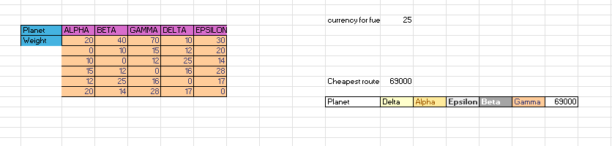
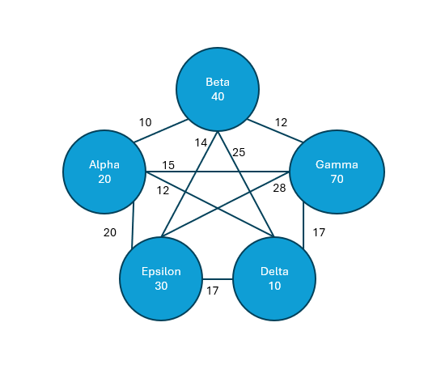

After running it through the whole brute forcing process, we can say that this is an inefficient way to solve this calculation because of the amount of time we take to find the cheapest solution (as it’s showed in the spreadsheet and the code for it). Going through all the possible combination in this case for 5 planets and gives me a O(n!), because I need to check the planets one by one in a factorial way so 5*4*3*2*1 = 120 combinations for this problem.
As seen during my research an algorithm with o(n!) requires high amount of time and is unusable for large input sizes.
Doing a bit more research into the brute-force I can say that there isn’t really any other O notations or ways to do it in a faster way because we want to get the cheapest value taking in weight, distance and fuel cost, taking in consideration that every planet we visit it will become heavier depending on the planet we are on, the best way to describe it would be an equation cost(D,W) = distance * weight* fuel cost.
I realised that I could use Dynamic programming to try and get the cheapest route faster and easier.

(10/11/2025) Medium: Mastering Big O Notation: https://medium.com/@sureshkumar.pawar/mastering-big-o-notation-a-comprehensive-guide-to-understanding-algorithm-efficiency-8d77d79384e1

Task 2
- int main()
- {
- int arr[10] = { 10, 15, 12, 12, 25, 16, 20, 14, 28, 17 };

- for (int i = 0; i < 10-1; i++)
- {
- int minIndex = i;
- for (int j = i + 1; j < 10; j++)
- {
- if (arr[j] < arr[minIndex])
- {
- minIndex = j;
- }
- }

- int temp = arr[minIndex];
- arr[minIndex] = arr[i];
- arr[i] = temp;
- }
- }

After looking through the process while programming it and the excel spreadsheet I realized that this wouldn’t have rare case of usage on the real world,it would be used mainly academically to show different sort algorithms. Since the Bubble Sort has a time complexity of O(n^2), it will result in being very slow for a larger amount of data sets.
Bubble sort is just a way to swap the adjacent value if they are in the wrong order.
There is an upside to it because if we get a fully sorted array the result would be O(n).
StudySmarter Bubble Sort (limitations of Bubble Sort (23November 2025))

Task 3

Prseudocode
- function Greedy(Graphic,source):
- for each vertex v in Graphic.Vertices:
- dist[v] ← INFINITY
- prev[v] ← UNDEFINED
- add v to Q
- dist[source] ← 0

- while Q is not empty:
- u ← vertex in Q with min dist[u]
- remove u from Q

- for each neighbor v of u still in Q:
- alt ← dist[u] + Graphic.Edges(u, v)
- if alt < dist[v]:
- dist[v] ← alt
- prev[v] ← u

- return dist[],prev[]

A Greedy Algorithm is a intuitive algorithm that normally used to optimize problems.
The algorithm makes optimal choices for each step following the given instructions, trying to find the overall optimal way to resolve the problem.

  - Description of the Pseudocode
Setting v as a number for the number of vectors sets the algorithm to O(V2) the main reason for this happening is because of the vertex with the lowest distance need to look for the next vertex to go to and that makes O(V) time. Regarding it we need to do It for every vertex connected to the current one, so we get time complexity O(V2) for the greedy algorithm Dijkstra’s strategy.
Time complexity do dijkstra’s algorithm W3Schools ( https://www.w3schools.com/dsa/dsa_algo_graphs_dijkstra.php) (20th November 2025)

Task 4
Dynamic Programming is used mainly to solve a certain type of problems that have overlapping subproblems and optimal substructure. It splits the problem into subproblems that it can at the same time split into smaller subproblems to resolve and reference later during the resolve. It helps lighten the usage of the CPU
https://www.programiz.com/dsa/dynamic-programming (22 November 2025)

Task 5
The job-scheduling problem is about figuring out the best way to organize a bunch of tasks, so they get done efficiently. Each job might have different lengths, deadlines, or priorities, and you might have multiple workers that can manage them. The catch is that you need to decide who does what and in what order. At first it might look straightforward but when we add it in the reality details like deadlines, limited resources or tasks that need other tasks to be completed, it becomes a lot more complicated. Because of this a lot of versions of this problem are NP complete, which means: “There is not fast way to solve this problem every time”
The scheduling shows is used everywhere around us. Starting from Factories that need to schedule production lines, Cloud Servers that need to assign tasks to processors, Retail to bring workers in for delivery and stuff of this matter. You might not believe it but even computers and laptop’s operating system are constantly deciding which programs get send to the CPU and for how long. Good scheduling means less waiting, more efficiency, and better use of resources. So even though it sounds abstract, the way we solve scheduling problems impacts everything from how fast your apps run to how companies save money and avoid delays. Researchers study these problems because they are not only practical, but they also tell us a lot about what computers can and cannot do efficiently.
The reason certain scheduling problems are NP-complete is because there are just way too many ways to arrange things, and the number of possibilities blows up super-fast as you add more jobs. As an example, imagine trying to split a bunch of tasks between two machines so they finish at the same time: that alone is already as hard as a Partition problem (the task of determining if a given set of integers can be divided into two subsets with equal sums). Add deadlines or profit values, and it becomes as challenging as Knapsack (classic combinatorial optimization problem where you must choose a subset of items, each with a given weight and value, to maximize total value without exceeding a maximum capacity). Scheduling becomes a puzzle that is easy to understand but extremely hard to solve perfectly.
If we use the greedy strategy to the job-scheduling problem, we can follow some steps.
We need to set up overall deadlines from the with the largest deadline, sort the jobs in a array by a descending order of profits, try to schedule each job the latest we can(if we can’t do the job by the deadline we skip it) an then output the new set of jobs.

Job | A | B | C | D | E
deadline | 2 | 1 | 3 | 1 | 2
profit | 27 | 25 | 15 | 19 | 100

Job | E | A | B | D | C
deadline | 2 | 2 | 1 | 1 | 3
profit | 100 | 27 | 25 | 19 | 15

Once we have the jobs sorted by profit, we can begin working our way through the algorithm assigning jobs into slots based on their deadlines.

Job | E | A | B | D | C
deadline | 2 | 2 | 1 | 1 | 3
profit | 100 | 27 | 25 | 19 | 15
1st 2nd 3rd
A | E | C

We will complete E as late as possible, in this case the 2s deadline, as a result we will not be able to complete A as late as possible because E is already occupying that slot, so we complete A before E. The following 2 Jobs (B and D) need to be completed before our first deadline, however since A is occupying this deadline, we will need to ignore them.
The last job available would-be C that has a deadline of 3, since the slot is still available, we can allocate the job in the last slot.
If we assume that the array of jobs is already sorted by profit, the example becomes a O(n2) in big O notation.

