/*
Program-1: Write a Java RMI program to accept an integer and check whether it is a Prime number or not.
Reg No: 24251115
Date: 23/10/2025
*/
Interface:
import java.rmi.RemoteException;
import java.rmi.Remote;

public interface PrimeCheckInterface extends Remote {
public boolean checkPrime(int number) throws RemoteException;
}

Implement:
import java.rmi.server.UnicastRemoteObject;
import java.rmi.RemoteException;

public class PrimeCheckImplement extends UnicastRemoteObject implements PrimeCheckInterface {
public PrimeCheckImplement() throws RemoteException{
super();
}

public boolean checkPrime(int number) throws RemoteException{
if (number <= 1) {
return false;
}
for (int i = 2; i <= Math.sqrt(number); i++) {
if (number % i == 0) {
return false;
}
}
return true;
}
}

Client:
import java.rmi.registry.*;
import java.util.Scanner;
public class PrimeCheckClient {
public static void main(String[] args) {
try{
Registry reg = LocateRegistry.getRegistry(4000);
PrimeCheckInterface imp = (PrimeCheckInterface) reg.lookup("PrimeCheck");
Scanner scanner = new Scanner(System.in);

System.out.println("Enter a number to check if it's prime: ");
int number = scanner.nextInt();

if(imp.checkPrime(number)){
System.out.println(number + " is a prime number.");
} else {
System.out.println(number + " is not a prime number.");
}
scanner.close();
}catch(Exception e){
System.out.println("Unexpected error: "+e);
}

}
}

Server:
import java.rmi.registry.Registry;
import java.rmi.registry.LocateRegistry;
public class PrimeCheckServer{
public static void main(String args[]){
try{
PrimeCheckImplement obj = new PrimeCheckImplement();
Registry registry = LocateRegistry.createRegistry(4000);
registry.bind("PrimeCheck", obj);
System.out.println("PrimeCheck Server is ready.");

}catch(Exception e){
System.out.println("Unexpected error: "+e);
}
}
}

Output:
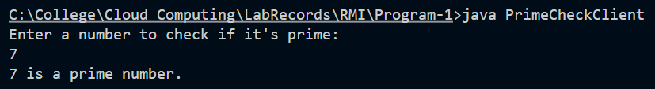

/*
Program-2: Write a Java RMI program to accept an integer and calculate the sum of factorial
of each digit in it. E.g.: Num = 251 → S = 2! + 5! + 1!
Reg No: 24251115
Date: 23/10/2025
*/
Interface:
import java.rmi.Remote;
import java.rmi.RemoteException;

public interface FactSumInter extends Remote
{
public int sumFact(int num) throws RemoteException;
}

Implement:
import java.rmi.server.UnicastRemoteObject;
import java.rmi.RemoteException;
public class FactSumImpl extends UnicastRemoteObject implements FactSumInter
{
public FactSumImpl() throws RemoteException
{
super();
}
public int sumFact(int num) throws RemoteException{
int rem=0,sum=0,fact;
while(num>0)
{
rem=num%10;
if(rem==0)
fact=0;
else
fact=1;
for(int i=2;i<=rem;i++)
fact=fact*i;
sum+=fact;
num=num/10;
}
return sum;
}
}
Client:
import java.rmi.registry.LocateRegistry;
import java.rmi.registry.Registry;
import java.util.Scanner;
public class FactSumClient
{ public static void main(String args[])
{
Scanner sc=new Scanner(System.in);
try
{
Registry reg=LocateRegistry.getRegistry(5000);
FactSumInter temp=(FactSumInter) reg.lookup("factsum");

System.out.println("Client is accessing...");
System.out.print("\nEnter an Integer: ");
int num=sc.nextInt();
System.out.println("The sum of the factorials of each digit in an integer "+num+" is: "+temp.sumFact(num));
}
catch(Exception e){
System.out.println(e.getMessage());
sc.close();
}
}
}
Server:
import java.rmi.registry.LocateRegistry;
import java.rmi.registry.Registry;
public class FactSumServer
{
public static void main(String args[])
{
try{
FactSumImpl obj=new FactSumImpl();
Registry reg=LocateRegistry.createRegistry(5000);
reg.rebind("factsum",obj);
System.out.println("Server is started...");
}
catch(Exception e){
System.out.println(e.getMessage());}
}
}

Output:
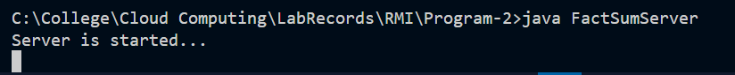
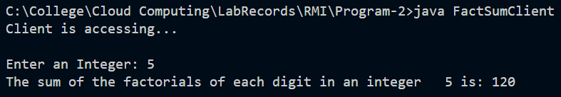

/*
Program-3: Write a Java RMI program to accept some integers and store the same in an array then find the maximum element among those.
Reg No: 24251115
Date: 23/10/2025
*/
Interface:

import java.rmi.Remote;
import java.rmi.RemoteException;

public interface MaxEleInterface extends Remote {
public int findMax(int num[]) throws RemoteException;
}

Implement:

import java.rmi.server.UnicastRemoteObject;
import java.rmi.RemoteException;

public class MaxEleClass extends UnicastRemoteObject implements MaxEleInterface {
public MaxEleClass() throws RemoteException {
super();
}
public int findMax(int num[]) throws RemoteException{
int max = num[0];
for (int i = 0; i<num.length;i++)
if(num[i]>max)
max = num[i];
return max;
}
}

Client:
import java.rmi.registry.LocateRegistry;
import java.rmi.registry.Registry;
import java.util.Scanner;

public class MaxEleClient {
public static void main(String args[]){
Scanner sc = new Scanner(System.in);
try {
Registry reg = LocateRegistry.getRegistry(8000);

MaxEleInterface temp = (MaxEleInterface) reg.lookup("maxele");

System.out.println("Client is accessing....");

System.out.print("Enter the size of an array: ");
int n = sc.nextInt();
int num[] = new int[n];

System.out.print("Enter " + n + " elements: ");
for(int i=0; i<num.length;i++){
num[i]=sc.nextInt();
}

int max = temp.findMax(num);
System.out.println("The maximum element among the given array is: " +max);
}
catch (Exception e) {
System.out.println(e.getMessage());
sc.close();
}
}
}

Server:

import java.rmi.registry.LocateRegistry;
import java.rmi.registry.Registry;
public class MaxEleServer {
public static void main(String[] args) {
try {
MaxEleClass obj = new MaxEleClass();
Registry reg = LocateRegistry.createRegistry(8000);
reg.rebind("maxele", obj);

System.out.println("Server is started....");
}
catch (Exception e) {
System.out.println(e.getMessage());
}
}
}

Output:
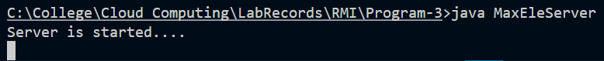
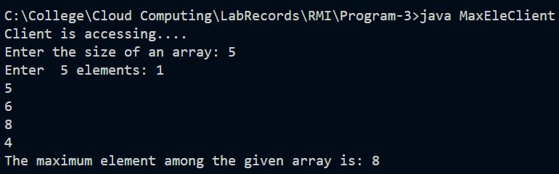

/*
Program-4: Write a Java RMI program to accept a String as command-line argument and
check whether it has repeated characters in it or not.
Reg No: 24251115
Date: 16/09/2025
*/
Interface:
import java.rmi.Remote;
import java.rmi.RemoteException;

public interface FindRepCharInterface extends Remote{
public boolean findRepChar(String str) throws RemoteException;
}

Implement:
import java.rmi.server.UnicastRemoteObject;
import java.rmi.RemoteException;

public class FindRepCharImpl extends UnicastRemoteObject implements FindRepCharInterface{
public FindRepCharImpl() throws RemoteException{
super();
}
public boolean findRepChar(String str) throws RemoteException{
for (int i = 0; i < str.length(); i++) {
for (int j = i + 1; j < str.length(); j++) {
if (str.charAt(i) == str.charAt(j)) {
return true;
}
}
}
return false;
}
}

Client:
import java.rmi.registry.LocateRegistry;
import java.rmi.registry.Registry;
import java.util.Scanner;

public class FindRepCharClient{
public static void main(String args[]){
Scanner sc = new Scanner(System.in);
try{
Registry reg = LocateRegistry.getRegistry(5000);
FindRepCharInterface temp = (FindRepCharInterface) reg.lookup("findrepchar");
System.out.println("Client is accessing...");
String st = args[0];
if(temp.findRepChar(st))
System.out.println("\nThe given string have repeatedcharacters.....");
else
System.out.println("\nThe given string does not have repeated characters.....");
}
catch (Exception e){
System.out.println(e.getMessage());
sc.close();
}
}
}

Server:
import java.rmi.registry.LocateRegistry;
import java.rmi.registry.Registry;

public class FindRepCharServer{
public static void main(String args[]){
try{
FindRepCharImpl obj = new FindRepCharImpl();
Registry reg = LocateRegistry.createRegistry(5000);
reg.rebind("findrepchar",obj);
System.out.println("Server is started...");
}
catch (Exception e){
System.out.println(e.getMessage());
}
}
}

Output:
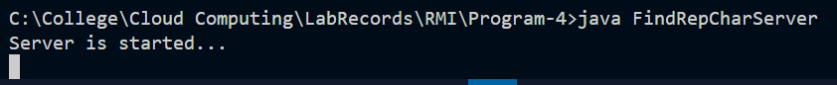
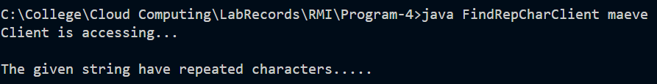

/*
Program-5: Write a Java RMI program to accept a line of text and display only the strings
which contains vowels in it.
Reg No: 24251115
Date: 23/10/2025
*/
Interface:
import java.rmi.Remote;
import java.rmi.RemoteException;

public interface StrVowInterface extends Remote{
public boolean findVow(String str) throws RemoteException;
}

Client:
import java.rmi.registry.LocateRegistry;
import java.rmi.registry.Registry;
import java.util.Scanner;

public class StrVowClient{
public static void main(String args[]){
Scanner sc = new Scanner(System.in);
try{
Registry reg = LocateRegistry.getRegistry(4000);
StrVowInterface temp = (StrVowInterface) reg.lookup("checkvow");
System.out.println("Client is accessing...");
System.out.print("\nEnter a line of text: ");
String st = sc.nextLine();

String strArray[] = st.split(" ");

System.out.println("\nWords With Vowels: ");
for (int i = 0 ; i < strArray.length; i++){
String str = strArray[i];
if(temp.findVow(str))
System.out.println(str);}
}
catch (Exception e){
System.out.println(e.getMessage());
sc.close();
}
}
}

Server:
import java.rmi.registry.Registry;
import java.rmi.registry.LocateRegistry;

public class StrVowServer {
public static void main(String args[]){
try{
StrVowImpl obj = new StrVowImpl();
Registry registry = LocateRegistry.createRegistry(4000);
registry.rebind("checkvow", obj);
System.out.println("Server is started...");

}catch(Exception e){
System.out.println(e.getMessage());
}
}
}

Implement:
import java.rmi.server.UnicastRemoteObject;
import java.rmi.RemoteException;

public class StrVowImpl extends UnicastRemoteObject implements StrVowInterface{
public StrVowImpl() throws RemoteException{
super();
}
public boolean findVow(String str) throws RemoteException{
boolean isVow = false ;
for (int i = 0 ; i < str.length() ; i++)
if(str.charAt(i) =='a' || str.charAt(i) =='e' || str.charAt(i) =='i' || str.charAt(i) =='o' || str.charAt(i) =='u'){
isVow = true;
break;
}
return isVow;
}
}

Output:
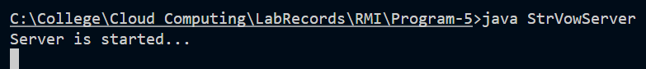
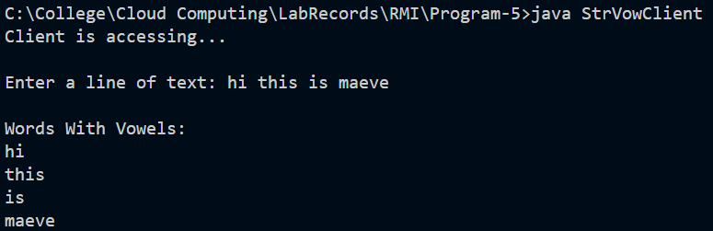

/*
Program-6: Write a Java RMI program to accept a line of text and display each string after
deleting all the repeated characters in it if it contains.
Reg No: 24251115
Date: 23/10/2025
*/
Interface:
import java.rmi.Remote;
import java.rmi.RemoteException;

public interface DelRepCharInterface extends Remote{
public String delRepChar(String str) throws RemoteException;
}

Client:
import java.rmi.registry.LocateRegistry;
import java.rmi.registry.Registry;
import java.util.Scanner;

public class DelRepCharClient{
public static void main(String args[]){
Scanner sc = new Scanner(System.in);
try{
Registry reg = LocateRegistry.getRegistry(5000);
DelRepCharInterface temp = (DelRepCharInterface) reg.lookup("delrepchar");
System.out.println("Client is accessing...");
System.out.print("\nEnter a line of text: ");

String st = sc.nextLine();
String strArray[] = st.split(" ");

System.out.println("\nWords after deleting repeated Characters.....");
for (int i = 0 ; i < strArray.length; i++){
String str = strArray[i];
System.out.print(temp.delRepChar(str)+" ");
}
}
catch (Exception e){
System.out.println(e.getMessage());
sc.close();
}
}
}

Server:
import java.rmi.registry.LocateRegistry;
import java.rmi.registry.Registry;

public class DelRepCharServer{
public static void main(String args[]){
try{
DelRepCharImpl obj = new DelRepCharImpl();
Registry reg = LocateRegistry.createRegistry(5000);
reg.rebind("delrepchar",obj);

System.out.println("Server is started...");
}
catch (Exception e){
System.out.println(e.getMessage());}
}
}

Implement:
import java.rmi.server.UnicastRemoteObject;
import java.rmi.RemoteException;

public class DelRepCharImpl extends UnicastRemoteObject implements DelRepCharInterface{
public DelRepCharImpl() throws RemoteException{
super();
}
public String delRepChar(String str) throws RemoteException{
StringBuffer st = new StringBuffer(str);
for (int i = 0; i < st.length(); i++) {
for (int j = i + 1; j < st.length(); j++) {
if (st.charAt(i) == st.charAt(j)) {
st.deleteCharAt(j);
}
}
}
String newst = st.toString();
return newst;
}
}

Output:
