/*
Program-7: Write a python script to find both maximum and minimum digit in a given multidigit number.
Reg No: 24251115
Date: 06/11/2025
*/

maxServer.py :
import socket as sc
import time

def find_max_min_digit(num):
# Convert number to string to access each digit
num_str = str(abs(num)) # abs() handles negative numbers too

# Initialize max and min with the first digit
max_digit = min_digit = int(num_str[0])

# Loop through remaining digits
for ch in num_str[1:]:
digit = int(ch)
if digit > max_digit:
max_digit = digit
if digit < min_digit:
min_digit = digit

return max_digit, min_digit

s_sock = sc.socket()
s_sock.bind(('localhost', 5000))
s_sock.listen(1) #waiting for client
print('Server is waiting for request')

c_sock, addr = s_sock.accept()
print('Connected with Client...', addr)

num = c_sock.recv(1024).decode()
print('Received from client:', num)

max_digit, min_digit = find_max_min_digit(int(num))
print(f'Maximum digit: {max_digit}, Minimum digit: {min_digit}')

response = f'{num} -> Maximum digit: {max_digit}, Minimum digit: {min_digit}'
data = bytes(response, 'utf-8')
c_sock.send(data)

time.sleep(0.5) # Ensure data is sent before closing
c_sock.close()
s_sock.close()

maxClient.py :
import socket as sc

c_sock = sc.socket()
c_sock.connect(('localhost', 5000))

number = input("Enter a multidigit number: ")
val = bytes(number, 'utf-8')
c_sock.send(val)

data = c_sock.recv(1024).decode()
print(data)

c_sock.close()

OUTPUT :

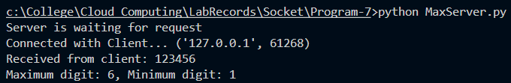

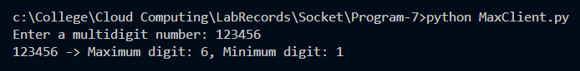

/*
Program-8: Write a python script to find the Nth term of a Fibonacci series.
Reg No: 24251115
Date: 06/11/2025
*/

fibServer.py :
import socket as sc
import time

def findNthFibonacci(n):
"""Find the Nth term of Fibonacci series"""
if n <= 0:
return "Invalid input"
elif n == 1:
return 0
elif n == 2:
return 1
else:
a, b = 0, 1
for i in range(2, n):
c = a + b
a = b
b = c
return b

s_sock = sc.socket()
s_sock.bind(('localhost', 5000))
s_sock.listen(1)

print('Server is waiting for request')
c_sock, addr = s_sock.accept()
print('Connected with Client...', addr)

num = c_sock.recv(1024).decode()
print('Received from client:', num)

nth_term = findNthFibonacci(int(num))
print(f'The {num}th term of Fibonacci series is: {nth_term}')

response = f'The {num}th term of Fibonacci series is: {nth_term}'
data = bytes(response, 'utf-8')
c_sock.send(data)

time.sleep(0.5) # Ensure data is sent before closing
c_sock.close()
s_sock.close()

fibClient.py :
import socket as sc

c_sock = sc.socket()
c_sock.connect(('localhost', 5000))

n = input("Enter the value of N (position in Fibonacci series): ")
val = bytes(n, 'utf-8')
c_sock.send(val)

data = c_sock.recv(1024).decode()
print(data)

c_sock.close()

OUTPUT :
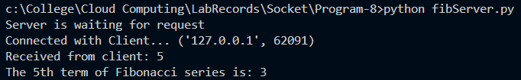

/*
Program-9: Write a python script to convert a given Binary number to its Decimal Equivalent number.
Reg No: 24251115
Date: 06/11/2025
*/

binaryServer.py :
import socket as sc
import time

def binaryToDecimalManual(binary_str):
"""Convert binary to decimal manually without built-in int() function"""
decimal = 0
power = 0

# Traverse binary string from right to left
for digit in reversed(binary_str):
if digit not in ['0', '1']:
return "Invalid binary number"
decimal += int(digit) * (2 ** power)
power += 1

return decimal

s_sock = sc.socket()
s_sock.bind(('localhost', 5000))
s_sock.listen(1)

print('Server is waiting for request')
c_sock, addr = s_sock.accept()
print('Connected with Client...', addr)

binary_num = c_sock.recv(1024).decode()
print('Received from client:', binary_num)

decimal_num = binaryToDecimalManual(binary_num)
print(f'Binary {binary_num} in Decimal is: {decimal_num}')

response = f'Binary {binary_num} = Decimal {decimal_num}'
data = bytes(response, 'utf-8')
c_sock.send(data)

time.sleep(0.5) # Ensure data is sent before closing
c_sock.close()
s_sock.close()

binaryClient.py :
import socket as sc

c_sock = sc.socket()
c_sock.connect(('localhost', 5000))

binary = input("Enter a binary number: ")
val = bytes(binary, 'utf-8')
c_sock.send(val)

data = c_sock.recv(1024).decode()
print(data)

c_sock.close()

OUTPUT :
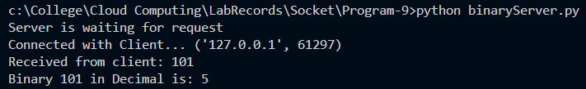

/*
Program-10: Write a python script to count the common characters in given two strings.
Reg No: 24251115
Date: 06/11/2025
*/

commonCharServer.py :
import socket as sc
import time

def countCommonChars(str1, str2):
"""Count common characters between two strings"""
# Convert both strings to sets and find intersection
common = set(str1.lower()) & set(str2.lower())
count = len(common)
return count, common

s_sock = sc.socket()
s_sock.bind(('localhost', 5000))
s_sock.listen(1)

print('Server is waiting for request')
c_sock, addr = s_sock.accept()
print('Connected with Client...', addr)

# Receive two strings separated by comma
strings = c_sock.recv(1024).decode()
print('Received from client:', strings)

# Split the strings
str1, str2 = strings.split(',')
count, common = countCommonChars(str1, str2)
print(f'Common characters: {common}')
print(f'Count: {count}')

response = f'Strings: "{str1}" and "{str2}" | Common characters: {sorted(common)} | Count: {count}'
data = bytes(response, 'utf-8')
c_sock.send(data)

time.sleep(0.5) # Ensure data is sent before closing
c_sock.close()
s_sock.close()

commonCharClient.py :
import socket as sc

c_sock = sc.socket()
c_sock.connect(('localhost', 5000))

str1 = input("Enter first string: ")
str2 = input("Enter second string: ")

# Send both strings separated by comma
combined = str1 + ',' + str2
val = bytes(combined, 'utf-8')
c_sock.send(val)

data = c_sock.recv(1024).decode()
print(data)

c_sock.close()

OUTPUT :
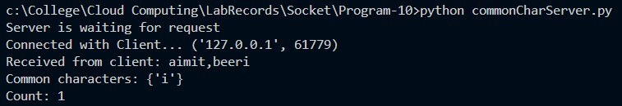

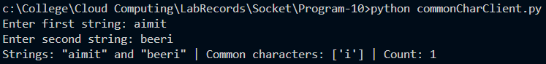

/*
Program-11: Write a python script to replace each vowel with next vowel in cyclic order. For e.g.,: a → e, e→i, i →o, o → u, u → a
Reg No: 24251115
Date: 06/11/2025
*/

vowelServer.py :
import socket as sc
import time

def replaceVowelsNext(text):
"""Replace each vowel with next vowel in cyclic order"""
# Create vowel mapping: a->e, e->i, i->o, o->u, u->a
vowels = 'aeiou'
vowel_map = dict(zip(vowels, vowels[1:] + vowels[0]))

# Add uppercase mappings
vowel_map.update(dict(zip(vowels.upper(), (vowels[1:] + vowels[0]).upper())))

# Replace each character
result = ''.join([vowel_map.get(char, char) for char in text])
return result

s_sock = sc.socket()
s_sock.bind(('localhost', 5000))
s_sock.listen(1)

print('Server is waiting for request')
c_sock, addr = s_sock.accept()
print('Connected with Client...', addr)

text = c_sock.recv(1024).decode()
print('Received from client:', text)

converted = replaceVowelsNext(text)
print(f'Original: {text}')
print(f'Converted: {converted}')

response = f'Original: {text} | Converted: {converted}'
data = bytes(response, 'utf-8')
c_sock.send(data)

time.sleep(0.5) # Ensure data is sent before closing
c_sock.close()
s_sock.close()

vowelClient.py :
import socket as sc

c_sock = sc.socket()
c_sock.connect(('localhost', 5000))

text = input("Enter a string: ")
val = bytes(text, 'utf-8')
c_sock.send(val)

data = c_sock.recv(1024).decode()
print(data)

c_sock.close()

OUTPUT :
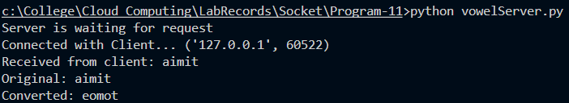

/*
Program-12: Write a python script to generate 10 multiples of a given number using a Generator Function.
Reg No: 24251115
Date: 06/11/2025
*/

multiplesServer.py :
import socket as sc
import time

def generateMultiples(n, count=10):
"""Generator function to yield multiples of a number"""
for i in range(1, count + 1):
yield n * i

s_sock = sc.socket()
s_sock.bind(('localhost', 5000))
s_sock.listen(1)

print('Server is waiting for request')
c_sock, addr = s_sock.accept()
print('Connected with Client...', addr)

num = c_sock.recv(1024).decode()
print('Received from client:', num)

# Generate 10 multiples using generator
multiples = list(generateMultiples(int(num), 10))
print(f'10 multiples of {num}: {multiples}')

response = f'10 multiples of {num}: {multiples}'
data = bytes(response, 'utf-8')
c_sock.send(data)

time.sleep(0.5) # Ensure data is sent before closing
c_sock.close()
s_sock.close()

multiplesClient.py :
import socket as sc

c_sock = sc.socket()
c_sock.connect(('localhost', 5000))

num = input("Enter a number: ")
val = bytes(num, 'utf-8')
c_sock.send(val)

data = c_sock.recv(1024).decode()
print(data)

c_sock.close()

OUTPUT :
