- What Is Data Warehousing? Explain the Benefits of Data Warehousing.
A Data Warehouse is a centralized system used for storing and managing large volumes of structured data from multiple sources. It is specifically designed for analytical processing (OLAP – Online Analytical Processing), enabling organizations to analyze historical and current data to support decision-making. Unlike operational databases, which handle real-time transactional data (OLTP – Online Transaction Processing), a data warehouse stores integrated, subject-oriented, time-variant, and non-volatile data, optimized for fast query performance and complex analysis.
Data is extracted from various sources like transactional databases, flat files, and cloud services, then transformed and loaded (ETL process – Extract, Transform, Load) into the data warehouse. Popular tools and platforms for data warehousing include Amazon Redshift, Google BigQuery, Snowflake, and Microsoft Azure Synapse.

Benefits of Data Warehousing
- Improved Decision-Making:
Data warehouses provide a consolidated view of organizational data, enabling better analysis and business intelligence, which leads to more informed and accurate decisions.
- High Performance:
Optimized for read-intensive operations, data warehouses handle complex queries and large-scale reporting much faster than operational databases.
- Data Consistency and Quality:
By integrating data from various sources and standardizing formats, data warehouses improve data accuracy and consistency.
- Historical Analysis:
Data warehouses store time-variant data, allowing users to analyze trends and patterns over time, which is useful for forecasting and strategic planning.
- Enhanced Business Intelligence Tools:
They support advanced BI tools, dashboards, and data mining techniques, improving the organization’s ability to interpret and act on data.
- Security and Data Governance:
Centralized control allows better implementation of security, privacy, and compliance measures for sensitive data.
- Scalability:
Data warehouses are scalable and can grow with increasing data volumes without significant performance degradation.

- Summarize the Distinct Features of OLTP vs OLAP.
Feature | OLTP (Online Transaction Processing) | OLAP (Online Analytical Processing)
Purpose | Handles day-to-day transactions | Performs complex analysis and reporting
Data Type | Current, real-time data | Historical, consolidated data
Operations | Read/write (INSERT, UPDATE, DELETE) | Read-only (SELECT, analytical queries)
Query Type | Simple, short queries | Complex, long-running queries
Normalization | Highly normalized to avoid redundancy | Denormalized for faster access
Response Time | Fast (milliseconds) | Slower (seconds to minutes)
Users | Clerks, database admins, front-end users | Managers, analysts, data scientists
Data Volume | Low to medium | Large volumes (gigabytes to terabytes)
Examples | ATM systems, e-commerce, inventory management | Sales forecasting, trend analysis, dashboards

- What Elements Would You Use to Relate the Design of a Data Warehouse? Explain
To relate the design of a Data Warehouse, we use several key elements that define its structure, operation, and usability. Here's a breakdown of the essential elements used in designing a data warehouse:

🔑 1. Data Sources
- Definition: Operational databases, external data feeds, flat files, etc.
- Purpose: Provide the raw data that will be extracted and loaded into the data warehouse.
- Examples: ERP systems, CRM tools, web logs, spreadsheets.

🛠️ 2. ETL Process (Extract, Transform, Load)
- Extract: Pull data from multiple sources.
- Transform: Clean, convert, and standardize data (e.g., converting date formats, removing duplicates).
- Load: Insert the processed data into the data warehouse.
- Tools: Apache NiFi, Informatica, Talend, Microsoft SSIS.

🗃️ 3. Data Storage (Data Warehouse Database)
- Central Repository: Stores historical and current data in an integrated format.
- Types:
  - Star Schema: One central fact table connected to dimension tables.
  - Snowflake Schema: More normalized version of star schema with sub-dimensions.
- Technologies: Amazon Redshift, Google BigQuery, Snowflake, Microsoft Azure Synapse.

📊 4. Data Marts
- Definition: Subsets of the data warehouse tailored for specific business departments (e.g., marketing, sales).
- Purpose: Improve performance and usability for specific user groups.

🧠 5. Metadata
- Definition: Data about data (describes origin, format, usage).
- Types:
  - Technical Metadata: Schema definitions, data types.
  - Business Metadata: Definitions, rules, KPIs.

🔍 6. OLAP Engine (Online Analytical Processing)
- Purpose: Enables multidimensional analysis and fast querying.
- Types:
  - ROLAP: Uses relational databases.
  - MOLAP: Uses multidimensional cubes.
  - HOLAP: Hybrid approach.

📈 7. Front-End Tools / BI Tools
- Used For: Reporting, dashboards, data visualization, ad-hoc querying.
- Examples: Tableau, Power BI, Looker, QlikView.

🔐 8. Security and Access Control
- Includes: User authentication, role-based access, data encryption.
- Purpose: Ensure that only authorized users can access or modify data.

🧭 9. Data Governance
- Focuses On: Data quality, integrity, consistency, and compliance.
- Includes: Policies, standards, and procedures.

- Draw the Data Warehouse Architecture and Explain Its Components
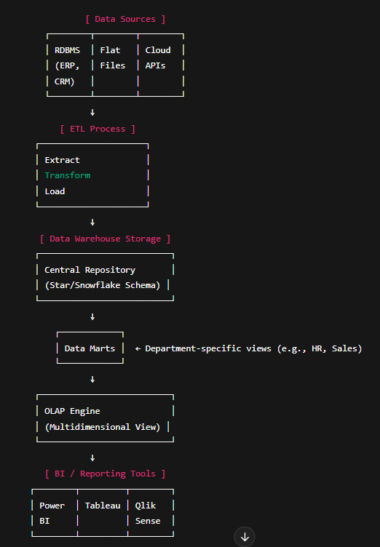

1. Data Sources
- Definition: The origin of raw data.
- Examples:
  - ERP / CRM databases (structured)
  - Flat files like CSV, Excel (semi-structured)
  - Web services, APIs (cloud-based sources)

2. ETL (Extract, Transform, Load)
- Extract: Retrieve data from multiple sources.
- Transform: Clean, format, and apply business rules.
- Load: Store the processed data into the data warehouse.

3. Data Warehouse Storage
- Definition: Centralized storage for historical data.
- Schemas:
  - Star Schema: Simplified, denormalized.
  - Snowflake Schema: Normalized, with sub-dimensions.

4. Data Marts
- Purpose: Serve the specific needs of departments.
- Example: A sales data mart will only contain sales-related data from the warehouse.

5. OLAP (Online Analytical Processing)
- Function: Allows fast querying and multidimensional analysis.
- Types:
  - ROLAP: Uses relational database backend.
  - MOLAP: Uses multidimensional cube.
  - HOLAP: Combines both.

6. BI / Reporting Tools
- Use: Generate reports, dashboards, and data visualizations.
- Examples: Power BI, Tableau, Google Data Studio, Looker.

Explain the Steps in Building a Data Warehouse
✅ Steps in Building a Data Warehouse
Building a data warehouse is a structured process that involves planning, design, development, testing, and deployment. Here's a step-by-step explanation:

1. Requirements Gathering
- Goal: Understand the business needs and define objectives.
- Activities:
  - Meet with stakeholders.
  - Identify key performance indicators (KPIs).
  - Define the type of reports and analytics required.

2. Data Source Identification
- Goal: Determine where the data will come from.
- Examples:
  - ERP, CRM, transaction systems.
  - Excel sheets, log files, APIs.

3. Data Modeling (Design Phase)
- Goal: Define the logical structure of the warehouse.
- Activities:
  - Choose schema type: Star Schema or Snowflake Schema.
  - Identify Fact Tables (numerical data) and Dimension Tables (context).

4. ETL Development (Extract, Transform, Load)
- Extract: Pull data from multiple sources.
- Transform: Clean, filter, normalize, and apply business rules.
- Load: Insert the transformed data into the warehouse.
- Tools: Informatica, Talend, SSIS, Apache Nifi.

5. Data Warehouse Implementation
- Goal: Create the actual data warehouse database.
- Steps:
  - Create tables and indexes.
  - Set up storage (cloud or on-premise).
  - Load initial data from ETL pipeline.

6. Data Marts Creation (Optional)
- Goal: Create subject-specific views for departments (e.g., Sales, HR).
- Use: Speeds up query performance and improves user experience.

7. OLAP Cubes Development
- Goal: Build multidimensional views of data for faster analysis.
- Enables: Slice, dice, drill-down, roll-up operations.

8. Front-End & BI Tool Integration
- Goal: Provide a user interface for data analysis.
- Tools: Power BI, Tableau, QlikView, Looker.
- Outputs: Dashboards, visualizations, reports.

9. Testing & Validation
- Goal: Ensure data accuracy, completeness, and performance.
- Testing Types:
  - Data Validation Testing: Check for correct transformations.
  - Performance Testing: Test response time.
  - Security Testing: Validate role-based access.

10. Deployment & Maintenance
- Deployment: Move the data warehouse to a production environment.
- Maintenance:
  - Schedule regular ETL jobs.
  - Monitor performance and usage.
  - Apply updates and fixes.

Summary Table
Step | Purpose
1. Requirements Gathering | Understand business goals
2. Data Source Identification | Identify input systems
3. Data Modeling | Design schemas and tables
4. ETL Development | Extract, transform, and load data
5. Warehouse Implementation | Set up the central repository
6. Data Marts Creation | Create department-specific data marts
7. OLAP Cubes | Enable multidimensional analysis
8. BI Tool Integration | Allow reporting and dashboards
9. Testing & Validation | Ensure data quality and performance
10. Deployment & Maintenance | Go live and manage the system

- Analyze the Types of Data Mart
✅ Types of Data Mart – Analyzed and Explained
A Data Mart is a subset of a Data Warehouse focused on a specific business line or team (like Sales, Marketing, or HR). There are three main types of data marts based on how they are created and where they source their data.

🔷 1. Dependent Data Mart
✅ Description:
- It is created from an existing enterprise data warehouse.
- Data is first extracted from source systems into the central warehouse, and then into the data mart.
📌 Features:
- High consistency of data across departments.
- Maintains single version of truth.
- Centralized data governance.
🟢 Advantages:
- Strong data integrity.
- Easier integration with other business units.
🔴 Disadvantages:
- More complex and costly to implement.
- Slower to build initially.
🎯 Use Case:
- Large organizations with an enterprise-wide data strategy.

🔷 2. Independent Data Mart
✅ Description:
- It is created directly from operational or external sources without using a central data warehouse.
- Standalone system for a specific team or function.
📌 Features:
- Quick to implement.
- Often built for specific analytical needs.
🟢 Advantages:
- Faster deployment.
- Lower cost and complexity.
🔴 Disadvantages:
- Data silos and possible inconsistencies across marts.
- Difficult to scale or integrate later.
🎯 Use Case:
- Small businesses or departmental solutions where enterprise data warehouse doesn't exist.

🔷 3. Hybrid Data Mart
✅ Description:
- Combines features of both dependent and independent data marts.
- It may use some data from a central data warehouse and some directly from source systems.
📌 Features:
- Flexible architecture.
- Supports varied analytical requirements.
🟢 Advantages:
- Balanced performance and data consistency.
- Easier to scale and customize.
🔴 Disadvantages:
- Design and management complexity.
🎯 Use Case:
- Organizations transitioning from independent marts to a full warehouse strategy, or with mixed architecture.

📊 Summary Comparison Table
Feature | Dependent Data Mart | Independent Data Mart | Hybrid Data Mart
Data Source | Enterprise Data Warehouse | Operational Systems | Both
Speed of Deployment | Slow | Fast | Medium
Data Consistency | High | Low | Medium
Cost | High | Low | Medium
Best For | Large Organizations | Small Teams/Startups | Evolving Enterprises

Let me know if you'd like a diagram or use-case examples for each!

- What Are the Applications of a Data Warehouse? Explain
✅ Applications of a Data Warehouse – Explained
A Data Warehouse is a central repository of integrated data from multiple sources, designed to support business intelligence, decision-making, and data analysis. It is widely used across industries to gain insights and drive strategic actions.

🔷 1. Business Intelligence (BI) and Analytics
- Application: Generating reports, dashboards, KPIs, and visualizations.
- Use: Helps managers and executives make data-driven decisions.
- Example: A sales dashboard showing regional performance trends.

🔷 2. Customer Relationship Management (CRM)
- Application: Storing and analyzing customer data (e.g., behavior, preferences, history).
- Use: Enables targeted marketing and better customer service.
- Example: Personalized email campaigns based on purchase history.

🔷 3. Financial Analysis
- Application: Consolidating financial data from different departments.
- Use: Supports budgeting, forecasting, and profitability analysis.
- Example: Analyzing expense trends across business units.

🔷 4. Supply Chain Management
- Application: Monitoring inventory, suppliers, and delivery performance.
- Use: Optimizes logistics and minimizes delays or costs.
- Example: Analyzing delivery times across suppliers to find the most efficient.

🔷 5. Healthcare Analytics
- Application: Integrating patient records, treatment outcomes, and clinical data.
- Use: Improves patient care and supports research.
- Example: Predicting disease outbreaks based on historical health records.

🔷 6. Retail and E-Commerce
- Application: Tracking customer purchases, inventory levels, and seasonal trends.
- Use: Enhances product placement and demand forecasting.
- Example: Suggesting products based on customer buying patterns.

🔷 7. Fraud Detection and Risk Management
- Application: Analyzing transaction data to detect anomalies.
- Use: Identifies suspicious behavior in real-time.
- Example: Flagging an unusually large transaction in banking.

🔷 8. Human Resource Management
- Application: Storing employee data, performance metrics, and attendance.
- Use: Supports workforce planning and employee engagement.
- Example: Generating attrition rate reports or training effectiveness analysis.

🔷 9. Education and Research
- Application: Storing academic records, research data, and performance reports.
- Use: Helps track student progress and support institutional planning.
- Example: Analyzing student dropout trends over the years.

🔷 10. Government and Public Services
- Application: Collecting data from various departments for transparency and policy decisions.
- Use: Improves governance and public resource allocation.
- Example: Analyzing census data for infrastructure planning.

Diagrammatically Illustrate and Discuss Preprocessing Techniques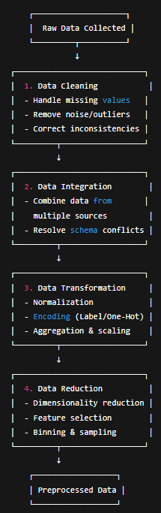
🔹 1. Data Cleaning
Purpose: Improve data quality by fixing or removing incorrect, corrupted, or incomplete records.
Techniques:
- Missing Value Handling: Replace with mean/median/mode or use interpolation.
- Noise Removal: Use smoothing techniques like binning or regression.
- Outlier Detection: Use Z-score, IQR, or box plots.
- Consistency Checks: Standardize data formats (e.g., date, currency).

🔹 2. Data Integration
Purpose: Merge data from different sources into a cohesive dataset.
Techniques:
- Schema Integration: Align column names/types.
- Entity Resolution: Match data entries that refer to the same entity (e.g., customer ID vs. email).
- Redundancy Removal: Eliminate duplicate records.

🔹 3. Data Transformation
Purpose: Convert data into a suitable format or structure for analysis.
Techniques:
- Normalization: Scale data to a range (e.g., 0–1).
- Standardization: Center data with mean 0 and standard deviation 1.
- Encoding: Convert categorical variables (e.g., one-hot or label encoding).
- Aggregation: Summarize data (e.g., average monthly sales).

🔹 4. Data Reduction
Purpose: Reduce the volume of data while preserving its integrity and information.
Techniques:
- Feature Selection: Keep only the most relevant variables.
- Dimensionality Reduction: Use PCA (Principal Component Analysis).
- Binning: Group values into bins (e.g., age 20–29 = "Young").
- Sampling: Analyze a representative subset of the data.

