MACHINE LEARNING

**1.Application of ML**

**1**. Healthcare

* Disease Prediction and Diagnosis: ML models detect diseases like cancer, diabetes, or heart conditions from medical images or patient data.
* Drug Discovery: Speeds up the identification of potential drug compounds.
* Personalized Treatment: Recommends treatments based on individual patient data.

2. Finance

* Fraud Detection: Identifies unusual patterns in transactions to prevent fraud.
* Algorithmic Trading: Executes stock trades based on predictive models.
* Credit Scoring: Assesses credit risk based on historical data.

3. Marketing & Sales

* Customer Segmentation: Groups customers for targeted marketing.
* Recommendation Systems: Suggests products or services (e.g., Amazon, Netflix).
* Predictive Analytics: Forecasts sales, churn, and customer behavior.

4. Manufacturing

* Predictive Maintenance: Anticipates equipment failure to avoid downtime.
* Quality Control: Uses vision systems to detect product defects.

5. Transportation

* Self-Driving Cars: Uses ML for object detection, path planning, and decision-making.
* Route Optimization: Improves delivery routes for efficiency.

6. Agriculture

* Crop Monitoring: Detects crop diseases and estimates yields.
* Precision Farming: Optimizes planting and irrigation using data analytics.

7. Cybersecurity

* Anomaly Detection: Identifies unusual network activity.
* Threat Intelligence: Predicts and blocks cyberattacks using past data.

**2.Use of ML in predicting cancer.**

Machine Learning (ML) helps in predicting cancer by analyzing large amounts of medical data, such as biopsy results, genetic information, and medical images. ML algorithms learn from past cases to detect patterns that indicate the presence of cancer.

For example, ML models can analyze mammograms to detect early signs of breast cancer or examine CT scans to identify lung tumors. These models can predict whether a tumor is benign (non-cancerous) or malignant (cancerous) with high accuracy.

**Use of Machine Learning in Predicting Cancer**

1. **Early Detection**:  
   ML models can detect cancer at an early stage by analyzing patterns in medical data like X-rays, CT scans, and MRI.
2. **Image Analysis**:  
   Used to examine medical images (e.g., mammograms) to identify abnormal growths or tumors.
3. **Classification of Tumors**:  
   ML algorithms can classify tumors as **benign** (non-cancerous) or **malignant** (cancerous).
4. **Genetic Data Analysis**:  
   ML is used to analyze DNA and genetic mutations to predict the likelihood of cancer development.
5. **Improved Accuracy**:  
   Reduces human error and provides more accurate results than traditional diagnostic methods.
6. **Speed and Efficiency**:  
   ML systems can process large amounts of data quickly, helping in faster diagnosis.
7. **Personalized Treatment**:  
   ML helps doctors recommend personalized treatments based on the patient's medical history and predicted cancer type.
8. **Risk Prediction**:  
   ML models can assess a person’s risk of developing cancer based on lifestyle, family history, and health data.

**3.use of deep learning in healthcare/Agriculture**

**Deep Learning is a subfield of Machine Learning that uses structures called artificial neural networks—inspired by the human brain—to learn from large amounts of data.**

**✅ Use of Deep Learning in Healthcare:**

1. **Medical Image Analysis**:  
   Deep learning models (especially CNNs) detect diseases like cancer, fractures, and organ damage from X-rays, MRIs, and CT scans.
2. **Tumor Detection and Classification**:  
   Identifies and classifies tumors (e.g., benign vs malignant) with high accuracy using image data.
3. **Disease Prediction**:  
   LSTM and other deep models can analyze patient history to predict diseases like diabetes, heart failure, or Alzheimer's.
4. **Drug Discovery and Development**:  
   Deep learning helps in finding new drug compounds by analyzing molecular structures and simulating chemical reactions.
5. **Personalized Treatment Plans**:  
   Predicts the best treatment based on individual patient profiles and genetic data.
6. **Virtual Health Assistants**:  
   Chatbots and voice assistants help patients schedule appointments, monitor symptoms, and manage medications.
7. **Automatic Report Generation**:  
   Converts radiology images into diagnostic reports using NLP and computer vision.

**✅ Use of Deep Learning in Agriculture:**

1. **Plant Disease Detection**:  
   CNNs can identify diseases in plants by analyzing images of leaves and stems, enabling early treatment.
2. **Crop Monitoring with Drones**:  
   Drones equipped with deep learning systems can monitor crop health, irrigation levels, and soil conditions.
3. **Yield Estimation**:  
   Predicts crop yield using satellite imagery, weather data, and soil health reports.
4. **Weed and Pest Detection**:  
   Detects the presence of unwanted plants or pests in crops and helps in targeted pesticide application.
5. **Soil Quality Analysis**:  
   Deep learning models process images and sensor data to assess soil types and fertility.
6. **Harvest Quality Control**:  
   Automated systems check the size, ripeness, and quality of fruits and vegetables using deep learning.
7. **Climate Prediction for Farming**:  
   Models forecast weather conditions to help farmers plan planting and harvesting.

**4.explain binary classification problem with real time eg.**

**🔹 Definition:**

A **binary classification** problem is a **supervised learning** task where the goal is to classify input data into **one of two possible categories**.

* The target variable has **only two classes**, such as:
  + Yes / No
  + Positive / Negative
  + 0 / 1
  + True / False

**🔹 How It Works:**

1. **Training Data**:  
   The model is trained using labeled data (input + output).

Example:

| **Email Text** | **Label (Spam?)** |
| --- | --- |
| "Win a free prize" | 1 (Spam) |
| "Meeting at 10 AM" | 0 (Not Spam) |

1. **Features Extraction**:  
   Raw input (like email text, images, etc.) is converted into **numerical features** the model can understand.
2. **Model Training**:  
   The machine learning algorithm (e.g., Logistic Regression, SVM, Decision Tree, or a Neural Network) learns the **relationship between input and output**.
3. **Prediction**:  
   For new data, the model outputs a **probability**, which is converted into a class:
   * If probability > 0.5 → Class 1
   * If probability ≤ 0.5 → Class 0

**🔹 Real-Time Examples:**

**📨 1. Email Spam Detection**

* **Goal**: Identify whether an email is **Spam (1)** or **Not Spam (0)**.
* **Input features**: Keywords, number of links, sender address, etc.
* **Model**: Naive Bayes, Logistic Regression, or Neural Networks.

**🏥 2. Medical Diagnosis (e.g., Breast Cancer Prediction)**

* **Goal**: Predict if a tumor is **Malignant (1)** or **Benign (0)**.
* **Input features**: Tumor size, cell shape, texture, etc.
* **Model**: SVM, Random Forest, Deep Learning.

**🏦 3. Loan Approval System**

* **Goal**: Approve (**1**) or Reject (**0**) a loan application.
* **Input features**: Income, credit score, employment history, etc.
* **Model**: Decision Trees, Logistic Regression.

**🛍️ 4. Customer Churn Prediction**

* **Goal**: Will the customer **leave (1)** or **stay (0)**?
* **Input features**: Usage frequency, payment delays, complaints, etc.
* **Use case**: Telecom, banks, SaaS companies.

**💳 5. Credit Card Fraud Detection**

* **Goal**: Is the transaction **Fraud (1)** or **Legit (0)**?
* **Input features**: Time, location, amount, pattern of usage.
* **Challenge**: Highly imbalanced data; requires precision.

**🔹 Popular Algorithms for Binary Classification:**

* **Logistic Regression**
* **Support Vector Machine (SVM)**
* **Random Forest**
* **Naive Bayes**
* **Deep Learning (Neural Networks)**
* Binary classification is one of the most common machine learning tasks, used across various industries—from spam filters and fraud detection to medical diagnostics and marketing analytics. Its simplicity and usefulness make it a foundational concept in data science and AI.

5.PCA

.What do you mean by Principal component Analysis?Explain with an example.

**What is PCA?**

Principal Component Analysis (PCA) is a **dimensionality reduction technique** used in machine learning and data analysis. It transforms high-dimensional data into a lower-dimensional form while preserving as much information as possible.

**Why Use PCA?**

* Reduces the number of features while keeping important patterns.
* Speeds up machine learning models by reducing complexity.
* Removes redundancy and correlation between features.
* Helps in visualizing high-dimensional data in **2D or 3D**.

**How Does PCA Work?**

PCA follows these main steps:

1. **Standardize the Data**
   * Convert data into the same scale (mean = 0, variance = 1).
2. **Compute the Covariance Matrix**
   * Understand relationships between features.
3. **Calculate Eigenvalues and Eigenvectors**
   * Eigenvectors define new feature directions (principal components).
4. **Select Top Principal Components**
   * Choose components that capture most of the variance (information).
5. **Transform Data to New Feature Space**
   * Convert original data into new principal components.

**Example of PCA**

**Scenario:**

Suppose you have a dataset of students’ performance with **three features**:

* Study Hours
* Attendance
* Exam Scores

You want to reduce this **3D data to 2D** while keeping important information.

**Steps of PCA:**

✅ **Step 1: Standardize Data**  
All features (study hours, attendance, scores) are converted to a common scale.

✅ **Step 2: Compute Covariance Matrix**  
This measures relationships between features. If attendance and study hours are highly correlated, PCA will combine them into a new feature.

✅ **Step 3: Find Eigenvectors & Eigenvalues**  
Eigenvectors represent new feature directions, and eigenvalues measure their importance.

✅ **Step 4: Select Principal Components**  
If **2 principal components** explain **95% of the data variance**, we drop the least important one.

✅ **Step 5: Transform Data**  
Now, each student’s performance is represented using only **two** new features instead of three.

**Result:**

We have a **2D dataset** that retains most of the original information while reducing complexity.

**Real-World Applications of PCA**

✅ **Image Compression:** Reducing the number of pixels while keeping the main details.  
✅ **Stock Market Analysis:** Identifying main trends from multiple financial indicators.  
✅ **Face Recognition:** Extracting essential features from facial images.  
✅ **Customer Segmentation:** Identifying key patterns in consumer behavior.

PCA is an [unsupervised learning](https://www.geeksforgeeks.org/supervised-unsupervised-learning/)**algorithm**, meaning it doesn’t require prior knowledge of target variables. It’s commonly used in exploratory data analysis and machine learning to **simplify datasets without losing critical information.**

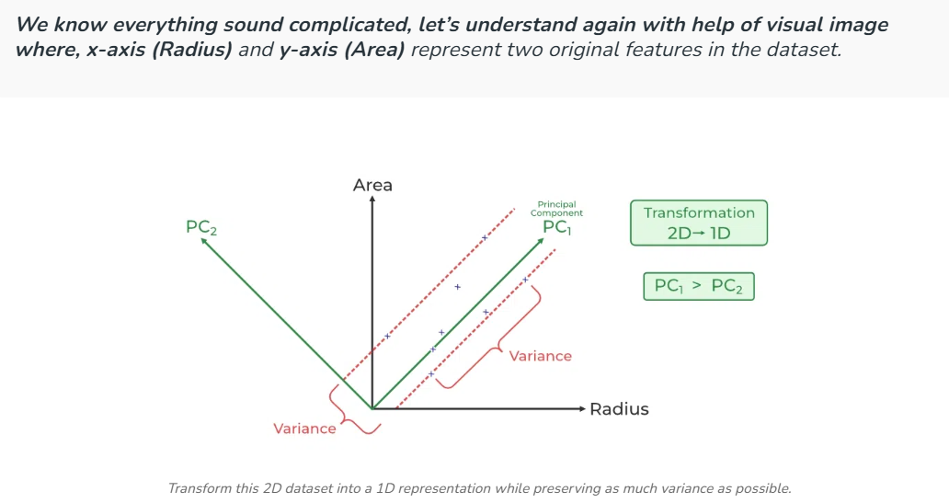

**Principal Components (PCs):**

* **PC₁ (First Principal Component):** The direction along which the data has the maximum variance. It captures the most important information.
* **PC₂ (Second Principal Component):** The direction orthogonal (perpendicular) to PC₁. It captures the remaining variance but is less significant.

Now, The **red dashed lines** indicate the spread (variance) of data along different directions . The variance along **PC₁ is greater than PC₂**, which means that PC₁ carries more useful information about the dataset.

* The data points (blue dots) are projected onto PC₁, effectively reducing the dataset from two dimensions (Radius, Area) to one dimension (PC₁).
* This transformation simplifies the dataset while retaining most of the original variability.

**LDA**

**Problem:**

**You want to classify emails into Spam or Not Spam using two features:**

* **Feature 1: Number of suspicious words**
* **Feature 2: Email length (number of words)**

**You want to find the best way to separate these two classes (Spam and Not Spam).**

**Step 1: Calculate the average for each class**

**Calculate the average number of suspicious words and average email length separately for Spam and Not Spam emails. These averages represent the "center" of each class.**

**Step 2: Measure how data varies within each class**

**Check how much the number of suspicious words and email length vary inside Spam emails and inside Not Spam emails. We want these variations to be small after projection.**

**Step 3: Measure how far apart the classes are**

**Check how different the averages of Spam and Not Spam emails are. We want these averages to be far apart on the new projection line.**

**Step 4: Find the best direction to project the data**

**Find a line (direction) in the two-feature space such that:**

* **Emails from the same class are close to each other after projection**
* **The Spam and Not Spam averages are as far apart as possible along this line**

**Step 5: Project the emails onto this new line**

**Transform each email’s features (suspicious words, length) into a single value by projecting it onto the line.**

**Step 6: Use the projected values for classification**

**Decide a threshold value on this line. Emails with a value above the threshold are classified as Spam; those below are Not Spam.**

**Summary**

**LDA helps by:**

* **Finding the best line to separate Spam and Not Spam emails**
* **Reducing two features into one dimension for easier classification**
* **Improving accuracy by clearly separating the classes in the new space**

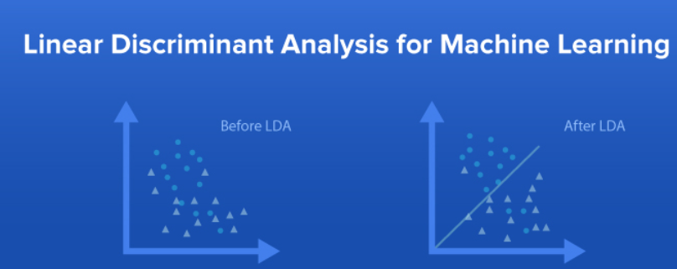

**MARKET BASKET ANALYSIS**

Market Basket Analysis is a machine learning technique focused on association rule mining. It helps find interesting relationships or patterns among large sets of transactional data.

How does it fit in ML?

* It’s an unsupervised learning method because it finds patterns without labeled outcomes.
* Often uses algorithms like Apriori, FP-Growth to generate association rules.
* These rules help predict what items are likely to be bought together.

Key steps in ML process:

1. Data Collection:  
   Collect transaction data (list of items purchased in each transaction).
2. Data Preprocessing:  
   Convert transactions into a format suitable for mining (like a binary matrix).
3. Frequent Itemset Mining:  
   Use algorithms (Apriori, FP-Growth) to find sets of items that appear frequently together.
4. Generate Association Rules:  
   Rules are formed such as:
   * If a customer buys A, they are likely to buy B.  
     Each rule has metrics like support, confidence, and lift to measure its strength.
5. Rule Evaluation & Selection:  
   Choose the best rules based on thresholds for support and confidence.

Applications in ML:

* Product recommendation systems
* Cross-selling and upselling
* Inventory management
* Personalized marketing

**UNIVARIENT TREES AND MULTIVARIENT TREES**

Univariate Trees vs Multivariate Trees

| Aspect | Univariate Trees | Multivariate Trees |
| --- | --- | --- |
| Definition | Splits data based on a single feature at each decision node | Splits data based on a combination of multiple features at each node |
| Splitting Criterion | Uses one feature and a threshold to divide data | Uses a linear combination of features to split data |
| Complexity | Simpler to build and interpret | More complex, harder to interpret |
| Computational Cost | Lower, faster to train | Higher, requires more computations |
| Interpretability | Easier to understand and visualize | More difficult to interpret |
| Accuracy | May be less accurate for complex data | Can be more accurate on complex data |
| Example Algorithms | Decision Trees like CART, ID3 | Oblique Decision Trees, Linear Combination Trees |

**CLUSTERING**

**WHAT DO YOU MEAN BY CLUSTERING?EXPLAIN WITH EG.**

**What is Clustering?**

Clustering is an unsupervised learning technique in machine learning used to group similar data points into clusters. The key idea is that data points in the same cluster have high similarity, while data points in different clusters are dissimilar.

Why Clustering?

* Helps discover hidden patterns or structures in data.
* Useful when labels are not available (unlabeled data).
* Common in many fields like marketing, biology, image processing, and social network analysis.

How Clustering Works:

1. The algorithm analyzes the data points based on their features.
2. It groups data points so that those in the same cluster are more similar to each other than those in other clusters.
3. The similarity is often measured using distance metrics like Euclidean distance.

Real-Life Examples:

* Customer Segmentation: Grouping customers based on buying behavior, age, location, etc., to create personalized marketing strategies.
* Image Segmentation: Grouping pixels in an image to detect objects or regions.
* Document Clustering: Grouping articles or web pages on similar topics.
* Social Networks: Detecting communities or groups of users with similar interests.

Popular Clustering Algorithms:

* K-Means Clustering: Divides data into ‘K’ clusters by assigning points to the nearest cluster center and updating centers iteratively.
* Hierarchical Clustering: Builds a tree of clusters by either merging smaller clusters or splitting larger ones.

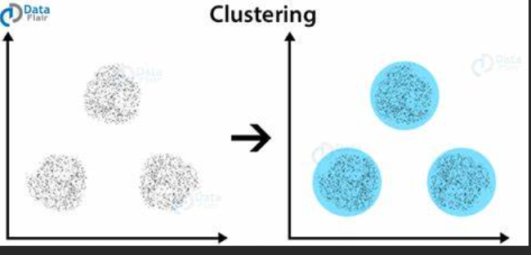

**PARAMETRIC METHODS AND NON PARAMETRIC METHODS**

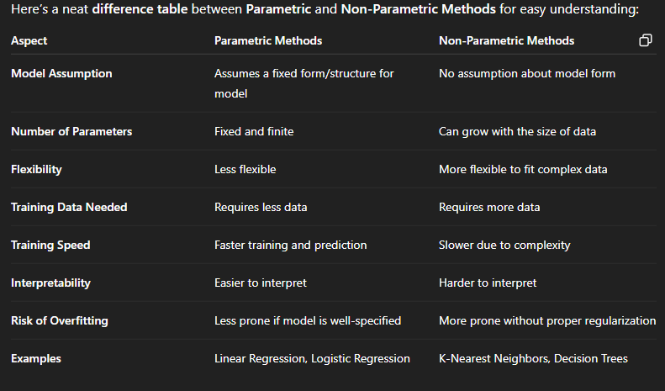

**WHAT DO YOU MEAN BY SVM?explain in detail**

**Support Vector Machine (SVM)**

**✅ What is SVM?**

Support Vector Machine (SVM) is a **supervised machine learning algorithm** used mainly for **classification** tasks, but it can also be used for regression. SVM finds a **hyperplane** (a line or a surface) that separates data points of different classes with the maximum margin.

**✅ How does SVM Work?**

1. **Data Points and Classes**:
   * Imagine you have two types of data, and you want to separate them. SVM tries to draw a **line** (or hyperplane) that divides the data into two parts, with each part representing one class.
2. **Support Vectors**:
   * The **support vectors** are the data points closest to the line (hyperplane) that helps SVM define the boundary. These points are crucial in deciding where the line should go.
3. **Maximizing the Margin**:
   * SVM tries to maximize the **distance** between the data points and the hyperplane. This helps the model make accurate predictions on new, unseen data.

**✅ Types of SVM:**

* **Linear SVM**:
  + If the data can be separated with a straight line (or flat surface in higher dimensions), we use **linear SVM**.
* **Non-Linear SVM**:
  + If the data can't be separated by a straight line, we use **non-linear kernels** (like **RBF** or **polynomial kernels**) to transform the data into a higher dimension where it can be separated by a line.

**✅ Advantages of SVM:**

1. **Effective in High Dimensions**:
   * SVM works well when there are many features or when the data is complex.
2. **Good Generalization**:
   * It helps in creating a model that performs well on new, unseen data by maximizing the margin.
3. **Robust to Overfitting**:
   * SVM tends to avoid overfitting, especially in high-dimensional spaces.

**✅ Disadvantages of SVM:**

1. **Slow with Large Datasets**:
   * SVM can be slow and computationally expensive for large datasets.
2. **Choosing the Right Kernel**:
   * The performance of SVM depends on choosing the right kernel. This can be tricky.
3. **Sensitive to Noisy Data**:
   * If there is too much noise in the data, SVM may not perform well.

**✅ Applications of SVM:**

* **Image Classification**: Used for recognizing faces, objects, or handwritten digits.
* **Text Classification**: Helps in categorizing emails as spam or not.
* **Bioinformatics**: Used for classifying genes, proteins, and medical data.

**✅ Conclusion**

Support Vector Machine is a powerful and popular machine learning algorithm that separates data into classes using a hyperplane. It works well in complex problems, especially with high-dimensional data, but may struggle with large datasets and noisy data. By using the right kernel, SVM can solve both linear and non-linear classification problems effectively.

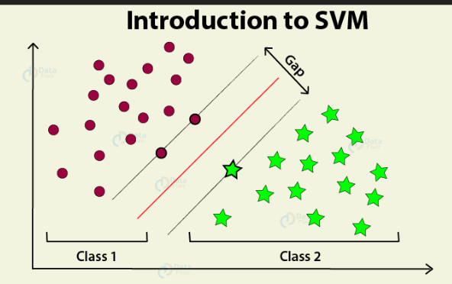

**HOW IS PROBABILITY THEORY USED IN ML?**

**Basic concepts of probability theory**

There are a few key concepts that are important to understand in probability theory. These include:

* Sample space: The sample space is the collection of all potential outcomes of an experiment. For example, the sample space of flipping a coin is {heads, tails}.
* Event: An event is a collection of outcomes within the sample space. For example, the event of flipping a head is {heads}.
* Probability: The probability of an event is a number between 0 and 1 that represents the likelihood of the event occurring. A chance of 0 means that the event is impossible, and a probability of 1 means that the event is specific.

**1. Modeling Uncertainty**

* Real-world data is often noisy and uncertain.
* Probability theory helps ML models **handle uncertainty** by representing predictions as probabilities rather than exact values.
* For example, instead of saying "this email is spam," a model can say "there is an 85% chance this email is spam."

**2. Probabilistic Models**

* Many ML algorithms are based on probabilistic models that describe the **likelihood of data** given certain parameters.
* Examples include **Naive Bayes**, **Hidden Markov Models (HMM)**, and **Bayesian Networks**.
* These models use probability distributions to learn patterns and make predictions.

**3. Bayes’ Theorem**

* Bayes’ theorem is fundamental in ML for updating beliefs with new evidence.
* It’s used in **Bayesian learning** and **classification algorithms** like Naive Bayes.
* Helps combine prior knowledge and observed data to calculate posterior probabilities.

**4. Loss Functions and Decision Making**

* Probability theory helps define **loss functions** that measure how well a model’s predicted probabilities match actual outcomes.
* For example, **cross-entropy loss** evaluates the difference between predicted probabilities and true labels in classification tasks.
* It also helps in making **optimal decisions** by choosing the class with the highest predicted probability.

**5. Parameter Estimation**

* Probability theory provides methods like **Maximum Likelihood Estimation (MLE)** and **Maximum A Posteriori (MAP)** to estimate model parameters that best explain the observed data.

**6. Handling Missing or Incomplete Data**

* Probabilistic models can naturally handle missing data by estimating distributions over missing values.
* This leads to more robust models

**overfiiting , underfiiting,variance,bias,validation dataset**

**. Overfitting**

* When a model learns the training data **too well**, including noise or small details.
* It performs great on training data but poorly on new, unseen data.
* Like memorizing answers instead of understanding the topic.

**2. Underfitting**

* When a model is **too simple** to learn the patterns in the data.
* It performs poorly on both training data and new data.
* Like not studying enough and missing important points.

**3. Variance**

* Variance means the model’s predictions change a lot with small changes in training data.
* High variance often causes overfitting.
* The model is too sensitive to the training data details.

**4. Bias**

* Bias means the model is too simple and makes strong assumptions.
* High bias causes underfitting.
* The model misses important patterns in the data.

**5. Validation Dataset**

* A separate set of data used to **check how well the model is performing** during training.
* Helps tune the model and avoid overfitting.
* Different from training data and test data.

**EXPLAIN ABOUT CONFUSION MATRIX.HOW WILL YOU ASSESS A CLASSIFIERS PERFORMANCE**

What is a Confusion Matrix?

* A Confusion Matrix is a table used to evaluate how well a classification model works.
* It shows the number of correct and incorrect predictions compared to the actual results.
* For a binary classification (two classes), it has 4 parts:

|  | Predicted Positive | Predicted Negative |
| --- | --- | --- |
| Actual Positive | True Positive (TP) | False Negative (FN) |
| Actual Negative | False Positive (FP) | True Negative (TN) |

* True Positive (TP): Correctly predicted positive cases.
* True Negative (TN): Correctly predicted negative cases.
* False Positive (FP): Incorrectly predicted positive (actually negative).
* False Negative (FN): Incorrectly predicted negative (actually positive**).**

How to Check a Classifier’s Performance Using Confusion Matrix?

1. Accuracy:  
   It tells how many predictions the model got right out of all predictions.
2. Precision:  
   Of all the times the model said “Yes,” how many were actually “Yes”?
3. Recall (Sensitivity):  
   Of all the actual “Yes” cases, how many did the model correctly find?
4. F1-Score:  
   A balance between precision and recall to show overall performance.

Why is this Important?

* The confusion matrix helps us see what kind of mistakes the model is making.
* Accuracy alone may not be enough, especially if one class happens much more often.
* Precision and recall help us understand if the model is missing important cases or making too many false alarms.
* F1-Score gives an overall idea by combining precision and recall.

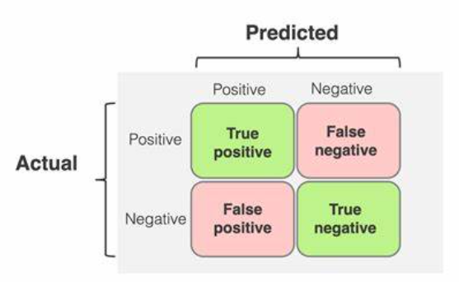

**Classification Metrics in Machine Learning**

When a machine learning model sorts data into categories (like spam or not spam), we use **classification metrics** to check how well it did. These metrics help us understand the model’s strengths and weaknesses.

**Common Metrics**

1. **Accuracy**

* The percentage of total correct predictions (both positive and negative).
* Good when classes are balanced (equal numbers of each).

1. **Precision**

* Out of all items the model predicted as positive, how many were actually positive?
* Important when false alarms (wrong positives) are bad.

1. **Recall (Sensitivity)**

* Out of all real positive cases, how many did the model find?
* Important when missing a positive is costly (like missing a sick patient).

1. **F1-Score**

* Combines precision and recall into one score.
* Useful when you want a balance between false alarms and missed cases.

1. **Specificity**

* Out of all real negative cases, how many did the model correctly find?
* Helps know if the model avoids false alarms well.

**Why Are These Important?**

* They help choose the best model based on the problem.
* For example, in fraud detection, recall is important (catch all frauds).
* In email filtering, precision is important (avoid marking good emails as spam).

**KFOLD CROSS VALIDATION**

**✅ What is K-Fold Cross Validation?**

K-Fold Cross Validation is a method used to **check how well a machine learning model performs** on different sets of data.

**🔄 How It Works:**

1. The entire dataset is divided into **K equal parts (folds)**.  
   For example, if K = 5, the data is split into 5 parts.
2. The model is trained **K times**. Each time:
   * One part is used for **testing/validation**.
   * The remaining K-1 parts are used for **training**.
3. This process is repeated so that **each fold gets a chance** to be the test set.
4. At the end, we calculate the **average performance** from all K runs.

**✅ Why Use K-Fold Cross Validation?**

* Gives a better idea of how the model will perform on new data.
* Reduces the chances of **overfitting** or **underfitting**.
* Makes the evaluation more **reliable and fair**.

**📝 Example:**

If you have 100 data points and choose K = 5:

* Each fold has 20 data points.
* The model is trained 5 times, using different folds for testing each time.

**🧠 When to Use:**

* When you want to test your model’s performance more accurately.
* Especially useful when you have **limited data**.

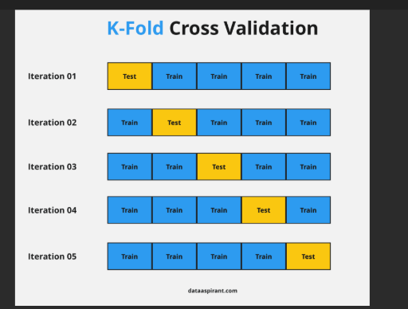

**EXPLAIN ANOVA**

ANOVA is useful when we need to compare more than two groups and determine whether their means are significantly different. Suppose you're trying to understand which ingredients in a recipe affect its taste. Some ingredients, like spices might have a strong influence while others like a pinch of salt might not change much.

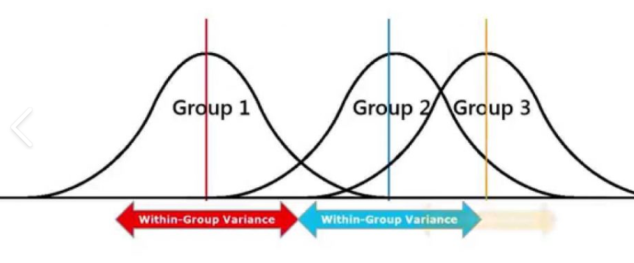ANOVA testing

In machine learning, features act like these ingredients they contribute differently to the final prediction. Instead of guessing, we need a way to measure which features matter most. This is where ANOVA (Analysis of Variance) comes in. It helps us determine if differences in feature values lead to meaningful changes in the target variable, guiding us in selecting the most relevant features for our model.

**Understanding ANOVA with a Real-World Example**

Let’s say we have three schools: **School A, School B and School C**. We collect test scores from students in each school and calculate the average score for each group. The key question is:

**Do students from at least one school perform significantly differently from the others?**

To answer this ANOVA uses hypothesis testing:

* **Null Hypothesis (H₀):** There is no significant difference between the mean scores of the three schools.
* **Alternative Hypothesis (H₁):** At least one school’s mean score is significantly different from the others.

ANOVA does not tell us **which** group is different it only tells us **a difference exists**. If the **p-value** from the ANOVA test is **less than 0.05** we reject the null hypothesis and conclude that at least one group has a significantly different mean score.

**Key Assumptions of ANOVA**

For ANOVA to work effectively three important assumptions must be met:

1. **Independence of Observations:**
   * Each data point should be independent of others.
   * In our example one student’s test score **should not influence** another student’s score.
2. **Homogeneity of Variances (Equal Variance):**
   * The variation in scores across all groups should be roughly the same.
   * If one school’s scores vary widely while the others have similar scores ANOVA results may be unreliable.
3. **Normal Distribution:**
   * The data within each group should follow a normal distribution.
   * If the data is highly skewed it can not work well.

⚙ Where is ANOVA used?

* In classification problems (to find relevant features)
* In feature selection methods, like SelectKBest with f_classif in Python’s scikit-learn
* In statistics-based ML models (like linear regression, logistic regression)

**NEURAL NETWORK**

**EXPLAIN NEURAL NETWORK WITH NEAT DIAGRAM?**

**Neural networks are machine learning models that mimic the complex functions of the human brain. These models consist of interconnected nodes or neurons that process data, learn patterns, and enable tasks such as pattern recognition and decision-making.**

**In this article, we will explore the fundamentals of neural networks, their architecture, how they work, and their applications in various fields. Understanding neural networks is essential for anyone interested in the advancements of artificial intelligence.**

**Understanding Neural Networks in Deep Learning**

**Neural networks are capable of learning and identifying patterns directly from data without pre-defined rules. These networks are built from several key components:**

1. **Neurons: The basic units that receive inputs, each neuron is governed by a threshold and an activation function.**
2. **Connections: Links between neurons that carry information, regulated by weights and biases.**
3. **Weights and Biases: These parameters determine the strength and influence of connections.**
4. **Propagation Functions: Mechanisms that help process and transfer data across layers of neurons.**
5. **Learning Rule: The method that adjusts weights and biases over time to improve accuracy.**

**Learning in neural networks follows a structured, three-stage process:**

1. **Input Computation: Data is fed into the network.**
2. **Output Generation: Based on the current parameters, the network generates an output.**
3. **Iterative Refinement: The network refines its output by adjusting weights and biases, gradually improving its performance on diverse tasks.**

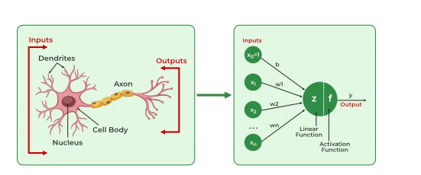

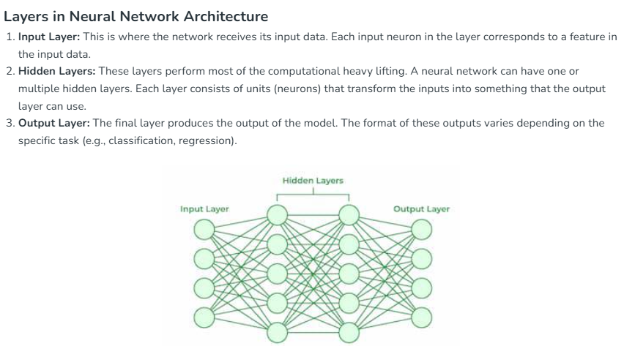

**🔄 How It Works (Step by Step):**

1. **Receive Input:  
   Data enters the network through the input layer.**
2. **Pass Through Neurons:  
   Each neuron multiplies the input by a weight, adds a bias, and passes it through an activation function (like a switch that decides whether to pass the signal or not).**
3. **Forward Propagation:  
   Data moves forward through the layers until it reaches the output.**
4. **Make Prediction:  
   The network gives an output (e.g., “cat” or “not cat”).**
5. **Compare with Actual Answer:  
   The model checks how wrong its prediction was (using a loss function).**
6. **Backpropagation:  
   The error is sent back through the network to adjust the weights, so the network learns and improves.**
7. **Repeat:  
   This process continues over many rounds (epochs) until the model performs well.**

**LSTM**

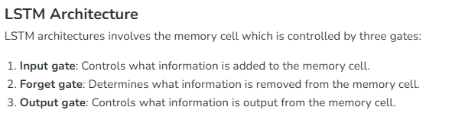

**🔄 How LSTM Works (Step-by-Step):**

**Imagine a sentence: “I love machine learning because it helps me learn.”**

**LSTM processes this one word at a time:**

1. **Takes input (e.g., "I").**
2. **Decides what to remember or forget using gates.**
3. **Updates memory (cell state).**
4. **Passes useful information to the next time step.**
5. **Repeats the process for next word ("love", "machine", etc.).**
6. **Eventually produces an output (e.g., sentiment = positive).**

**✅ LSTM in Real Life**

| **Use Case** | **How LSTM Helps** |
| --- | --- |
| **Language Translation** | **Remembers long sentence structure** |
| **Chatbots** | **Keeps context across messages** |
| **Stock Forecasting** | **Learns from previous time steps** |
| **Text Generation** | **Remembers what was written earlier** |

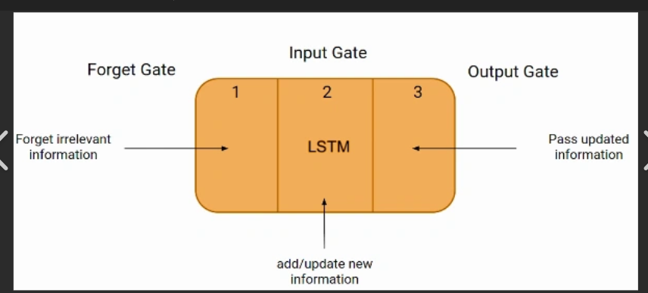

**CNN/RNN/AUTOENCODER**

**DESCRIBE CONVUTIONAL NEURAL NETWORKS(CNN).EXPLAIN THE THREE STAGES OF CONVUTIONAL LAYER.**

**What is a Convolutional Neural Network (CNN)?**

**A CNN (Convolutional Neural Network) is a type of deep learning model used mainly for image processing and computer vision tasks, like:**

* **Image classification (e.g., cat vs dog),**
* **Object detection,**
* **Face recognition,**
* **Medical image analysis.**

**It is especially good at learning patterns like shapes, edges, and textures in images.**

**🔍 Why CNN?**

**Traditional neural networks struggle with images because they have too many pixels. CNNs reduce this complexity by focusing on important areas using filters.**

**🧱 Three Main Stages of a CNN (Convolutional Layer):**

**1. Convolution Stage (Feature Extraction)**

* **This is the first step.**
* **A small filter (also called a kernel) moves over the image and detects patterns like edges, colors, or textures.**
* **It creates a feature map, which shows where that pattern appears in the image.**

**🟢 Example: A filter might detect vertical edges in a photo.**

**2. ReLU Activation Stage (Non-linearity)**

* **ReLU stands for Rectified Linear Unit.**
* **After convolution, this function is applied to the feature map to remove negative values.**
* **It makes the model better at learning complex patterns.**

**🟢 Think of ReLU as helping the network focus only on important signals.**

**3. Pooling Stage (Downsampling)**

* **This step reduces the size of the feature maps while keeping the most important information.**
* **Common method: Max Pooling – it keeps the highest value in each small section.**
* **This makes the model faster and less likely to overfit.**

**🟢 Example: If you have a 4x4 grid, max pooling may turn it into 2x2 by picking the biggest value from each section.**

**✅ Final Layers (after convolution stages):**

* **After several rounds of convolution + activation + pooling, the data goes through:**
  + **Flattening: Turning the feature maps into a 1D array.**
  + **Fully Connected Layers: Like regular neural networks, they make the final prediction (e.g., "This is a cat").**

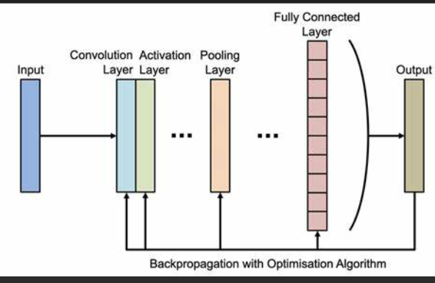

**What is autoencoder?explain the architecture of autoencoder with the help of neat diagram**

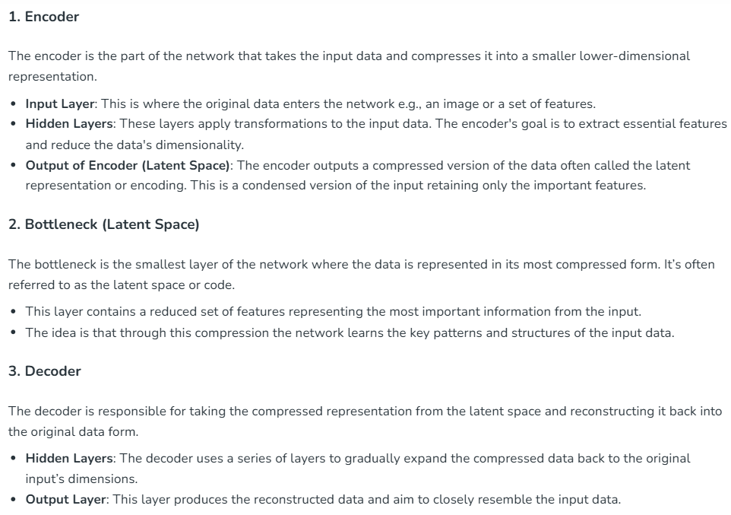

✅ What is an Autoencoder?

An autoencoder is a type of neural network used to:

* Learn efficient representations of data (called encoding),
* Reduce the size of data (dimensionality reduction),
* Remove noise from data (denoising),
* Or even generate new data.

It is an unsupervised learning technique — it learns from the input data without needing labels.

🧠 Basic Idea:

An autoencoder tries to:

1. Compress the input data into a smaller form (encoding),
2. Reconstruct the original input from that compressed version (decoding).

🏗️ Architecture of an Autoencoder

The autoencoder has three main parts:

1. Encoder:

* Compresses the input into a smaller representation.
* Learns what’s most important in the input.
* Example: Turns a 100-dimensional image into a 10-dimensional encoded vector.

2. Bottleneck (Latent Space):

* This is the smallest/central layer that holds the compressed information.
* The most important features are stored here.
* This layer forces the model to learn the most essential patterns.

3. Decoder:

* Rebuilds the original input from the compressed data.
* Learns how to restore data as close as possible to the input.
* 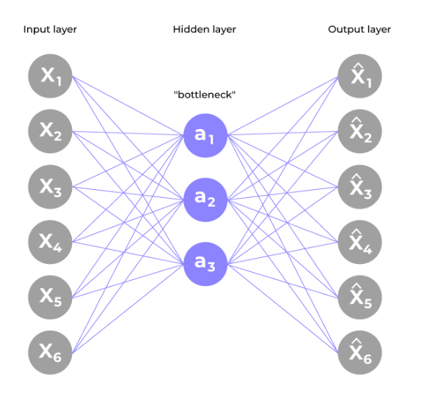

**Describe the variants of autoencoders with relevant description**

**✅ Variants of Autoencoders – Explained Simply**

Autoencoders can be modified for different tasks. These variants change how the model works or what it focuses on. Here are the main types:

**1. Vanilla Autoencoder (Basic Autoencoder)**

🔹 **What it is**: The simplest form of autoencoder  
🔹 **How it works**: Compresses the input and tries to reconstruct it  
🔹 **Use**: Dimensionality reduction, simple feature learning  
🔹 **Limitation**: Doesn’t work well with noise or complex data

**2. Denoising Autoencoder**

🔹 **What it does**: Learns to **remove noise** from input data  
🔹 **How it works**: Adds random noise to the input and trains the model to recover the clean version  
🔹 **Use**: Cleaning noisy images or sound files  
🔹 **Benefit**: More robust and learns better features

🧠 **Example**: Give it a blurry image and it learns to make it sharp again

**3. Sparse Autoencoder**

🔹 **What it does**: Forces the model to use **only a few neurons** in the hidden layer  
🔹 **How it works**: Adds a constraint that most neurons must stay inactive  
🔹 **Use**: Feature selection, interpretable patterns  
🔹 **Benefit**: Learns key features that matter most

🧠 **Think of it as**: Focusing only on the “important” features, ignoring the rest

**4. Variational Autoencoder (VAE)**

🔹 **What it does**: Learns a **probability distribution** instead of exact points  
🔹 **How it works**: Outputs a range of possible values, not just one  
🔹 **Use**: **Data generation**, like generating new images or text  
🔹 **Benefit**: Can create new examples similar to the training data

🧠 **Popular in**: AI-generated art, faces, and deepfake tech

**5. Contractive Autoencoder**

🔹 **What it does**: Tries to **make the learned features more stable**  
🔹 **How it works**: Penalizes large changes in the encoding when input changes slightly  
🔹 **Use**: Makes the model less sensitive to small changes  
🔹 **Benefit**: Good for feature robustness and generalization

**6. Stacked Autoencoder**

🔹 **What it does**: Combines multiple autoencoders on top of each other  
🔹 **How it works**: Each layer learns more complex features  
🔹 **Use**: Deep feature extraction  
🔹 **Benefit**: Can learn very detailed and layered representations

**HIERARCHICAL CULSTERING AGGLOMERATIVE AND DIVISIVE**

**✅ What is Hierarchical Clustering?**

**Hierarchical Clustering** is a method of **grouping data points into clusters** based on their similarity.  
It builds a **tree-like structure (called a dendrogram)** that shows how data points are grouped step by step.

There are **two main types**:

1. **Agglomerative (Bottom-Up)**
2. **Divisive (Top-Down)**

**🔹 1. Agglomerative Hierarchical Clustering (Bottom-Up)**

* **Most commonly used** type of hierarchical clustering.
* Starts with **each data point as its own cluster**.
* Then, **joins the two closest clusters** step by step.
* Continues until all points are merged into **one big cluster**.

**🧠 Think of it as:**

"Start small and keep merging."

**📌 Steps:**

1. Start with all data points as individual clusters.
2. Find the two closest clusters and merge them.
3. Repeat until all data points are in a single cluster.
4. Draw a **dendrogram** to show the process.

**🔹 2. Divisive Hierarchical Clustering (Top-Down)**

* Less common, but also useful.
* Starts with **one big cluster** containing all data points.
* Then, **splits the cluster into smaller parts** step by step.
* Continues splitting until each point is its own cluster.

**🧠 Think of it as:**

"Start big and keep splitting."

**📌 Steps:**

1. Start with all data points in one cluster.
2. Split the cluster into two.
3. Keep dividing the clusters based on dissimilarity.
4. Continue until each data point is separate.

**🔁 Comparison Table**

| **Feature** | **Agglomerative** | **Divisive** |
| --- | --- | --- |
| Approach | Bottom-up | Top-down |
| Starting point | Each point as a cluster | All points in one cluster |
| Merging or splitting | Merging | Splitting |
| Common usage | Very commonly used | Less commonly used |
| Computation | Faster and simpler | More complex |
| Visualization | Dendrogram | Dendrogram |

**📊 Example Use Cases**

* **Customer Segmentation** – Group similar customers
* **Document Clustering** – Group similar articles or emails
* **Gene Expression Analysis** – Cluster similar gene behavior in biology

**✅ Summary**

* **Hierarchical Clustering** creates a tree of clusters.
* **Agglomerative**: Starts from small clusters → builds up.
* **Divisive**: Starts from one large cluster → breaks down.
* Both methods can be visualized using a **dendrogram**, which helps you decide the number of clusters visually.

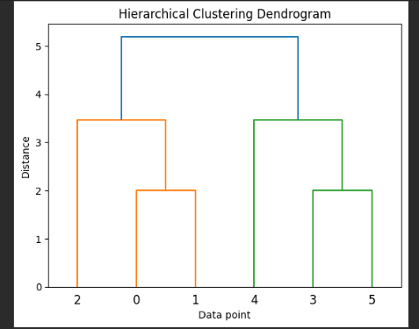

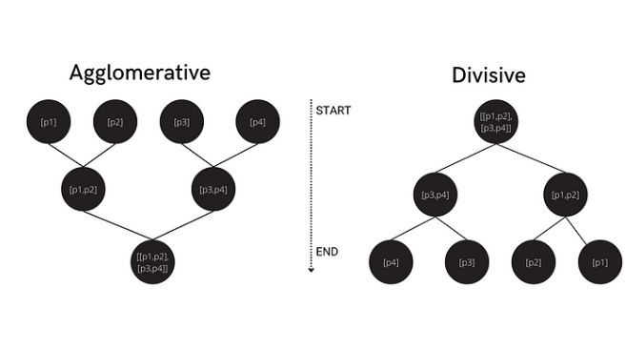

**EM algorithm**

**ML | Expectation-Maximization Algorithm**

**In the real-world applications of machine learning, it is very common that there are many relevant features available for learning but only a small subset of them are observable. So, for the variables which are sometimes observable and sometimes not, then we can use the instances when that variable is visible is observed for the purpose of learning and then predict its value in the instances when it is not observable.**

**On the other hand, *Expectation-Maximization algorithm* can be used for the latent variables (variables that are not directly observable and are actually inferred from the values of the other observed variables) too in order to predict their values with the condition that the general form of probability distribution governing those latent variables is known to us. This algorithm is actually at the base of many unsupervised clustering algorithms in the field of machine learning.  
Algorithm:**

1. **Given a set of incomplete data, consider a set of starting parameters.**
2. **Expectation step (E – step): Using the observed available data of the dataset, estimate (guess) the values of the missing data.**
3. **Maximization step (M – step): Complete data generated after the expectation (E) step is used in order to update the parameters.**
4. **Repeat step 2 and step 3 until convergence.**

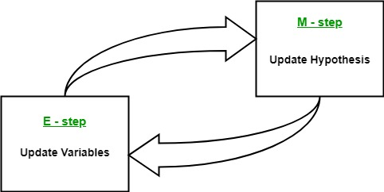

**The essence of Expectation-Maximization algorithm is to use the available observed data of the dataset to estimate the missing data and then using that data to update the values of the parameters. Let us understand the EM algorithm in detail.**

* **Initially, a set of initial values of the parameters are considered. A set of incomplete observed data is given to the system with the assumption that the observed data comes from a specific model.**
* **The next step is known as “Expectation” – step or *E-step*. In this step, we use the observed data in order to estimate or guess the values of the missing or incomplete data. It is basically used to update the variables.**
* **The next step is known as “Maximization”-step or *M-step*. In this step, we use the complete data generated in the preceding “Expectation” – step in order to update the values of the parameters. It is basically used to update the hypothesis.**
* **Now, in the fourth step, it is checked whether the values are converging or not, if yes, then stop otherwise repeat *step-2* and *step-3* i.e. “Expectation” – step and “Maximization” – step until the convergence occurs.**

**Flow chart for EM algorithm –  
7**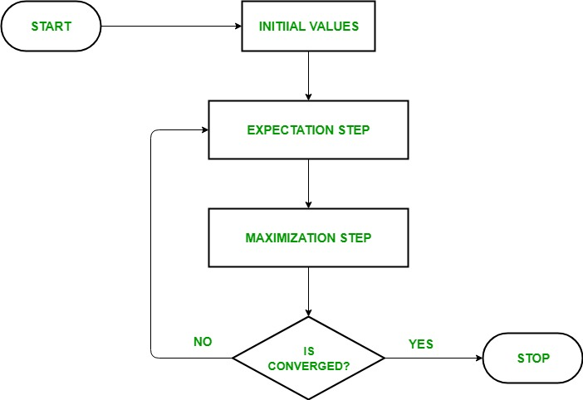

**Usage of EM algorithm –**

* **It can be used to fill the missing data in a sample.**
* **It can be used as the basis of unsupervised learning of clusters.**
* **It can be used for the purpose of estimating the parameters of Hidden Markov Model (HMM).**
* **It can be used for discovering the values of latent variables.**

**Advantages of EM algorithm –**

* **It is always guaranteed that likelihood will increase with each iteration.**
* **The E-step and M-step are often pretty easy for many problems in terms of implementation.**
* **Solutions to the M-steps often exist in the closed form.**

**Disadvantages of EM algorithm –**

* **It has slow convergence.**
* **It makes convergence to the local optima only.**
* **It requires both the probabilities, forward and backward (numerical optimization requires only forward probability).**

**REINFORCEMENT LEARNING?EXPLAIN the elemenst of reinforcement learning?**

**✅ What is Reinforcement Learning?**

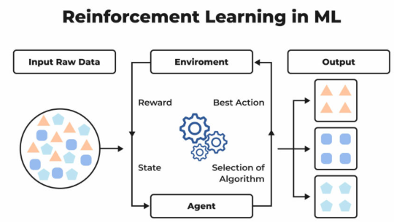

**Reinforcement Learning** is a type of **machine learning** where an **agent** learns to make decisions by **interacting with an environment**.

It **learns from experience** by getting **rewards or penalties** for the actions it takes, and tries to **maximize the total reward** over time.

**🎯 Real-Life Example:**

Imagine training a dog:

* You say "sit" → if the dog sits → you give a **treat (reward)**
* If the dog doesn't sit → **no treat (penalty)**  
  Over time, the dog learns what to do to **get more rewards**.

**🧩 Elements of Reinforcement Learning**

Here are the **main components**:

**1. Agent**

* The **learner or decision maker**.
* It performs actions to achieve goals.
* Example: A robot, a self-driving car, or a game-playing bot.

**2. Environment**

* The **outside world** with which the agent interacts.
* It gives **feedback** to the agent after each action.
* Example: A maze, road, or game board.

**3. State**

* A snapshot or **current situation** of the environment.
* The agent observes the state before taking action.
* Example: Position of the agent in a maze.

**4. Action**

* A **move or decision** taken by the agent.
* Based on the current state, the agent picks an action.
* Example: Move left, right, forward, or backward.

**5. Reward**

* A **positive or negative feedback** given after an action.
* Goal of the agent: **maximize rewards over time**.
* Example: +1 for reaching the goal, -1 for hitting a wall.

**6. Policy (π)**

* The agent’s **strategy** or rule for choosing actions.
* It maps states to actions.
* Good policy = higher long-term reward.

**7. Value Function**

* Tells the agent **how good** a state or action is in the long run.
* Helps the agent **plan ahead** and not just take immediate rewards.

What do you mean by machine learning?explain the different types with eg.

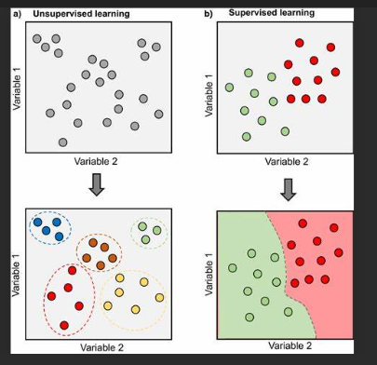

**✅ What is Machine Learning?**

**Machine Learning (ML)** is a branch of artificial intelligence that allows computers to **learn from data** and **make decisions or predictions** without being explicitly programmed for every task.

In other words, instead of telling the computer exactly what to do, we **teach it using examples**, and it figures out patterns to solve problems.

**🔹 Types of Machine Learning**

There are **three main types** of machine learning:

**1. Supervised Learning**

* The model learns from **labeled data** (input-output pairs).
* The goal is to learn a function that maps inputs to correct outputs.
* **Example**:
  + Email spam detection: The model learns from emails labeled as "spam" or "not spam" to classify new emails.
  + Predicting house prices based on features like size, location, etc.

**2. Unsupervised Learning**

* The model learns from **unlabeled data** (no output labels).
* It tries to find **hidden patterns or groupings** in the data.
* **Example**:
  + Customer segmentation: Group customers based on buying behavior without predefined categories.
  + Market basket analysis: Finding items frequently bought together.

**3. Reinforcement Learning**

* The model learns by **interacting with an environment**.
* It takes actions and gets **rewards or penalties**, learning to maximize rewards.
* **Example**:
  + Training a robot to walk by rewarding it when it moves successfully.
  + Game AI learning to play chess or Go by winning games.

**✅ Classification in Machine Learning**

**What is Classification?**

**Classification** is a type of supervised learning where the goal is to **assign input data into predefined categories or classes**.

* The output variable is **categorical** (i.e., it belongs to a set of classes).
* The model learns from labeled examples to **predict the correct class** for new data.

**Examples of Classification:**

* Email spam detection: Classify emails as "spam" or "not spam".
* Medical diagnosis: Predict if a patient has a disease ("positive" or "negative").
* Image recognition: Identify objects like "cat", "dog", or "car" in images.

**How Classification Works:**

* The model is trained on input data with known class labels.
* It learns the patterns that separate different classes.
* When given new data, it predicts which class the data belongs to.

**Types of Classification:**

* **Binary Classification**: Two classes (e.g., spam or not spam).
* **Multi-class Classification**: More than two classes (e.g., digit recognition from 0 to 9).
* **Multi-label Classification**: Data can belong to multiple classes simultaneously (e.g., tagging a photo with multiple labels like "beach" and "sunset").

**✅ Regression in Machine Learning**

**What is Regression?**

**Regression** is another type of supervised learning where the goal is to **predict a continuous numerical value** based on input data.

* The output variable is **continuous** (e.g., height, price, temperature).
* The model learns the relationship between inputs and output to **predict values** for new data.

**Examples of Regression:**

* Predicting house prices based on features like size and location.
* Forecasting sales for the next month.
* Estimating temperature based on historical weather data.

**How Regression Works:**

* The model learns from data points with known numerical values.
* It fits a function (like a line or curve) that best describes the relationship between input features and output.
* For new inputs, it predicts a numerical value.

**Types of Regression:**

* **Linear Regression**: Models the relationship with a straight line.
* **Polynomial Regression**: Models more complex curves.
* **Logistic Regression**: Actually a classification method but uses regression techniques to estimate probabilities.

**📊 Key Differences Between Classification and Regression**

| **Aspect** | **Classification** | **Regression** |
| --- | --- | --- |
| Output Type | Categorical (discrete classes) | Continuous numerical values |
| Goal | Assign data to categories/classes | Predict a numeric value |
| Examples | Spam detection, disease diagnosis | House price prediction, temperature forecasting |
| Algorithms | Decision Trees, SVM, Neural Networks | Linear Regression, Polynomial Regression |

**✅ Summary**

* **Classification** predicts categories or labels (e.g., spam/not spam).
* **Regression** predicts numerical values (e.g., price, temperature).
* Both are supervised learning techniques but differ in the type of output they predict.

