

Project finder

Project by: Aviv Assayag

Project finder is built for the cloud platform including many micro-services which provides a strong backend and a bonus of possible frontend. That platform meant to solve a problem that many programmers get stuck on. In the project finder you will be able to search a project of your interest and choose between several parameters like difficulty, knowledge and technologies or even insert your own project for other users use.

**Architecture**

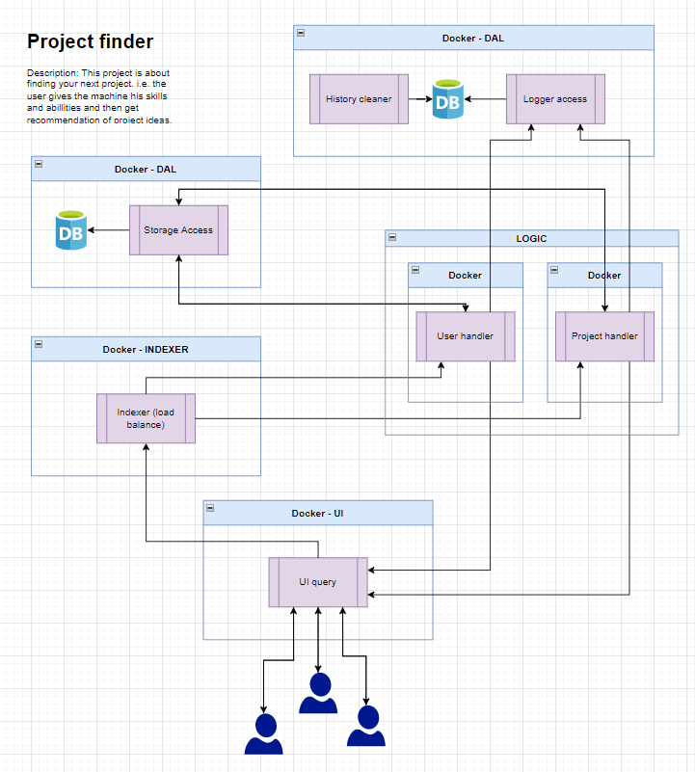

Micro-services:

* Storage access => Database wrapper, used for CRUD queries. For instance, create a new user, search a specific project, update user's password or delete old irrelevant project.
* Indexer => Handle all the requests and map them into the right micro-service. The indexer is also used as a load balancer and will create new instances of an overloaded micro-service.
* User handler => Handle all the user related transaction and do a validation of the information like checking if user already exist when creating a new one or whether the password is strong enough or not.
* Project handler => Handle all the project related transaction like search for the right project for some user or for adding new project.
* Logger access => Write logs of the previous queries

Technologies that will be used – ELK for logger mongoDB/PostgreSQL for storage access docker for every micro-service



* History cleaner => delete all of the all logs
* UI query => user interface for search and logging onto the website.



JSON

Project –

{

"project_id": id,

"programming_langauges": [

"c",

"c++",

"python"

],

"databases": [

"elasticsearch"

],

"technologies": [

"docker",

"micro-services",

"cloud"

],

"post_time_stamp": timestamp,

"last_update": timestamp,

"additional_information": {

"stack": "ELK",

"cryptography": "AES_256"

},

"difficulty": "easy",

"field": [

"Cloud",

"IoT"

]

}

Template source:

<https://poweredtemplate.com/word-templates/technology-computers/11977/0/index.html>