

Module Lecturer: Dr. Sumitra S Kotipalli
Submission Deadline: 02/11/2025

Introduction:
When I first began my Cybersecurity and Digital Forensics program, I found it quite challenging — especially coming from a science background. The curriculum plunged me straight into programming, with Python in one module and C in another. Although overwhelming at first, I quickly came to appreciate this hands-on approach. It pushed me to develop a new skill with grit and determination and ultimately sparked a genuine love for Python.
I think this infatuation with Python partly stemmed from the contrast with C. C operates at a much lower level of abstraction, and its syntax felt difficult to grasp. That made me look forward to my Python lessons with even more enthusiasm.
Over time, I progressed steadily in Python at my own pace. While the module’s practicals initially felt fast-paced, I gradually found it easier to keep up. Today, I’ve come a long way — as I hope my programs will demonstrate — but I still consider myself a learner, continuously refining my skills and deepening my understanding.
This experience has taught me the value of persistence in self-study, the importance of consistency in small daily efforts, and the power of time management. Learning to code for this portfolio has not only made me a better Python programmer, but also a more disciplined and resilient student. I’m excited to showcase my Pythonic skills and growth through this project.

Table of Contents
- Week 1:
Getting Started with Python
1.1 Question Explanation
1.2 Code
1.3 Explanation of the code
1.4 Reflection

2. Week 2:
Control Structures and Lists
2.1 Question Explanation
2.2 Code
2.3 Explanation of the code
2.4 Reflection
3. Week 3:
Functions, Lambda Expression and Multidimensional Lists
3.1 Question Explanation
3.2 Code
3.3 Explanation of the code
3.4 Reflection
4. Week 4:
String, Special Methods and Regular Expressions
4.1 Question Explanation
4.2 Code
4.3 Explanation of the code
4.4 Reflection

5. Week 5:
File Handling, Exceptions and Data Structures
5.1 Question Explanation
5.2 Code
5.3 Explanation of the code
5.4 Reflection
6. References & AI usage.
- Week 1 – Excellent 4 – System Information Banner Printer:
  - Question Explanation: I had to use the import statement for the module platform and then use the different functions on platform to acquire my system information. This code is so concise and simple to read that doesn’t require comments as the pythonic syntax refrains from adding unnecessary comments that clutter code.
Step 1: I had to import the module platform in order to access the functions needed to display my system information.
Step 2: printed the call to functions directly in the code to achieve my desired output. Did this as this would serve to keep my code concise.

1.2 Code + Output:
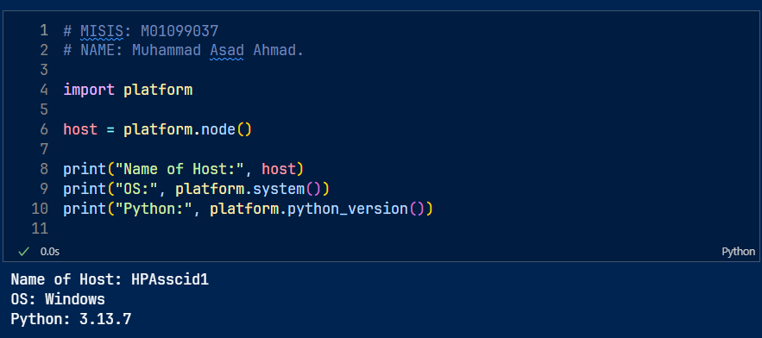

1.3 Code Explanation: I imported the module platform (module is just a collection of Python Code in a .py file). The platform module in particular is a built-in library that provides a portable way to access information about the underlying platform on which a Python program is running. This includes details about the hardware, operating system, and Python interpreter.
Then I used the print(dir(platform)) statement in the python shell to print out the necessary commands amongst which I chose the .node() , .system() , .python_version() functions as per the question requirement.
Regarding the dir() function in python: The dir() function in Python is a built-in function used for introspection, providing a list of names in the current local scope or the attributes of a given object.

Usage:
- Without arguments: When called without an argument, dir() returns a list of names in the current local scope, including variables, functions, classes, and imported modules.
  - Reflection: Week 1 was all about getting started with python so during this week I learnt the very basics of python as before this I had never coded. It was also during this week that I installed and learnt how to use my preferred IDE (visual studio code), I installed and setup python and the jupyter notebooks extension in my IDE as well. To be honest I found the language very easy to grasp as the syntax for python is very beginner friendly.

- Week 2 – Typical 15 – Finding the highest score amongst the number of students entered:

2.1: Question Explanation: I had to write a python program that prompted me for the total number of students I would enter the marks for and then from amongst them the program would print the name of the student with the highest marks and that student’s respective marks as well.
Step 1: I had to establish 2 empty list to store my data that I would get from the user.
Step 2: Added error handling to the code in case of bad inputs.
Step 3: had to add a for loop to iterate over the iterable which is the std_number in this instance.
Step 4: appended or added data to lists.
Step 5: had to find the student with highest score.
Step 6: printed that particular students marks and name.

2.2 Code + Output:
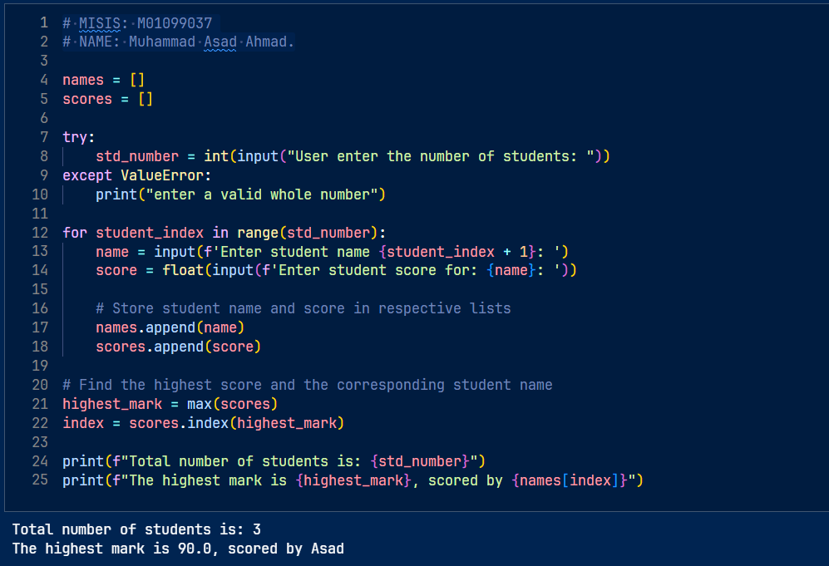

2.3 Explanation of Code: First I began with creating two empty lists to store the students names and scores. This would ensure that on each program execution we change the number of students and their scores.

Then I proceeded with a simple input validation method on the variable std_number, which is the total number of students, to ensure only an integer value would be accepted.

Now to use a for loop to add the data to the empty list, I assigned loop variables (student_index – iterator and range function on std_number – iterable). Name and score were chosen as variables and will prompt the user to enter first the student name and then the mark of that particular student, f-string literals were used to embed variables and expression {student_index + 1} within the string.
Then list.append() method used on both the lists to populate them.
Then the max() built-in function was used to find the highest score and the list.index() method used to get it’s index and store it in a variable called index which will be used later.

Finally f-string literals used within the print statements to embed expressions and to get the highest mark for a particular student list indexing used.

  - Reflection: Week 2 was all about list operations and using loops. I learnt the implementation and use of the for loop to iterate over an iterable object such as a list in this instance ‘n’ number of times. The use of in range(start, stop, step) was also learnt. Additionally, I also improved my understanding and implementation of the f-string literals in python as after learning how to use them they made my coding tasks easier and more readable.

- Week 3 – Excellent 10 – Scientific Conversion Calculator:

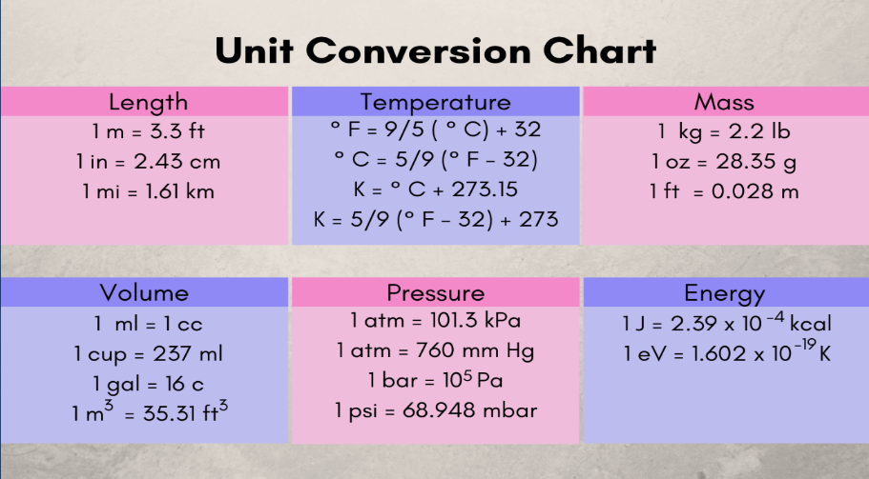
3.1 Question Explanation: A scientific conversion calculator had to be made taking inspiration from the typical 5 question included within the same week but instead of writing separate functions for each of the we had to use lambda functions instead. Also this conversion chart was used as a reference:

Step 1: make a separate .py including all conversion formulae using the above picture as reference. Named it calculation_formulae.py
Step 2: imported that into my main logic file.
Step 3: made menus for all the different units and program navigation. Sub-menus and main menu.
Step 4: wrote a custom function to get input from user and pass it on to the program.
Step 5: wrapped main logic in while loop so the calculator kept running even after one conversion until it was distinctly closed by the user.
Step 6: used if else conditional within the loop to ensure the different inputs had the desired effect and right output was chosen.

3.2 a) Code + Imported Module .py file:
3.2 b) Code Output: 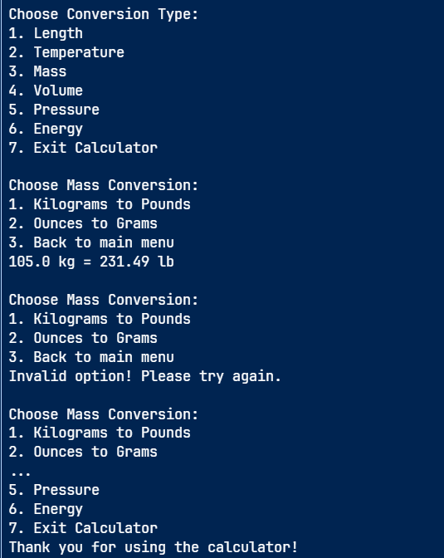

3.3 Code Explanation: After reading the question I decided first to create menu functions to display the various options the conversion calculator would offer as this would be the easiest way to navigate the program without a GUI present and also quite easy to implement. Then using the picture as a guide, I wrote another .py code file in the same working directory including all the unit conversions as single use lambda functions.

Having my lambda functions present in a separate file that I could import to my main logic file as a module would serve to make my main code less cluttered, more readable, easier to decode and troubleshoot.

Here lambda functions are preferred over the normal def name(): (function syntax) as for unit conversions we just need single line expressions that we can assign to variable names and later call in the main logic file, also complex reasoning like if else conditionals or while loops are also not needed so lambda functions work best.

The program adheres to good software design principles by separating the user interface logic from the core calculation logic:
- import calculations_formulae as cf: This line imports a separate Python file (module) named calculations_formulae.py and gives it the alias cf. This allows the main program to call functions for specific conversions (e.g., cf.m_to_ft(value)) without cluttering the main file with mathematical formulas. This concept is called modularity.

User Interface and Function Definitions:
The program defines a series of functions using the def keyword:
- Menu Functions (show_..._menu): These functions simply use the print() function to display navigation options to the user. This keeps the main logic clean and makes it easy to add or change menu options.
- Input Validation Function (get_valid_number): This function is crucial for robust user input. It uses a while True loop and a try...except ValueError block to repeatedly prompt the user for input until a valid floating-point number is entered. This prevents the program from crashing if the user types text instead of a number.

Program Flow and Control Structures:
The main part of the program manages the user's navigation through different menus using loops and conditional logic:
- Main Program Loop (while True): The entire application runs within an infinite while loop. This ensures the calculator remains running until the user explicitly chooses to exit. The loop can only be terminated by a break statement when the user selects option "7". The boolean literal True maintains the loop's execution.
- Nested Loops: Within the main loop, if a user selects a specific conversion type (e.g., "1" for Length), another while True loop starts for that sub-menu. This allows the user to perform multiple conversions within a single category without returning to the main menu immediately. They can break out of the inner loop to return to the main menu.
- If-Else Conditionals (if/elif/else): These conditional statements are used extensively to direct the program's flow based on the user's input:
  - They check which menu option was selected.
  - They determine which specific conversion function to call from the cf module.
  - An else block handles "Invalid option" messages when unexpected input is received.

Function Calls and Variable Usage:
- User Input: The built-in input() function is used to capture user choices and values for conversion.
- Variable Assignment: Variables like choice, length_choice, value, and result are used to store user input and function outputs.
- Function Calls: The program repeatedly calls the menu functions to display options and the calculation functions (cf.m_to_ft, cf.c_to_f, etc.) to get results.
- F-Strings: Modern formatted string literals (f-strings) like print(f"{value} meters = {result:.2f} feet") are used for clean and readable output, including formatting the result to two decimal places (:.2f).
3.4 Reflection: During this week I consolidated my knowledge about the use of if/else conditionals and additionally I learnt the use of functions and calling functions later on in the code. I also learnt the use of while loop to keep the program running on a loop while the given condition or a very Boolean variable would remain true, the use of loop control statements was something that I also experimented with but albeit (only with using the break statement).

- Week 4 – Excellent 17 – Decimal to Binary Convertor:

4.1 Question Explanation: I had to write a program which included a function that converted a decimal number into a binary number as a string. The program had to prompt the user to enter a decimal integer value and then it had to display the corresponding binary value. (Decimal number system is base 10 number system that we use every day, 0 till 9).
Step 1: learnt the theory behind the conversion myself before writing code.
Step 2: made custom function for conversion. Included a docstring that can be referenced by the user for clarification.
Step 3: wrote if else conditional with my main logic for the program.
Step 4: Used and learnt about python arithmetic operators for floor division and modulo division.
Step 5: added error handling to user input.
Step 6: printed the output.
- Theory Behind Decimal to Binary Conversion: (Example 13)
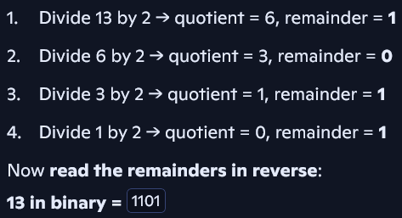

4.2 Code + Output: 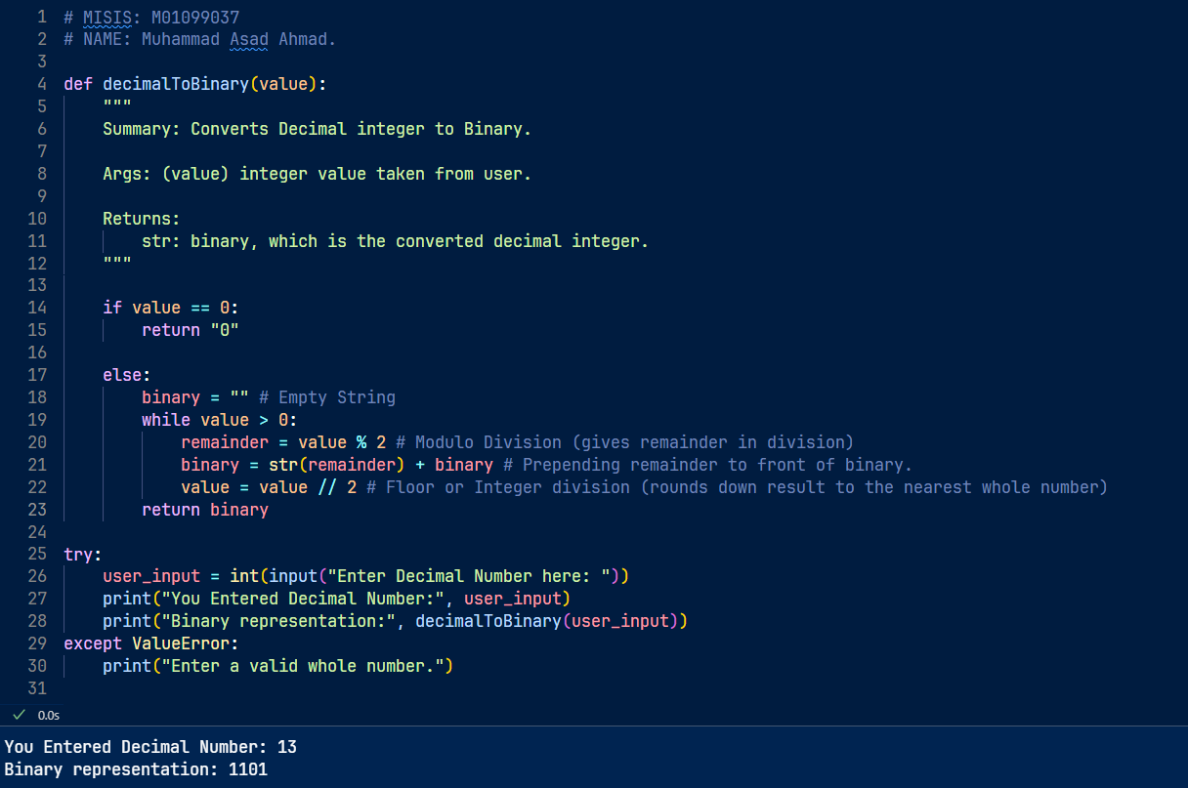
4.3 Code Explanation: The function decimalToBinary(value) takes an integer input and returns its binary form as a string.
- Special Case for Zero
If the user enters 0, the function immediately returns "0" because the binary of zero is just zero.
- Binary Conversion Logic
  - An empty string binary is created to build the result.
  - A while loop runs as long as the number is greater than 0.
  - In each loop:
  - The number is divided by 2.
  - The remainder (0 or 1) is added to the front of the binary string.
  - The number is updated using integer division (//) to remove the last bit.
- User Input and Error Handling
- The program asks the user to enter a whole number.
- It uses a try-except block to catch invalid input (like letters or symbols).
- If the input is valid, it prints both the original number and its binary version otherwise an error message.
4.4 Reflection:
During this week I reinforced my knowledge and working of while loops, error handling in python and defining and writing custom functions embedded with more complex logic. This can be seen in the above showcased example.
- Week 5 – Excellent 17 – Counting Words in Les_Brown.txt

5.1 Understanding the Question: I had to open the pre given text file Les_Brown.txt in the Lab 5 folder on myMDX and open and read its contents to return a word count or an occurrence for each word in the file.
Step 1: downloaded the necessary files from mdx portal and imported the counter and string modules in python.
Step 2: ensure all files were in the same working directory.
Step 3: used file handling in python to open and read the file to enable me to work on its contents.
Step 4: clean text function applied on the text file downloaded.
Step 5: for loop used to filter out the special characters from the text.
Step 6: used a for loop to write the filtered content to a new text file and saved that as the output file.

5.2 Code Input & Output:
Input file:

Output:
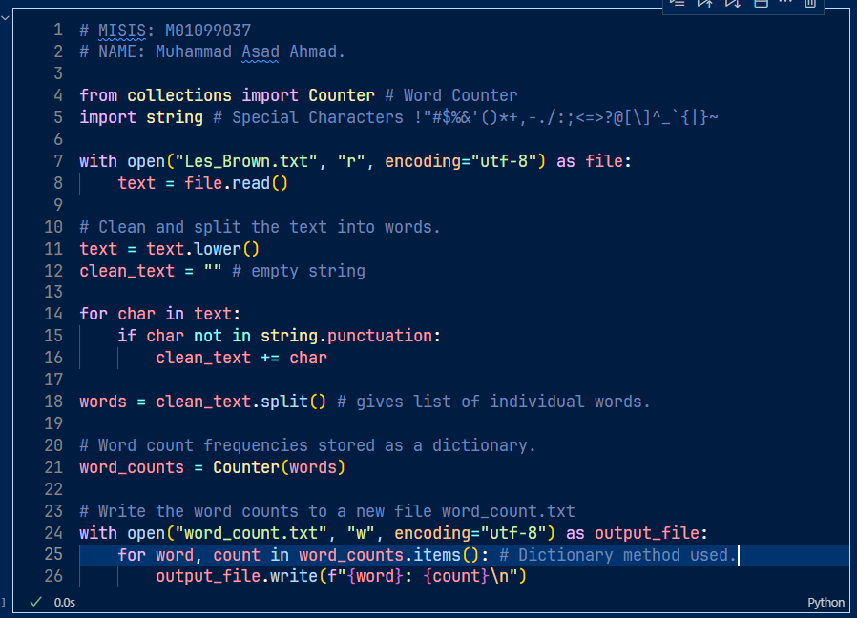

5.3 Code Explanation: I imported the collections module and from within that the counter function. Additionally, the string module was also imported as that contain all the special characters ( !"#$%&'()*+,-./:;<=>?@[\]^_`{|}~ )
This will allow us to clean the text later on. This is important as for example without removing special characters or punctuation words like: dream and dream! Are treated as 2 different characters or instances and leads to inaccurate word counts.
With open statement used which automatically closes the file after performing the specified operations on it. This statement takes 3 parameters (“file path”, mode= , encoding= ). I didn’t use the specific file path as I saved the Les_Brown file in the same working directory as the main portfolio file.
File path given for reference (C:\Users\ahmed\Documents\Coding\Python\CourseWork Final\Les_Brown.txt)
Mode = r, means that the file was opened into read ONLY mode.
Encoding engine I used utf-8 (universal transformation format) this is a character encoding format — a system that maps characters (like letters, numbers, symbols) to binary values (0s and 1s) so computers can store and process text and encoding="utf-8" ensures consistent, error-free text handling while preventing errors like UnicodeDecodeError.
Then .lower() method used to convert everything to lowercase and then an empty string variable created by the name of clean_text. This will store our text in the file as a string with punctuation and special characters removed, and for that I used a simple for loop.
Then .split() method used on the object class string in this case it was the clean_text and this is stored in a new variable called words. Then the counter function used on words and this makes a special dictionary from the words list.
This dictionary is named as word_counts and this assigns each word (key) with its count (value) making a key-value pair.
Then another file handling command used to open or in this instance create a new file called word_count.txt (attached in the output section) and the method .items() used on the object class dictionary in a for loop to print the key: value pairs in the output file.

  - Reflection: Week 5 was focused on file handling within python enabling us to work with and manipulate external file types. We learnt the importance of opening reading files in programming languages and then closing them so as to minimize vulnerabilities. And with python closing is handled automatically using the with open command. The syntax for with open command is as follows: with open(“file name if in same cwd or file path”, “mode”, “encoding”). The only limitation of this week was that we only worked with text files so handling other richer file types such as pictures, audio and videos is still out of my purview as of now.

- References & Ethical AI Usage: *(links are inserted as hyperlinks)
- datacamp f strings
- Introduction to functions in python datacamp
- Python Pathway on datacamp.
- CISCO Python course. (provided by the SLE from the University)
- Python Syntax PEP-8

AI Usage: Throughout the development of this Python project, I made a conscious effort to use artificial intelligence tools ethically and responsibly. Rather than relying on AI to simply provide answers, I treated it as a learning companion — a guide that helped me understand concepts, troubleshoot errors, and refine my thinking.
One of the tools I used was Google's Gemini AI, particularly its Guided Learning feature. This option allowed me to explore Python topics interactively, offering hints, explanations, and structured pathways instead of direct solutions. For example, when I encountered challenges with list manipulation or control flow, I used Gemini’s guided prompts to clarify my understanding and build the solution myself — reinforcing my learning rather than shortcutting it.
I also used AI to help me debug code, interpret error messages, and explore best practices in Python. In each case, I made sure to ask questions that focused on why something works, not just how to fix it. This approach helped me grow as a programmer and ensured that the final code in this portfolio reflects my own effort, reasoning, and creativity.
By using AI as a mentor rather than a crutch, I’ve upheld the integrity of my learning process and demonstrated a commitment to ethical, independent development.

Conclusion:
So to summarise from week 1 till 5 from covering the very basics of python such as variable naming in the global namespace, basic I/O operations, and handling simple data types all the way to learning how to use methods and functions on more complex data types such as list, dictionaries and tuples, using loops and conditionals, input validation and error handling, and finally defining custom functions. I have to say my python journey was very fruitful and I’m already looking forward to the upcoming weeks where we’ll be learning about VCS (version control system) particularly the industry standard, which is GitHub, implementing secure logins, how to integrate AI using python (using API’s) and object-oriented programing to top it all off.
Finally for the main capstone project as I’m in the cyber security and digital forensics program I’ll be making a Streamlit app (alerting/logging tool) which will be documented and hosted on GitHub.

