## Technical Documentation

# Todos Manual

**OVERVIEW**:

This manual is to learn about how to navigate through the site and use it’s functionality.

# PURPOSE OF THE APPLICATION

To create tasks, write them down, and toggle finished tasks with deleting them from the list afterwards.

# KEY FEATURES

* Opening site on a web browser
* Create a list of tasks
* Mark them as completed
* Show all tasks
* Show only active tasks
* Show completed tasks
* Delete completed tasks
* Mark all tasks

## Opening todos site on a web browser

## To open a site on a web browser type the following address in the address bar <http://localhost:8080/> or open a folder containing files and click on index.html file.

## Create a list of tasks

To add a new task, type on a bar with text “What needs to be done?” and press enter. The new task will be added to ‘ALL’ list (1) .

## Mark them as completed

After a new task is created and after it is done one can mark it as completed by checking the radio button. A radio button is situated on the left side of the task (2).

## Show all tasks

All buttons are activated by default. As a result we see all the tasks, both active and completed in the list (3).

## Show only active tasks

Active tasks can be displayed by activating the ‘Active’ button which allows to hide completed tasks (4).

## Show completed tasks

Completed tasks can be displayed by pressing the ‘Completed’ button which will filter all tasks and display only completed ones (5).

## Mark all tasks as completed

An Arrow button situated on the top left side of the card allows the user to mark all tasks as completed at the same time (6).

## Delete completed tasks

Completed tasks can be deleted by ‘Clear completed’ button, which will be activated after some tasks will be marked as completed (7).

## How many tasks are left?

The number of active tasks left to do is shown on the bottom left part of the document (8).

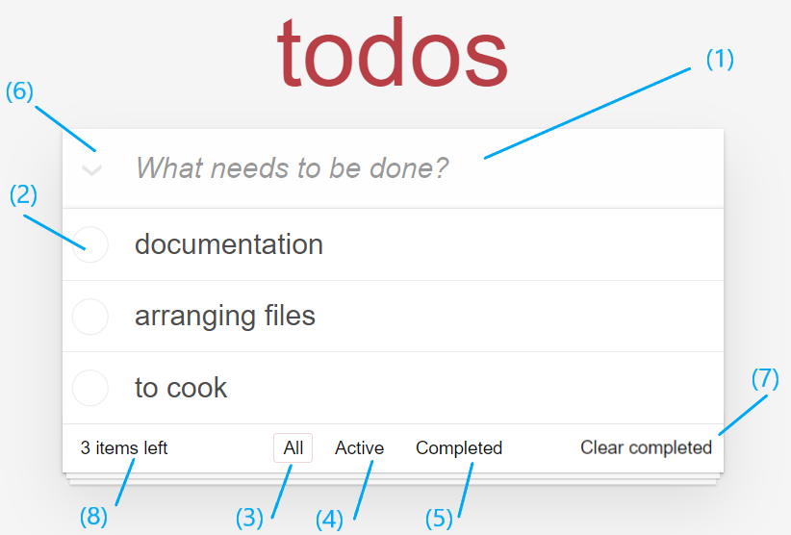

## 

**TODOS AUDIT RESULTS: MOBILE**

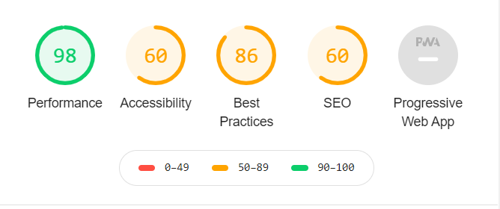

**Mobile performance** contains of the following parameters and has good results in each:

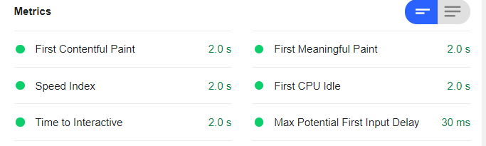

Yet following suggestion would make site performance better: 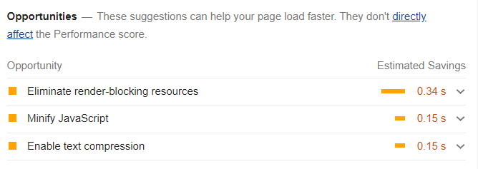

## Accessibility

As accessibility results are 60%, the audit results suggest improvements in semantics.

More precisely, it is good to add label to the input form in the following text:

<input class="new-todo" placeholder="What needs to be done?" autofocus="">

This may enhance the experience for users.

**Best practices**

Best practices result is 86% and the result was affected by errors in console log and requests that has errors through ‘http’ :

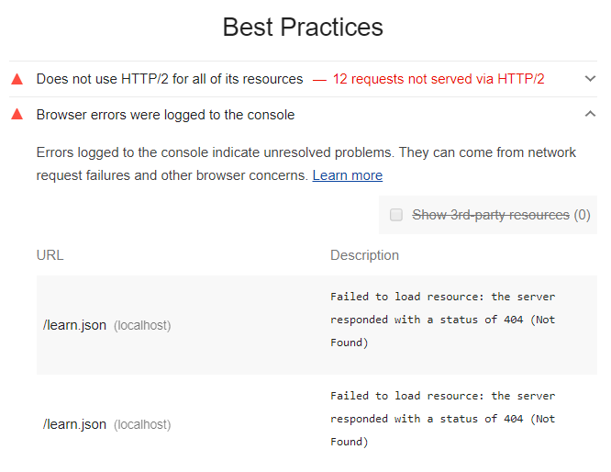

As a result it is suggested to reduce code errors and warnings.

**SEO**

These checks ensure that your page is optimized for search engine results ranking.

Content Best Practices Format your HTML in a way that enables crawlers to better understand your app’s content.

Document does not have a meta description. Meta descriptions may be included in search results to concisely summarize page content. Other than that, these is the summary for SEO:

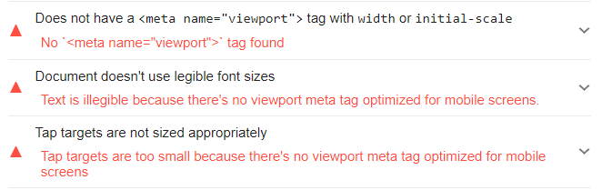

**Desktop**

Audit of desktop the web site gives close results to the mobile version. Only difference in SEO part with less corrections to do.

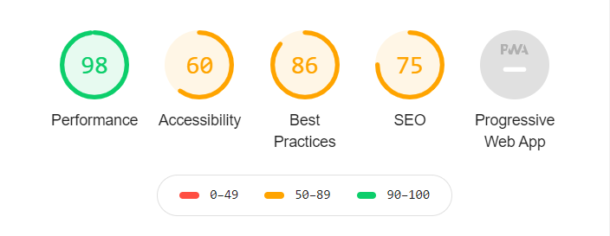

**ToDoListMe AUDIT RESULTS: MOBILE**  (<http://todolistme.net/>)

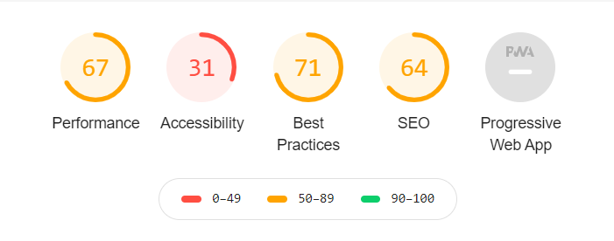

**Performance**

Performance less effective in comparison with the Todos site.

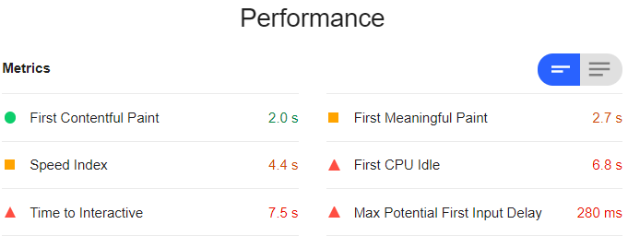

**Accessibility**

Accessibility is the weakest part of the results and needs careful detection. There is a lot of impact from 3rd party scripts, the code contains several frames from google, twitter, facebook and other parties. These external scripts are not static and use more resources in comparison to Todos site which has no advertisement.

Also cache policy is not working efficiently.

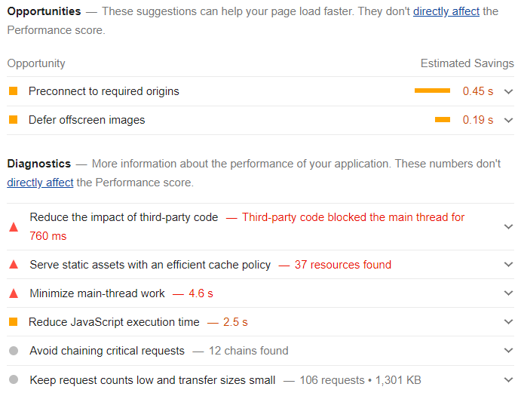

**Best practices**

There are a lot of insecure requests, scripts with insecure libraries as well as errors on the console log.

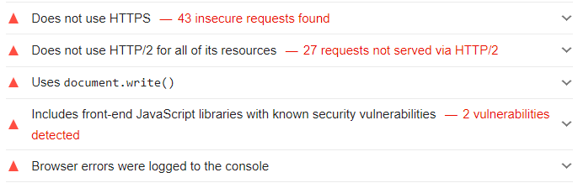

**SEO**

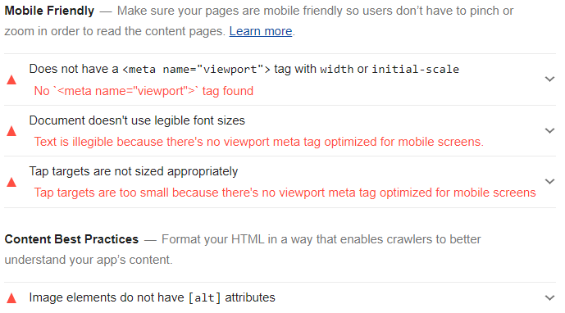

The desktop result for this site has more variety in values.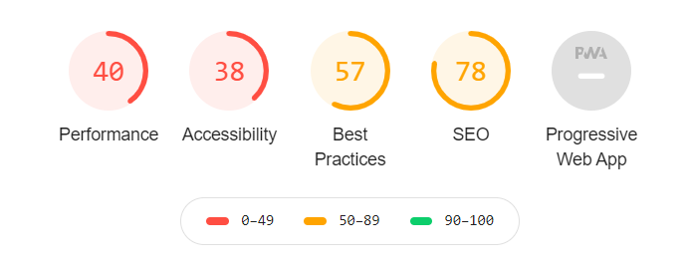

**Conclusion**

<http://todolistme.net/> is more complex site with more functionality and more to work to do to make it work better. Moreover the code contains external scripts, more broken code pieces and cache problems. As a result the audit gives various results for desktop and mobile versions of a site for the parameters like, performance, best practices and SEO.

While todo site is simple and gives close results for both desktop and mobile performance.