Project Report



(An-Najah National University)

(Prepared by): Assem Ahmad , Omar Morsi, Yazan Dewikat

(Instructor): Dr.Jehad Hamamreh

(Course): Data Communication and Network

Pilot-Efficient Channel Estimation for OFDM Systems

Abstract
This project investigates pilot-based channel estimation techniques in Orthogonal Frequency Division Multiplexing (OFDM) systems using both Least Squares (LS) and Minimum Mean Square Error (MMSE) estimators. A MATLAB simulation is developed using QPSK modulation over a multipath Rayleigh fading channel with additive white Gaussian noise (AWGN). The system performance is evaluated in terms of both Mean Square Error (MSE) and Bit Error Rate (BER) across a range of Signal-to-Noise Ratio (SNR) values and different pilot spacings. The results demonstrate that MMSE significantly outperforms LS, particularly at low SNR and larger pilot spacing, while LS maintains lower computational complexity.

Introduction
Modern wireless communication systems such as WiFi rely heavily on OFDM due to its robustness against multipath fading and its ability to support high data rates. However, accurate channel estimation is essential for reliable data recovery at the receiver.
In practical environments, especially indoor wireless channels, signals experience multipath propagation, fading, and noise. These factors make channel estimation a challenging task. Pilot-based estimation techniques are commonly used to address this issue.
This project focuses on evaluating and comparing two widely used channel estimation techniques: Least Squares (LS) and Minimum Mean Square Error (MMSE), while also analyzing the impact of pilot spacing on system performance.

System Model
The OFDM system implemented in this project follows these steps:
1. Random binary data generation.
2. QPSK modulation.
3. Pilot insertion with configurable spacing.
4.OFDM modulation using IFFT.
5. Cyclic Prefix (CP) addition.
6. Transmission through a multipath Rayleigh fading channel.
7. Addition of AWGN noise.
8. Receiver processing (CP removal and FFT.
9. Channel estimation using LS and MMSE.
10. Equalization.
11. Demodulation.
12. Performance evaluation using MSE and BER.

3. Channel Estimation Techniques
3.1 Least Squares (LS)
The LS estimator is a simple and widely used method. It estimates the channel at pilot positions by dividing the received pilot symbols by the known transmitted pilot symbols. The estimated channel is then extended to all subcarriers using interpolation.
Although LS has low computational complexity, it is sensitive to noise and performs poorly at low SNR.
3.2 Minimum Mean Square Error (MMSE)
The MMSE estimator improves the LS approach by incorporating noise statistics and channel correlation. It minimizes the mean square error between the estimated and true channel.
In this project, MMSE is implemented using a correlation-based model, where channel correlation is approximated using an exponential function. This allows better estimation accuracy, especially when pilot spacing is large or SNR is low.
However, MMSE has higher computational complexity due to matrix operations.

MATLAB Implementation
The system is implemented using MATLAB, simulating a complete OFDM transmission and reception chain.
4.1 Signal Generation and Modulation
Random bits are generated and mapped into QPSK symbols, where each pair of bits corresponds to one complex symbol.
txBits = randi([0 1], bitsPerOFDM, 1);
txDataSymbols = qpsk_mod(txBits);

4.2 Pilot Insertion
Pilots are inserted at fixed intervals defined by the pilot spacing.
X(dataPos) = dataSymbols;
X(pilotPos) = pilotValue;

4.3 OFDM Modulation
H_LS(pilot_pos) = Y(pilot_pos) ./ X(pilot_pos);
H_MMSE = H_LS ./ (1 + noise_var);

4.4 Channel Modeling
A multipath Rayleigh fading channel with multiple taps is used to simulate realistic wireless conditions.
h = (randn(L,1) + 1j*randn(L,1)) / sqrt(2*L);
y_channel = conv(x_cp, h);

4.5 Noise Addition
AWGN noise is added based on the selected SNR value.
noisePower = signalPower / (10^(snr/10));

4.6 Channel Estimation

LS Estimation:
H_ls = Y(pilotPos) / pilotValue;
The channel is then reconstructed over all subcarriers using linear interpolation.

MMSE Estimation:
The MMSE estimator uses correlation matrices to improve estimation accuracy:
Rpp(i,j) = 0.9^(delta);
This model captures the correlation between subcarriers and improves estimation quality.

4.7 Equalization and Demodulation
The received symbols are equalized using the estimated channel and then demodulated to recover the transmitted bits.

Results and Discussion
The system performance is evaluated using both MSE and BER metrics across different SNR values and pilot spacings.
  - MSE Performance
- MMSE consistently achieves lower MSE than LS.
- The advantage of MMSE is more significant at low SNR.
- As SNR increase, both methods improve and converge.
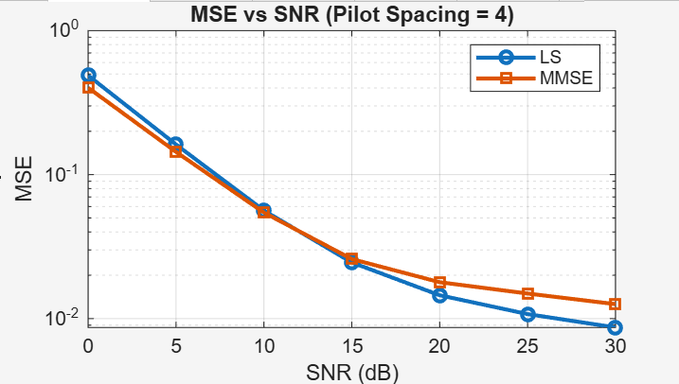
Figure 1: Mean Square Error(MSE) vs. SNR for LS and MMSE estimators with a pilot spacing of 4.
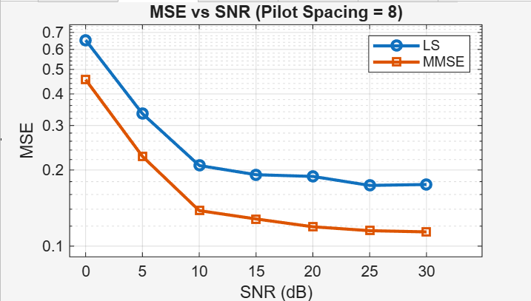
Figure 2: Mean Sequare Error (MSE) vs. SNR for LS and MMSE estimators with a pilot spacing of 8.
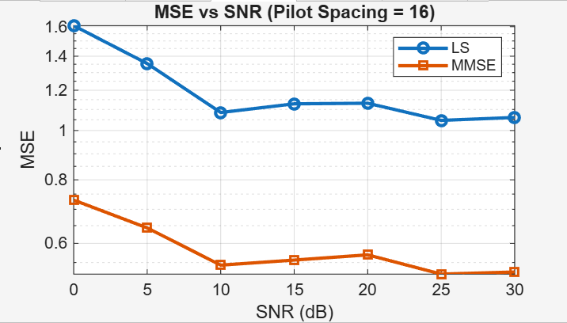
Figure 3: Mean Square Error (MSE) vs. SNR for LS and MMSE estimators with a pilot spacing of 16.

As illustrated in Figures 1,2, and 3, while LS performs adequately at a dense pilot spacing of 4, its performance degrades severely when the pilot spacing in increased to 16. MMSE, on the other hand, maintains a much more stable and lower MSE across all configurations.

5.2 BER Performance
- MMSE results in lower BER compared to LS.
- BER decreases as SNR increase for both methods.
- Improved channel estimation directly leads to better data recovery.
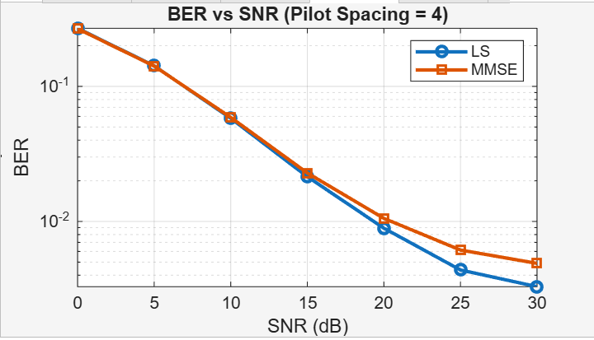
Figure 4: Bit Error Rate (BER) vs. SNR for LS and MMSE estimators with a pilot spacing of 4.

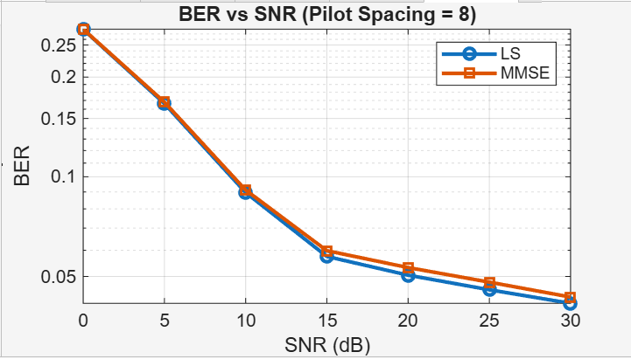
Figure 5: Bit Error Rate (BER) vs. SNR for LS and MMSE estimators with a pilot spacing 8.

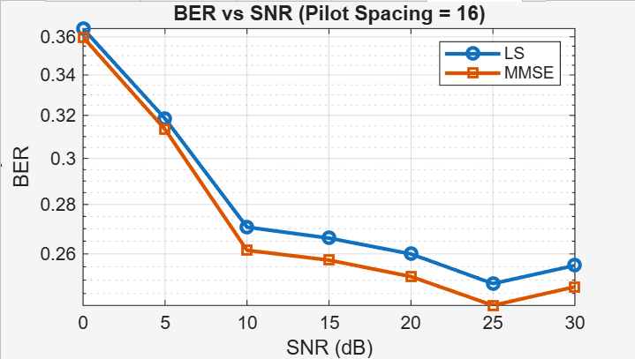
Figure 5: Bit Error Rate (BER) vs. SNR for LS and MMSE estimators with a pilot spacing 8.

Figures 4 through 6 demonstrate the direct impact of estimation accuracy on the overall system Bit Error Rate. At a sparse pilot spacing of 16 (Figure 6), the LS estimator struggles to properly equalize the signal, resulting in a high BER even a higher SNRs. The MMSE estimator exhibits superior robustness, keeping the BER significantly lower.

5.3 Effect of Pilot spacing

1. Smaller pilot spacing improves channel estimation accuracy.
2. Larger pilot spacing reduces overhead but degrades performance.
3. MMSE handles larger pilot spacing better than LS.
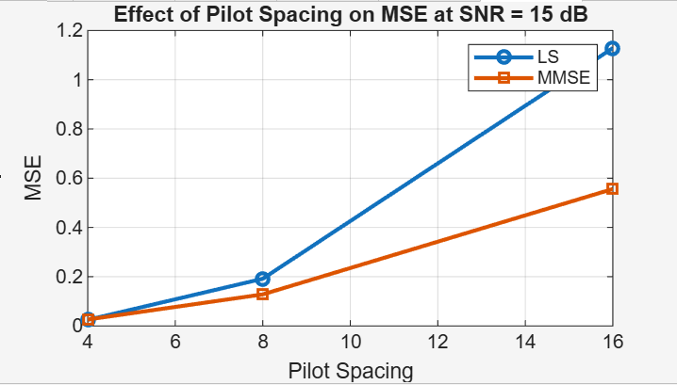
Figure 7: The effect of increasing pilot spacing on MSE performance at a constant SNR of 15 dB.

Figure 7 clearly summarizes the trade-off between spectral efficiency (larger pilot spacing) and estimation accuracy. At an SNR of 15 dB, increasing the pilot spacing from 4 to 16 causes a massive spike in the MSE for the LS estimator. The MMSE estimator also experiences an increase in error, but the slope is much more gradual, proving its superiority in pilot-sparse environment.

Observations
- MMSE outperforms LS in all scenarios.
- The performance gap is larger at low SNR.
- Increasing pilot spacing negatively impacts both MSE and BER.
- There is a trade-off between pilot efficiency and estimation accuracy.

Conclusion
This project demonstrated the importance of channel estimation in OFDM systems using realistic simulation conditions. The results show that MMSE provides superior performance in terms of both MSE and BER, especially under low SNR and sparse pilot configurations.
On the other hand, LS remains useful due to its simplicity and low computational cost.
Additionally, the study highlighted the impact of pilot spacing, showing that increasing spacing reduces estimation accuracy, which introduces a trade-off between spectral efficiency and performance.

Future Work
Future improvements may include:
- Adaptive pilot spacing techniques
- Advanced interpolation methods (e.g., spline or Wiener filtering)
- Machine learning-based channel estimation
- Implementation of higher-order modulation schemes

References
- Proakis, J. G. (2001). Digital Communications
2. Goldsmith, A. (2005). Wireless Communications
3. MATLAB Documentation

