Lightweight Post-Quantum Cryptography for IoT Devices

1. Introduction
This project proposes a lightweight post-quantum cryptography scheme tailored for IoT devices.

2. Problem Statement
Traditional cryptographic algorithms such as RSA and ECC are vulnerable to quantum attacks and require high computational resources.

3. Proposed Solution
We propose optimized lattice-based and hash-based PQC algorithms focusing on reducing memory usage, computation time, and energy consumption.

4. Methodology
Simulation using Python and embedded benchmarks to evaluate performance.

5. Diagram
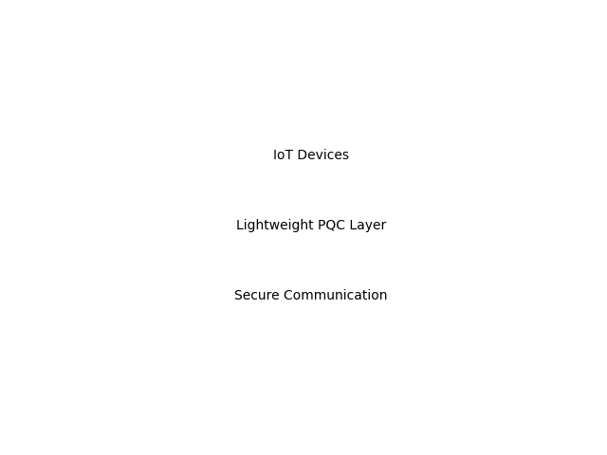

6. Results & Discussion
The proposed system shows improved efficiency compared to standard PQC implementations.

7. Conclusion
Lightweight PQC is suitable for IoT environments.

