**Report on Running Odoo, Jitsu, and Apache Superset Using Docker Commands**

**Introduction**

This report outlines the commands used to run Odoo, Jitsi (though the provided commands do not include Jitsu), and Apache Superset using Docker. Each section will provide the command used and a brief explanation of its function.

Running PostgreSQL for Odoo

**Command**

docker run -d -e POSTGRES_USER=odoo -e POSTGRES_PASSWORD=odoo -e POSTGRES_DB=postgres --name db postgres:15

**Description**

This command runs a PostgreSQL 15 container in detached mode. The environment variables set the PostgreSQL user to "odoo", the password to "odoo", and the database to "postgres". The container is named "db".

Installing WSL and Ubuntu

**Command**

wsl --install -d ubuntu

**Description**

This command installs Windows Subsystem for Linux (WSL) and downloads the Ubuntu distribution. This allows for a Linux environment to run alongside your Windows OS.

**Running Odoo**

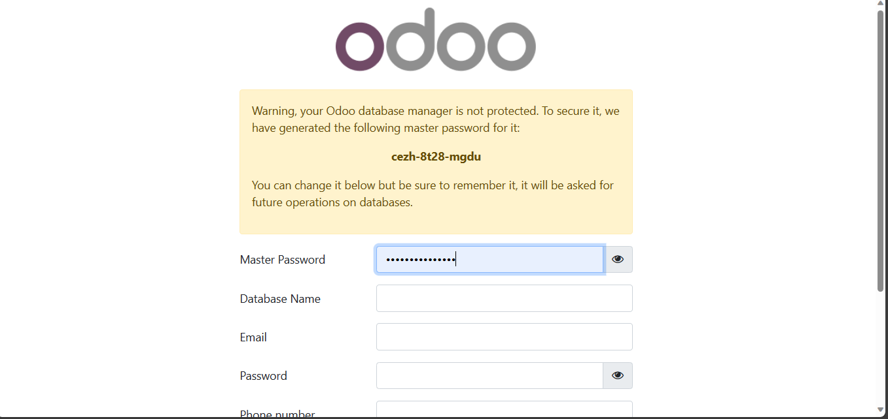

**Command**

docker run -p 8069:8069 --name odoo --link db:db -t odoo

**Description**

This command runs an Odoo container, mapping port 8069 of the host to port 8069 of the container. It links this container to the "db" container, which is our PostgreSQL database. The container is named "odoo".

Listing Running Containers

**Command**

docker ps

**Description**

This command lists all running Docker containers, showing their IDs, names, and other information.

Running Redis

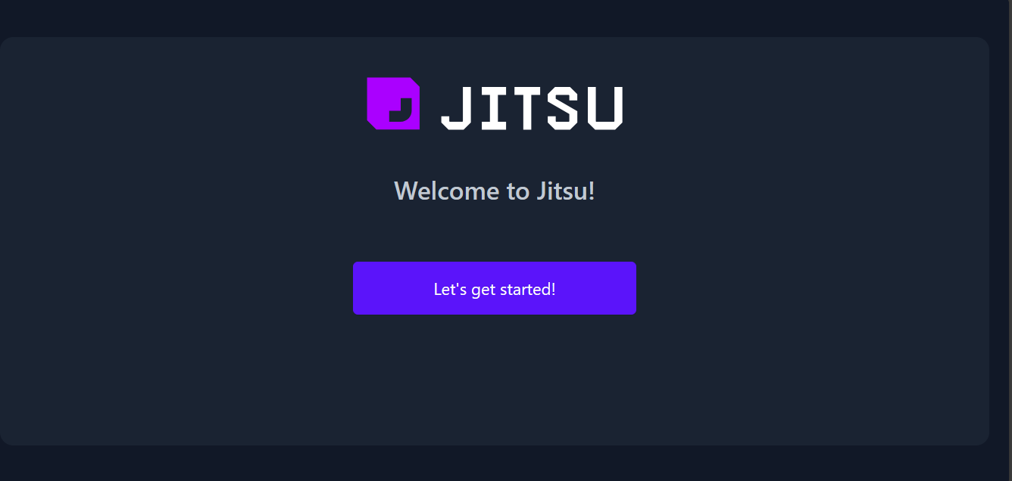

**Command**

docker run --name some-redis -d redis

**Description**

This command runs a Redis container in detached mode and names it "some-redis".

Inspecting Docker Container

**Command**

docker inspect -f '{{range .NetworkSettings.Networks}}{{.IPAddress}}{{end}}' 172db6e6f018

**Description**

This command inspects a Docker container with ID `172db6e6f018` and outputs its IP address using a Go template.

**Running Apache Superset**

**Command**

docker run -d -p 8080:8088 -e "SUPERSET_SECRET_KEY=vQmRkwpRNm5u_6IKXBX9739bXkhiueMF" --name superset apache/superset

**Description**

This command runs an Apache Superset container in detached mode, mapping port 8080 of the host to port 8088 of the container. A secret key is provided through an environment variable. The container is named "superset".

**Conclusion**

This report provided an overview of the commands used to run Odoo and Apache Superset applications using Docker. Each command was explained to provide a better understanding of its purpose and function. Note that the commands for running a Jitsi container were not provided in the initial list.  
  
  
