**Uzair Waseem 20F-1116**

**Explore different tools that are used for CI/CD. Each group has to explore 3 tools. You need to run sample projects on each tool.**

**GITHUB ACTIONS**

**Using GitHub Actions for Continuous Integration (CI)**

GitHub Actions is an automated workflow service provided by GitHub that allows you to set up, customize, and automate your software development workflows directly within your repository.

Setting Up a CI Workflow

1. Created a. new repisotory and github/workflows Directory:
2. Create a Workflow File a YAML file .ci:
3. Initialized/started a basic ci file.

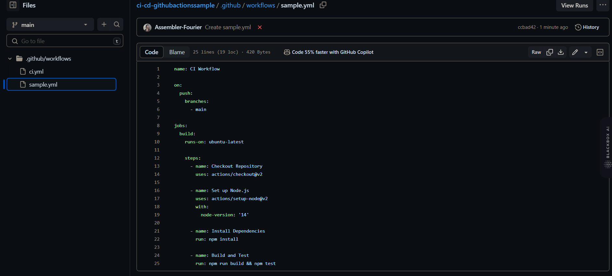

Running the Workflow

* When a push is made to the main branch, GitHub Actions will automatically trigger the workflow defined in ci.yml.

Sample Project: Performing Arithmetic Operations

Display Results:

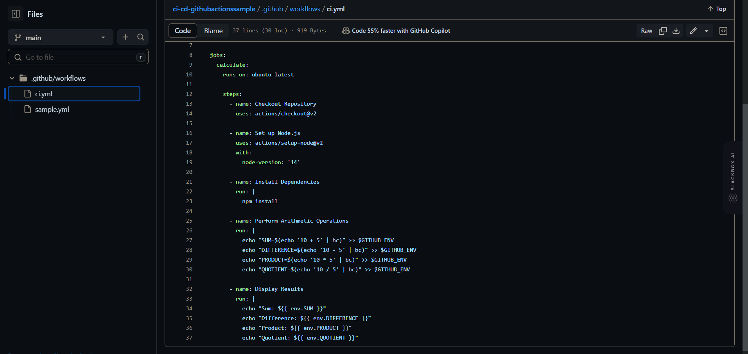

* + Used environment variables to display the calculated results.

1. Verify the Workflow:
   * GitHub Actions will run the workflow on your pull request. Check the "Actions" tab for the workflow status and results.

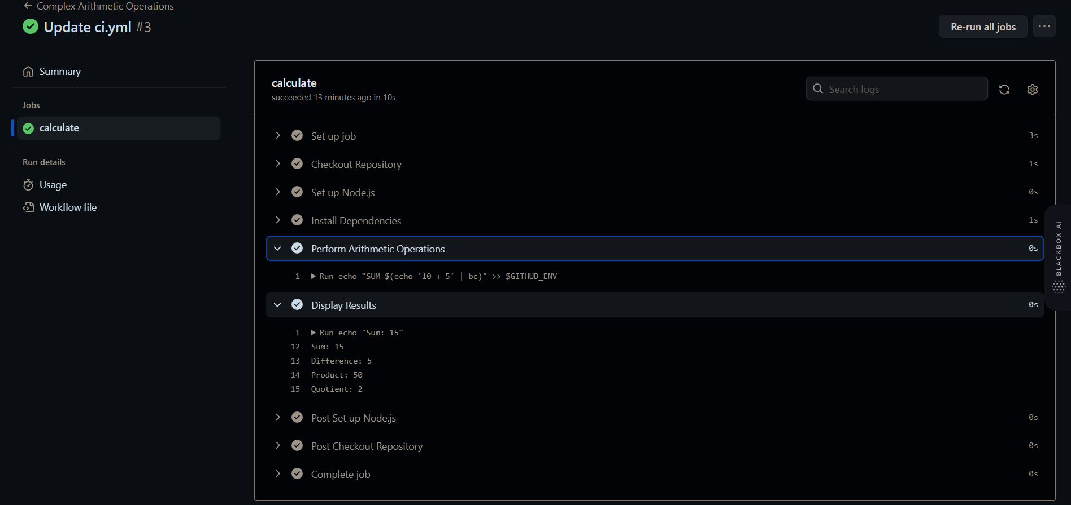

For the main task I forked the repository provided by sir and implemented ci/cd on it through github actions.

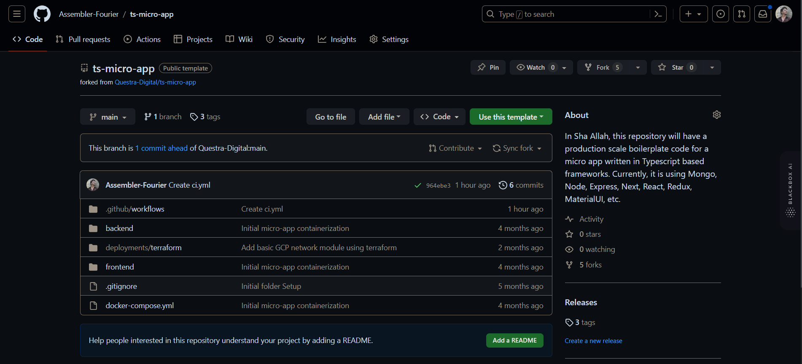

Next I switched the tags. And added a basic ci/cd job to do yarn install on every commit to main branch and every update to pull-request

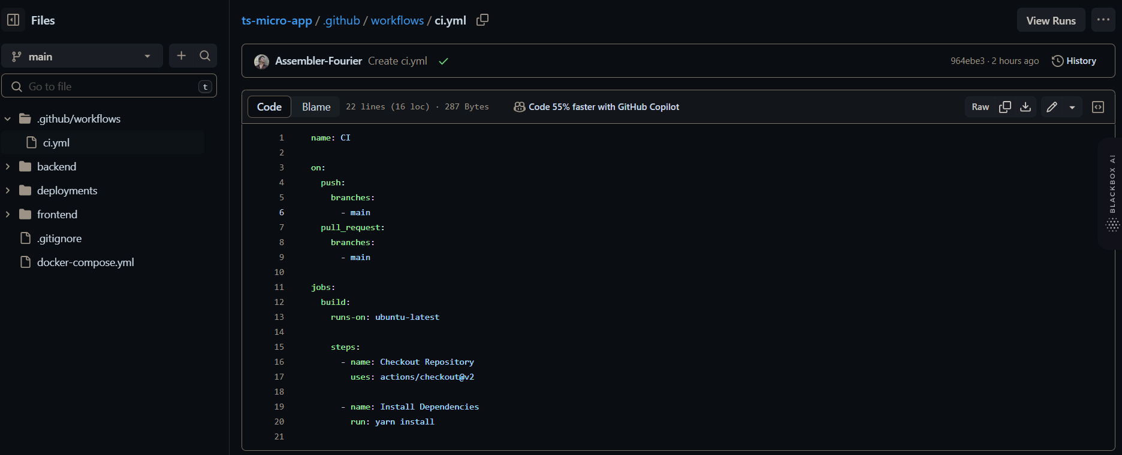

Displaying the results.