***Heart Disease Classification***

AIE121: Machine Learning

Spring semester 2024

**Project Team**

|  |  |  |  |
| --- | --- | --- | --- |
| **Student ID** | **Student Name** | **Project Evaluation** | |
| **222100946** | **Abdelrahman Atef Saad Osheba** | Report |  |
| Presentation |  |
| Code |  |
| Total |  |
| **222100032** | **Ahmed Ashraf Mohamed Abouelela** | Report |  |
| Presentation |  |
| Code |  |
| Total |  |
| **222101943** | **Youssef Husseiny Fathy** | Report |  |
| Presentation |  |
| Code |  |
| Total |  |
| **222100195** | **Adham Mohamed Elsied Elwakeel** | Report |  |
| Presentation |  |
| Code |  |
| Total |  |
| **222100123** | **Ahmed Alaa Eldin Moustafa** | Report |  |
| Presentation |  |
| Code |  |
| Total |  |
| **222100211** | **Osama Adel Fawzy Elsayed** | Report |  |
| Presentation |  |
| Code |  |
| Total |  |
| **222102487** | **Aser Mohamed Ali Mahmoud** | Report |  |
| Presentation |  |
| Code |  |
| Total |  |

**Project with paper :** Yes [ ✔ ] – No [ ]

**Under supervision of Professor :** Shaker El-Sappagh

2023-2024

**Abstract**

Heart disease remains a leading cause of mortality worldwide , Current diagnostic methods can be invasive, expensive, and inaccessible to many populations There is a need for a non-invasive, cost-effective, and highly accurate method for early detection and classification of heart disease to improve patient outcomes and reduce healthcare costs.

In recent years **machine learning (ML)** models have shown promise in predicting **Cardiovascular disease (CVD)** risk based on various data sources, including **electronic health records (EHR)**, clinical measurements, and demographic information. However, the lack of transparency and interpretability in these models has raised concerns among medical practitioners and researchers.

In this project, we explore the integration of **explainable artificial intelligence (XAI)** techniques to enhance the trustworthiness of CVD prediction models. XAI aims to provide insights into model decisions, making them more interpretable for healthcare professionals. By understanding how the ML model arrives at its predictions, clinicians can confidently apply the recommended treatments.

Our project focuses on a heart disease dataset, leveraging diverse features such as patient demographics, clinical measurements, and historical health records. [We demonstrate the effectiveness of XAI techniques, emphasizing their importance in creating trust and facilitating the adoption of ML-based systems in healthcare](https://arxiv.org/abs/2011.03195). Future work could involve larger datasets, and seamless integration of trained models into user-friendly XAI interfaces.

With the increasing availability of structured and unstructured data and the swift progress of analytical techniques, Artificial Intelligence (AI) is bringing a revolution to the healthcare industry. With the increasingly indispensable role of AI in healthcare, there are growing concerns over the lack of transparency and explainability in addition to potential bias encountered by predictions of the model. This is where Explainable Artificial Intelligence (XAI) comes into the picture. XAI increases the trust placed in an AI system by medical practitioners as well as AI researchers, and thus, eventually, leads to an increasingly widespread deployment of AI in healthcare. In this paper, we present different interpretability techniques. The aim is to enlighten practitioners on the understandability and interpretability of explainable AI systems using a variety of techniques available which can be very advantageous in the health-care domain. Medical diagnosis model is responsible for human life and we need to be confident enough to treat a patient as instructed by a black-box model. Our paper contains examples based on the heart disease dataset and elucidates on how the explainability techniques should be preferred to create trustworthiness while using AI systems in healthcare.

**Introduction**

Heart disease prediction models play a crucial role in early detection and prevention of cardiovascular diseases. Leveraging machine learning techniques, these models analyze patient data to assess risk factors and predict outcomes. However, their black-box nature raises concerns about interpretability. Enter **explainable artificial intelligence (XAI)** a paradigm that aims to demystify model decisions. By incorporating XAI methods, we enhance transparency, enabling clinicians to understand and trust the predictions. This introduction highlights the intersection of heart disease modeling and XAI, emphasizing the importance of interpretable AI in healthcare.

**Scope:** For healthcare applications where explanation of the inherent logic is important for people who make decisions, machine learnings lack of explainability restricts the wide-scale deployment of AI. If AI cannot explain itself in the domain of healthcare, then its risk of making a wrong decision may override its advantages of accuracy, speed and decision-making. This would, in turn, severely limit its scope and utility. Therefore, it is very important to look at these issues closely. Standard tools must be built before a model is deployed in the health care domain. One such tool is **explainability (or Explainable AI)**. The rationale behind the use of Explainable AI techniques is to increase transparency, result tracing and model improvement . For instance, they explain why someone is categorized as ill or otherwise. This would increase the trust level of medical practitioners to rely on AI. Eventually, XAI can be integrated into smart health care systems involving **IoT**, Cloud computing and AI primarily used in the areas of cardiology, cancer and neurology. These smart healthcare systems can then be used for diagnosing diseases and selection of the appropriate treatment plan. In this project, we look at some examples of various XAI techniques carried out on the Heart Disease Dataset from **Kaggle** along with the use cases related to the technique.

**Objectives:** The objective of this project is to study and utilize different explain able **AI techniques** in the healthcare sector, as it gives transparency, consistency, fairness and trust to the system. The particulars for the objectives are : To study feature-based and example-based explainable AI techniques using the heart disease dataset. To draw out the inferences from the results of these techniques and conclude selection of one technique over the other for a particular area of healthcare. We have worked on various techniques that give explanation of outcomes given by the black box models. The paper gives insights on how these techniques are advantageous in different conditions.

**The Business Problem Analysis**

**Business Context :**

* **Healthcare Providers:** Hospitals, clinics, and healthcare institutions aim to improve patient outcomes by identifying high-risk patients early.
* **Health Insurers:** Insurance companies want to assess risk accurately to optimize premium pricing and coverage.
* **Pharmaceutical Companies:** Companies developing cardiovascular drugs need insights into patient populations for clinical trials and drug efficacy studies.

**Data Availability :**

* **Patient Data:** Collecting relevant patient information (e.g., age, sex, blood pressure, cholesterol levels, family history) is essential.
* **Medical Records:** Access to historical medical records, diagnostic tests, and lifestyle data (e.g., smoking, exercise habits) enhances model performance.
* **Feature Engineering:** Creating meaningful features (e.g., risk scores, comorbidity indicators) from raw data is crucial.

**Business Impact :**

* **Early Intervention:** Identifying high-risk patients early allows for timely interventions (e.g., lifestyle modifications, medication).
* **Cost Savings:** Reducing hospitalizations and emergency treatments leads to cost savings for healthcare providers and insurers.
* **Improved Patient Outcomes:** Accurate predictions enhance patient care and quality of life.
* The data science and machine learning part of the project entail the following steps:

**The UI of the project:**

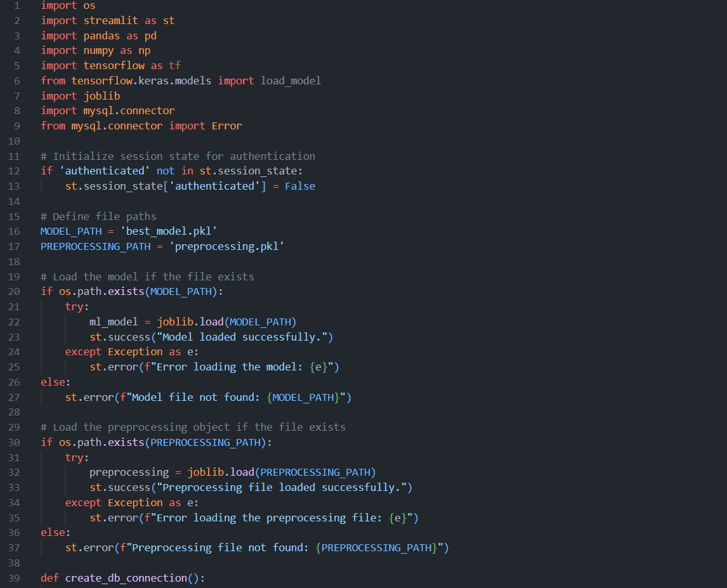

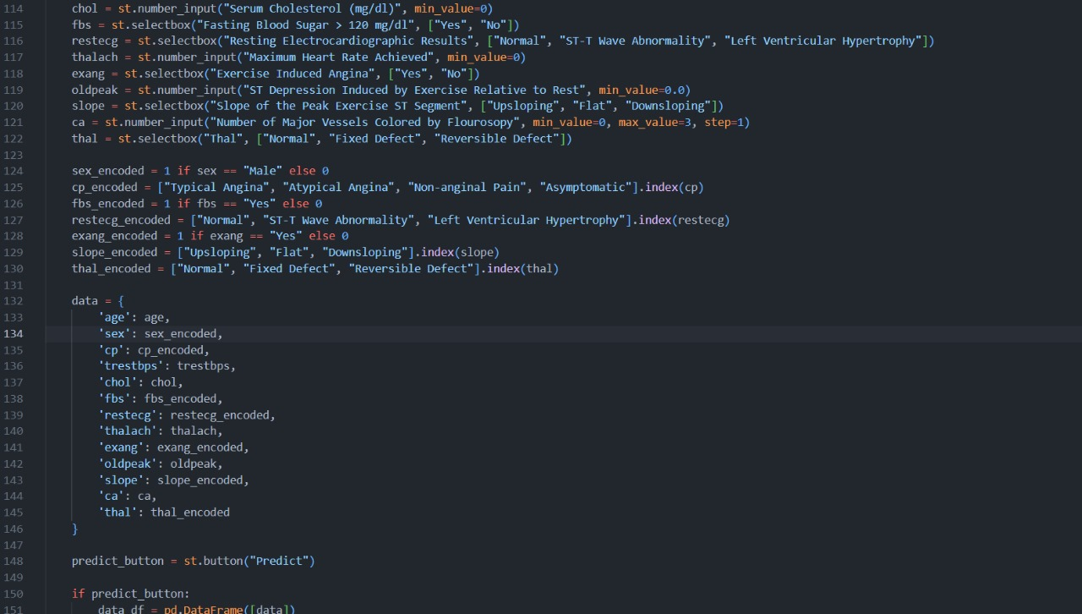

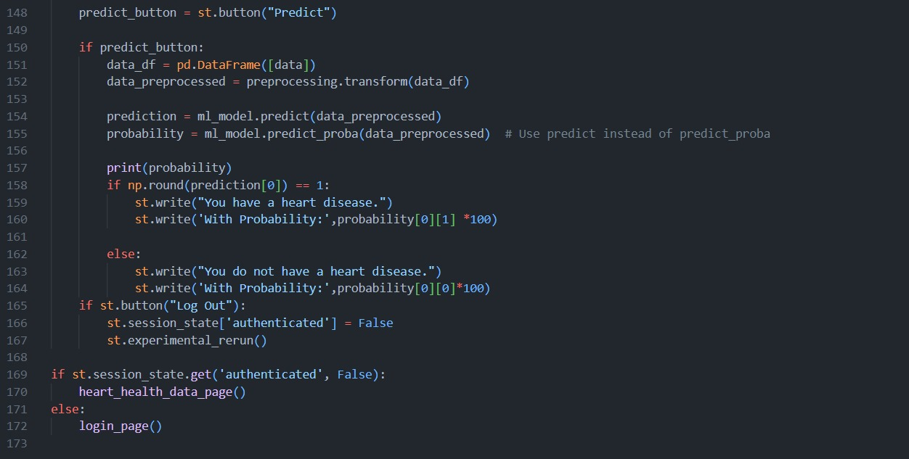

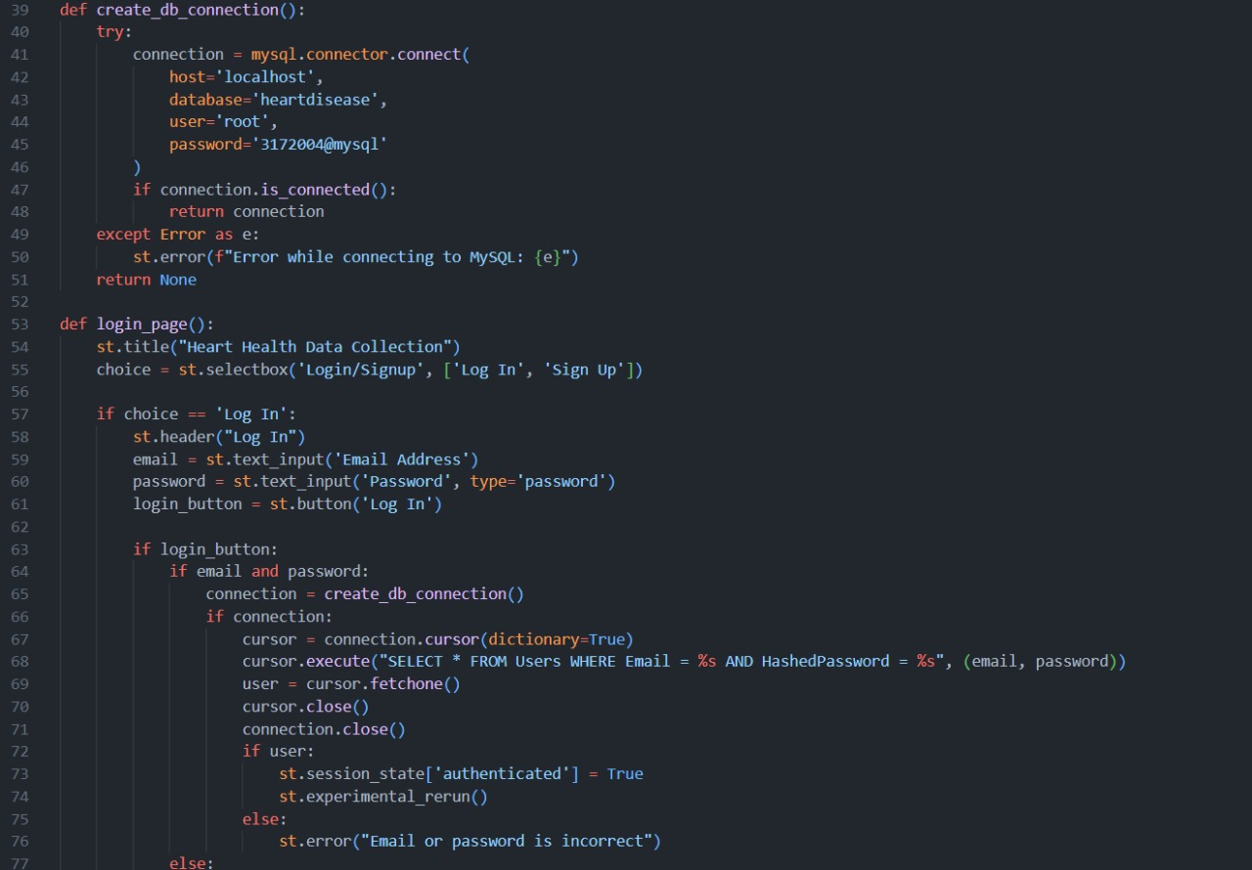

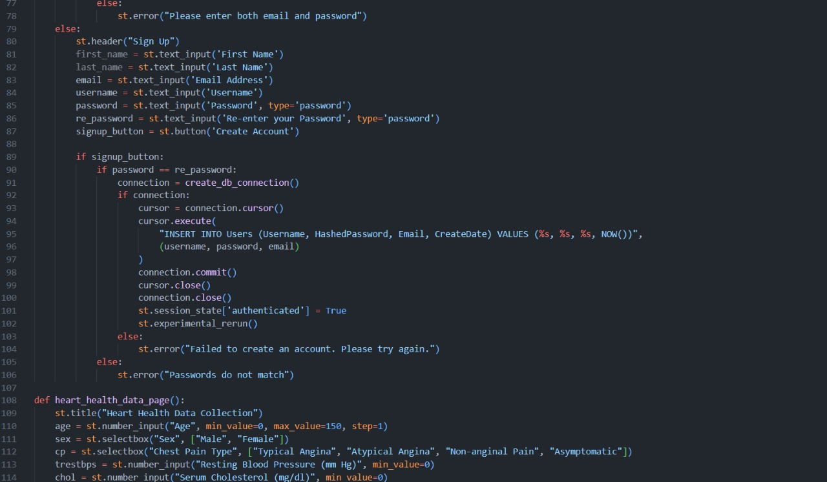

**Dataset Description**

**Link of the dataset in Kaggle:** https://www.kaggle.com/datasets/johnsmith88/heart-disease-dataset

**Data Collections :**

Our data source is a public health dataset from Kaggle, comprising 1,025 entries and 14 columns. The dataset includes the following variables:

Age: Age of the patient in years. Increasing age is generally associated with a higher risk of heart disease.

Sex: Sex of the patient, where 1 indicates male and 0 indicates female. Males are generally at a higher risk of heart disease compared to females.

**Chest Pain Type (cp):**

* 0: Typical angina
* 1: Atypical angina
* 2: Non-anginal pain
* 3: Asymptomatic

Different types of chest pain are indicators of heart disease, with typical angina being a stronger indicator.

Resting Blood Pressure (trestbps): Blood pressure measured in mm Hg on hospital admission. Higher blood pressure is a known risk factor for heart disease.

Serum Cholesterol (chol): Cholesterol level in mg/dl. High cholesterol levels can lead to the development of plaques in arteries, contributing to heart disease.

Fasting Blood Sugar (fbs): Indicates if fasting blood sugar is >120 mg/dl, where 1 is true and 0 is false. Elevated fasting blood sugar levels can indicate diabetes, which is a risk factor for heart disease.

**Resting Electrocardiographic Results (restecg):**

* 0: Normal
* 1: ST-T wave abnormality
* 2: Left ventricular hypertrophy by Estes' criteria

Abnormal ECG results can indicate heart problems.

Maximum Heart Rate Achieved (thalach): Maximum heart rate achieved during a stress test. Lower maximum heart rate might be an indicator of poorer heart function.

Exercise Induced Angina (exang): Indicates whether exercise induced angina (1 = yes, 0 = no). Angina induced by exercise is a strong indicator of heart disease.

ST Depression Induced by Exercise Relative to Rest (oldpeak): This value represents the difference in ST depression induced by exercise. Higher values can indicate significant heart problems.

**Slope of the Peak Exercise ST Segment (slope):**

* 0: Upsloping
* 1: Flat
* 2: Downsloping

The slope of the ST segment can indicate the severity of heart disease, with downsloping being the most severe.

Number of Major Vessels Colored by Fluoroscopy (ca): The number of major vessels (0-3) colored by fluoroscopy. Higher numbers indicate more significant heart disease.

**Thalassemia (thal):**

* 1: Normal
* 2: Fixed defect
* 3: Reversible defect

Different types of thalassemia defects can affect the heart differently, with reversible defects being a serious concern.

Target: Diagnosis of heart disease (0 = no heart disease, 1 = heart disease). This is the outcome variable we aim to predict using the features above.

* **Summary of Data Set:**
* *Age and Sex:* Older age and being male are associated with higher heart disease risk.
* *Chest Pain Type:* Typical angina is strongly correlated with heart disease, while asymptomatic cases are less so.
* *Resting Blood Pressure and Cholesterol:* High levels are significant risk factors.
* *Fasting Blood Sugar:* Elevated levels suggest diabetes, which is a heart disease risk factor.
* *ECG Results:* Abnormal results indicate potential heart issues.
* *Maximum Heart Rate:* Lower rates during stress tests can indicate poor heart health.
* *Exercise Induced Angina:* Indicates a strong likelihood of heart disease.
* *ST Depression and Slope:* Higher ST depression and downsloping ST segment are significant indicators.
* *Fluoroscopy:* Higher numbers of colored vessels suggest more severe heart disease.
* *Thalassemia:* Certain types can impact heart health differently.

Overall, this dataset contains critical indicators that can be used to predict the presence of heart disease. Analyzing these features using machine learning models can help develop accurate predictive models to aid in early diagnosis and treatment planning.

**Background of the Used Machine Learning Algorithms**

**Code for the project :**

https://drive.google.com/drive/folders/1wpITDa4PlZt2i0Ly3DZZ6h2-rlETF99W?usp=drive_link

**Logistic Regression:**

* + - Logistic regression is a widely used classification algorithm.
    - It’s an extension of linear regression, adapted for binary or multi-class classification tasks.
    - The model estimates the probability of an instance belonging to a particular class.
    - It uses the logistic function (sigmoid) to map linear predictions to probabilities.

1. **Random Forest:**
   * + Random forests are ensemble methods based on decision trees.
     + They combine multiple decision trees to improve predictive accuracy.
     + Each tree is trained on a random subset of data and features.
     + Random forests handle overfitting and provide feature importance scores.
2. **Support Vector Machines (SVMs):**
   * SVMs find a hyperplane that best separates data points into different classes.
   * They maximize the margin (distance) between classes.
   * SVMs work well for both linear and non-linear problems.
3. **K-Nearest Neighbors (K-NN):**
   * K-NN is a simple instance-based algorithm.
   * It classifies data points based on the majority class among their k nearest neighbors.
   * The choice of k affects the model’s performance.
4. **XGBoost (Extreme Gradient Boosting):**
   * XGBoost is an optimized gradient boosting framework.
   * It builds an ensemble of weak learners (usually decision trees).
   * It uses gradient boosting with regularization and parallelization.
   * XGBoost excels in Kaggle competitions and real-world applications.
5. **Neural Networks:**
   * Neural networks are inspired by the human brain’s interconnected neurons.
   * learning involves neural networks with multiple hidden layers.
   * Activation functions (ReLU, sigmoid), backpropagation, and optimization techniques (gradient descent) are essential.
   * Architectures like CNNs (image recognition) and RNNs (NLP) have transformed AI.

**The needed packages and libraries:**

import numpy as np  
import pandas as pd  
import seaborn as sns  
import joblib  
from sklearn.linear_model import LogisticRegression  
from sklearn.ensemble import RandomForestClassifier  
from sklearn.svm import SVC  
from sklearn.neighbors import KNeighborsClassifier  
from xgboost import XGBClassifier  
from sklearn.metrics import confusion_matrix, accuracy_score, recall_score, precision_score, f1_score  
from sklearn.model_selection import train_test_split ,cross_val_score  
from sklearn.feature_selection import f_classif,SelectKBest  
import matplotlib.pyplot as plt  
from sklearn.preprocessing import StandardScaler,MinMaxScaler  
from sklearn.impute import SimpleImputer  
from sklearn.model_selection import train_test_split  
from sklearn.pipeline import Pipeline

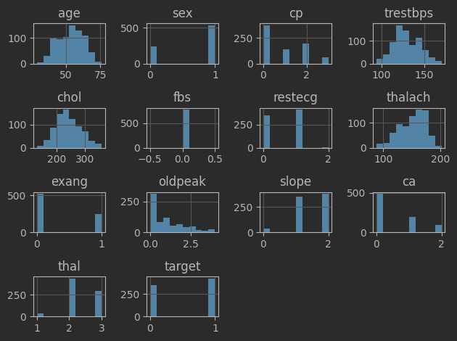**Data Correlation and Visualization:**

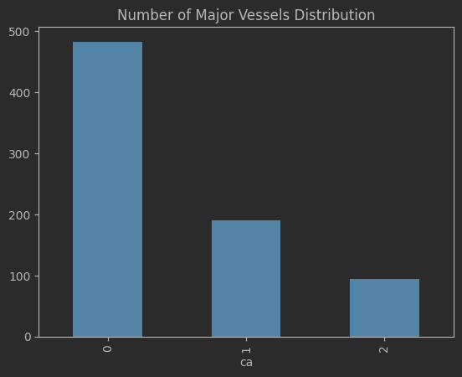

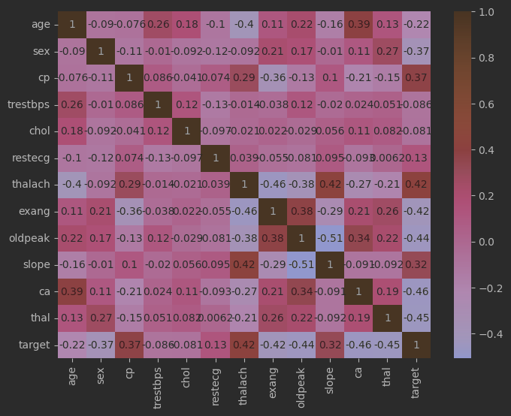

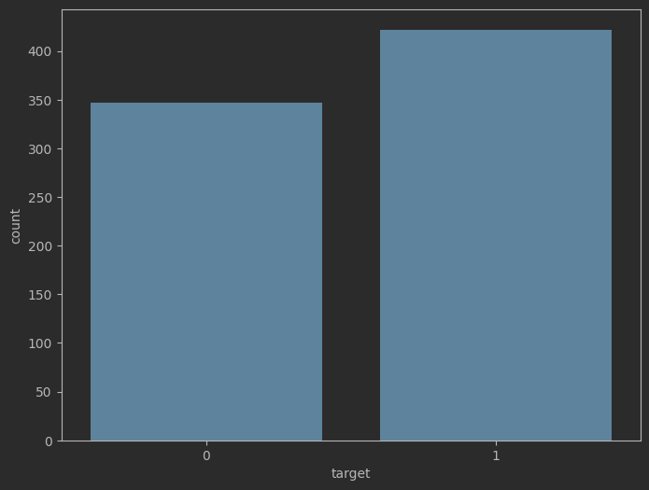

**Proposed Machine Learning Pipeline and Tuned Hyperparameters**

1. **Logistic Regression**:

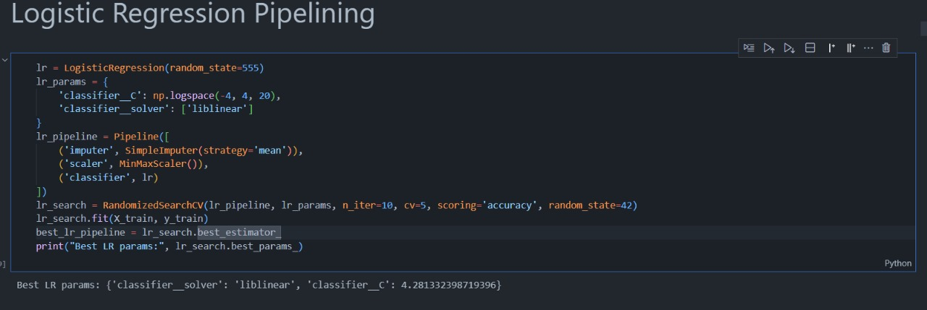

1. **Random Forest**:

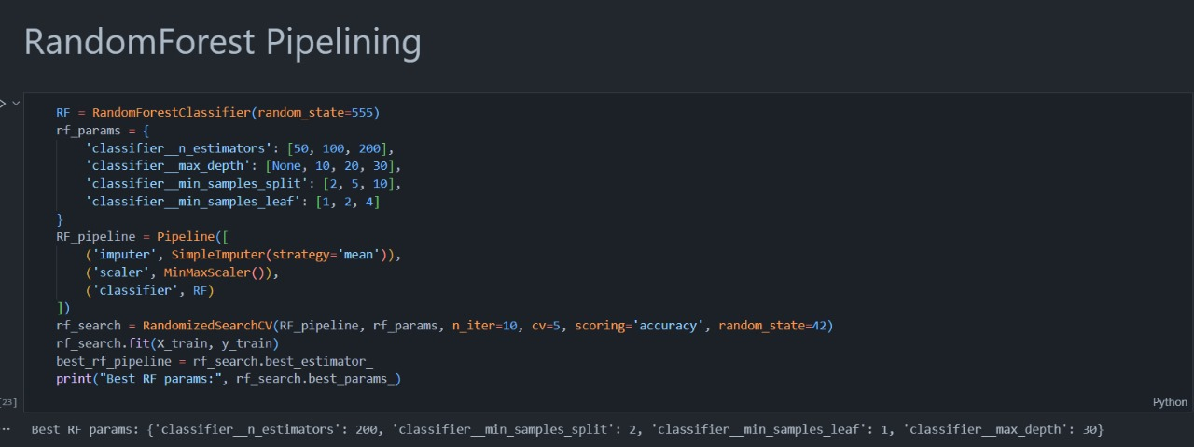

1. **Support Vector Machine (SVM)**:

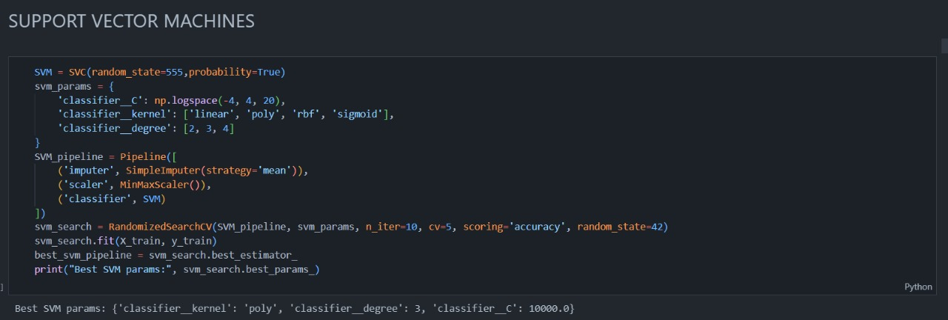

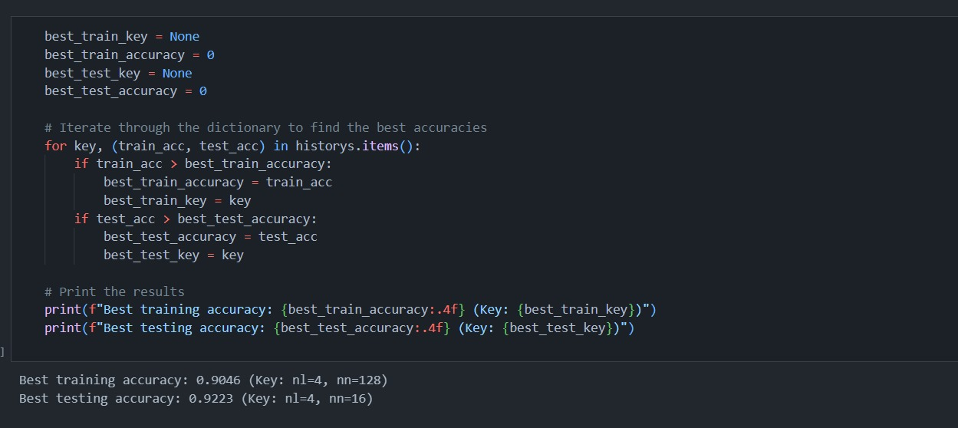

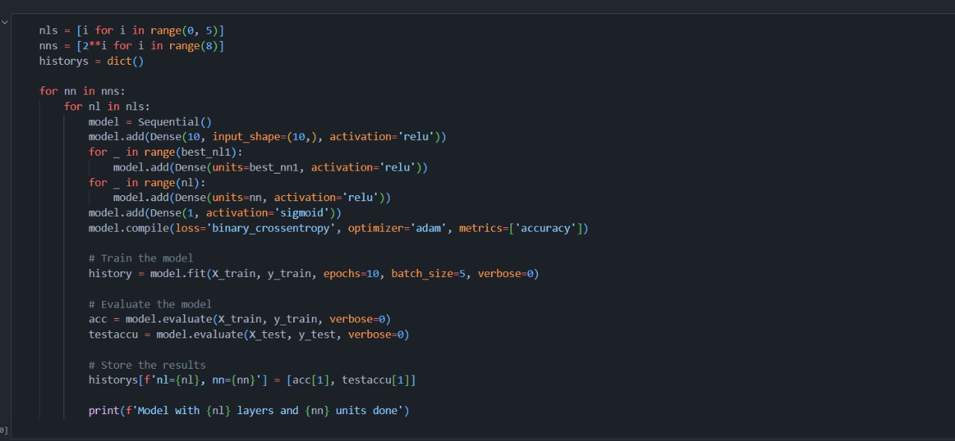

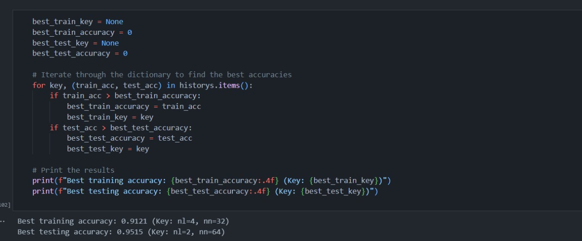

1. **K-Nearest Neighbors (KNN)**:

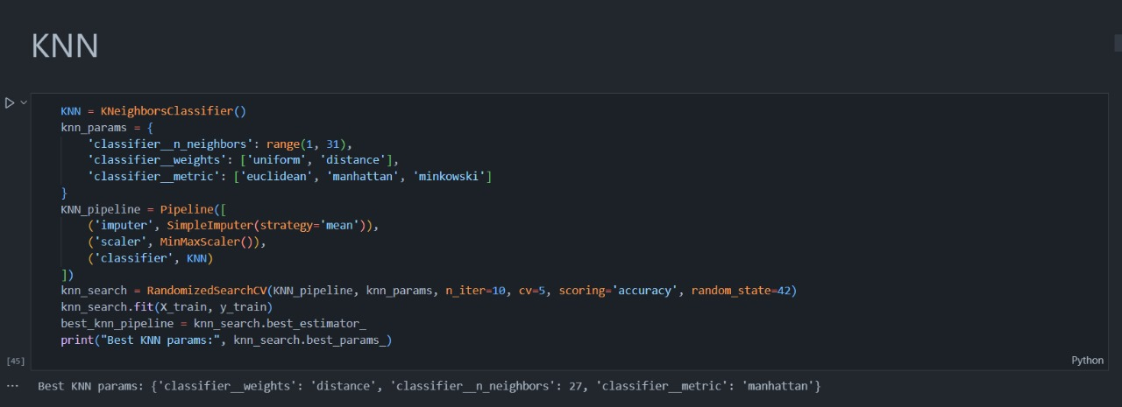

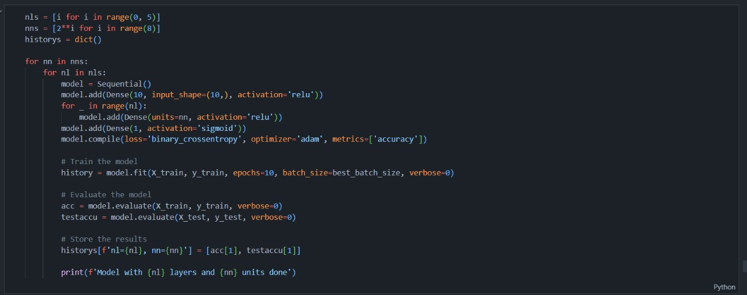

1. **XGBoost is a gradient boosting algorithm:**

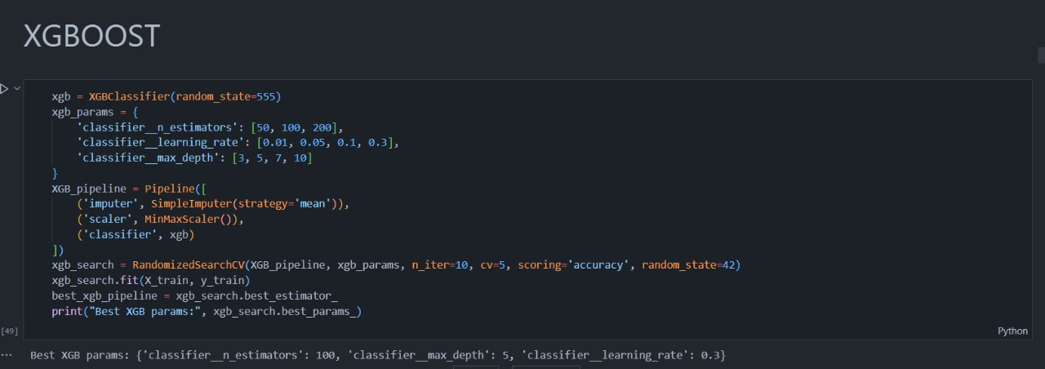

1. **Neural Networks:**

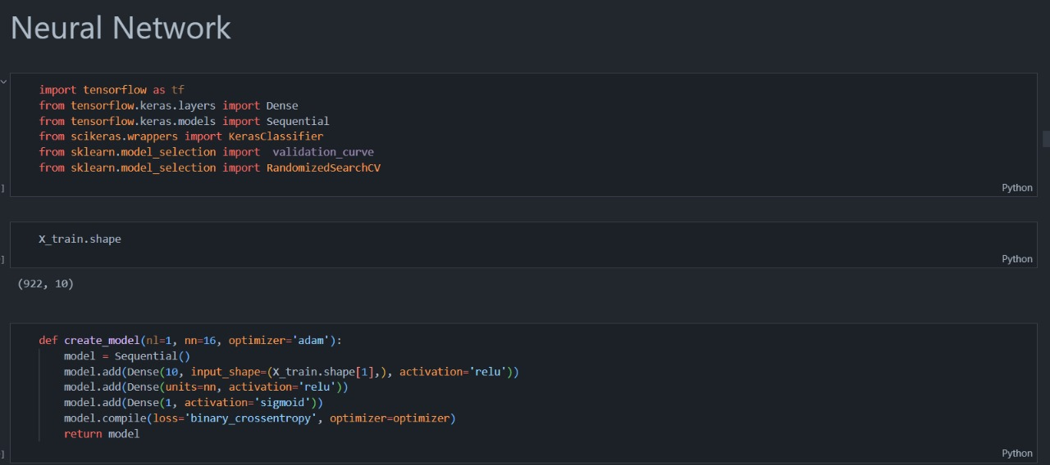

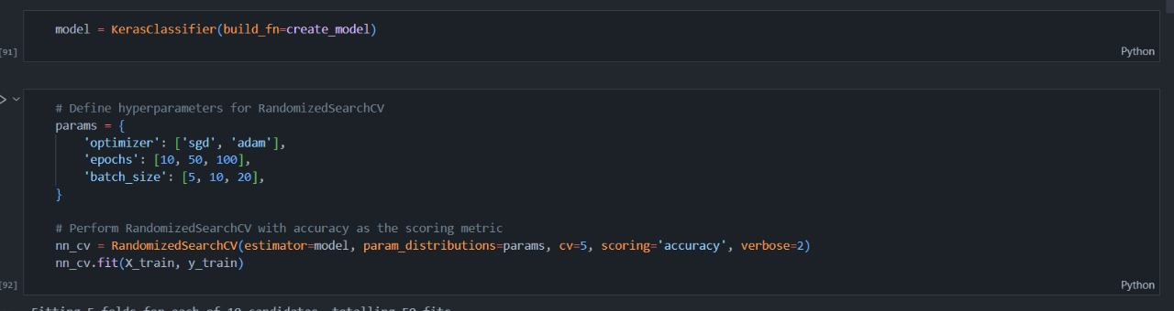

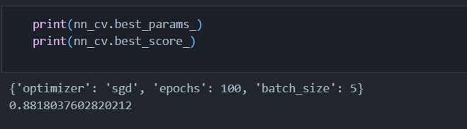

**Accuracy:**

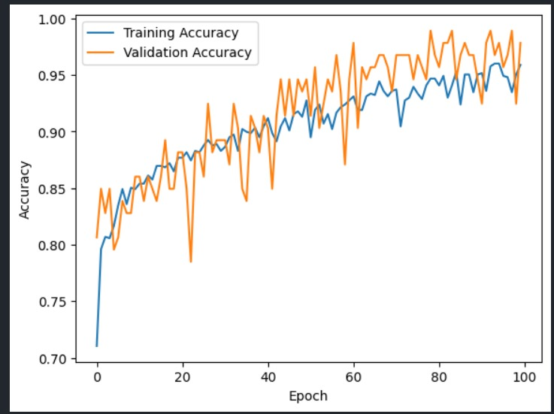

**Results of ML algorithms [Before the randomized search]:**

|  |  |
| --- | --- |
| Logistic Regression Pipelining | Accuracy: 0.857  Precision: 0.803  Recall: 0.976  F1: 0.881 |
| Random Forest Pipelining | Accuracy: 0.896  Precision: 0.886  Recall: 0.928  F1: 0.906 |
| Support Vector Machin | Accuracy: 0.870  Precision: 0.880  Recall: 0.880  F1: 0.880 |
| K-Nearest Neighbor | Accuracy: 0.831  Precision: 0.891  Recall: 0.785  F1: 0.835 |
| XGBoost | Accuracy: 0.974  Precision: 0.954  Recall: 1.0 (overfitting)  F1: 0.976 |

**Results of ML algorithms [after the randomized search]:**

The best model have 2 layers and 64 neurons, Fortunately the accuracy is high and when we tried again we Cannot be better without overfitting.

|  |  |
| --- | --- |
| Logistic Regression | Accuracy: 0.8640776699029126  Precision: 0.8421052631578947  Recall: 0.9056603773584906  F1: 0.8727272727272727 |
| Random Forest | Accuracy: 1.0  Precision: 1.0  Recall: 1.0  F1: 1.0 |
| Support Vector Machin | Accuracy: 1.0  Precision: 1.0  Recall: 1.0  F1: 1.0 |
| K-Nearest Neighbor | Accuracy: 1.0  Precision: 1.0  Recall: 1.0  F1: 1.0 |
| XGBoost | Accuracy: 1.0  Precision: 1.0  Recall: 1.0  F1: 1.0 |

**Explainable AI:**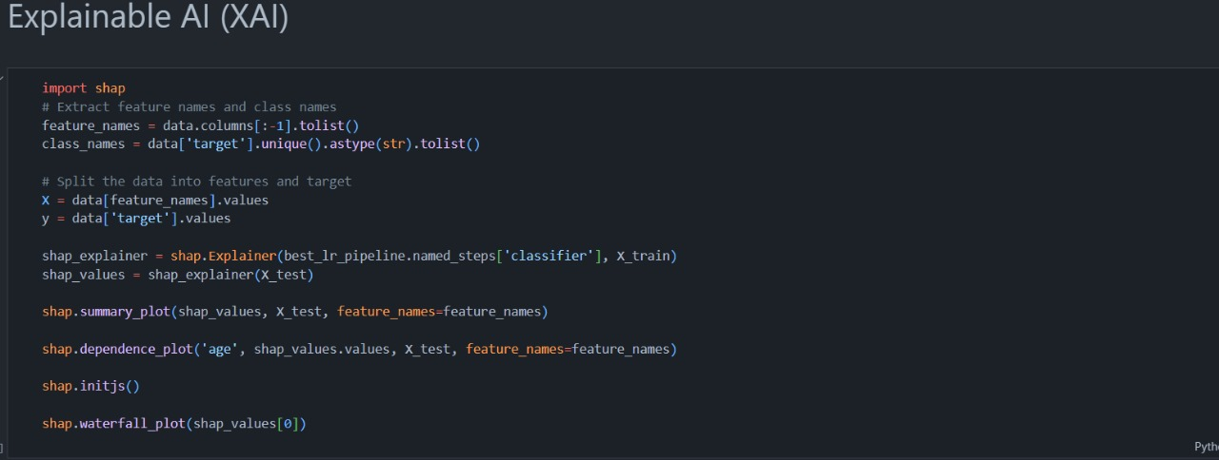

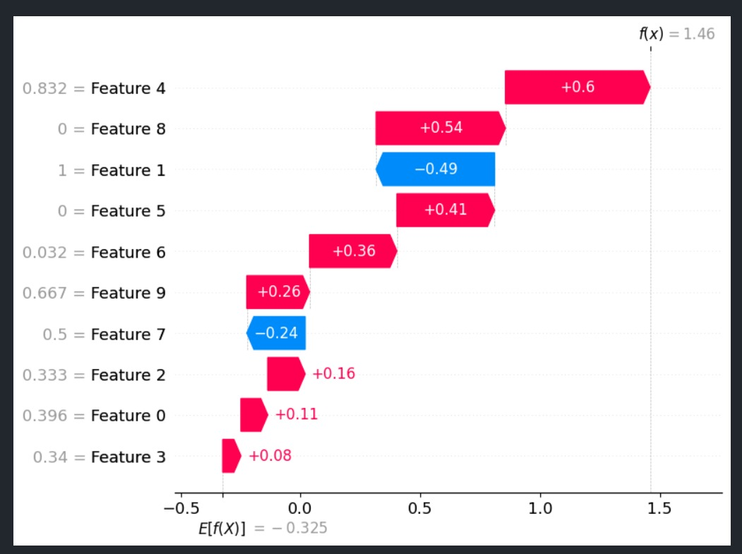

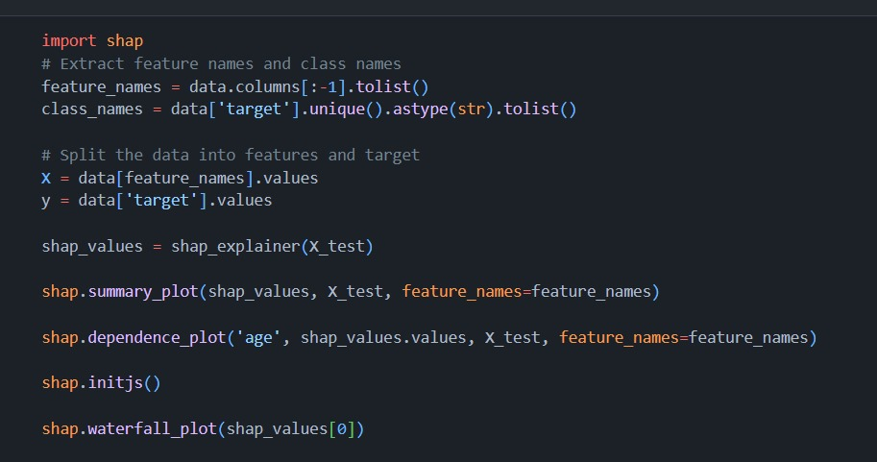

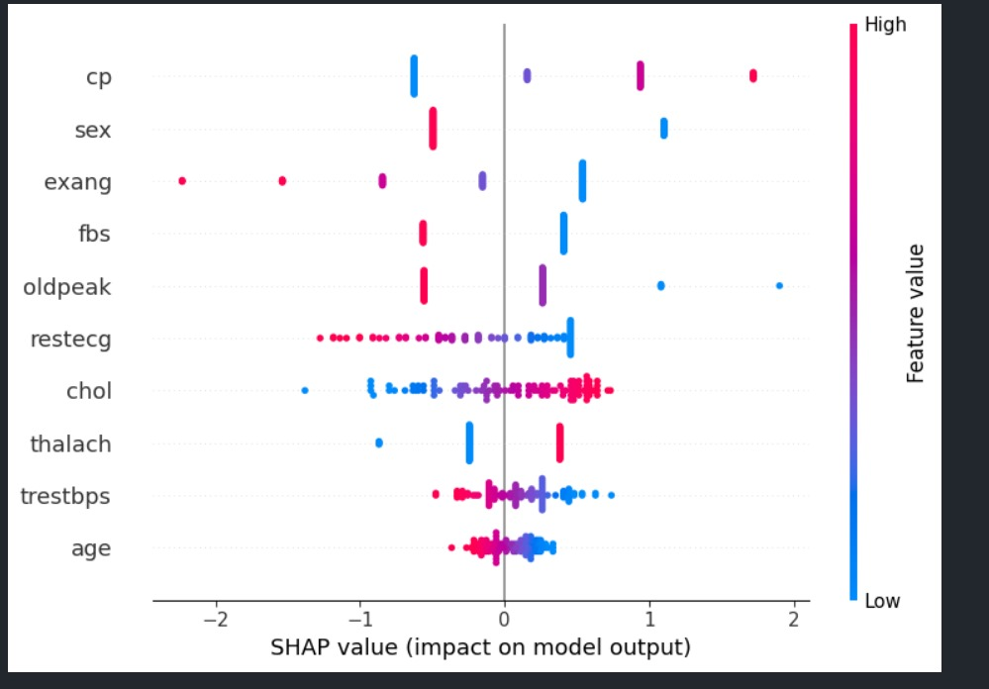

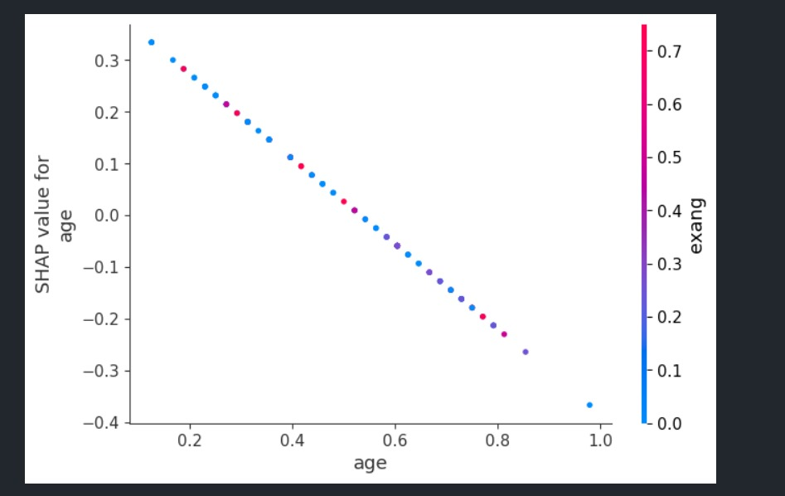

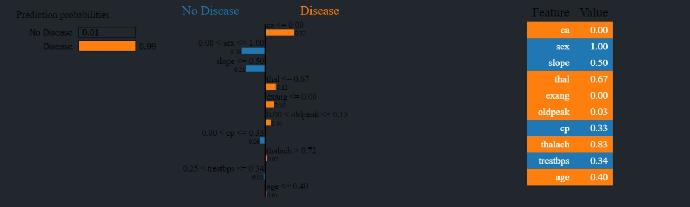

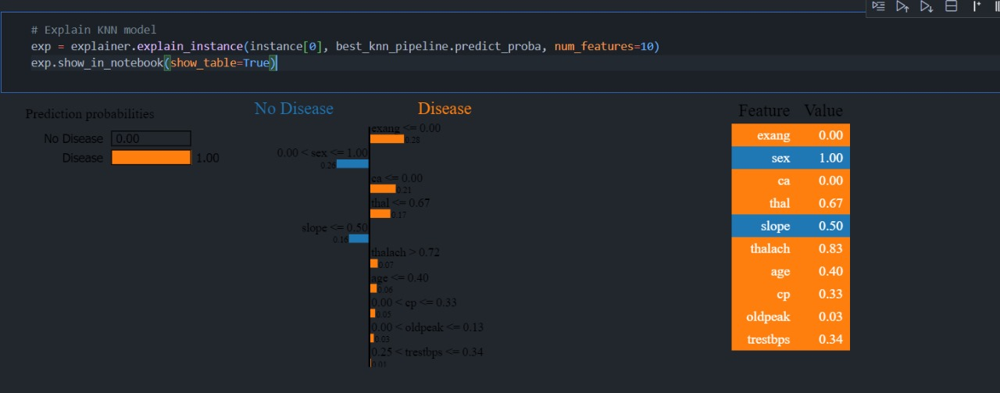

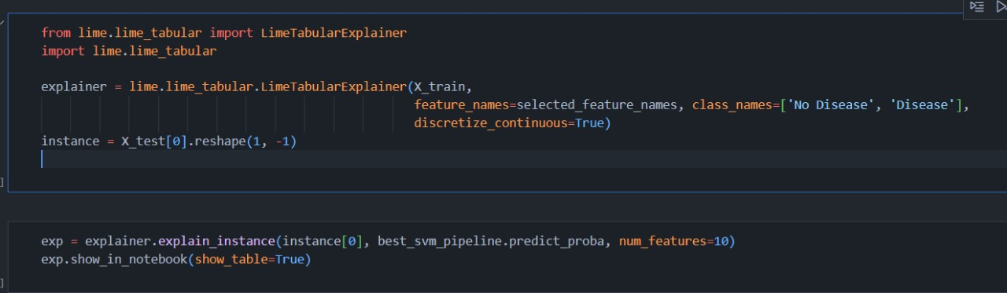

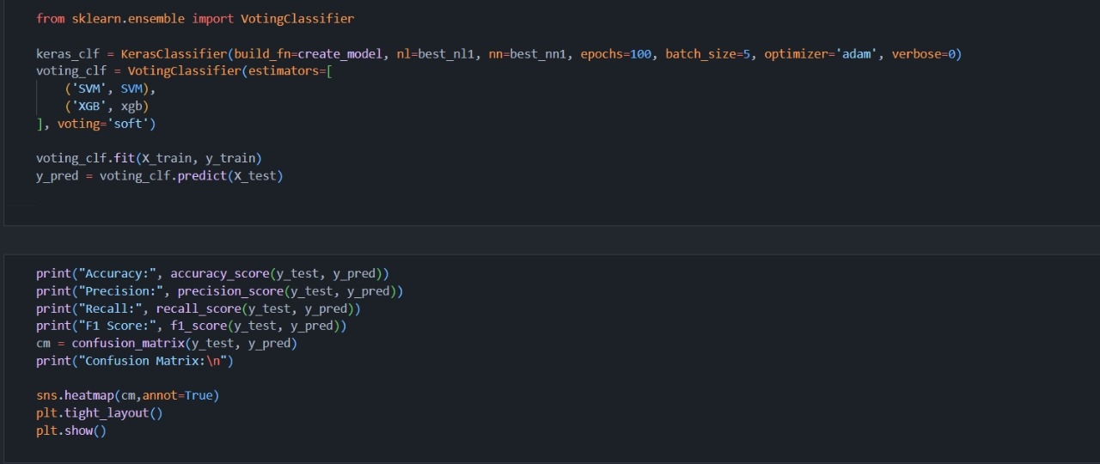

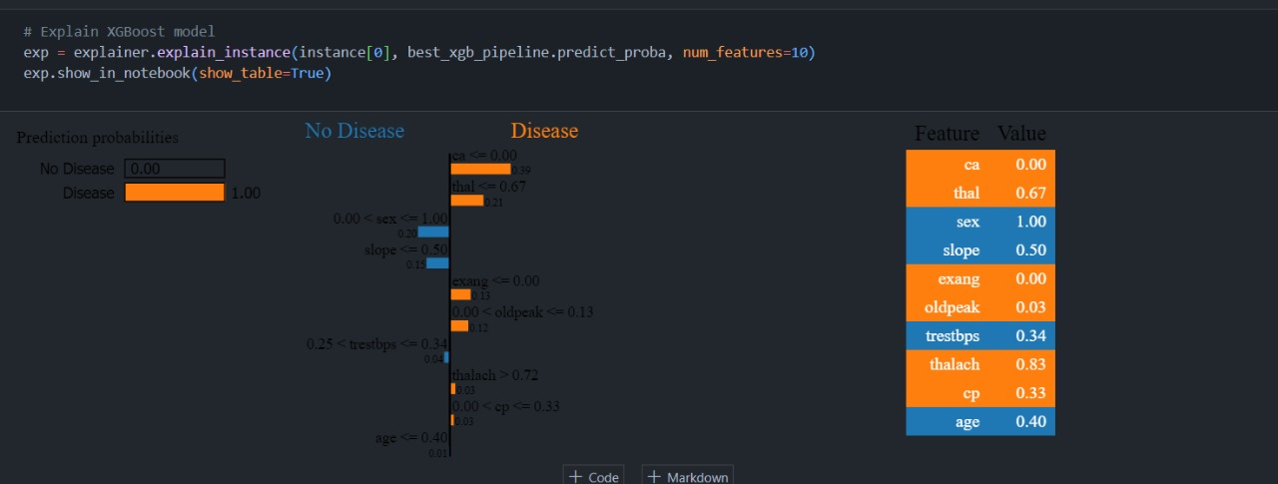

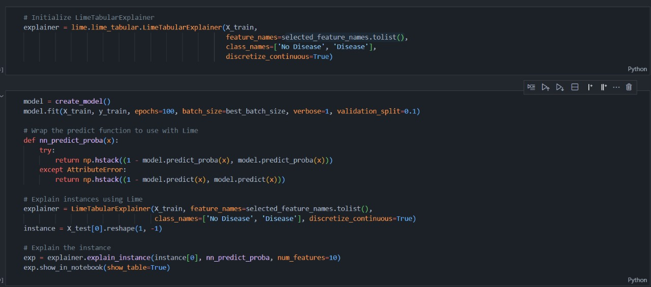

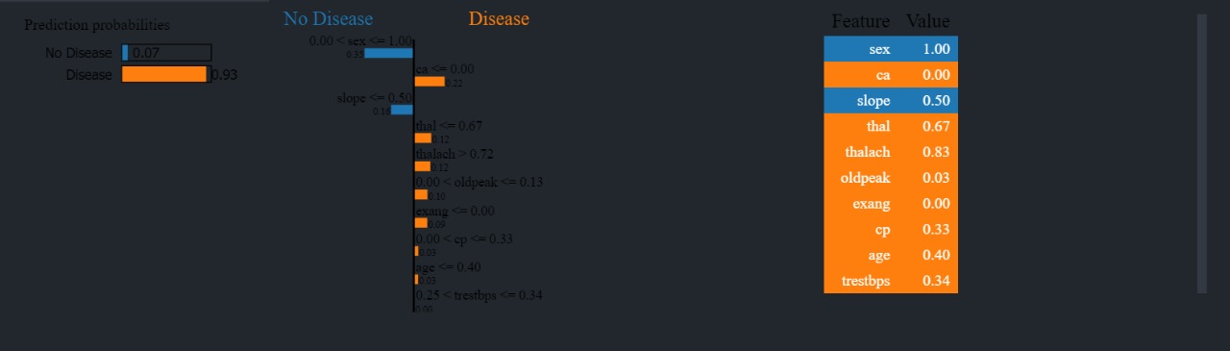

**Results and Discussion**

**The data science and machine learning part of the project entail the following steps:**

Data Preprocessing: The dataset containing heart disease-related data is loaded and preprocessed using pandas. Initial exploratory data analysis (EDA) is performed to understand the data's characteristics and structure. Visualization: Visualizations such as count plots, histograms, and heatmaps are generated using Matplotlib and Seaborn libraries to gain insights into the data and explore correlations. Model Building: Several machine learning models including Logistic Regression, Random Forest, XGBoost, K Neighbors, and Support Vector Machine (SVM) are trained and evaluated using techniques like validation curves and confusion matrices to determine the best-performing model. Model Evaluation: Model performance is evaluated using accuracy scores and confusion matrices to assess their predictive capabilities. Model Selection and Export: XGBoost is identified as the best-performing algorithm and is exported using joblib for integration into the Streamlit application.

**Streamlit Web Application:**

The Streamlit web application component enables users to interactively input their medical data and obtain predictions about the presence of heart disease.

**Key features of the application include:**

User Interface: The user interface is designed to be intuitive and user-friendly, allowing users to input parameters such as age, gender, cholesterol levels, and other relevant factors. Prediction: Upon user input, the application leverages the pre-trained XGBoost model to predict the likelihood of heart disease based on the provided data. Visual Feedback: Users receive visual feedback in the form of error or success messages, indicating whether they are likely to have a heart disease based on the input parameters.

**Conclusion and Future Work**

In this machine learning project, we have embarked on a journey to solve complex problems using a combination of **Explainable AI** and a diverse set of machine learning algorithms and we have talked about different interpretability techniques. The aim is to enlighten practitioners on the understandability and interpretability of explainable AI systems using a variety of techniques available which can be very advantageous in the health-care domain.

Medical diagnosis model is responsible for human life and we need to be confident enough to treat a patient as instructed by a black-box model. Our paper contains examples based on the heart disease dataset and elucidates on how the explain ability techniques should be preferred to create trustworthiness while using the systems in healthcare.

Explainable AI now a days has more merits than any other approach present. It makes the process easier, clear, uses less time and energy, and more effective. We harnessed the power of Explainable AI, which provides transparency and interpretability to our models.

By understanding how our models arrive at decisions, we can gain insights into feature importance, model behavior, and potential biases.

Machine Learning is a powerful technique that enables machines to perform tasks faster and often better than humans. Throughout this project, we’ve explored various aspects of machine learning.

**Algorithm Selection:** We experimented with various machine learning algorithms:

* **Logistic Regression**: A simple yet interpretable model.
* **Random Forests**: Ensemble of decision trees.
* **Support Vector Machines (SVM)**: Effective for non-linear data.
* **Neural Networks**: models for complex patterns.

**Hyperparameter Tuning:**

* Grid search and cross-validation helped optimize model hyperparameters.
* Regularization parameters, learning rates, and tree depths were fine-tuned.

**Model Evaluation:** **Metrics:**

* We evaluated models using common metrics:
* **Accuracy**: Overall correctness.
* **Precision**, **Recall**, and **F1-score**: Crucial for imbalanced datasets.
* **ROC-AUC**: Assessing model performance across different thresholds.

**Confusion Matrix:**

* Visualizing true positives, true negatives, false positives, and false negatives.

**Future work:**

The future work of a heart disease classification ML project could involve several aspects:

**1. Improving Accuracy:** Continuously refining the model to enhance its accuracy and reliability in diagnosing heart diseases.

**2. Feature Engineering:** Exploring additional relevant features or optimizing existing ones to capture more nuanced patterns in the data.

**3. Data Augmentation:** Expanding the dataset through techniques like data augmentation to diversify the training data and improve generalization.

**4. Model Interpretability:** Enhancing model interpretability to provide insights into the factors influencing predictions, aiding clinicians in understanding and trusting the model's outputs.

**5. Deployment and Integration:** Integrating the model into clinical workflows and healthcare systems to support real-time decision-making by healthcare professionals.

**6. Continuous Monitoring and Updating:** Implementing mechanisms for continuous monitoring of model performance and updating it with new data to ensure its relevance and effectiveness over time.

**7. Ethical Considerations:** Addressing ethical concerns related to data privacy, bias, and fairness to ensure the responsible and equitable use of the model in healthcare settings.

**8. Clinical Validation:** Conducting rigorous clinical validation studies to assess the model's performance in real-world healthcare settings and its impact on patient outcomes.

**9. User Interface Optimization:** Designing user-friendly interfaces for healthcare providers to interact with the model effectively and seamlessly integrate it into their practice.

**10. Collaboration and Stakeholder Engagement:** Collaborating with healthcare professionals, researchers, and regulatory bodies to garner feedback, address concerns, and ensure the successful adoption of the model in clinical practice.

**Unfortunately, the lack of time in this semester have negatively affected us, but we intend to complete this project completely in the next vacation, and we intend to complete the data base for this project so that it will be possible to record the diagnosis of each patient with his name and his ID, and health condition, and we will search for stronger data, because this data is few. It is not enough and caused us to have overfitting.**

**At the end,** Our heart disease classification model combines the power of machine learning algorithms, feature engineering, and interpretability. By leveraging domain knowledge and robust techniques, we contribute to early detection and better patient outcomes. Remember, every accurate prediction brings us closer to healthier hearts!

**References**

1. H. Niebling, “JetAdvice release Information | JetAdvice Updates,” *JetAdvice*, Mar. 25, 2020. https://www.jetadvice.com/support/release-information/
2. J. W. Johnson, “Automatic Nucleus Segmentation with Mask-RCNN,” *Advances in Intelligent Systems and Computing*, pp. 399–407, Apr. 2019, doi: 10.1007/978-3-030-17798-0_32.
3. N. Hou *et al.*, “Predicting 30-days mortality for MIMIC-III patients with sepsis-3: a machine learning approach using XGboost,” *Journal of Translational Medicine*, vol. 18, no. 1, Dec. 2020, doi: 10.1186/s12967-020-02620-5.
4. Azizozmen, “Heart_Failure_Predict_8_Classification_Techniques,” *Kaggle*, Oct. 20, 2021. https://www.kaggle.com/code/azizozmen/heart-failure-predict-8-classification-techniques
5. Arezoodahesh, “Heart failure prediction | With ensemble models,” *Kaggle*, Jul. 15, 2022. https://www.kaggle.com/code/arezoodahesh/heart-failure-prediction-with-ensemble-models
6. Pythonafroz, “Heart disease prediction using 11 algorithms,” *Kaggle*, Sep. 19, 2022. <https://www.kaggle.com/code/pythonafroz/heart-disease-prediction-using-11-algorithms/log>
7. E. Onose, “Explainability and Auditability in ML: Definitions, techniques, and tools,” *neptune.ai*, Aug. 17, 2023. https://neptune.ai/blog/explainability-auditability-ml-definitions-techniques-tools
8. “Topics | IBM.” https://www.ibm.com/topics/explainableai#:~:text=Explainable%20artificial%20intelligence%20(XAI)%20%20is,expected%20impact%20and%20potential%20biases
9. G. Visani, “Explainable machine learning - towards data science,” *Medium*, Dec. 23, 2021. [Online]. Available: https://towardsdatascience.com/explainable-machine-learning-9d1ca0547ae0
10. M. Mittal, K. Kumar, and S. Behal, “Deep learning approaches for detecting DDoS attacks: a systematic review,” *Soft Computing*, vol. 27, no. 18, pp. 13039–13075, Jan. 2022, doi: 10.1007/s00500-021-06608-1.
11. Diamond, “Predicting_Coronary_Heart_Disease_Using_an_Improved_LightGBM_Model_Performance_Analysis_and_Comparison,” *Scribd*. https://www.scribd.com/document/639816395/Predicting-Coronary-Heart-Disease-Using-an-Improved%20LightGBM-Model-Performance-Analysis-and-Comparison
12. “What is coronary heart disease? | NHLBI, NIH,” *NHLBI, NIH*, Dec. 20, 2023. https://www.nhlbi.nih.gov/health/coronary-heart-disease
13. “Annual heart failure costs in the US could surpass $70B by 2030,” *Cardiovascular Business*, Sep. 01, 2023. [Online]. Available: https://cardiovascularbusiness.com/topics/clinical/heart-failure/annual-heart-failure-costs-us-could-surpass-70b-2030

**Thank You**