 **Year 7 – Humanities and Social Sciences**

**A significant individual in an ancient society**

**Name: _______________________________**

**Date Due: ________________________**

|  |  |  |  |
| --- | --- | --- | --- |
| **Your Target** | **Mark** | **Percentage** | **Weighting (10%)** |
| **/20** | **/20** |  |  |

**Part A: Inquiry Process**

Investigate the life of a significant individual in an ancient society.

* Choose one individual from the list provided.
* Use the inquiry booklet to record your information.
* You will have three lessons to conduct your inquiry.
* Lastly, remember to include a bibliography. A range of references must be used.

**Part B: Constructing the display**

Present your findings as a museum display which will be conducted in class, in three lessons, using your inquiry booklet.

The museum display must include:

* The background of the significant individual (family background, early influences)
* The career of the significant individual (key events in their lives, methods used to achieve aims, relationships with other individuals and groups)
* Challenges to the individual presented by others
* Manner and impact of their death
* 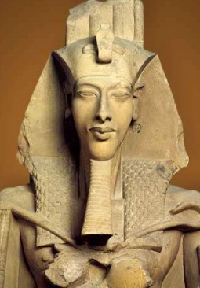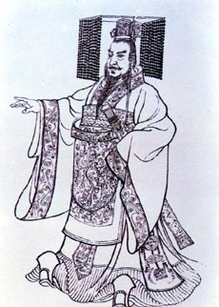The legacy of the significant individual (assessment of their life and career, ways they shaped or changed their society, their long-term impact and legacy).

1. **Choose a significant individual from the following list:**
2. Egypt – Akhenaten
3. Egypt – Rameses II
4. Egypt – Cleopatra
5. Egypt – Tutankhamen
6. 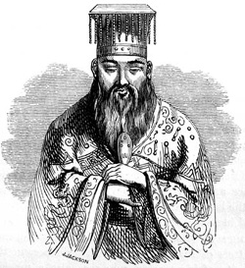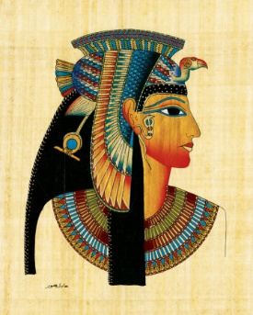China – Qin Shi Huang
7. China – Confucius
8. China – Hua Mulan
9. China – Genghis Khan

**Inquiry Process Booklet**

Which significant individual did you choose for this inquiry?

________________________________________________________

1. **Complete the KWL chart below**

|  |  |  |
| --- | --- | --- |
| K | W | L |
| What do you already **know** about the topic? | What do you **want** to know about the topic? | What have you **learned** about the topic? |
|  |  |  |

1. **Note taking sheet**

Focus Question 1

|  |
| --- |
|  |

Key points from information sources and reference details

|  |
| --- |
|  |

Focus Question 2

|  |
| --- |
|  |

Key points from information sources and reference details

|  |
| --- |
|  |

Focus Question 3

|  |
| --- |
|  |

Key points from information sources and reference details

|  |
| --- |
|  |

Focus Question 4

|  |
| --- |
|  |

Key points from information sources and reference details

|  |
| --- |
|  |

Focus Question 5

|  |
| --- |
|  |

Key points from information sources and reference details

|  |
| --- |
|  |