 NAME:_­­­­­­________________ Target: ____/44 or ____ % 👍 👎

**Year 7 HASS**

**/44**

**(Water in the World In-class Task)**

In-class Test - Task 2 (10%)

**Instructions: 45 minutes Working Time and 5 minutes Reading Time, Test conditions apply.**

**Section 1: Please circle the correct response. (12 marks)**

1. What form of precipitation is the most common in Australia?
2. Rain
3. Hail
4. Sleet
5. Snow
6. What does the ‘E’ in SPICESS stand for?
7. Empathy
8. Economic
9. Environment
10. Exception
11. Which of the following is not a renewable resource?
12. Solar
13. Wind
14. Coal
15. Hydroelectricity
16. Evaporation, precipitation and condensation make up the _____________________.
17. Ecosystem
18. Lake effect
19. Weather pattern
20. Water cycle
21. The water cycle is driven by the:
22. Moon
23. Clouds
24. Oceans
25. Sun
26. When water evaporates directly from plants, it’s called:
27. Condensation
28. Sublimation
29. Transpiration
30. Precipitation
31. In which continent is water scarcity a major issue?
32. Europe
33. Africa
34. Antarctica
35. Asia
36. During evaporation water goes from a _________________ to a ___________________.
37. Solid, gas
38. Liquid, gas
39. Liquid, solid
40. Liquid, plasma
41. What is the acronym used to remember the processes in the Water Cycle?
42. SPICESS
43. SHEEPT
44. BOLTSS
45. PERTIC
46. When water is said to enter the ground, the process is known as
47. Condensation
48. Infiltration
49. Transpiration
50. Evapo-transpiration
51. The name given to freshwater running underground is called…
52. Aquifers
53. Creeks
54. Streams
55. Rivers
56. Which of the following is a contributing factor to the issue of Water Scarcity?
57. Lack of rainfall
58. Rapid population growth
59. Urbanisation

**End of Section One**

1. All of the above

**Section 2: (32 marks)**

1. Differentiate between renewable and non-renewable resources and provide examples to support your response.

(4 marks)

_______________________________________________________________________________

_______________________________________________________________________________

_______________________________________________________________________________

_______________________________________________________________________________

_______________________________________________________________________________

_______________________________________________________________________________

1. Categorise the list of resources below into the correct category. (2 marks)

|  |  |  |  |
| --- | --- | --- | --- |
| *Coal* | *Tides* | *Fresh Air* | *Oil* |
| *Solar* | *Plants and Animals* | *Natural Gas* | *Wind* |

|  |  |  |
| --- | --- | --- |
| Renewable | Non-Renewable | Continuous |
|  |  |  |

1. List four uses of water. (2 marks)

* ___________________________________________________________
* ___________________________________________________________
* ___________________________________________________________
* ___________________________________________________________

1. Explain one example of where water is misused. (2 marks)

_______________________________________________________________________________

______________________________________________________________________________________________________________________________________________________________

1. Outline two examples of sustainable water strategies for the area you researched on your inquiry task . (4 marks)
2. ________________________________________________________________________________________________________________________________________________________
3. _______________________________________________________________________________­­­­­­­­­­­­­­­­­­­­­­_________________________________________________________________________
4. Define the term ‘water footprint’. (2 marks)

_______________________________________________________________________________

_______________________________________________________________________________

_______________________________________________________________________________

1. List an advantage and disadvantage of ground water. (2 marks)

Advantage

_______________________________________________________________________________

_______________________________________________________________________________

Disadvantage

_______________________________________________________________________________

_______________________________________________________________________________

1. a) List the 3 types of rainfall: (3 marks)
2. _________________________________________________________________
3. _________________________________________________________________
4. 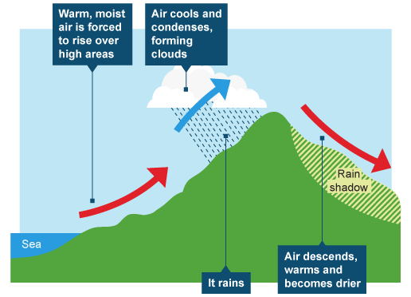_________________________________________________________________

b) Referring to the diagram below – which type of rainfall is depicted? (1 mark)

_______________________________________

1. a) Label the diagram of the water cycle with following processes. (5 marks)

• Evaporation

• Transpiration

• Condensation

• Precipitation

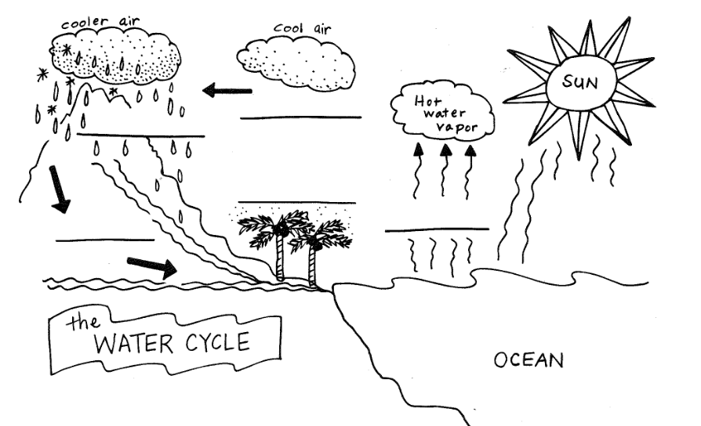• Run Off

1. Which part of PERTIC is missing from the diagram above? (1 Mark)

______________________________________________________________________________

1. Explain the term water scarcity and provide an example (4 marks)

_______________________________________________________________________________

_______________________________________________________________________________

_______________________________________________________________________________

_______________________________________________________________________________

_______________________________________________________________________________

______________________________________________________________________________________________________________________________________________________________

_______________________________________________________________________________

_______________________________________________________________________________

_______________________________________________________________________________

**End of test**