Egyptian Mummification Practices

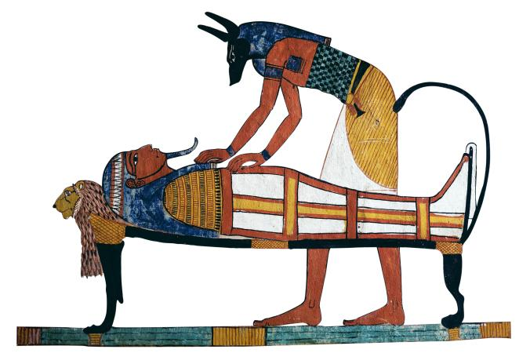

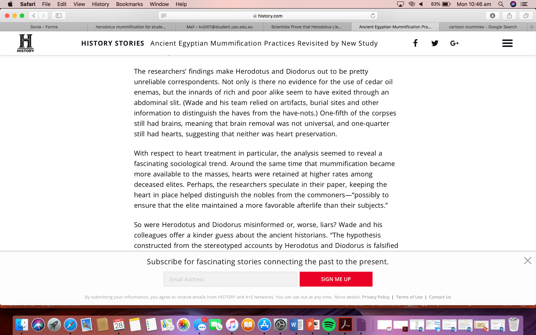Herodotus was the one of the first historians to document the embalming and mummification practices of Ancient Egypt. Modern research has shown that Herodotus’s accounts of mummification practices were not accurate.

Source: <https://www.history.com/news/ancient-egyptian-mummification-practices-revisited-by-new-study>  
  
**Questions**

1. What did Herodotus document about mummification practices?
2. What does this source tell us about mummification practices? Is it the same information as Herodotus’s account?
3. Is this source reliable? Why or why not?
4. Is this source a primary or secondary source? Explain your answer.
5. Is this source literary or non-literary?