Chapter 10: Investigating Medieval Europe

# Chapter overview

The period from the fall of Rome until about 1500 is called the Middle Ages or the medieval period. At the time, Europe consisted of many small countries ruled by kings in a feudal system, and there was a strict hierarchy of power and influence. It was a time of conflict and warfare, so knights and their lords held an important place in society. The Church was very powerful and played a vital role in all aspects of people’s lives. European countries sent warriors to the Middle East to gain Christian control of Jerusalem and the Holy Land. There was little scientific knowledge and superstition was rife. Justice was arbitrary and punishments were harsh. Developments that took place included the first steps towards parliamentary democracy and the growth of trade.

## Syllabus links

|  |  |  |
| --- | --- | --- |
| **Knowledge and understanding** | **Humanities and Social Sciences skills** | **General capabilities** |
| **Depth study 1: Investigating medieval Europe (c. 590 –c. 1500)**  The way of life in medieval Europe (e.g. social, cultural, economic and political features) and the roles and relationships of different groups in society  Significant developments and/or cultural achievements, such as changing relations between Islam and the West (including the Crusades), architecture, medieval manuscripts and music  Continuity and change in society in one of the following areas: crime and punishment; military and defence systems; towns, cities and commerce  The role of significant individuals in the medieval period (e.g. Charlemagne) | **Questioning and researching**  Identify current understandings to consider possible gaps and/or misconceptions, new knowledge needed and challenges to personal perspectives  Use a variety of methods to collect relevant information and/or data from a range of appropriate sources, such as print, digital, audio, visual and fieldwork  Select the best method for recording selected information and/or data (e.g. graphic organisers, such as structured overviews for classifying; mind maps, for identifying relationships and overviews; fieldwork, which may require sketch drawings, a list of observable features and photographs)  **Analysing**  Identify points of view/perspectives, attitudes and/or values in information and/or data (e.g. from tables, statistics, graphs, models, cartoons, maps, timelines)  Translate information and/or data from one format to another (e.g. from a table to a graph)  Apply subject-specific skills and concepts in familiar and new situations  **Communicating and reflecting**  Represent information and/or data using appropriate formats to suit audience and purpose (e.g. tables/graphs, visual displays, models, timelines, maps, other graphic organisers)  Develop texts, particularly descriptions and explanations, using appropriate subject-specific terminology and concepts that use evidence to support findings, conclusions and/or arguments, from a range of sources | Critical and creative thinking  Personal and social capability  Ethical understanding  Intercultural understanding |

## Key concepts/terms

Black Death—type of bubonic plague that spread throughout Europe and

Asia in the fourteenth century and is estimated to have killed a quarter of the population of Europe

citadel—fortress that is usually on high ground above a city

concentric—circles or other shapes with a common centre

epidemic—widespread infectious disease affecting many people in the same area at the same time and often spreading very quickly

expansionism—policy of territorial growth by a state

guilds—an organisation of craftsmen and merchants that set standards of work and protected its members

legacy—something handed down from the past

stagnation—state of inactivity

## Getting started

### Using the image

Students refer to Source 10.0.1 and answer the following question.

Imagine you are a traveller during the Middle Ages, approaching this citadel on foot for the first time. Describe everything you would have seen.

*A castle-like structure on a high hill. It has high and continuous walls, small windows and towers, and looks as if it would be difficult to attack. It is an imposing sight.*

**Medieval videos**

There are a number of YouTube clips that would make an interesting start to the Middle Ages topic. These can easily be found by using search terms such as ‘medieval period’ or ‘Middle Ages’. Present several clips to the class and ask students to brainstorm questions they have as a result of watching the clips. These questions could form the basis of an introductory class discussion about the Middle Ages. In pairs or small groups, students could then create a PMI (Plus, Minus, Interesting) table about the medieval period.

## Interconnections

Students can reflect on the significance of the Magna Carta and the development of parliament (Unit 10.3) to democracy in Australia. Refer to Chapter 1 ‘Democracy in action’ to review information.

Crime and punishment (discussed in Unit 10.3) can be compared and contrasted with crime and punishment today in Australia by referring to Chapter 2 ‘Law in action’.

# 10.1 The medieval European world

## Learning strategies

### Europe now and then

Students examine Source 10.1.1. Using an atlas or internet maps, students find out which modern countries now occupy the territory shown on the map of medieval Europe.

*The main countries that should be included are:*

* *Roman Empire: Germany, France, Italy, Switzerland*
* *Kingdom of Castile: Spain*
* *Kingdom of Aragon: Spain*
* *Domain of the Angevins: England, France*
* *Kingdom of Sicily: Italy*
* *Kingdom of Hungary: Hungary, Slovakia, Croatia*
* *Byzantine Empire: Greece, Turkey*
* *Dominions of Saladin: Syria, Egypt, Israel.*

## Activity answers

### Remembering and understanding

**1** Ways in which Europe grew strong again during the High Middle Ages could include three points from the following list:

* increased agricultural production because of new farming techniques
* growing population
* expanding territories
* development of towns
* expanding trade.

**2** The key social groups in medieval society were kings and nobles, clergy, townsfolk and peasants.

### Applying and analysing

**3** The hypotheses of the circumstances in which wealthy lords needed to rely on the feudal bond to raise an army could include:

* lords needed knights to fight for them when they led an invasion to gain territory
* lords needed to rely on the feudal bond that they had with knights in order to protect their property and lands from attack by another lord.

**4** Student answers will vary. A sample answer is provided.

Knights were involved in a feudal bond with other lords higher up the social ladder, and these promises relied on virtues such as loyalty and honour in order to make those relationships work. Knights were also trained warriors and needed to have their aggression under control. As warriors they promised to protect the weak—including women— during this period. Chivalric virtues guided behaviour.

### Evaluating and creating

**5** Student answers will vary. A sample answer is provided.

Some ways to make male medieval society less rigid would be:

* Increase the freedom of the ‘villeins’ by abolishing the need for them to seek permission from their lords for moving away, marriage or hunting.
* Abolish the bond between serfs and lords, meaning all peasants could be freeborn and own land.
* Decrease the power of the clergy so the divide between the clergy and ordinary citizens would be reduced.
* Make knights swear allegiance to the king rather than their lord, reducing the power of individual lords

# 10.2 Everyday life

## Learning strategies

### The life of a peasant

Students undertake a brief research task on the internet to answer the questions below. Search terms could include ‘medieval serfs’, ‘peasants in the Middle Ages’, ‘peasant women in the Middle Ages’ and ‘women serfs’.

**1** What jobs did male peasants do?

Peasants farmed their allocated strips of land to provide for their families and cared for any animals they owned. They had to perform unpaid work on the lord’s land.

**2** What rights did male serfs have?

Male serfs had no rights and were owned by their lord. They were not allowed to leave his property. They needed the lord’s permission to marry.

**3** What obligations did male peasants have to their lord?

As well as working on the lord’s property, sometimes doing building as well as farming work, they had to pay taxes to the lord, generally in wheat. They could also be conscripted into military service for their lord if he went into battle.

**4** What jobs did peasant women do?

Peasant women helped their husbands or fathers with the farming. They also collected firewood, carried water from wells, gathered wild foods, made and repaired clothing, cooked food, cleaned the house, washed clothes and cared for children.

**5** What rights did women have?

Women had no rights and their views were generally disregarded.

**6** At what age were women generally married?

Women were married very young and were regarded as the property of their husbands.

**7** What were their chances of dying during childbirth?

Approximately 20 per cent of medieval women died in childbirth, while 15 per cent of babies died in their first month of life.

**8** As a class, students could consider the following question: Would you have preferred to be a male or female peasant during the Middle Ages?

Student answers will vary.

### Noble or now?

Students read the paragraphs on ‘Housing’ and ‘Food’ and look at Sources 10.2.1, 10.2.3 and 10.2.4.

In groups, they discuss whether they would prefer to be a nobleman or noblewoman in medieval times, or to live as they do today. Students should refer to evidence from these sources in their discussion. Each group could report briefly to the class, and then students could vote by a show of hands to find the prevailing class view.

### Good works of the Church: then and now

Students read the sections entitled ‘The Church’ and ‘Monasteries and nunneries’ and conduct some brief further research. In groups, they discuss what aspects of the good work done by the Church in medieval times are still done by Australian churches today, and answer the following questions: Have things changed? How have they changed?

*Aspects that are much the same: students would be aware of Church schools, but might not be aware of hospitals and universities that are affiliated with a church. Church charitable works both in Australia and overseas could also be identified.*

*Aspects that have changed: organisations other than the Christian churches now play a greater role in providing charity. For instance, government plays a huge role today and there are many secular charities. Some schools and universities, and a lot of hospitals and nursing homes, are run as commercial enterprises. The provision of meals and accommodation for travellers has been almost completely taken over by the private sector.*

## Activity answers

### Remembering and understanding

**1** Three kinds of work that women could do in medieval society:

* spinning
* weaving
* working in the fields.

**2** Medieval farming was based on the open-field system. Large areas of common land were divided into three fields and crops were rotated. Livestock grazed on the third field and provided fertiliser. This ensured that there was always a crop to be harvested.

**3** Three reasons why people travelled in the medieval period:

* religious reasons—pilgrimage
* study at universities
* trade.

### Applying and analysing

**4** Student answers will vary. Students might devise a menu of several courses. Sweet and savoury dishes were usually served in any order (that is, there was no concept of serving savoury foods then finishing with a sweet dessert as in modern times).

**5** Student answers will vary. A sample answer is provided.

The Church provided a unifying culture in Europe. Celebrations within the Church year such as Lent, Easter, Pentecost, Advent and Christmas dominated life and brought people together. Church sacraments such as baptism and marriage were important to families. The Church provided education, and promised salvation and a life after death in Heaven.

### Evaluating and creating

**6** Student answers will vary. A sample answer is provided.

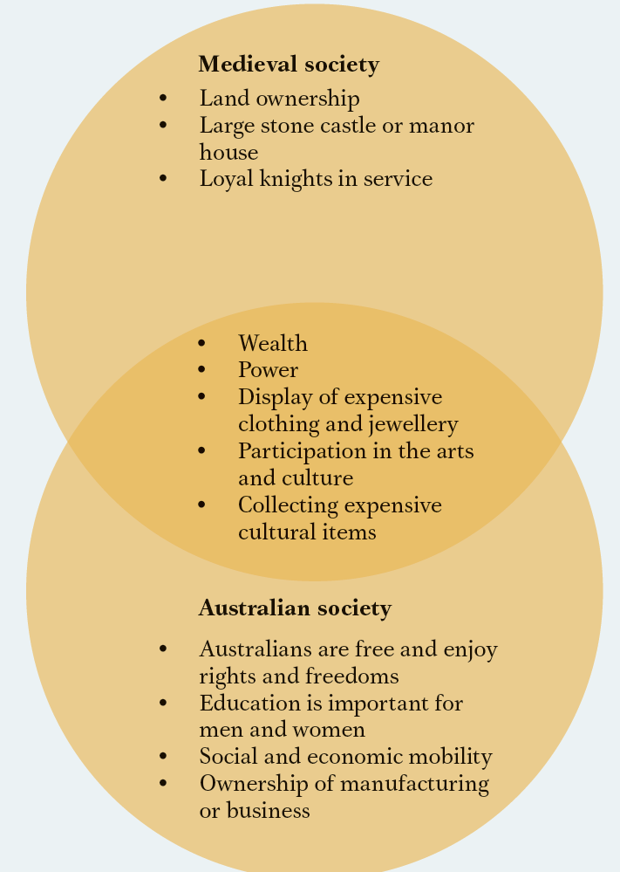

# 10.3 The Crusades

## Learning strategies

### Richard the Lionheart PMI

Students conduct research on the leader of the Third Crusade, Richard the Lionheart. Students should note the important points about Richard’s roles as king of England and Crusader and chart them on a PMI (Plus, Minus, Interesting) table. Students should consider both European and Islamic perspectives.

*Student answers will vary. A sample answer is provided.*

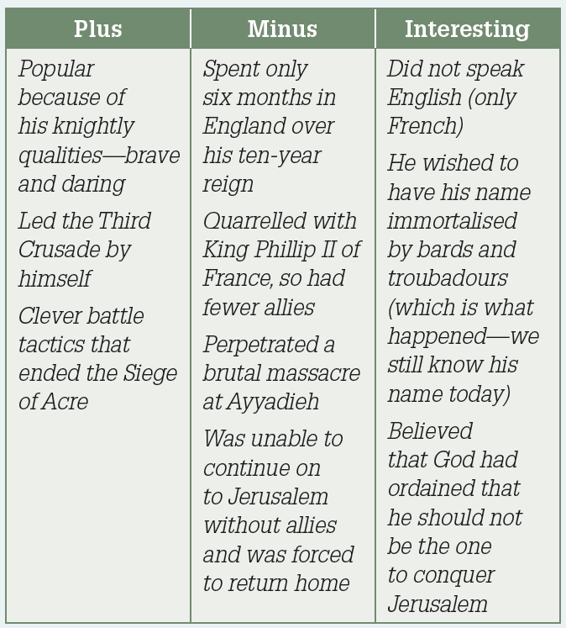

### Crusade leaders in the hotseat

In pairs, students research one of the Crusades, either of their choosing, or as allocated by the teacher. Their research should cover the following aspects:

* causes of the Crusade
* who led the Crusade
* the aim of the Crusade
* the strategy
* how successful the Crusade was
* its effects
* what, if anything, should have been done differently.

Each pair is placed in the ‘hot seat’ as the leaders of the Crusade to answer questions from the class.

*Student answers will vary. Some suggestions for ‘hot-seat’ questions follow:*

* *Why did you choose to go on Crusade?*
* *How did you feel when you reached the Holy Land?*
* *Did your Crusade succeed or fail?*
* *How do you account for your success/failure?*

This task allows students to further explore the short-term and long-term impacts of the Crusades.

### Consequences of the crusades

Students research the impact of the Crusades in Europe and on the Islamic world in the library or on the internet. They should present their findings in a visual form, for example as a concept map or a flow chart.

*Student answers will vary, but could include the following points.*

* *The Crusades probably had more impact on the European world than the Islamic world.*
* *Ancient Greek scholarship, which had been preserved by Arabic scholars, became more available to Christian scholars.*
* *Systems of taxation (originally to finance the Crusades) were developed in Europe.*
* *The Church became wealthier as Crusaders often sold their estates to the Church prior to setting out, often at a lower rate than the estate’s real value.*
* *Feudalism was weakened, partly because estates were sold and partly because many Crusaders died and their property reverted to the Crown.*
* *Trade increased in some cities to meet the needs of the Crusaders.*
* *The Holy Land eventually reverted to Muslim control.*
* *Castle design in both Europe and the East improved.*

## Activity answers

### Remembering and understanding

**1** Spain was under Muslim control in the medieval period.

**2** Muslim learning and culture brought medicine, science, mathematics and technological knowledge to Europe.

**3** The holy wars against Islam occurred because:

* the Church did not want Jerusalem to be in the hands of non-believers
* pilgrimages to Jerusalem were accepted as penance for sins
* the noblemen of Europe wanted to find new opportunities for land and wealth.

**4** Saladin was a well-known warrior and leader in the Muslim world. He was involved in the Third Crusade.

### Applying and analysing

**5** The Europeans gained territory and wealth because they were able to establish feudal kingdoms in the Holy Land. However, it was at a great cost because they were always trying to consolidate their kingdoms and they were always under attack.

**6** Student answers will vary. A sample answer is provided.

The first Crusaders found it easy because the tribes and communities in the Holy Land were not united and were squabbling over territory themselves. The Crusaders were able to capture cities such as Antioch easily because the locals were unprepared as well.

**7** To regain their lands, the Muslims needed to build a large enough army to defeat the Crusaders. In order to do this, Saladin had to prove to the Muslim warriors that he was a real leader.

### Evaluating and creating

**8** Student answers will vary. A sample answer is provided.

Both religious orders of monks were trained as warriors and both lived in the Holy Land. The Knights Templar were given the task of defending pilgrims and knights in the Holy Land. The Hospitallers cared for the sick pilgrims and knights.

# 10.4 Medieval achievements

## Learning strategies

### Looks like ... a cathedral!

Show students one or more video clips of Notre Dame Cathedral. (YouTube has clips with pictures and music—search using the terms ‘notre dame organ music’.)

Divide the whiteboard into four quadrants. The main heading is ‘What is it like to be inside a medieval cathedral?’ Label the quadrants ‘Looks like’, ‘Sounds like’, Smells like’ and ‘Feels like’. Students try to imagine what it would be like to go into a medieval cathedral such as Notre Dame.

A class discussion is held as students brainstorm responses to the four statements.

*Student answers will vary. A sample answer is provided.*

*There is a church service in progress. The organ is playing. Someone in robes is singing out the front, near the altar. There is the smell of incense in the air. People are sitting, hushed and reverent, in the pews. The lighting inside is dim, but the daylight outside shines brightly through the stained-glass windows. The ceiling is high up above the people.*

### Universities then and now

Students read the section entitled ‘Knowledge and universities’ and conduct some brief further research. In groups, they discuss what aspects of universities are the same today, and what aspects are different?

*Aspects that are much the same:*

* *universities are more important centres of learning than monasteries*
* *logical analysis is an important skill that is developed during a university education*
* *different universities are renowned for certain subjects*
* *common features of university life, such as lectures, exams, degrees, students, academic teachers and researchers*

*Aspects that are different:*

* *educational studies were divided into seven liberal arts (today’s universities offer a much wider number of subject areas)*
* *women were not permitted to attend universities or teach there*
* *universities are usually funded through governments and students paying fees, rather than kings and princes*

## Activity answers

### Remembering and understanding

**1** The invention of the printing press revolutionised learning and the spread of information, as texts could be mass produced. The use of metal letters improved the quality and consistency of the printing.

**2** The Magna Carta reduced the power of the king, making him subject to the law.

**3** Identification of architectural features of Gothic cathedrals may include:

* soaring or high towers
* spires
* flying buttresses
* high vaulted ceilings
* stained-glass windows.

**4** Student answers will vary. A sample answer is provided.

Manuscripts were made out of vellum or parchment, which was fine lamb- or calfskin. Codices were books of many pages of vellum. Manuscripts were produced initially in monasteries, and the text and illuminations or illustrations were hand-drawn. Codices included the Gospels, prayers and psalms from the Bible. Manuscripts were also used to record property deeds and laws.

### Applying and analysing

**5** Student answers will vary.

**6** Student answers will vary, but could include the following gothic features:

* pointed arches
* flying buttresses
* tall towers
* spires
* minimal walls
* stained glass windows
* silver and gold ornaments

### Evaluating and creating

**7** Student answers will vary. A sample answer is provided.

Like today, people enjoyed listening to music for entertainment. Lords would hire travelling minstrels to perform at feasts to entertain their guests and to show off their wealth.

**8** Student answers will vary but could include the following features:

* handwritten texts
* decorative initials
* borders
* miniature illustrations (possibly including dogs, a symbol of faith)
* gold and silver decoration

**9** Student answers will vary but could include the following ideas.

* Mary of Burgundy sits in the foreground reading from a psalter with a dog on her lap.
* She is richly dressed and there are some jewellery pieces on a table and a vase of lilies.
* She is sitting in front of an open window.
* Through the window you can see a noble lady and her ladies and a nobleman kneeling before the Virgin Mary.
* There are angels on the floor and the Virgin has Christ as a baby on her lap.
* They are all in a Gothic cathedral and in the background there are two men talking.

Interpretation: Mary is in her chamber reading from her prayer book. The window reveals an imagined scene. She is in the midst of contemplation or meditation and is imagining herself in front of the Virgin Mary.

# 10.5 Crime and punishment

## Learning strategies

### The execution of the Despensers

Students examine Source 10.5.2 and answer the following questions.

**1** Is this a primary or a secondary source? How do you know?

This is a secondary source as it was created after the event.

**2** What aspects of medieval punishment are shown in this picture?

The use of the gallows to hang people, in a public place. It is likely that the bodies would have been left there as a deterrent to others. The blindfolds were used so that the victims could not see the sword coming and move, which would make the beheading more difficult.

**3** Why do you think these forms of punishment are not used in modern democracies today?

These forms of punishment violate a range of human rights. They are brutal and inhumane.

## Activity answers

### Remembering and understanding

**1** Justice was carried out:

* according to local customary laws
* according to ‘common law’, which applied to everyone
* through Acts of Parliament
* through trial by ordeal.

**2** Different types of punishment included:

* hanging
* beheading and disembowelling
* cutting off limbs
* imprisonment
* burning at the stake.

### Applying and analysing

**3** Student answers will vary. A sample answer is provided.

Punishment during the medieval period was about deterrence. If people witnessed the horrible consequences, it was believed that they would be less inclined to commit a crime themselves.

**4** Student answers will vary. A sample answer is provided.

Courtrooms today generally include only one judge. The prisoners in the medieval scene are bound with shackles at the ankles. Prisoners today have handcuffs, or no restraint if they are not considered to be a threat. People on trial in court today are not usually shackled. Today, as in the medieval period, there is a table in front of the judge for the lawyers.

### Evaluating and creating

**5** Student answers will vary, but could include the following arguments:

* the ordeals that people are subjected to cannot be withstood by anyone, regardless of whether they are innocent or guilty
* the system of trial by ordeals is old-fashioned and needs modernising
* the system of trial by ordeals is not rational – introducing a system of trial by judge or jurors will ensure decisions are reached using logical analysis of the facts.

# 10.6 Military and defence systems

## Learning strategies

### Devising a war strategy

In pairs, or groups of up to four, students research medieval siege warfare in the library or on the internet and do one of the following activities. You are part of the advisory group to a baron who is besieging the castle of an earl. It is your job to devise a siege strategy to enable your army to take the castle successfully as quickly as possible before the earl’s allies arrive and encircle your army and you are all trapped.

*OR*

You are part of the advisory group to the earl who rules the castle that is being besieged. It is your job to devise a defensive strategy that will allow your earl to hold the castle for as long as possible so that his allies can come to his aid. For either scenario, your group must create the following to complete the task properly:

* a written report that outlines your strategy
* accompanying diagrams to support your strategy
* at least one three-dimensional model that details your strategy (for example, a model of the castle or the area of it that you wish to attack/defend, the surrounding terrain or a siege engine)
* one or two concluding paragraphs explaining the reasoning behind the strategy your group has devised
* a bibliography.

Students could use search terms such as ‘medieval siege warfare’, ‘medieval siege tactics’ and ‘famous medieval sieges’ to help them with their research.

The teacher may decide to have each group present their report and models to the class and have the class peer review each group’s work.

## Activity answers

### Remembering and understanding

**1** Ways in which castle defences changed over time:

* the main building material shifted from timber to stone.
* round towers replaced square towers
* an extra wall was built around an existing wall
* drawbridges were added
* crenellations were added to walls
* moats were added or made deeper and wider.

**2** Castles were important defence systems for wealthy lords. Castles could protect the lord’s family and his possessions. The lord’s peasants could also shelter in the castle during times of attack.

### Applying and analysing

**3** Student answers will vary. A sample answer is provided.

The soldiers in Source 10.6.3 are shown attacking a castle; others are shown defending it. Some soldiers are archers, with longbows and crossbows. The castle in 10.6.1 provides the fantasy backdrop for a meeting between lovers.

**4** Student answers will vary but should include the key developments noted in the suggested answer to question 1.

### Evaluating and creating

**5** Student answers will vary. A sample answer is provided.

I would include the following features:

* round towers to make it hard for intruders to scale the walls
* concentric rings of ditches and walls to make unwanted entry hard
* a motte to allow a good view of the surrounding area and potential invaders
* a moat to add an extra barrier to defences – not all intruders will be able to swim.
* a drawbridge to prevent access to the main castle building

**6** Student answers will vary. A sample answer is provided.

If I were a medieval invader, my strategy would be for the castle to be surrounded so no supplies could enter the castle. This strategy would include blocking the long stairway from the castle to the cliff base, preventing supplies being brought in to the castle from the sea. Once the supplies in the castle had been depleted and the people inside weakened, I and my fellow soldiers would launch an attack from all angles, including the path from the sea.

# 10.7 Towns, cities and commerce

## Learning strategies

### Preferred town: Modern or medieval?

Students read the paragraphs on ‘Ownership and security’ and ‘Houses and streets’. In groups, they discuss whether they would prefer to live in a town in medieval times, or to live in modern town.

Students should refer to evidence from the text in their discussion. Each group could report briefly to the class, and then students could vote by a show of hands to find the prevailing class view. This activity will greatly assist students to do activity 5 at the end of this unit.

### London: A changing city

Students examine Source 10.7.4. Using an atlas or internet maps, students consider:

**1** How has this part of London changed since1593?

Student answers will vary but could include:

* *South of the River Thames, rural land has become densely populated with buildings*
* *North of the River Thames, the urban sprawl has extended in all directions*
* *Train lines and underground lines have been added (in 1593 there were just roads)*
* *There are more bridges across the Thames.*

**2** How have city maps changed since 1593?

Student answers will vary but could include:

* *they no longer include guild emblems (but city maps for tourists may include adverts for tourist attractions)*
* *they are not usually hand-drawn, but computer generated*
* *the scale does not have Latin text or a compass image (and distance on Australian city maps would be given in kilometres)*
* *they do not usually have all the houses drawn on them (just key buildings).*

## Activity answers

### Remembering and understanding

**1** A guild was an organisation of people who joined together because they made or sold the same type of goods.

**2** London grew to be the largest city in England for the following reasons:

* political: the Normans established their seat of government there in 1066
* economic: it was the main port through which goods passed between Europe and the rest of England, and as a result was a hub for merchants and craftsmen
* religious: it was the site of Westminster Abbey, one of England’s largest cathedrals and place where English kings and queens had their coronations.

**3** The walls were designed to keep towns secure by controlling the entry and exit of large numbers of people. The gates were locked at night and curfews introduced for greater security.

**4** The town crier made important announcements to town residents such as the news and calling people to meetings. He also told people the time and warned them of fires.

### Applying and analysing

**5** Student answers will vary. A sample answer of items that could appear in the Venn diagram is provided:

Medieval towns:

* town walls and curfews for security
* town criers
* guilds controlling trade
* owned by lords
* all narrow streets
* open drains and rubbish thrown into streets
* dirty drinking water
* livestock in streets

Modern towns:

* no walls
* wifi hotspots give access to news on mobile devices
* security cameras and policemen for security
* owned by governments and individuals
* houses made of stone, metal and glass
* a mix of wide and narrow streets
* sewage pipes and rubbish collection
* clean water accessed from taps
* no livestock permitted

Similarities:

* have important religious buildings
* are trade and manufacturing hubs
* have regular markets
* houses made of wood

**6** The symbols are the bowl of Hygeia with the serpent of Epidaurus coiled around it. Hygeia was a Greek Goddess of health, and these were her symbols.

**7** Student answers will vary. A sample answer is provided.

The fact that the guild emblems were included on the map shows the powerful position they had in the town. Craftsmen and merchants that moved to the town would be able to look for their relevant guild on the map.

### Evaluating and creating

**8 a** Student answers will vary.

**b** Student answers will vary.

**9** Student answers will vary but should be similar in style and approach as the guild emblems to the ones shown in the unit.

# 10.8 Significant people

## Learning strategies

### A 360-degree view of Eleanor of Aquitaine

This activity encourages students to see Eleanor of Aquitaine from a range of perspectives. Students use the information in the unit and further research Eleanor of Aquitaine. They complete the following chart, predicting how she may have been viewed by various people and groups in medieval society.

*Student answers will vary. A sample answer is provided.*

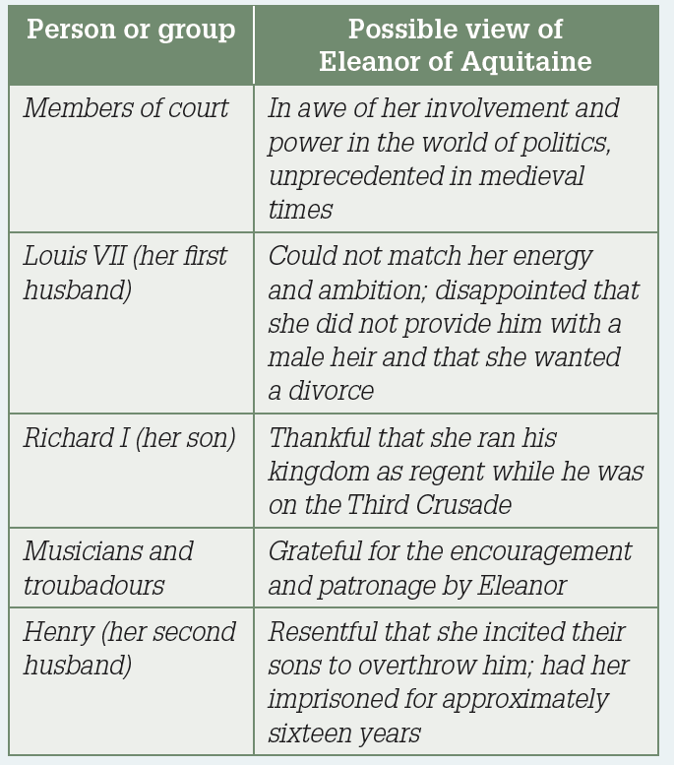

## Activity answers

### Remembering and understanding

**1** Charlemagne was a Frankish king who united parts of Western Europe into a centralised state. He revitalised culture and learning as well. He standardised weights, measures and customs dues, which helped improve commerce, and he initiated important legal reforms.

**2** Eleanor had many children and lived to an old age, which is exceptional as many women died young and in childbirth. She travelled widely, was very cultured, patronised the arts, including music, and promoted troubadour culture. She ruled over her own court of Poitou and Aquitaine, which was unusual. She survived a lengthy imprisonment and ruled on behalf of her son Richard.

### Applying and analysing

**3** Charlemagne was a wise and generous ruler. He was a pious man and he looked after the poor. Source 10.8.2 shows Charlemagne eating with the poor.

**4** Student answers will vary. Annotations may include:

* Source 10.8.4 shows Eleanor as beautiful and strong-willed, with lots of energy.
* Source 10.8.5 shows Eleanor as a young queen with her husband.

### Evaluating and creating

**5** Student answers will vary but should draw on the content of the unit (and possibly additional research).