**Name_________________________ Teacher______________________**

**YEAR 9 NEAP ENGLISH**

**SEMESTER 2 TASK 2: Heroes**

|  |  |  |
| --- | --- | --- |
| **Sub-Strands**  **Literature**  **Responding to Literature:**  Explore and reflect on personal understanding of the world and significant human experience gained from interpreting various representations of life matters in texts (ACELT1635) | **Literacy**  **Creating Literature:**  Create literary texts, including hybrid texts, that innovate on aspects of other texts, for example by using parody, allusion and appropriation (ACELT1773) | **Language**  **Expressing and developing ideas:**  Analyse and explain the use of symbols, icons and myth in still and moving images and how these augment meaning (ACELA1560) |

**Task 2 – Create a narrative of between 500-800 words that explores a section of the hero’s journey.**

Process:

1. Brainstorm a character who has, or will grow to have heroic qualities.
2. Identify the section of the hero’s journey that your character will undertake.
3. Draft your creative piece and finalise your good copy.

Hand in:

* Planning
* Drafts
* Good hand written copy

**Assessment will be based on: Writing and creating**

|  |  |
| --- | --- |
| **Responding to Literature:**  Explore and reflect on personal understanding of the world and significant human experience gained from interpreting various representations of life matters in texts (ACELT1635) | **Creating literature**  Create literary texts, including hybrid texts, that innovate on aspects of other texts, for example by using parody, allusion and appropriation (ACELT1773) |

|  |  |
| --- | --- |
| **LEARNING INTENTION** | **SUCCESS CRITERIA** |
| **Skills:** Write in correct sentence structure and paragraphs.  **Knowledge: (Content)**  Understand what narrative conventions are.  **Understanding: (Process)**  How the use of narrative conventions affects readers’ responses. |  |

Comments:

**Assessment Criteria:**

**Writing:**

|  |  |  |  |
| --- | --- | --- | --- |
|  | **A**  Excellent achievement  80-100 | **B**  High achievement  65-79 | **C**  Satisfactory achievement  50-64 |
| **Language features** | Makes a range of effective creative language choices in an imaginative text, including the use of descriptive and figurative language, to enhance meaning and reader engagement. | Makes a range of creative language choices in an imaginative text to influence reader response, e.g. uses emotive language to elicit sympathy. | Uses relevant, but often clichéd figurative language in an imaginative text. |
| **Text structure** | Creates an engaging imaginative text that develops own ideas and/or that accurately replicates the language and style of other texts. | Creates an imaginative text that presents own ideas and/or replicates some aspects of the language or style of other texts. | Creates an imaginative text that includes some ideas and language features of other texts. |
| **Editing** | Consistently uses a range of editing strategies to demonstrate control over sequencing of ideas, selection of vocabulary, spelling and punctuation. | Monitors and edits own work effectively for accuracy of spelling and punctuation and to achieve specific effects. | Reviews and edits own work to improve paragraphing, vocabulary and/or sentence structure. |

Score:**_____________**

**Writing: self-assessment checklist** (complete before submission)  **Narrogin SHS**

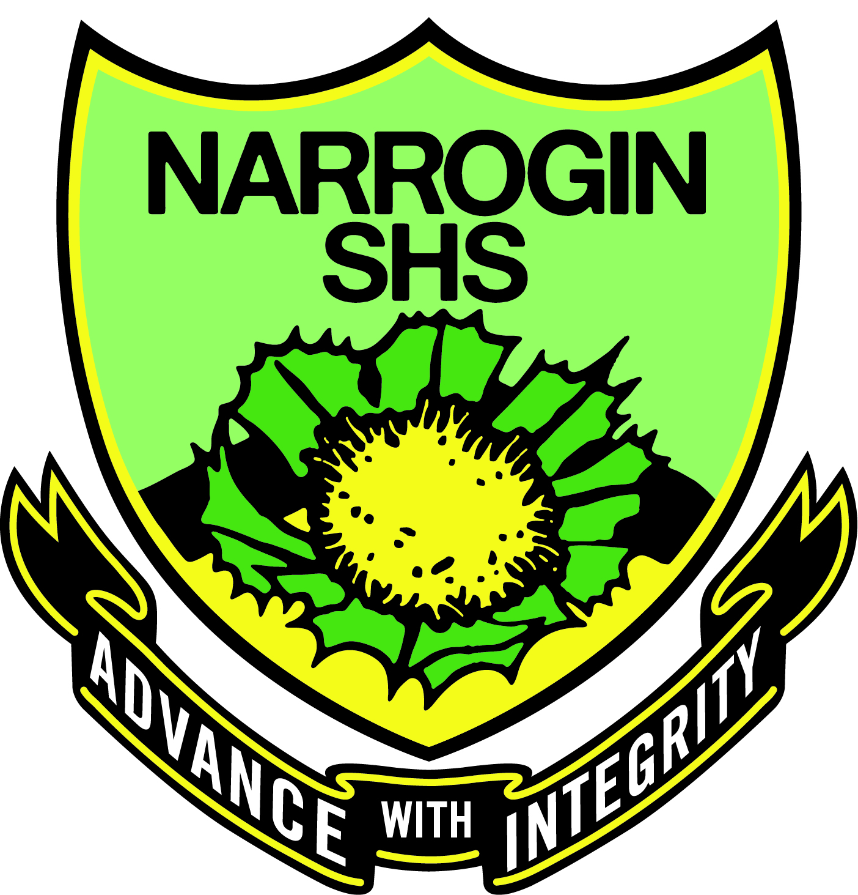 Name__________________________________________________ Year_______

|  |  |  |  |  |
| --- | --- | --- | --- | --- |
| AUDIENCE AND PRESENTATION | PUNCTUATION | CAPITALISATION | SPELLING AND VOCABULARY | IDEAS |
| ⃝ My handwriting is  legible and any typed copies have no typing errors. | ⃝ I have used a full stop at the end of each sentence. | ⃝ I have used capital letters for the first word of each sentence. | ⃝ I have used the dictionary to spell the words I don’t know. | ⃝ I have used brainstorming and planning to organise my ideas. |
| ⃝ I have written the title, my name and the date on my work. | ⃝ I have used commas between words in a list. | ⃝ I have used capitals for proper nouns (the names of people, places and the days of the week). | ⃝ I have used the correct terminology for this topic. | ⃝ I have acted on suggestions from the teacher. |
| ⃝ My sentences are complete, make sense and use the key words from the question. | ⃝ I have used apostrophes to show contraction and possession. | ⃝ I have capitalised the pronoun ‘I’. | ⃝ I have used the correct homophones within my sentences:  your/you’re  there/their/they’re  allowed/aloud | ⃝ Each paragraph only has one main idea. My ideas are in a logical order. |
| ⃝ I have attempted all questions and presented them in the correct order | ⃝ I have used a question mark after a question. | ⃝ I have written the main body of the text using lower case letters. | ⃝ There is evidence of editing on my drafts. | ⃝ I have used linking words to connect my ideas. |

I have carefully checked all of the above before submitting this piece of work.

Signature: _________________________________________ Date: / / 2017

**REFLECTION**

|  |  |  |  |
| --- | --- | --- | --- |
| **What I need to improve on:** | **STRENGTHS:** | **WHAT I ENJOYED:** | **SPELLING WORDS: Write out the correct word three times** |
|  |  |  |  |
| **SELF REFLECTION WITH TEACHER** | **WHAT I DID WELL:** | **AREAS TO WORK ON IN MY NEXT ASSIGNMENT:** | GRAMMAR: Write out the correct grammar rule |
|  |  |  |  |