**ARANMORE CATHOLIC COLLEGE**

**YEAR 11 ATAR PHYSICS**

**ASSIGNMENT 4 - SOUND**

|  |
| --- |
| /50 |

**NAME: __________________________________ MARK:**

1. The diagram below shows how the sound level varied with time when a note was played on a particular musical instrument.

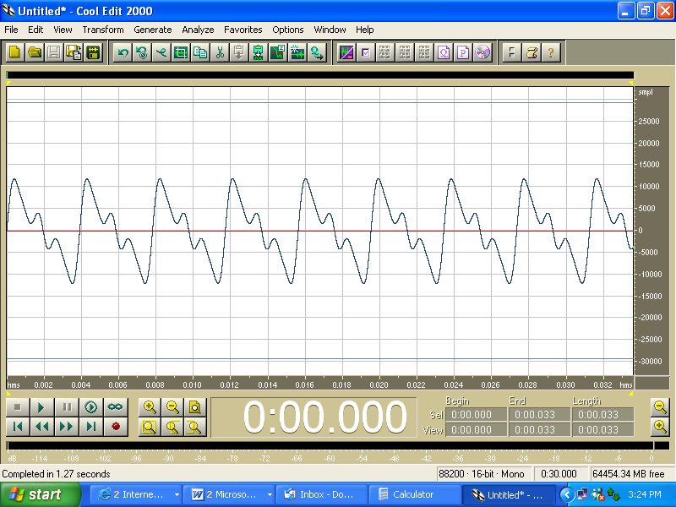

TIME AXIS

(s)

* 1. Is the note a “fundamental note” or are there other harmonics present? Explain. [2 marks]
  2. Given that the time axis units are seconds. Estimate the frequency of the note. [2 marks]
  3. When a section of an orchestra comprising 15 musicians is playing the same instrument as above, the sound level recorded approximately 10 metres away is 86.0 dB. Assuming that each musician is playing at about the same amplitude, what would the sound level be during a duet of these musicians? [5 marks]
  4. Estimate the acoustic power output of just one of the above musicians. [4 marks]
  5. Although music is a subjective phenomena, in physics there is a clear distinction between music and noise. Explain this distinction and use it to decide if the above output is music or noise. [3 marks]

1. A recording studio builds a simple didgeridoo which is a wind instrument closed at one end. The effective length of the didgeridoo is 135 cm and is fixed.

Microphone on end of rod within the air column

Open end of didgeridoo

Closed end of didgeridoo

Mouthpiece

1. The didgeridoo has a fundamental frequency of 64.0 Hz. Calculate the speed of sound in air in the studio. [3 marks]
2. Explain how a musician can play notes of a higher frequency on this fixed length instrument.

[3 marks]

1. The musician is unable to produce a sound of frequency 128 Hz on this didgeridoo. Explain why this is not possible. [3 marks]

When the didgeridoo is playing a note of frequency 320 Hz, a sound technician slides a small microphone into the tube without disrupting the sound. As he does, he notices the sound volume varies between loud and soft.

1. Explain why there are loud and soft spots within the instrument. [2 marks]

For a given note played on a musical instrument, the dominant frequency heard is called the fundamental frequency or the first harmonic. Harmonic frequencies above the fundamental frequency, that are present, are known as overtones. Harmonics above the fundamental frequency are known as the first overtone, the second overtone, etc.

1. When the didgeridoo is sounding a note of 64.0 Hz, sound waves travel through a small gap in a partially open window to the outside where reflections are negligible. A microphone placed to the side of the gap can still detect these sound waves. This is shown in the following diagram.

Didgeridoo

Outside

Wavefronts 🡪

Gap

Microphone

1. Explain the wave phenomenon that causes the didgeridoo sound to be detected by the microphone. [2 marks]
2. Show on the diagram how wavefronts from a stringed instrument sounding at 320 Hz will reach the window and continue through the air gap. You must show relative wavefront dimensions approximately to scale originating from the same location as the didgeridoo. [2 marks]
3. The studio has a simple stringed instrument in which a steel string in tension can oscillate between two fixed bridges. On the diagram below sketch the wave envelope of the second overtone. [1 mark]

Bridge

Bridge

1. Bats emit ultrasonic waves. The shortest wavelength emitted in air by a bat is about 3.3mm.

* 1. What is the highest frequency that this bat can emit? [3 marks]
  2. Would humans be able to hear these sounds? Explain your answer. [2 marks]
  3. Dolphins use similarly high frequency sounds to navigate, however, they are unable to detect similar sized objects as bats. If they both use the diffraction of sound to do this, explain, with a calculation, this difference. [4 marks]

1. The effective length of the ‘A’ string on a guitar is 74.0 cm.

a) When sounded, the ‘A’ string produces at least the **first three harmonics**. Label the axes below and sketch the standing waves (one on top of the other), for all three harmonics (label them). [5 marks]

b) If the speed of propagation of a wave along the ‘A’ string is 296 ms-1, calculate the frequencies of these harmonics. [4 marks]