* Copyright for test papers and marking guides remains with *West Australian Test Papers*.
* The papers may only be reproduced within the purchasing school according to the advertised conditions of sale.
* Test papers must be withdrawn after use and stored securely in the school until Wednesday 1st July 2015.



**YEAR 11 CHEMISTRY**

**UNIT 1**

**2015**

**MARKING GUIDE**

|  |  |
| --- | --- |
| **Question No.** | **Answer** |
| 1 | C |
| 2 | C |
| 3 | B |
| 4 | D |
| 5 | D |
| 6 | B |
| 7 | C |
| 8 | D |
| 9 | B |
| 10 | D |
| 11 | C |
| 12 | D |
| 13 | A |
| 14 | D |
| 15 | B |
| 16 | B |
| 17 | D |
| 18 | C |
| 19 | C |
| 20 | C |
| 21 | A |
| 22 | D |
| 23 | C |
| 24  25 | B  D |

**Section Two: Short answer 35% (70 marks)**

This section has 13 questions. Answer all questions. Write your answers in the spaces provided.

When calculating numerical answers, show your working or reasoning clearly. Express numerical answers to three significant figures and include appropriate units where applicable.

Spare pages are included at the end of this booklet. They can be used for planning your responses and/or as additional space if required to continue an answer.

* Planning: If you use the spare pages for planning, indicate this clearly at the top of the page.
* Continuing an answer: If you need to use the space to continue an answer, indicate in the original answer space where the answer is continued, i.e. give the page number. Fill in the number of the question(s) that you are continuing to answer at the top of the page.

Suggested working time: 60 minutes.

26. Isotopes of carbon are used to determine the age of fossilised organic samples dug up by archaeologists.

1. Explain what is meant by the term isotope. (2 marks)

_________________________________________________________________________Two or more forms of same element with same # protons and electrons (1)

and different number of neutrons (1)

_________________________________________________________________________

1. Explain why isotopes of the same element have the same chemical properties.

(2 marks)

_________________________________________________________________________

Chemical properties describe reactivity which is due principally to electronic configuration (1)

Isotopes of same element have same number of protons and same number of electrons (1)

_________________________________________________________________________

1. Calculate the mass, in grams, of a single atom of this isotope of carbon-12.

(2 marks)

_____________________________________________________________________

N (C) in a mole = 6.022 x 1023 atom

Therefore m (C atom) = 12.00/6.022x1023

= 1.99 x 10-23g

_____________________________________________________________________

27. Draw electron-dot diagrams showing the arrangement of valence electrons in the following chemical species. (4 marks)

Represent all valence shell electron pairs either as : or –

|  |  |
| --- | --- |
| Ethane C2H6 | Hydroxide ion OH- |
| H H  I I  H - C - C - H  I I  H H | http://upload.wikimedia.org/wikipedia/commons/thumb/b/b0/Hydroxide_lone_pairs-2D.svg/170px-Hydroxide_lone_pairs-2D.svg.png  1 for correct electrons  1 for brackets and charge |

28. (a) Using labelled arrows, on the periodic table below clearly label the trends in electronegativity, first ionisation energy and atomic radius. (3 marks)

atomic radius decreases  
ionisation energy increases

electronegativity increases

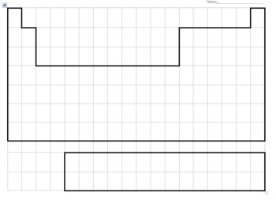

Atomic radius increases

Ionisation energy decreases

Electronegativity decreases

1. Describe and explain the trends for atomic radius. (4 marks)

_________________________________________________________________________

Atoms get bigger as you go down groups (1)

As we go down we are adding extra layers (shells, principal quantum levels) of electrons (1)

Atoms get smaller as you go across a period (1)

The atomic radius is being decreased because of increased nuclear charge (1)

_________________________________________________________________________

29. Explain, with the aid of a diagram, how movement of electrons within an atom produces the emission spectra responsible for observations in flame tests. (4 marks)

|  |
| --- |
| Explanation must include photon absorption/ electron excitation/ photon emission.  2 for diagram |

___________________________________________________________________

When excited an electron moves to a higher energy level or orbital (1)

When the electron falls back to its ground state a photon of particular wavelength is emitted. (1)

1. Complete the following table (4 marks)

|  |  |  |
| --- | --- | --- |
| **SUBSTANCE** | **NAME** | **TYPE of BONDING** |
| Ti | Titanium | metallic |
| CS2 | Carbon disulphide | Covalent |
| NH3 | Ammonia | Covalent |
| NH4Cl | Ammonium chloride | Covalent & Ionic (1/2 each) |

31. Describe the differences in malleability and electrical conductivity for metals and ionic compounds. Explain these properties by referring to the bonding involved. (6 marks)

_________________________________________________________________________Metals are good conductors of electricity because ‘free electrons’ can carry the charge of an electric current when a potential difference is applied (1)

Metals are malleable because when planes of metal atom are bent or slide the mobile electrons can run in between the cations to maintain bond strength (1)

Bonding in metals is non-directional due to mobile electrons (1)

Ionic solid crystals do not conduct electricity because the ions are not free to move to carry a current (1) If the solid is dissolved in H2O or melted the ions are free to carry a current (1)

Ionic solids are hard and brittle. When stressed the bonds are broken along the planes of ions (1)

OR ionic compounds are brittle because when the crystal lattice is distorted this causes like charged ions to be aligned which then repel causing crystal to shatter (1)

_________________________________________________________________________

1. Compare the properties of hardness, melting point and electrical conductivity for a covalent molecular substance like water, and a covalent network substance like diamond. Explain the properties by referring to the bonding involved.

(6 marks)

_________________________________________________________________________Hardness – c.v. molecules are soft and weak due to weak intermolecular forces between molecules (1)

* c.v. network are very hard due to continuous network of strongly bonded atoms (1)

Melting point – c.v. molecules have low melting points as little energy required to disrupt weak intermolecular forces (1)

* c.v.network have very high mp due to all atom being strongly bonded to others (1)

electrical conductivity – c.v. molecular localised electrons so cannot conduct in any phase (1)

* c.v.network (diamond) is a non-conductor due to localised electrons (1)

_________________________________________________________________________

1. The element gallium has the electron configuration 2,8,18, 3. Using the same notation, give the electron configuration of: (2 marks)

(a) A chlorine atom, Cl 2,8,7   
  
(b) a calcium ion, Ca2+ 2,8,8

1. Give IUPAC names for the following two organic compounds. (2 marks)

H H

* 1. \ /

C = C

/ \

H CH2 ─CH3 but-1-ene

CH2 ─ CH3

|

* 1. CH3─ CH ─CH2─CH ─ CH2 ─ CH3

| |

CH2 CH3 3-ethyl-4, 5-dimethyl heptane

| also 5-ethyl-3,4-dimethyl heptane

CH3

1. Draw structural diagrams for the two organic compounds named here (2,2,6 marks)
2. 2-iodo-3-methyl-pent-2-ene b. 5,6-dimethyl-oct-2-ene

CH3 CH3

CH3–CH=CH–CH2 –C – C– CH2 – CH3

H H

also accept cis isomer 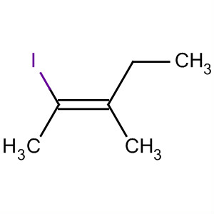

36.Draw, and name using correct IUPAC nomenclature complete structural formulae for the isomers with molecular formula C6H14 (do not include hexane) (6 marks)

2 – methylpentane

3 – methylpentane

2.2 – dimethylbutane

* 1. – dimethylbutane

37.A sample of gaseous vanadium is analysed by mass spectrometry. The vanadium atoms are first ionised then accelerated before being deflected. (2,1,1 marks)

(a) Describe briefly how positive ions are formed from gaseous vanadium atoms in a mass

spectrometer.

electron beam ‘knocks’ outer electrons from atoms to create ions

1. What is used in a mass spectrometer to accelerate the positive ions?

Ion accelerator or an electric field

(c)What is used in a mass spectrometer to deflect the positive ions?

Magnetic field or magnet.

38.Diagram representing fractional distillation of crude oil.

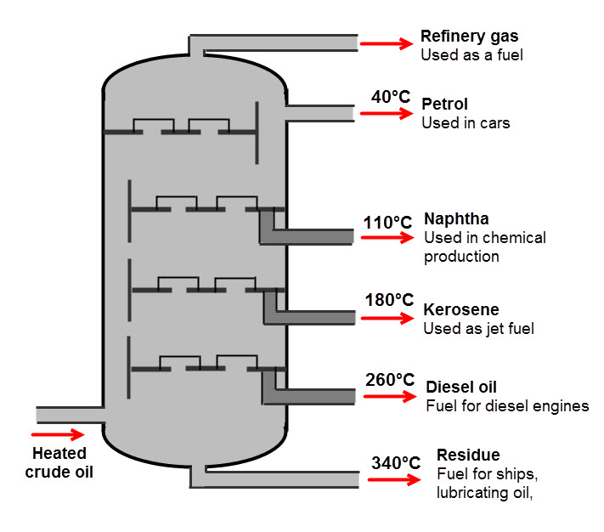

a) Give a brief description demonstrating your understanding of what is occurring in the diagram.

(2 marks)

Separation of hydrocarbons (1) based on chain length / M.W (1) ________________________________________________________________________

b) Name the physical property that the process depends upon (1 mark)

Boiling Point _________________________________________________________________________

c) What is the chemical property that underlies the physical property (1 mark)

Intermolecular forces _________________________________________________________________________

d) Give the molecular formula for an alkane with seven carbon atoms. (1 mark)

C7 H16 _________________________________________________________________________

e) Write an equation for the complete combustion of the alkane C8H18  (2 marks)

2C8 H18 + 25 O2 16CO2 + 18H2O (or ½ coeffiecients)

_________________________________________________________________________

39. Write a balanced equation for the following reactions. Give the name of any organic products.

1. methane and chlorine gases react to completion (4 marks)

_________________________________________________________________________CH4(g) + 2Cl2(g) CCl4 (g) + 4HCl(g) (1) Carbon tetrachloride (1)

_________________________________________________________________________

1. Bromine water is added to pent-2-ene

_________________________________________________________________________CH3 – CH = CH – CH2 – CH3 (l) + Br2 (ag) CH3 – CHBr-CHBr- CH2 – CH3 (1)

2,3 dibromopentane (1)

________________________________________________________________________

40. Write **observations** for any reactions that occur in the following procedures. In each case describe in full what you would observe: (4 marks)

1. Methane gas and excess chlorine gases are mixed in the presence of UV light

Yellow greenish gas mixed with colourless gas (1)

Yellow greenish gas decolourises or fades (1) Or colourless liquid produced (1)

_________________________________________________________________________

1. Bromine water is added to hex-1-ene

Orange solution added to colourless liquid (1) producing a colourless liquid (1)

_________________________________________________________________________

END OF SECTION TWO

**Section Three: Extended answer 40% (80 marks)**

This section contains five (5) questions. You must answer all questions. Write your answers in the spaces provided below.

Where questions require an explanation and/or description, marks are awarded for the relevant chemical content and also for coherence and clarity of expression. Lists or dot points are unlikely to gain full marks.

Final answers to calculations should be expressed to three significant figures.

Spare pages are included at the end of this booklet. They can be used for planning your responses and/or as additional space if required to continue an answer.

* Planning: If you use the spare pages for planning, indicate this clearly at the top of the page.
* Continuing an answer: If you need to use the space to continue an answer, indicate in the original answer space where the answer is continued, i.e. give the page number. Fill in the number of the question(s) that you are continuing to answer at the top of the page.

Suggested working time: 70 minutes.

**Question 41 (11 marks)**

The annual contribution of Western Australia's mineral and petroleum industry to the Australian economy is well over $100 billion dollars. The industry employs approximately 100,000 people. Drug testing is an important process where Chemists are employed to ensure that the workplace remains safe. All employees are subjected to a stringent drug testing regime before they enter the workplace in addition to testing whilst they are on site.

Despite their best efforts, mining inspectors claim that synthetic drug use remains a major issue in the industry. It seems that synthetic versions of cannabis and ‘ice’ or crystal methamphetamine, in particular, are changing rapidly to avoid detection.

1. Using your knowledge of Chemistry, explain a technique of chemical analysis that could be used to identify a particular drug based on its chemical composition. (5 marks)

EITHER: mass spectrometry (1) ionisation of source by electron beam (1)

Accelerated as ion beam (1)

ions separated by magnetic field based on mass and charge (1)

detector counts number of ions for each mass/charge (1)

OR: atomic absorption spectroscopy (1)

light source containing elements to be analysed (1)

sample aspirated into the flame of the AAS becoming atomised (1)

beam passes through sample, atoms absorb light beam passes through wavelength filter or prism (1)

signal detector receives certain frequencies of light (1) ___________________________________________________________________

A sample of suspected crystal methamphetamine confiscated from one of the mine workers was submitted for analytical testing. The following data was obtained regarding the isotopic composition of elements present in the sample.

b) Identify the two elements present (2 marks)

Carbon (1) Zirconium (1) ___________________________________________________________________

c) Determine the relative atomic mass of each element. You must show your working to attain full marks. (4 marks)

___________________________________________________________________C- (12 x 98.9/100) + 13 x 1.1/100) = 12.011g

Zr- (90 x 51.45/100) + (94 x 17.38/100) + (92 x 17.15/100) + (91 x 11.22/100) + 96 x 2.8/100) = 91.32g __________________________________________________________________

**Question 42 (10 marks)**

Saponification (the making of soap) is the hydrolysis of plant oil or an animal fat by treating it with a strong base. Below is a chemical reaction depicting the conversion of a fat molecule (triglyceride) into glycerol and the salt of a fatty acid (soap).

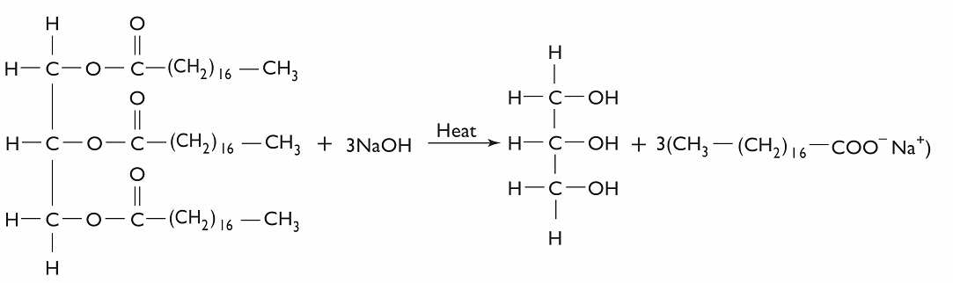

**Triglyceride** (fat) **🡪 glycerol + salt of fatty acid**

1. Determine the mass of one mole of the triglyceride molecule (2 marks)

M = (C x 57) + (0 x 6) + (H x 110) = (12.01 x 57) + 16 x 6) + (1.008 x 110) = 891g 3sf (891.45g) _________________________________________________________________________

1. If 0.14 moles of triglyceride reacts, how many moles of the salt of a fatty acid are produced?

(1 mark)

1 mol TGC : 3 mol SALT therefore 0.140 mol TGC : 3 x 0.140 mol SALT = 0.420 mol SALT _________________________________________________________________________

1. What is the mass of salt of fatty acid resulting from the breakdown of 0.14 moles triglyceride? (2 marks)

M (SALT) = n x M

= 0.420 x 306.45

= 129g 3sf (128.71g) _________________________________________________________________________

1. Determine the percentage composition of each element in a triglyceride molecule.

(3 marks)

M (891.45g)

% C = 12.01 x 57/891.45 = 76.8%

% H = 1.008 x 110/891.45 = 12.4%

% O = 16 x 6/891.45 = 10.8% _________________________________________________________________________

1. Why is heat required for the reaction to occur? (2 marks)

Breaking of covalent bonds _________________________________________________________________________

**Question 43 (10 marks)**

The study and assembly of materials at the subatomic level is otherwise known as **Nanotechnology**. This emerging area of Science is aiming to provide solutions to some of the problems that humanity faces.

1. Describe two examples of nanotechnology potentially solving present day problems

(4 marks)

Medicine – customised nanoparticles the size of molecules delivering drugs directly to diseased cells. No damage to healthy calls like in chemotherapy (2)

Cleaner water – nanoparticles devised to decontaminate waste/chemicals (2)

Others – air quality, food

_________________________________________________________________________

1. Describe one potential risk arising from the use of nanotechnology. (2 marks)

Very small particle size (1) may be inhaled / pass through body’s defences (1)

any reasonable inference* _________________________________________________________________________

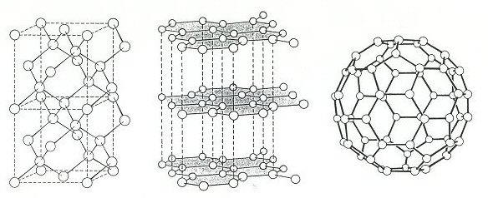

1. Three allotropes of carbon (diamond, graphite and a fullerene) are shown above.
2. What do you understand by the term ‘allotrope’ (1 mark)

Two or more different physical forms of an element ___________________________________________________________________

1. Account for one physical property of each allotrope with reference to the bonding type present. Your answer must include a different property for each (3 marks)

Diamond – from hard, brittle, insulator, insoluble, very high M.P

Graphite – soft and slippery, brittle, conductor, insoluble, very high M.P

Fullerene – soft and slippery, brittle, insulator, insoluble, low M.P solids

MUST EXPLAIN: can only use once

Hard – many strong covalent bonds

Soft and slippery – strong c.v. in two dimension, free moving electrons between sheets

Brittle – directional bonds, stress across a layer will break them

Insulator – all valence electrons held in bonds

Conductor – some freedom of valence electrons

Insoluble – weak IMF between carbon atoms and water molecules

Melting point – many strong bonds holding the structures together.

**Question 44 (22 marks)**

A typical petro diesel molecule has the molecular formula **C16H34**. It is produced by the fractional distillation of crude oil. Biodiesel, however, is derived from renewable sources such as vegetable oil or animal fat and has a typical molecular formula, **C17H34O2**.

1. Assuming complete combustion, write separate balanced equations for the combustion of petro diesel and biodiesel. (4 marks)

(i) 2C16 H34 + 49 O2  32 CO2 + 34 H2O ______________________________________________________________(ii) 2C17 H34 O2 + 49 O2 34 CO2 + 34 H2O ______________________________________________________________

1. In order to determine the mass of Carbon Dioxide released from the combustion of one tonne of C16H34 and one tonne of C17H34O2, first determine the number of moles of each reactant in one tonne. (4 marks)
2. n (C16 H34) = 1 x 106/ 226.432 (1)

= 4.42 x103 moles (1)

1. n (C17 H34 O2) = 1 x 106/ 270.442 (1)

= 3.70 x103 moles (1)

1. Determine the number of moles of carbon dioxide released from the combustion of one tonne of each diesel molecule. (2 marks)
2. 1 mol C16 H34 produces 16 mol CO2

produces 70,661 mol CO2 (1)

1. 1 mol C17 H34 O2 produces 17 mol CO2

produces 62,860 mol CO2 (1)

1. Assuming 3.5 tonnes of oxygen gas is available for each reaction determine whether there is sufficient oxygen for complete combustion. You must show all working for maximum marks

(4 marks)

1. N (O2) = 3.5 x 106/32 = 109,375 moles available (1) for 1 x C16 H34 need 24 ½ x O2 so 4,416 C16 H34  requires 108,200 mol O2 (1)

enough available ( ½ )

1. 1 mol C17 H34 O2 requires 24 ½ mol O2

so 3,698 mol C17 H34 O2 requires 90,592 moles (1)

plenty available ( ½ )

______________________________________________________________

1. On the axes below draw an energy profile diagram for the enthalpy change in either reaction. Be sure to provide all the appropriate labels. (5 marks)

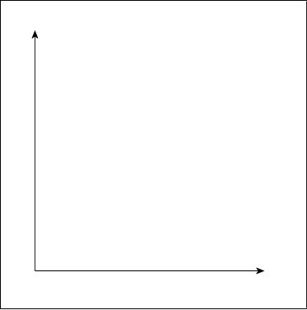

1 for plot-exothermic

1 for labelled axes

Progress

Enthalpy (KJ/mol)

Transition State (1)

Heat of reaction (1)

Activation Energy (1)

1. If the heat of reaction is (–10,700 kJ/mol) for the combustion of petro diesel, determine the amount of heat released from the combustion of one tonne of the substance.

(3 marks)

1 mol petro diesel (C16 H34) 10,700KJ

1 tonne = 4,416.33 mol

Therefore heat of reaction = n x energy

= 4,416.33 x 10,700

= 47.255 MJ

____________________________________________________________

**Question 45 (9 marks)**

Our current conception of the atomic model is due to a series of findings from key experiments in the past. Some involved newly developed devices of that time. Below are depictions of some of the devices or data obtained from the experiment. Outline how the principal findings of each contributed to our current understanding of atomic structure.

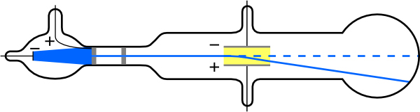

Cathode Ray Tube

1. Applying an electric field across the cathode ray caused the ray to be deflected towards the positive pole proving that

(1) cathode rays were composed of negatively charged particles.

(1) particles had a high charge to mass ratio. ______________________________________________________________

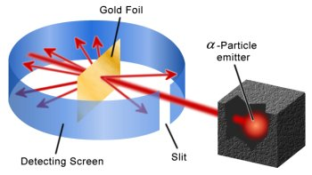

Rutherford’s Gold Foil Experiment

(1) based on alpha particle scattering after striking a thin foil

(1) most of atom empty space or space occupied by electrons

(1) nucleus source of mass, atom contains a nucleus.

______________________________________________________________

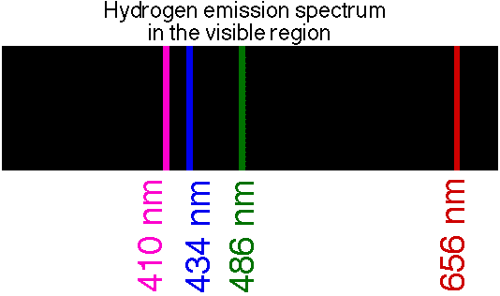

(1) observed spectral lines for hydrogen atom

(1) lines due to electron making transitions between energy levels

(1) certain orbits/energy levels for electrons are available

(1) led to developments in quantum mechanics

______________________________________________________________

**Question 46 (18 marks)**

When analysing combustion data from a range of fossil fuels and biofuels the following was claimed. “Different fuel types, combusted under identical conditions, produced significantly different amounts of important exhaust gases and different particle characteristics”. Carbon monoxide emissions have been a concern due to their toxicity. It is hypothesised that the combustion of biofuels produces significantly lower CO (g) emissions than the combustion of a similar mass of fossil fuel.

Answer the following questions based on the above information:

1. What is the independent variable? (1 mark)

Fuel type

______________________________________________________________

1. What is the dependent variable? (1 mark)

CO(g) emissions ______________________________________________________________

1. What are three variables that you would **have** to control? (3 marks)

Amount of fuel burnt Degree of vaporisation

Amount of O2 available Particle size

Temperature

pressure

______________________________________________________________

1. Design an investigation to verify the above claim. Include the procedure to be followed, the materials required, and the type and amount of primary and/or secondary data to be collected (4 marks)

(1) measure mass or volume of CO

(1) repetition

(1) some equipment named

(1) primary data detailing emission value

______________________________________________________________

1. Conduct a risk assessment (2 marks)

(1) identify at least two risks (explosion of fuel, burns from combustion process, carbon dioxide poisoning, carbon monoxide poisoning)

(1) determine consequences of risk

______________________________________________________________

1. identify sources of random and systematic error (2 marks)

(1) limitations in sensitivity of instruments

(1) limitations in techniques

(1) mistakes made by individuals ______________________________________________________________

1. estimate the effect of the errors on the measurement results (2 marks)

describe an estimate based on one of the factors outlined in the answer given in 46 f. ______________________________________________________________

1. Outline the evidence that you would require to make and justify conclusion (3 marks)

The evidence that the researcher would require would be the interpretation of his data and relating it to the hypothesis (1)

.ie is the CO emission from the combustion of sample of biofuel significantly less than the combustion of fossil fuel (1)

Then discussion could go onto are samples tested representative of these groups and further testing to justify (1). ______________________________________________________________

END OF EXAMINATION