|  |  |
| --- | --- |
| **ACC Logo_P_rgb_web_sml** | Aranmore Catholic College YEAR 12 CHEMISTRY 2012TEST TWO: Reaction Rates & Equilibrium |

**MULTIPLE CHOICE QUESTIONS: (10 marks)**

**Complete this section on your answer booklet.**

1. A small increase in temperature can produce a relatively large increase in the rate of a chemical reaction. Which one of the following statements **best** explains this?

(A) The extra energy orients the molecules for a reaction.

(B) At a higher temperature there is a large increase in the proportion of reactant particles with sufficient energy to form the activated complex.

(C) The activation energy for the reaction gets lower as the temperature gets higher.

(D) The increase in temperature strengthens the bonds in the products so that it is easier for the new compound to form.

1. What would happen to the value of K in the following reaction if the pressure of the N2O4 is doubled?

N2O4(g) **⇔**  2NO2(g)

(A) K would not be affected.

(B) K would be halved.

(C) K would be doubled.

(D) K would increase by a factor of 4.

The next three questions refer to the following chemical system:

2SO**2(g)** + O**2(g)**  2SO**3(g)** H = -188kJ/mol

1. Which is the correct equilibrium constant expression for the above chemical system?

(A) 

(B) 

(C) 

(D) 

1. At a certain temperature, after equilibrium has been reached, the concentrations of the reactants and products were found to be the following:



The numerical value of the equilibrium constant, K, for this system at this temperature is:

(A) 2.7

(B) 0.033

(C) 10

(D) 30

1. Which of the following changes would increase the equilibrium amount of oxygen gas?

(A) adding more sulfur dioxide

(B) decreasing the temperature of the system

(C) increasing the volume of the reaction vessel

(D) removing some of the sulfur trioxide from the reaction vessel

1. Which of the following is true of a solution of pure silver chloride in equilibrium with some solid silver chloride?

(A) The silver chloride solution is saturated.

(B) Use of a catalyst would allow more solid silver chloride to dissolve.

(C) If more solid silver chloride is added to the mixture this will change the concentrations of the silver and chloride ions in the solution.

(D) The reaction in which silver and chloride ions precipitate to form solid silver chloride is not taking place.

1. One way of producing ammonia is by the Haber process. In this process, hydrogen and nitrogen gases are reacted together and the overall equation is:

N2(g) + 3H2(g) **⇔**  2NH3(g) ΔH = -92 kJ moL-1 of NH3 produced.

Using your knowledge of equilibrium and Le Chatelier’s Principle, what conditions of temperature and pressure favour the production of ammonia?

(A) High temperature and low pressure.

(B) Low temperature and high pressure.

(C) Low temperature and low pressure.

(D) High temperature and high pressure.

**SECTION TWO: Short Answer [41 marks]**

1. Write the equilibrium constant expression for each of the following:

a) **4NO2(g) + 6H2O(g) ⇔ 7O2(g) + 4NH3(g)**

K =

b) **2H2O(l) + 4Au(s) + O­2(g) + 8CN-(aq) ⇔ 4Au(CN)2-(aq) + 4OH-(aq)**

K =

[4 marks]

1. Hydrogen chloride gas, HCl, decomposes according to the equation:

*K = 0.25* at a certain temperature.

1. If a mixture of 0.050 moles each of all three gases is placed in a vessel of volume 2 L at this temperature, is the system at equilibrium? Justify your answer.

[3 marks]

1. If the above mixture is not at equilibrium, describe the changes that will occur as the system does move toward equilibrium?

[2 marks]

1. Ammonia is an industrially important gas produced by the Haber process, as illustrated by the reaction below:

**N2(g) + 3H2(g) ⇔ 2NH3(g) ΔH = -92 kJ mol-1 (at 25°C)**

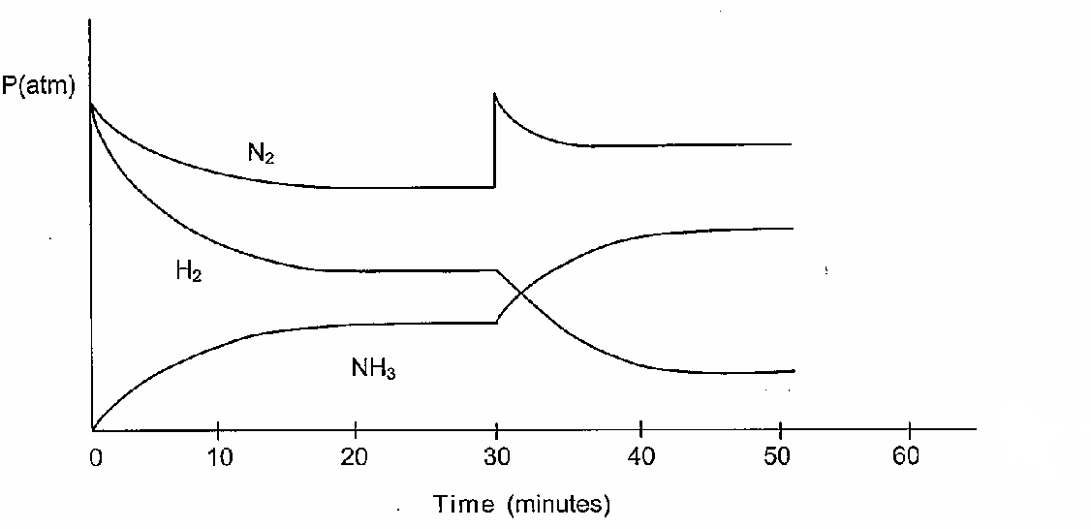

The reaction is catalysed by iron(III) oxide (Fe2O3).

The above graph shows the partial pressures of the three species involved in the reaction:

Refer to this graph to answer the following questions:

a) Why does the partial pressure of H2 decrease more rapidly than that of the N2 from t=0 to t=10?

[1 mark]

b) The partial pressures of each of the three species stabilises between 20 and 30 minutes. Describe what is happening during this time.

[1 mark]

c) What has occurred at the 30-minute mark to cause the changes shown in the graph?

[1 mark]

d) By the 40-minute mark, what difference will the change in (c) have made to the rate of :

i) the forward reaction? \_\_\_\_\_\_\_\_\_\_\_\_\_\_\_\_\_\_\_\_\_\_\_\_\_\_\_\_\_\_\_\_\_\_\_\_\_\_\_\_\_

ii) the reverse reaction? \_\_\_\_\_\_\_\_\_\_\_\_\_\_\_\_\_\_\_\_\_\_\_\_\_\_\_\_\_\_\_\_\_\_\_\_\_\_\_\_\_\_

[2 marks]

e) Using the Collision Theory, explain why the rate of the forward reaction is affected by the change that occurs at the 30-minute

\_\_\_\_\_\_\_\_\_\_\_\_\_\_\_\_\_\_\_\_\_\_\_\_\_\_\_\_\_\_\_\_\_\_\_\_\_\_\_\_\_\_\_\_\_\_\_\_\_\_\_\_\_\_\_\_\_\_\_\_\_\_\_\_\_\_\_\_\_\_\_\_\_\_\_\_\_\_\_\_\_\_\_\_\_\_\_\_\_\_\_\_\_\_\_\_\_\_\_\_\_\_\_\_\_\_\_\_\_\_\_\_\_\_\_\_\_\_\_\_\_\_\_\_\_\_\_\_\_\_\_\_\_\_\_\_\_\_\_\_\_\_\_\_\_\_\_\_\_\_\_\_\_\_\_\_\_\_\_\_\_\_\_\_\_\_\_\_\_\_\_\_\_\_\_\_\_\_\_\_\_\_\_\_\_\_\_\_\_\_\_\_\_\_\_\_\_\_\_\_\_\_\_\_\_\_\_\_\_\_\_\_\_\_\_\_\_\_\_\_\_\_\_\_\_\_\_\_\_\_\_\_\_\_\_\_\_\_\_\_\_\_\_\_\_\_

[2 marks]

1. At t=50 minutes, the system was heated and equilibrium was established again at t=65 min.

Estimate the equilibrium concentration of each gas to complete the concentration graph above up to t=80 minutes.

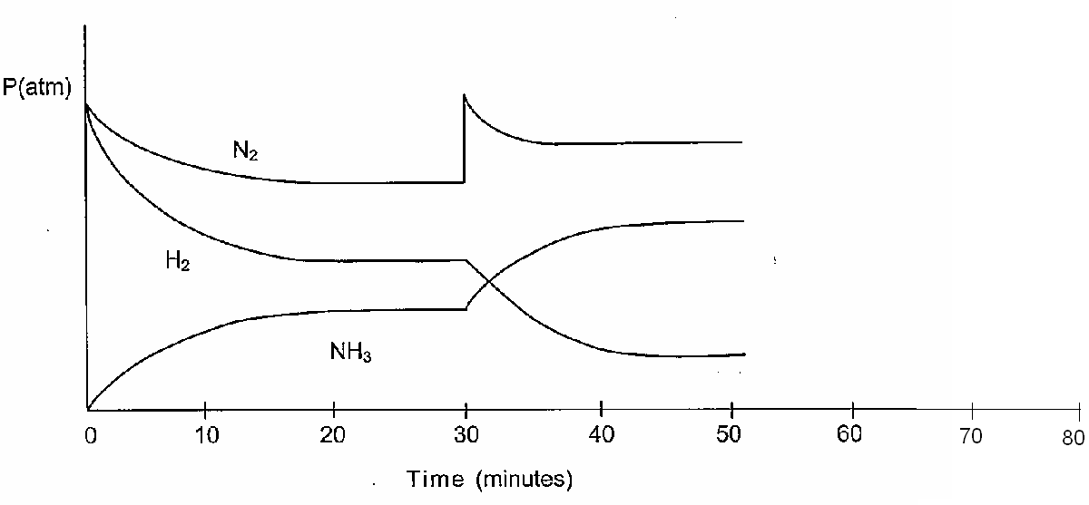[3 marks]

1. For this process, plot the estimated rates of the forward and reverse reactions from t=0 to t=80 minutes on the following graph.

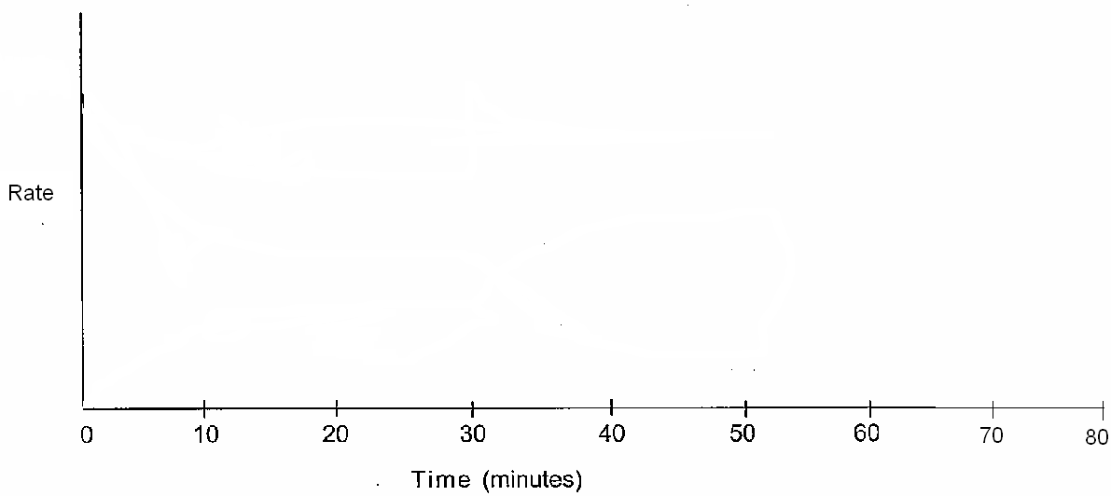

[6 marks]

1. When cobalt chloride is dissolved in dilute hydrochloric acid, the following equilibrium is set up:

**Co(H2O)62+(aq) + 4Cl-(aq)  🡪 CoCl42-(aq) + 6H2O(l) ) ΔH = +ve**

**RED DEEP BLUE**

Both the red and deep blue ion are present in the reaction mixture which is hence PURPLE in colour.

Three test-tubes are set up, each containing some of the purple equilibrium mixture.

Each of the test tubes is treated as described below. In each case, describe how the equilibrium will shift, and explanation and what will be observed.

|  |  |  |  |
| --- | --- | --- | --- |
| What is done | How the equilibrium shifts. *Write 🡪, 🡨 or ‘no change’* | Explanation | What is observed.  Give the complete observation. |
| A few drops of concentrated hydrochloric acid is added to test-tube 1 |  |  |  |
| A few drops of concentrated silver nitrate is added to test-tube 2 |  |  |  |
| The solution in test-tube 3 is heated |  |  |  |

[9 marks]

1. The first step in the production of nitric acid is summarized by the following balanced chemical equation.

4NH3(g) + 5O2(g) <==> 4NO(g) + 6H2O(g)    kJ

* 1. Write the equilibrium expression for this reaction.
  2. Describe the conditions that maximize the yield of NO.
  3. Describe the conditions that maximize the rate of production of NO.
  4. Discuss the factors chemists must take into account when trying to determine which conditions will be used to maximise the yield at the greatest rate.”

[8 marks]