YEAR 12 ECONOMICS – UNIT FOUR 2018

Practice Questions - AE, AD/AS

NAME _____________________________ %

**Section B: Short Answer (Total Marks: 18)**

**Question 1. (6 marks)**

Explain and demonstrate, using an aggregate expenditure (AE) model, how an economy would move towards macroeconomic equilibrium if output was greater than spending.

**Question 2. (6 marks)**

Using an appropriate model which you have studied, demonstrate the impact that Government’s plans to spend $15b on infrastructure may have on the economy.

**Question 3. (6 marks)**

1. Calculate the multiplier for an economy where the marginal propensity to consume is 0.9.

(1 mark)

1. By how much will national income increase if there is an injection of $100,000 and the MPC is 0.5. (2 mark)
2. An economy has a MPC of 0.6, calculate the amount of injections that would be needed to increase national income by $20,000,000. (3 marks)

**Question 4. (6 marks)**

Describe four effects on an economy of a decrease in investment. Draw an appropriate model to support your description.

**Question 5. (6 marks)**

Using the aggregate demand/aggregate supply (AD/AS) model, explain how the discovery of new oil and gas deposits will affect the Australian economy in the short run and long run.

**Question 6. (6 marks)**

Discuss in detail, the significance of the distinction between short run aggregate supply, and long run aggregate supply, with reference to optimal GDP.

**Question 7. (5 marks)**

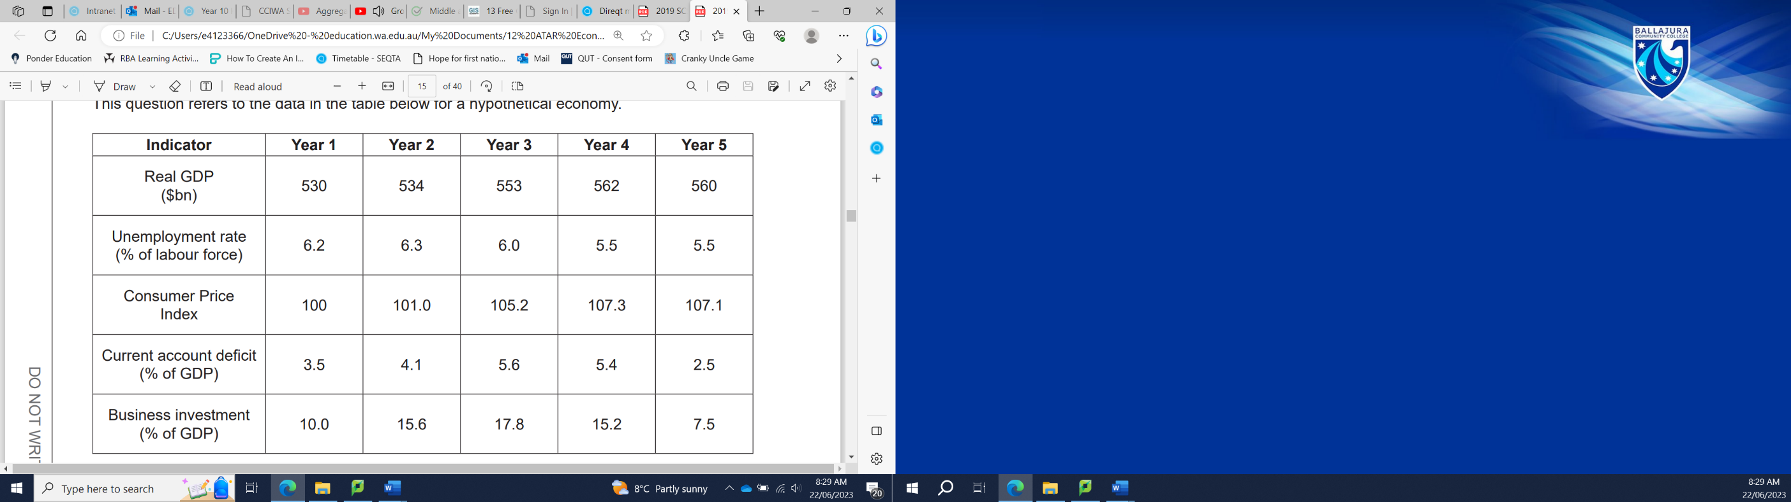

Describe and demonstrate, using the aggregate demand and aggregate supply (AD/AS) model, the performance of the economy from Year 4 to Year 5 in the above table.

**ANSWERS**

|  |  |
| --- | --- |
| **Question 1.**  Draw a fully labelled **AE model** identifying the area where output is greater than spending (disequilibrium) and the equilibrium level where total output is equal to planned spending where the AE function crosses the 45-degree line (Point E). Equilibrium occurs where total planned spending is equal to total output.  At an income level (Real GDP) greater than the equilibrium level, planned spending is less than output, so there is an increase in inventories. This will automatically lead to a situation where firms will cut back on production and the level of output and income will fall back to the equilibrium level Ye. | **3 marks**  **3 marks** |
| **Question 2.**  Define the multiplier: ‘How one man’s spending is another man’s income’. The Multiplier refers to the proportion by which income will rise following an initial change in spending. Multiplier formula: k = 1/1-MPC. Briefly explains the meaning of the MPC: The higher the MPC, the greater the impact will be from a change in spending.  Explains that this $15b being spent on infrastructure is G2 spending, and this increase is an increase in autonomous spending.    Correctly drawn diagram showing the $15b increase in G2 spending and the corresponding multiplied increase in Real GDP. The impact and diagram must be clearly labelled for full marks. | **3 marks**  **1 marks**  **2 marks** |
| **Question 3.**   1. Multiplier = 1 / (1 – 0.9) = 1 / (0.1) = 10 2. Multiplier = 1 / (1 – 0.5) = 1 / (0.5) = 2   ∆ Injections x Multiplier = ∆ Income  $100,000 x 2 = $200,000 **increase** in national income     1. ∆ Injections x Multiplier = ∆ Income   ∆ Injections x Multiplier = $20,000,000  Multiplier = 1 / (1 – 0.6) = 1 / (0.4) = 2.5  ∆ Injections x 2.5 = $20,000,000  $20,000,000 ÷ 2.5 = ∆ Injections = $8,000,000 **increase** in injections | **1 mark**  **2 marks**  **3 marks** |
| **Question 4.**  Draw a fully labelled **AD/AS model** showing a leftward shift (decrease) in AD.  **OR**  Draw a fully labelled **AE model** showing a downward shift (decrease) in AE.  *(For full marks, the model must clearly show the resulting decrease on both axes.)*  Describes any four effects:  • Decline in Real GDP/output  • Fall in employment, loss of jobs  • Fall in price level  • Fall in living standards  • Negative multiplier effect, etc. | **2 marks**  **4 marks** |
| **Question 5.**  Draw a fully labelled **AD/AS model** showing a rightward shift (increase) in LRAS, SRAS and AD.  *(For full marks, the model must clearly show increase in price level and GDP)*  Explains with reference to the model, how this discovery has increased the availability of key resources, which would lead to an increase in potential GDP and a contractionary gap. This is represented by a shift rightward in the Long Run Aggregate Supply for the economy, because in the **long run** the economy will self-correct to that level of output (increased GDP and slight increase in prices).  Explains with reference to the model, how the market would be slow to react to the increase in the availability of resources, however eventually both demand and supply would increase. Firms will increase their supply capacity to capitalise on the increased availability of oil and gas, this will increase SRAS. As output increases, so will wages which leads to a simultaneous increase in AD. SRAS and AD will self-correct until they meet at the potential output level (represented by LRAS). | **2 marks**  **2 marks**  **2 marks** |
| **Question 6.**  LRAS   * Long Run Aggregate Supply represents the optimal level of GDP, and the economy will self-correct to that level of output in the long run. * Long run equilibrium will be at the price and output where LRAS is equal to AD, the optimal level of GDP. * LRAS increases and decreases when the maximum output an economy is capable of producing (optimal level of GDP) expands and contracts. The capacity (maximum output) of an economy changes due to changes in productivity, changes in the availability of capital resources and changes in the amount of labour available.   SRAS   * Short Run Aggregate Supply reflects where the economy is currently operating, not the optimal level of GDP. SRAS takes into account the costs of production (price of inputs) as well as productivity, changes in the availability of capital resources and changes in the amount of labour available. * In the short run, equilibrium will be at the price and output where SRAS is equal to AD, and this might be different from the optimal level of output. * If the short run equilibrium point is less than the optimal level of output, then the economy is in a trough and will expand output to optimal level of GDP. If its more than the optimal level of output, then the economy is at a peak, (operating at an **unsustainable** level of output) and will contract output to optimal level of GDP. | **3 marks**  **3 marks** |
| **Question 7.**  Correctly labelled AD/AS diagram showing AD intersecting the SRAS to the left of the LRAS and labelling the resulting contractionary gap.  Explains the changes in the economy reflected by the changes in the indicators  Describes the change in the indicators  Identifies the change in the indicators  Answer(s) could include: • the economy is in a contraction/recession as Real GDP has declined from $562 billion to $560 billion (negative growth) • unemployment (5.5%) has stopped falling as the demand for labour begins to slow • deflation is being experienced as prices have fallen due to a lack of demand • the CAD has dramatically decreased (5.4% to 2.5%) because there is less spending on imports/reduced inflow of foreign investment • the weakening demand conditions have caused firms to slash their investment spending (15.2% to 7.5%). | **2 marks**  **3/3 marks**  **2/3 marks**  **1/3 marks** |