YEAR 12 ATAR ECONOMICS

Assessment Details

**Unit**

Unit 4, Fiscal Policy

**Schedule**

Task 9, Semester 2, Term 3, Week 3

**Assessment Type**

Multiple Choice/Data Interpretation/Short Answer

**Task weighting**

5% of the school mark

**Conditions**

In class under test conditions

**Contents**

This assessment contains: 12 multiple choice questions and two data interpretation questions.

**Structure**

|  |  |  |  |  |  |
| --- | --- | --- | --- | --- | --- |
| Section | Number of questions available | Number of questions to be answered | Marks available | Percentage of assessment | My score |
| Section One: Multiple Choice | 12 | 12 | 12 | 35.3% |  |
| Section Two:  Data Interpretation /Short Answer | 2 | 2 | 22 | 64.7% |  |
|  | | **Total:** | 34 | 100% |  |

**Items Allowed**

Pens (blue / black preferred), pencils (including coloured), sharpener, correction fluid / tape, eraser, ruler, highlighters and non – programmable calculators approved for use in the WACE examinations.

REMEMBER TO USE YOUR READING TIME EFFECTIVELY!

**Section One – Multiple Choice 12 Marks**

1. Which of the following is an example of discretionary fiscal policy?
2. A fall in government revenue due to the falling price of iron ore.
3. An increase in the amount of Newstart Allowance.
4. Lower than expected government revue from income tax collections.
5. **Increasing the instant asset write-off** threshold to $30,000.
6. One advantage of fiscal policy is
7. Fiscal policy and automatic stabilisation counteract each other
8. It has short effect lag
9. The social and political constraints of the budget process
10. It has a short action lag
11. The best example of an automatic stabiliser is:
12. Interest rates.
13. Tax rates.
14. Total welfare payments.
15. The good and services tax rate

4. Financing a budget deficit through selling government bonds may have the negative effect of

1. Crowding in investment
2. Decreasing interest rates which then leads to inflation
3. Reducing the level of aggregate expenditure in the economy
4. Creating financial crowding out
5. A contractionary budget stance is likely to:
6. Slow economic growth and result in higher levels of unemployment.
7. Slow economic growth and result in increased levels of employment.
8. Increase the rate of economic growth and reduce the level of unemployment.
9. Increase the rate of growth and increase the level of unemployment.

6. If the federal government deficit falls from the previous year, but expenditure still exceeds the revenue, then the budget outcome is:

a) Balanced and the economy is stimulated.

b) In surplus.

c) In deficit.

d) Requiring higher GST taxes.

7. A possible cause of the government’s actual budget surplus being smaller than its planned budget surplus could be:

1. A lower level of tax avoidance than expected
2. Policy initiatives to increase spending
3. A significant appreciation of the Australian dollar
4. A lower level of economic activity than forecast

8. Which of the following is the best reason for a variation in the planned and actual Commonwealth Budget outcome?

1. A large fall in the iron ore price
2. A drought in the ACT
3. A small rise in the employment rate
4. Increased commitments to send troops to the UN

9. An increase in the rate of income tax is an example of

1. Expansionary fiscal policy
2. Automatic fiscal policy
3. Discretionary fiscal policy
4. Redistributive fiscal policy

10. Which of the following are the largest expenditure and revenue categories in the Commonwealth Budget?

1. Education and company tax
2. Social security and welfare and income tax
3. Health and GST
4. Defence and social security

11. If the Government always delivered a balanced budget, what effect would it have on the business cycle?

1. No effect
2. Reduce the volatility
3. Increase the volatility
4. Increase the level of economic activity

12. The cyclical component of the budget outcome refers to

1. Discretionary spending
2. Automatic stabilisers
3. The level of taxation revenue
4. Deliberate fiscal policy changes by the government

**Section two – Short answer and data analysis 22 marks**

**Question 13 (12 marks)**

Refer to the table below to answer parts (a) to (c).

**Australian Government Budget**

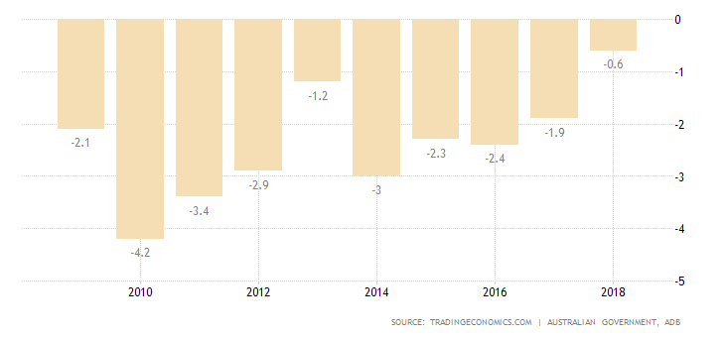

Per cent of GDP

(a) (i) Explain what is meant by a budget deficit. (1 mark)

_________

_________

_________

(ii) Identify the year with the largest deficit. (1 mark)

_________

(iii) Between which two years was the budget most contractionary? (1 mark)

_________

_________

(iv) When is a budget deficit most likely to be used by a government? (2 marks)

_________

_________

_________

_________

_________

(b) Identify and briefly describe three methods the government could use to finance a budget deficit. (3 marks)

_________

_________

_________

_________

_________

_________

_________

_________

_________

_________

_________

_________

(c) Discuss the likely impact on the level of economic activity of the Australian Government’s fiscal policy stance between 2016 and 2018. (4 marks)

_________

_________

_________

_________

_________

_________

_________

_________

_________

_________

_________

_________

_________

_________

_________

_________

_________

_________

_________

_________

**Question 14 (10 marks)**

Use the information from these tables to answer the questions in part (a).

**Australian Federal Budget**

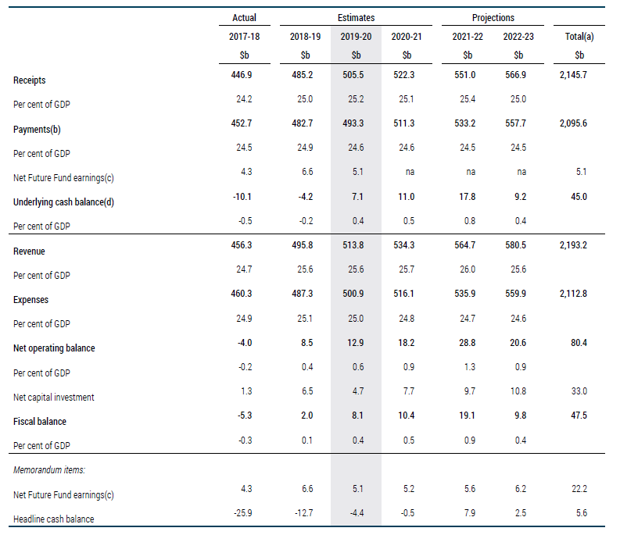

1. (i) What is the actual revenue collected in 2017-2018? (1 mark)

_______________

_________

1. Do budget projections after 2017-2018 show Australia moving towards a deficit or surplus?

(1 mark)

_______________

1. State two disadvantages of fiscal policy and explain using examples. (4 marks)

_______________

_________

_______________

_________

_______________

_________

_______________

_________

_______________

_________

_______________

_________

_______________

_________

_______________

_________

_______________

_________

_______________

_________

_______________

_________

1. If a government wanted to lift its economy out of a recession, what fiscal policy measures could it use? Explain using a diagram. (4 marks)

_______________

_________

_______________

_________

_______________

_________

_______________

_________

_______________

_________

_______________

_________

_________

_______________

_________

_______________

_________

_______________

_________

_______________

_________

_______________

_________

_________

_______________

_________

_______________

_________

_______________

_________