**Section One – Multiple Choice 12 Marks**

|  |  |  |  |  |  |  |  |
| --- | --- | --- | --- | --- | --- | --- | --- |
| 1 | D | 4 | D | 7 | D | 10 | B |
| 2 | B | 5 | A | 8 | A | 11 | C |
| 3 | C | 6 | C | 9 | C | 12 | B |

**Section two – Short answer and data analysis 22 marks**

**Question 13 (12 marks)**

**Australian Government Budget**

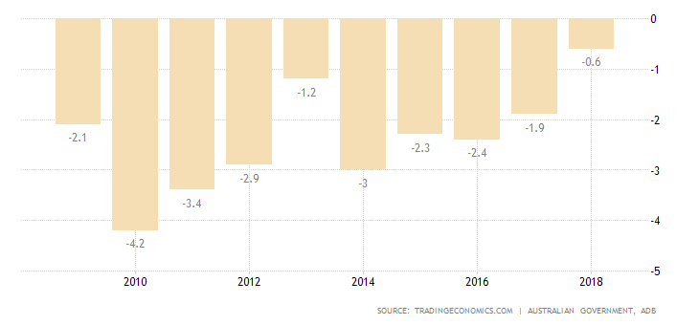

Per cent of GDP

(a) (i) Explain what is meant by a budget deficit. (1 mark)

*A budget deficit occurs when planned/actual revenue is less than planned/actual expenditure over an accounting period.*

(ii) Identify the year with the largest deficit. (1 mark)

*2010*

(iii) Between which two years was the budget most contractionary? (1 mark)

*2012 – 2013change*

(iv) When is a budget deficit most likely to be used by a government? (2 marks)

*A budget deficit has an expansionary effect on aggregate demand and economic activity and would be used when the economy is at the bottom of the business cycle or during early parts of the expansion phase following a recession.*

(b) Identify three methods the government could use to finance a budget deficit. (3 marks)

* *Borrowing from O/s (selling govt. bonds)*
* *The RBA (printing money)*
* *Selling government assets (e.g. Telstra)*

(c) Discuss the likely impact on the level of economic activity of the Australian Government’s fiscal policy stance between 2016 and 2018. (4 marks)

**1 mark – expansionary stance**

**1 mark (or 2 marks at teachers discretion) will increase level of spending in economy**

**1-2 marks for factors that will determine the level of the increase (i to iii)**

*Between 2016 and 2018 the budget deficit fell from -2.4% of GDP to 0.6% of GDP.*

*In 2016 the figures appear to expansionary with 2017 and 2018 less expansionary or moving to a neutral stance.*

*Expansionary policy stances are usually used during periods of low economic activity and are used to increase the level of spending in the economy.*

*The impact on the economy will depend on:*

1. *The make-up of the deficit – how much is cyclical (automatic stabilizers)and how much of the proportion is structural (discretionary spending).*
2. *Whether the change in the budget deficit will have a crowding-in effect (less pressure on i.r. and more resources available to support private sector spending)*
3. *The strength of the multiplier effect.*

**Question 14 (10 marks)**

1. (i) What is the actual revenue collected in 2017-2018? (1 mark)

*$456.3bn*

1. Do budget projections after 2017-2018 show Australia moving towards a deficit or surplus?

(1 mark)

*Surplus*

1. State two disadvantages of fiscal policy and explain using examples. (4 marks)

**2 marks each disadvantage.**

**1 mark for the disadvantage and 1 mark for the example.**

*Time lags (action) - a long time can pass whilst a government designs/consults, approves and implements its fiscal policy. Excessive time lags can weaken discretionary fiscal policy as the measures could be ineffective. Example: Elizabeth Quay construction – long lead in before construction due to planning and environmental regulations. Roe 8 – decision taken, started construction, project subsequently cancelled by new Government.*

*Political problems*

*- Social + political constraints cannot be ignored just to get the economy/budget into shape.*

*- Politicians expansionary bias (politically difficult to wind back spending after periods of higher spending)*

*- Political impact on budgets (1st year tough, 3rd election budget to ‘buy’ votes + marginal seats get more funding). Example: recent Federal election.*

*Crowding out - Possible negative multiplier effects resulting from crowding out (govt. spending leads to falls in other components of AD). Examples: NBN could have been built privately (resource crowding out), private companies ↓ planned investment as ↑ in i.r. due to financial crowding in, Xn crowding out 🡪 Aust. suppliers less competitive as ↑ value of AUD.*

*Other possible answers (must include examples)*

* *Costs of complying with fiscal policy need to be considered.*
* *State Govts may undermine the Federal Govts fiscal plans with own spending.*
* *Economy’s capacity for self-regulation (neo classical economics).*
* *The legacy of debt for future generations.*

1. If a government wanted to lift its economy out of a recession, what fiscal policy measures could it use? Explain using a diagram. (4 marks)

**1 mark – expansionary stance**

**2 marks - examples of fiscal policy measures (must have at least two, preferably 1 tax based, 1 expenditure based.**

**1 mark - diagram (showing a rise in agg. expenditure or using AD/AS model with a deflationary gap and SRAS moving towards LRAS)**

*Expansionary fiscal policy is appropriate to pull an economy out of recession. Expansionary policy will stimulate aggregate demand and expand the economy.*

*Expansionary policy is when the government spends more than it collects through revenue/taxation measures. When aggregate expenditure increases, aggregate demand also expands as there is more money to buy goods and services. Expansionary policy will result in overall expansion of the economy but especially in the sectors where the money is being spent.*

*This could be achieved by*

* *Reducing income tax. This will lead to increased household purchasing power and in increase in the level of disposable household income. Example: recent Federal Govt. income tax cuts/bracket changes.*
* *Cutting corporate tax to increase business spending on input, investments and employments (business profits increase). Example: company tax in Australia coming down from 30% to 25%.*
* *Increase government spending. Infrastructure a particularly effective area, e.g. Government School Building Program post GFC.*

*Diagram: P&K p.257*