NIP Project — Submission Template
Pega Platform project · This document is your complete submission
Read this before you start:
1. Fill in Section 1 completely. The Pega application name must follow the format NIP-[Project]-[YourName].
2. Create a new Operator in Pega with your full name and log in as that operator before taking any screenshot.
3. When you create your test case, enter YOUR FULL NAME in the Issue Description (Vehicle) or Movie Name (Movie) field.
4. Complete only the section for your chosen project. Delete the other project section.
5. Paste one screenshot per user story (10 total). Follow the screenshot rules in your selected project section.
6. Answer every question in Sections 3 and 4 in your own words.
7. Save the file using this format: ProjectName_FirstName_LastName.docx. Use VehicleService or MovieTicket as the ProjectName. Examples: VehicleService_Ravi_Kumar.docx or MovieTicket_Ravi_Kumar.docx.

Section 1 — Your Details
Full Name | Adduri Aswani
Email ID (registered on NIP) | 24335a0501@mvgrce.edu.in
Phone Number | 7569113442
College Name | MVGR College Of Engineering
Course (e.g. IT, CS) | Computer Science And Engineering
State | Andhra Pradesh
Project Chosen (Vehicle Service OR Movie Ticket Booking) | Movie Ticket Booking
Pega Application Name (e.g. NIP-VehicleService-YourName) | NIP-MovieTicket-AdduriAswani
Case Type Name (exact) | Movie Ticket Request
Pega Instance URL | https://qe27cr6z.pegaacademy.net/prweb/app/movie-ticket-booking-management/1O3kfChUoyqPj2zmFwqFq7C8uA6oWcaK*/!STANDARD?pzuiactionzzz=CXtycX1iNDc4NGMyNmM0NjVmODAxZmQ5ZjNhOWUwMjIyNDU5MjU1YjFjYTA5YWRlNGZkMTc3MGQ0YWUxNjQyZjNkN2ExMDA5Y2I3NzhkODVjYTcyMzU3NjI5ZjJjMTkzMzIyMWM=*
Operator Name (created in Pega with your full name) | adduri aswani

Section 2B — Movie Ticket Booking Management Application
Complete this section only if you selected this project. Delete the other project section before submitting.

Screenshot rules — IMPORTANT before you start:
1. Name your Pega application as: NIP-VehicleService-YourName OR NIP-MovieTicket-YourName
2. Create a new Operator in Pega with your full name (Security → Operators) and log in as that operator.
3. When you create your test case, enter YOUR FULL NAME in the Issue Description (Vehicle) or Movie Name (Movie) field.
4. The logged-in operator name must be visible in every screenshot wherever the Pega interface displays it.
5. The student's full name must be visible in all running-case screenshots.
6. Configuration screenshots must clearly show the relevant application or rule name.
Screenshots that do not show these will not be accepted.

US-001 — Submit Movie Ticket Request
What is expected:
Case created, customer submits Movie Name, Show Date, Show Time, Number of Tickets. Validation applied.
Screenshot — paste your screenshot below this line:
[ Paste screenshot here - follow the screenshot rules above ]

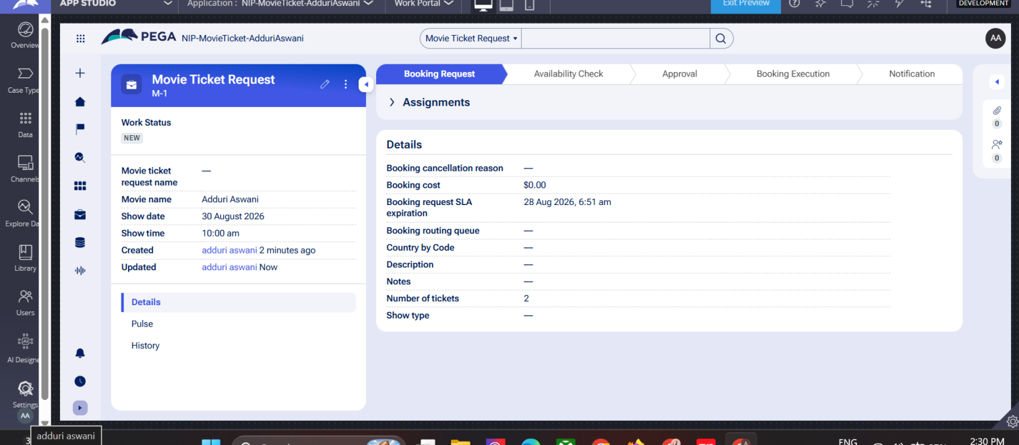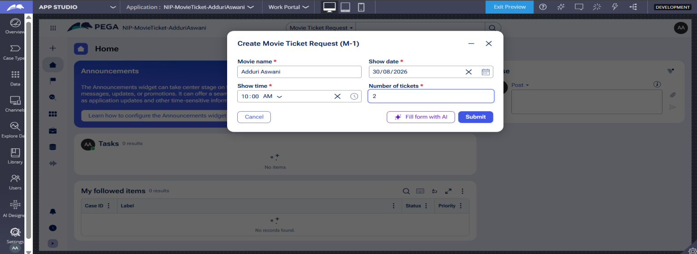
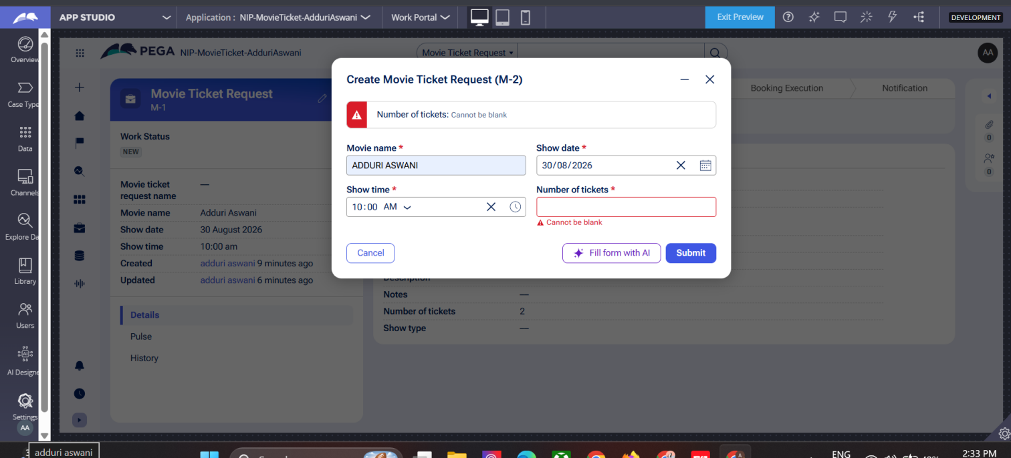

What I built for this (1–2 lines in your own words):
I built a movie ticket booking form where the customer enters the movie name, show date, show time, and number of tickets. I also added required field validation.

US-002 — Check Show Availability
What is expected:
Availability stage. Seat Availability Status and Available Seats Count captured. Booking proceeds only if available.
Screenshot — paste your screenshot below this line:
[ Paste screenshot here - follow the screenshot rules above ]

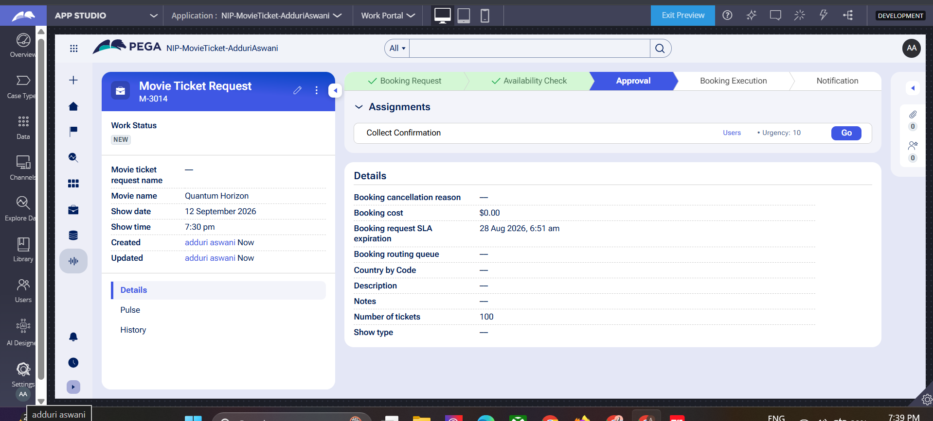

What I built for this (1–2 lines in your own words):
Built the Availability Check stage in the Movie Ticket Request workflow to capture Seat Availability Status and Available Seats Count. Configured conditional logic to ensure the booking proceeds to the next stage only if seats are available.

US-003 — Calculate Booking Cost
What is expected:
Total Cost calculated automatically from Ticket Price and Number of Tickets using a business rule.
Screenshot — paste your screenshot below this line:
[ Paste screenshot here - follow the screenshot rules above ]

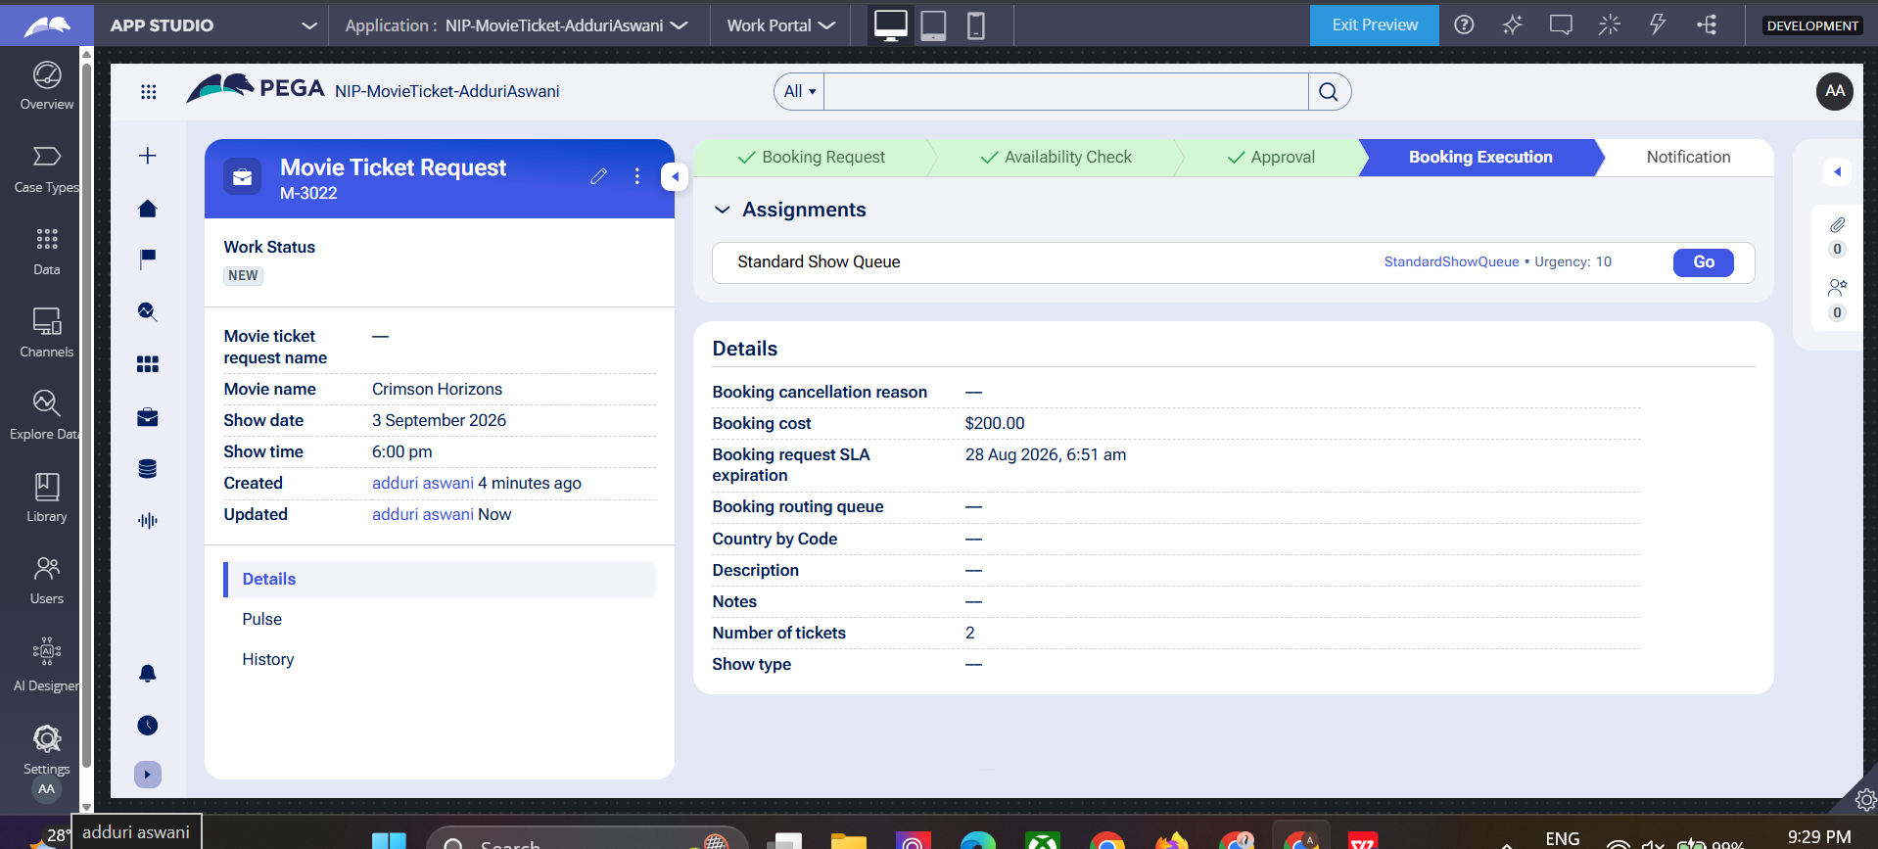

What I built for this (1–2 lines in your own words):
[ Type here ]Built a Declare Expression and Data Transform (CalculateBookingCost) to automatically calculate Booking Cost using the formula Ticket Price × Number of Tickets. Configured LookupShowDetails Data Transform to fetch the Ticket Price from the Show/Movie data and set it on the case before the calculation runs.

US-004 — Confirm Booking Request
What is expected:
Approval stage assigned to Customer. Booking Status captured. Flow branches on confirm/cancel.
Screenshot — paste your screenshot below this line:
[ Paste screenshot here - follow the screenshot rules above ]
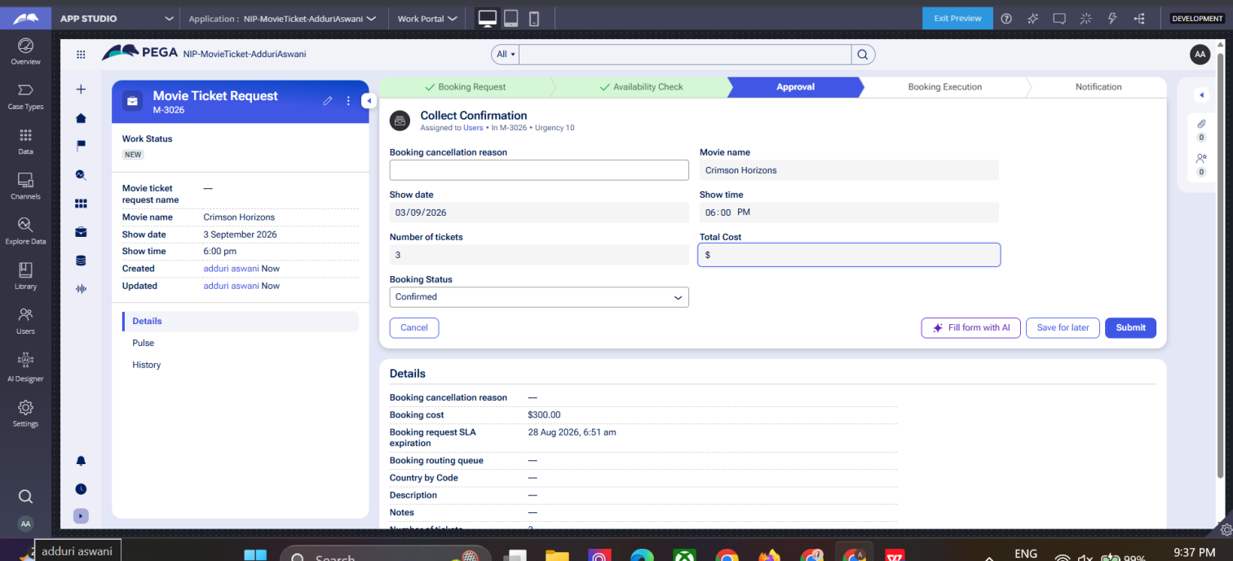

What I built for this (1–2 lines in your own words):
[ Type here ]
Built the Approval stage with a "Collect Confirmation" assignment assigned to the Customer/Users to capture the Booking Status (Confirmed, Pending, Cancelled). Configured the flow to branch based on the Booking Status — proceeding to Booking Execution on Confirm or stopping the booking on Cancel.

US-005 — Maintain Movie and Show Data
What is expected:
Reusable Movie and Show data objects created with Movie Name, Genre, Show Date, Show Time, Seat Capacity — linked to case.
Screenshot — paste your screenshot below this line:
[ Paste screenshot here - follow the screenshot rules above ]
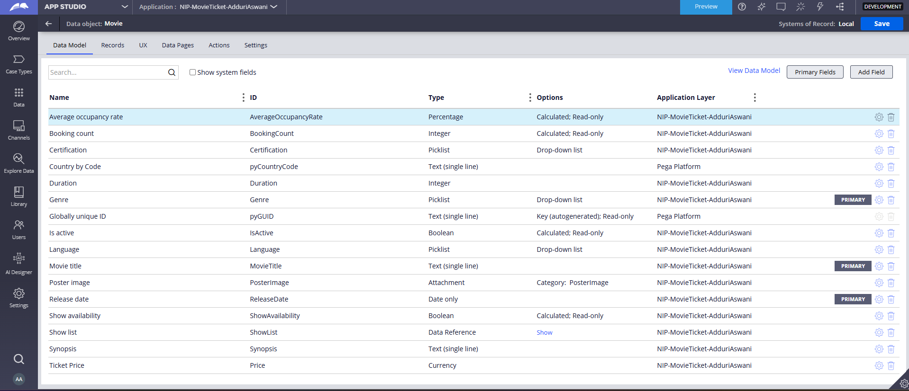
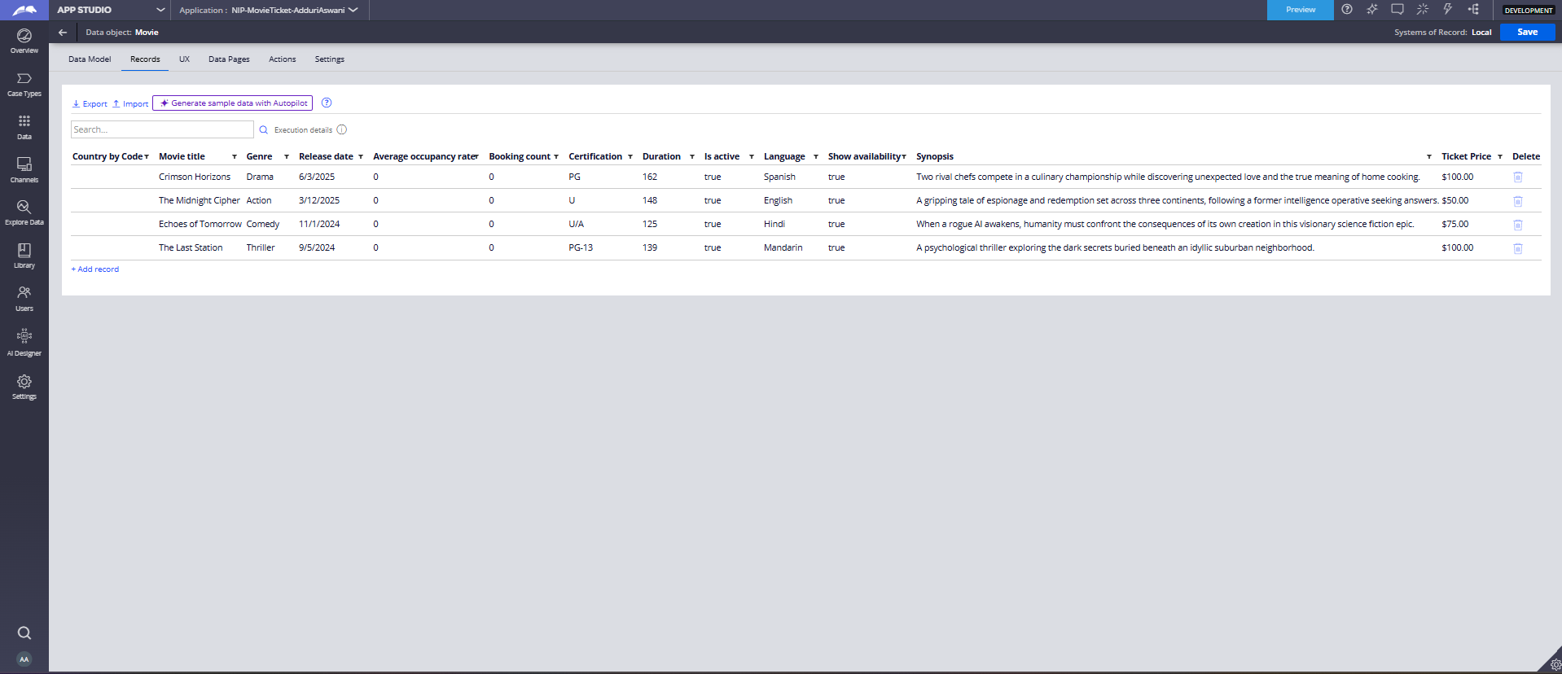
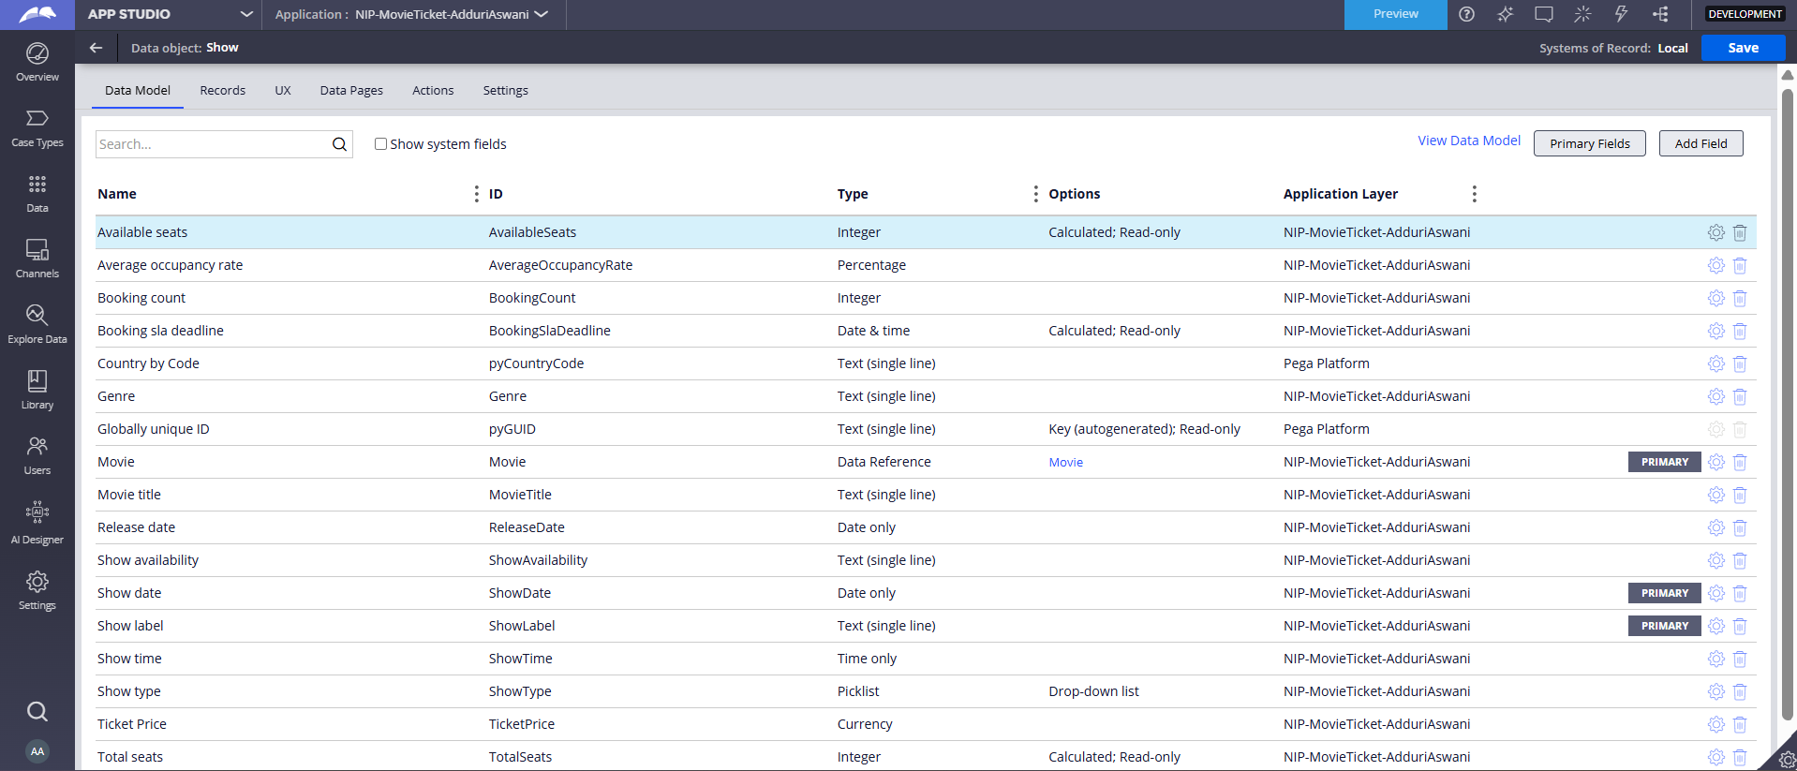


What I built for this (1–2 lines in your own words):
Created reusable Movie and Show data objects in App Studio with fields like Movie Name, Genre, Ticket Price, Show Date, Show Time, and Total Seats (Seat Capacity). Configured a Data Reference to link the Show data object to the Movie, and connected both to the Movie Ticket Request case to enable data reuse across bookings.

US-006 — Review Booking Details
What is expected:
Confirmation screen shows Movie Name, Show Timing, Number of Tickets and Total Cost clearly.
Screenshot — paste your screenshot below this line:
[ Paste screenshot here - follow the screenshot rules above ]
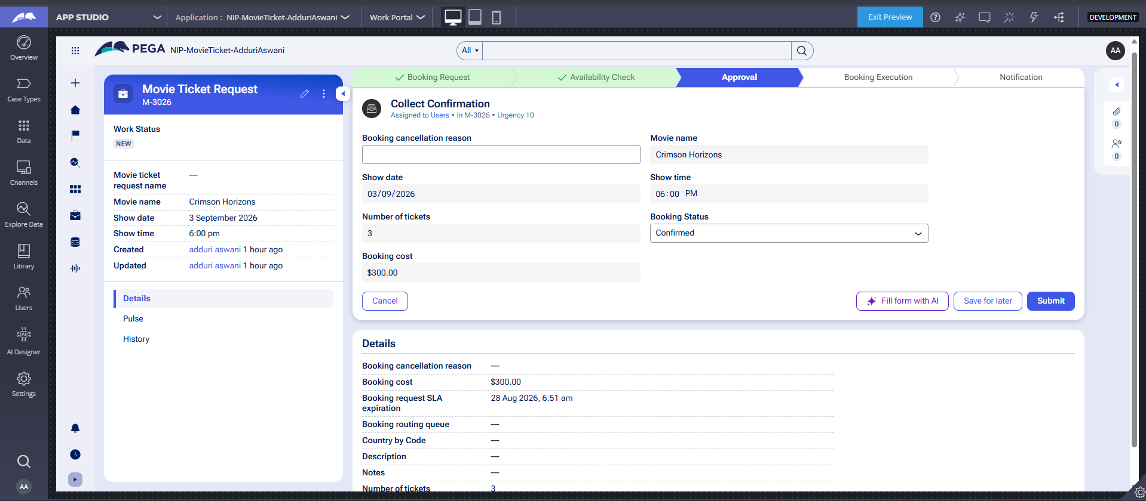

What I built for this (1–2 lines in your own words):
[ Type here ]
Built the Collect Confirmation view in the Approval stage displaying Movie Name, Show Date, Show Time, Number of Tickets, and Total Cost as a confirmation screen for the customer to review before confirming. Configured the view to pull data from the case fields ensuring all booking details are clearly visible to the user at the time of confirmation

US-007 — Process Ticket Booking
What is expected:
Booking Execution stage. Seat Numbers, Ticket ID and Booking Confirmation Status maintained.
Screenshot — paste your screenshot below this line:
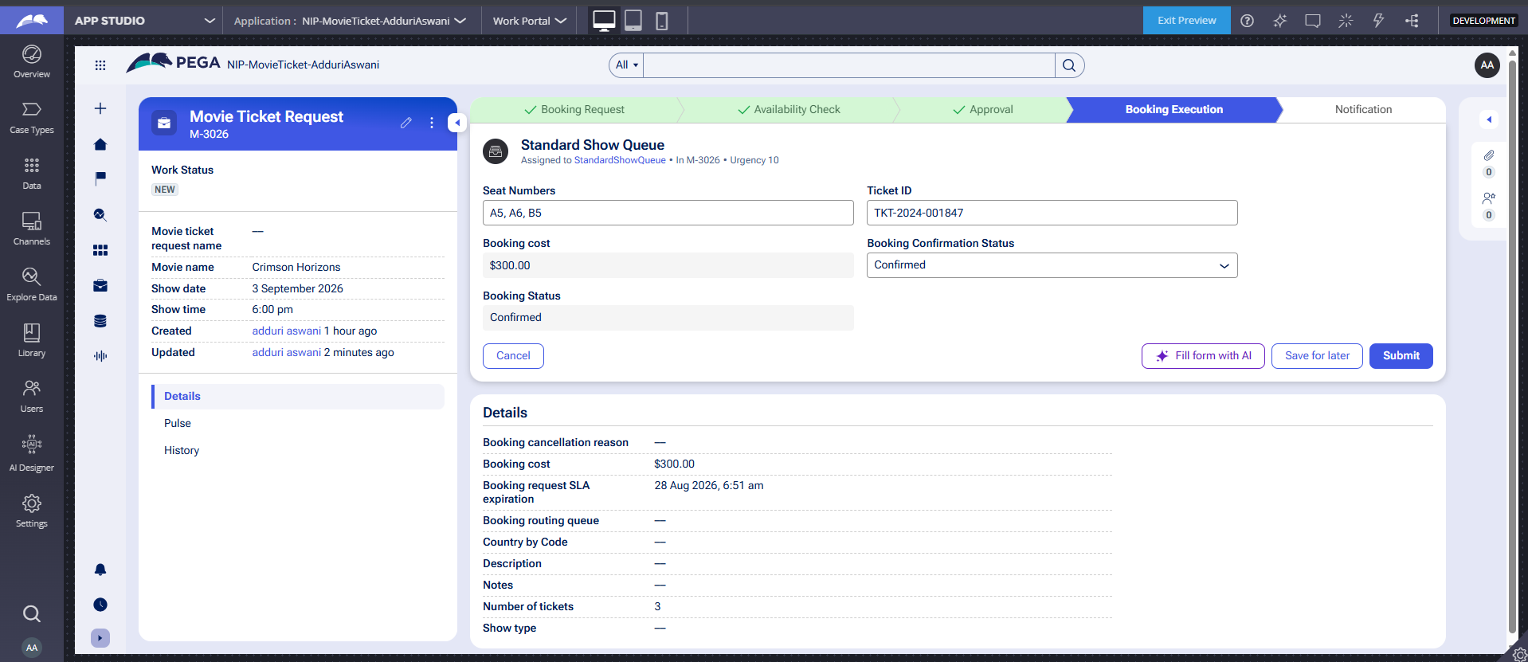

What I built for this (1–2 lines in your own words):
Built the Booking Execution stage with a Standard Show Queue assignment to capture Seat Numbers, Ticket ID, and Booking Confirmation Status during ticket processing. Configured the stage to automatically populate Booking Cost and allow agents to confirm seat allocation and generate a unique Ticket ID (e.g., TKT-2024-001847) for each booking.

US-008 — Notify Booking Confirmation
What is expected:
Correspondence rule triggered on case resolution. Email includes movie, show, seat and cost details.
Screenshot — paste your screenshot below this line:
[ Paste screenshot here - follow the screenshot rules above ]
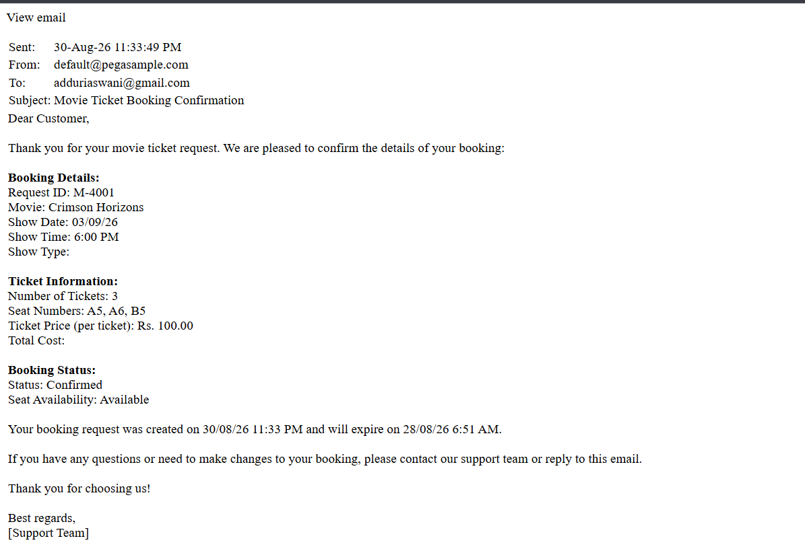

What I built for this (1–2 lines in your own words):
[ Type here ]
Built the Notification stage with a Send Email step using the SendConfirmation_0 Correspondence rule triggered on case resolution to send a booking confirmation email to the customer. The email template includes dynamic fields for Movie Name, Show Date & Time, Seat Numbers, Number of Tickets, Ticket ID and Total Cost auto-populated from the case. 😊

US-009 — Define Booking SLA
What is expected:
SLA configured on the case type. Goal: 1 day. Deadline: 2 days. Priority increases on breach.
Screenshot — paste your screenshot below this line:
[ Paste screenshot here - follow the screenshot rules above ]
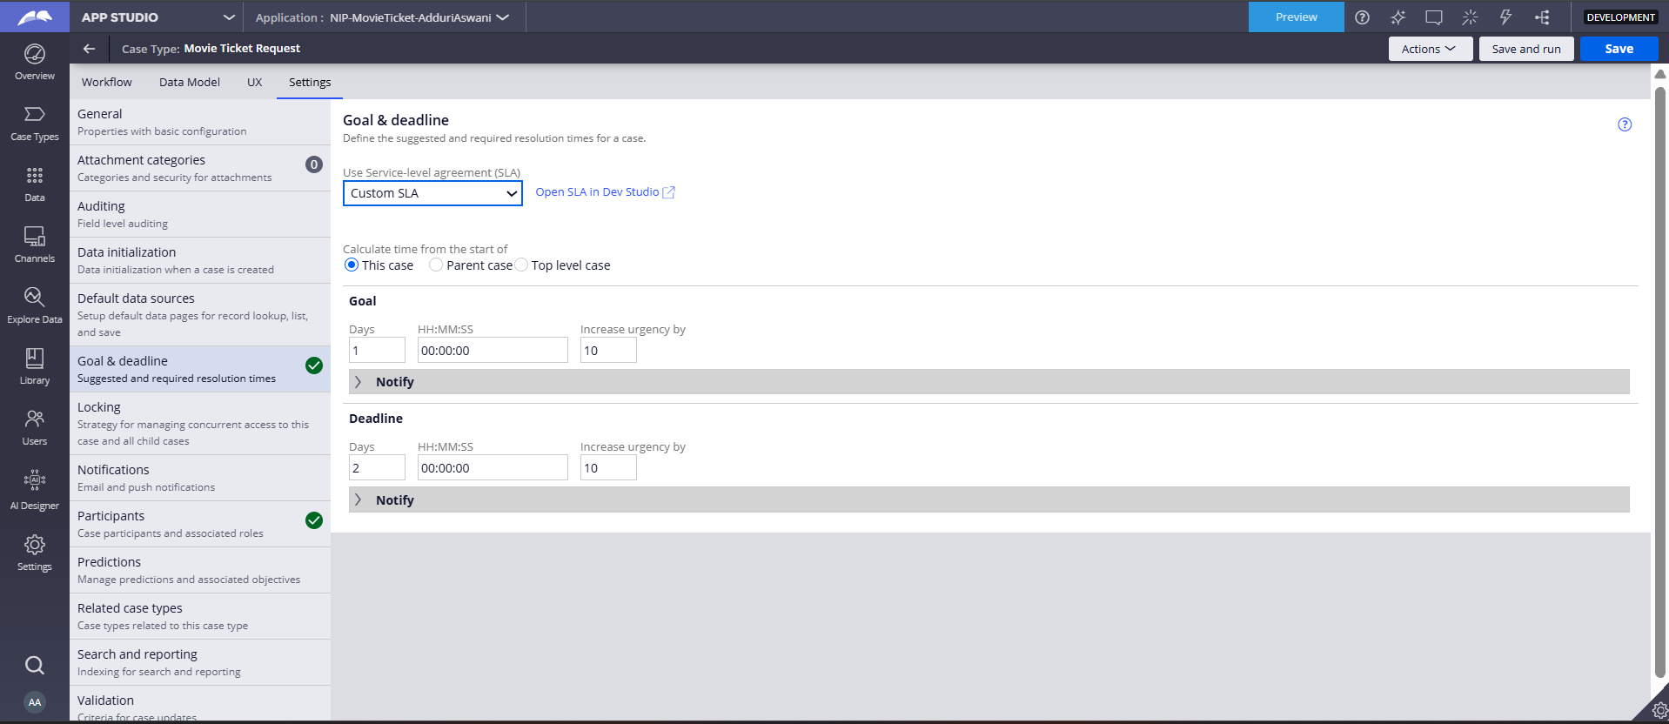
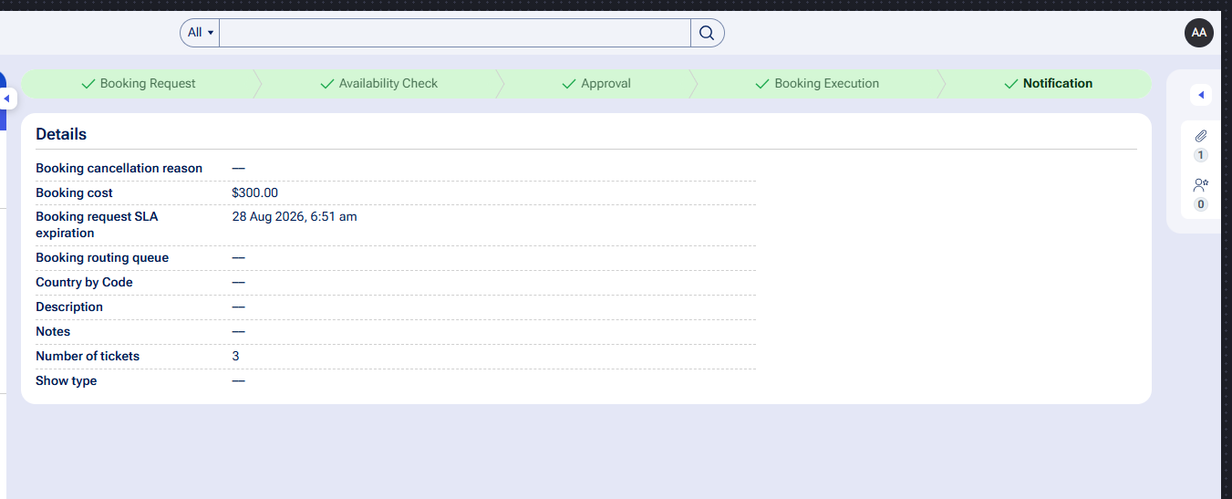

What I built for this (1–2 lines in your own words):
Configured an SLA on the Movie Ticket Request case type with a Goal of 1 day and a Deadline of 2 days from case creation to ensure timely booking processing. Set up urgency escalation so that the case priority automatically increases when the Goal or Deadline is breached, ensuring high-priority cases are addressed promptly.

US-010 — Route by Show Type
What is expected:
Routing rule or Decision Table routes to PremiumShowQueue or StandardShowQueue based on Show Type property.
Screenshot — paste your screenshot below this line:
[ Paste screenshot here - follow the screenshot rules above ]
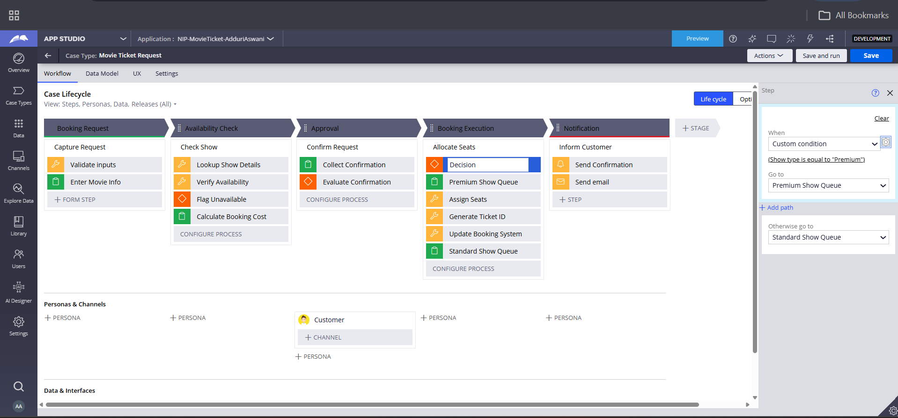

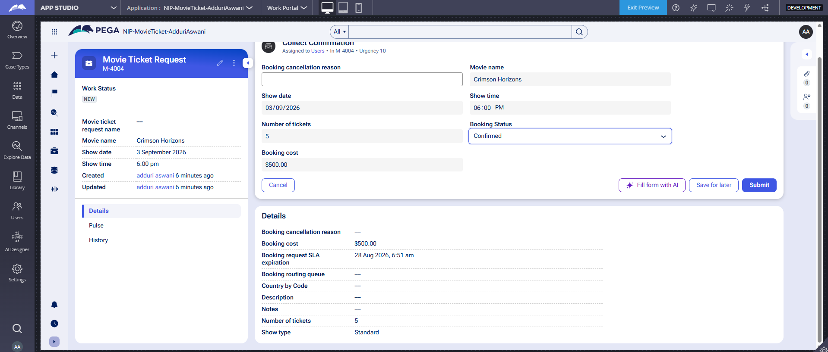

What I built for this (1–2 lines in your own words):
Built a Decision shape in the Booking Execution stage that routes the booking to either PremiumShowQueue or StandardShowQueue based on the Show Type property of the case. Configured the LookupShowDetails Data Transform to fetch the Show Type from the Show data record and set it on the case, enabling dynamic queue routing logic.

Section 3 — About Your Application
These answers are checked against your screenshots. Write exactly what is in your application.

Q1. List your stages in the order they appear in your case lifecycle.
Stage names in order, separated by commas.
[ Type here ]
Booking Request, Availability Check, Approval, Booking Execution, Notification

Q2. Name the data object(s) you created and the properties inside them.
Data object name and its properties.
Data Object 1-Movie
Movie Title, Genre, Language, Duration, Certification, Ticket Price, Release Date, Synopsis, Show List (Data Reference → Show), Is Active, Show Availability, Poster Image
Data Object 2-Show
Show Label, Show Date, Show Time, Show Type, Total Seats, Available Seats, Ticket Price, Movie (Data Reference → Movie), Genre, Booking SLA Deadline, Booking Count, Average Occupancy Rate, Show Availability

Q3. What is the exact name and type of the rule you used to calculate Total Cost?
Provide:
• Rule Name
• Rule Type
• Properties used in the calculation
• Formula used
Rule Details:
Rule Name - BookingCost
Rule Type -Declare Expression
Class -MoV-MovieTic-Work-MovieTicketRequest
Properties Used - TicketPrice × .NumberOfTickets
Formula - BookingCost = TicketPrice * NumberOfTickets

Section 4 — Your Understanding
Short, honest and specific answers score well.

Q4. What did Blueprint generate for you, and what did you add or change yourself afterwards?
Be specific about what was already there and what you built or modified on top.
Case Lifecycle & Stages:
。 All 5 stages: Booking Request, Availability Check, Approval, Booking Execution, Notification
Data Types:
。 Movie and Show data objects with basic fields
Rules (Auto-generated stubs):
Data Transforms: CalculateBookingCost, LookupShowDetails, VerifyAvailability, AssignSeats, GenerateTicketID, UpdateBookingSystem
Declare Expression: BookingCost
。 Correspondence rule: SendConfirmation_0
。 Flow: BookingRequest_Flow
Views: CalculateBookingCost
。 SLA configuration on the case type
What I Built / Modified:
Fixed/Configured:
。 Declare Expression (.BookingCost) → Changed formula from 0 to .TicketPrice *NumberOfTickets
Data Transform (CalculateBooking Cost) → Fixed Target from .TotalCost to BookingCost with correct formula
LookupShowDetails Data Transform → Added TicketPrice and ShowType mappings from Show data (was completely empty)
Correspondence Rule (SendConfirmation_0) → Added dynamic property fields (Movie Name, Show Date, Seat Numbers, Total Cost etc.)
Show Data Records Created and configured Show record with Ticket Price, Show Type linked to Movie
Movie Data Records → Added 4 Movie records with Genre, Ticket Price etc.
。 Booking Execution View → Added Seat Numbers, Ticket ID, Booking Confirmation Status fields
。 Notification Stage → Added Send Email step linked to correspondence rule

Q5. Was there anything Blueprint created that you had to correct or configure further? Describe one example.
A real example from your own work.
Real Example: Declare Expression (.BookingCost)
What Blueprint Generated:
Blueprint created the Declare Expression.BookingCost but the formula was set to a hardcoded value of `0`:
Set Booking cost = Value of 0
The Problem:
The Booking Cost was always showing $0.00 on every case regardless of the number of tickets or ticket price.
What I Fixed:
I opened the Declare Expression in Dev Studio, clicked Check Out, and changed the formula from 0 to:
Set Booking cost = Value of TicketPrice * .NumberOfTickets
But that alone wasn't enough - I also discovered that the LookupShowDetails Data Transform (also generated by Blueprint) was completely empty with just a comment:
"Created from run data transform smart shape"
So I added the TicketPrice mapping in LookupShowDetails:
Set TicketPrice = equal to .Show.TicketPrice
Result:
After both fixes, the Booking Cost calculated correctly e.g., ₹100 x 3 tickets = ₹300 as seen in case M-3026

Q6. Explain your case flow from creation to resolution, in order.
What happens first, who does what, when the case closes.
Movie Ticket Request Case Flow (Creation to Resolution)
Booking Request (Customer)
Customer creates a new Movie Ticket Request by entering Movie Name, Show Date, Show Time and Number of Tickets.
The system runs LookupShowDetails to fetch Ticket Price and Show Type from the Show data object and automatically calculates Booking Cost = Ticket Price Number of Tickets via the Declare Expression.
Availability Check (System)
The VerifyAvailability Data Transform checks if seats are available for the selected show.
Seat Availability Status and Available Seats Count are captured. If seats are available, the case moves forward otherwise it is stopped.
Approval (Customer/Users)
A "Collect Confirmation" assignment is routed to the Users queue.
The customer reviews booking details (Movie Name, Show Date, Show Time, Number of Tickets, Total Cost) and selects Booking Status Confirmed, Pending or Cancelled.
If Confirmed case moves to Booking Execution. If Cancelled case is stopped.
Booking Execution (System + Agent)
A Decision shape routes the case to either PremiumShowQueue or StandardShowQueue based on the Show Type.
The agent Assigns Seats, Generates a Ticket ID and updates the Booking Confirmation Status.
The Booking System is updated via the UpdateBooking System Data Transform.
5 Notification (System)
The SendConfirmation_0 Correspondence rule is triggered automatically.
A confirmation email is sent to the customer including Movie Name, Show Date, Show Time, Seat Numbers, Ticket ID and Total Cost.
The case is marked as RESOLVED and the workflow is complete.

Q7. Pick two design choices you made in your application and explain why you made them.
For each design choice, provide:
• What you implemented
• Why you chose that approach
• What benefit it provides to the application
Design Choice 1: Declare Expression for Booking Cost Calculation
What I implemented:
Used a Declare Expression (.Booking Cost) to automatically calculate the Booking
Cost using the formula:
BookingCost = TicketPrice x NumberOfTickets
Why I chose this approach:
Declare Expressions in Pega use forward chaining they automatically recalculate whenever the source properties (TicketPrice or NumberOfTickets) change, without needing to manually trigger the calculation at a specific step.
Benefit to the application:
The Booking Cost is always accurate and up-to-date in real time. If the customer changes the number of tickets, the cost recalculates instantly no manual intervention or step-specific logic needed. This reduces errors and improves the user experience.
Design Choice 2: Reusable Movie and Show Data Objects with Data Reference
What I implemented:
Created two separate data objects - Movie and Show and linked them using a Data Reference (Show has a Movie reference, Movie has a ShowList reference).
Why I chose this approach:
Instead of storing Movie and Show details directly on every case, I used reusable data objects so that the same Movie/Show data can be shared across multiple booking requests without duplication.
Benefit to the application:
This ensures data consistency if a Movie's Ticket Price changes, it only needs to be updated in one place (Movie data object) and all new bookings will automatically get the correct price. It also makes the application scalable and maintainable.

Q8. What was the hardest part, and how exactly did you fix it?
Specific and honest. A real challenge scores much better than a generic answer.
The Hardest Part: Getting Booking Cost to Calculate Correctly
The Challenge:
The Booking Cost was always showing $0.00 even after I set the Ticket Price in the Show data record. This was frustrating because the Declare Expression and Data Transform both looked correct on the surface, but the cost still wouldn't calculate.
What Made It Difficult:
The problem wasn't in one place it was a chain of three separate issues:
1. The Declare Expression (.Booking Cost) was hardcoded to by Blueprint not using any formula
2. The CalculateBooking Cost Data Transform was setting. TotalCost instead of BookingCost wrong target field
3. The LookupShowDetails Data Transform was completely empty it had only a comment and was never actually fetching TicketPrice from the Show data record and setting it on the case
How I Fixed It:
I had to fix all three in order:
Fixed the Declare Expression changed formula to .NumberOfTickets
. TicketPrice
Fixed the Data Transform → changed target from. TotalCost to .BookingCost
Fixed LookupShowDetails added the mapping Set
TicketPrice
.Show.TicketPrice
I also discovered a picklist mismatch the Show data type had Regular/Premiere values but the case only accepted Standard/Premium/IMAX which caused a validation error. I resolved this by updating the Show record to use Standard and hardcoding the Show Type in LookupShowDetails.
What I Learned:
In Pega, Blueprint generates rule stubs but doesn't fully configure the logic. You need to trace the entire data flow from data object data transform → property → calculation to find where the chain breaks.

Q9. If the approval step was only needed when Total Cost is above a certain amount, what would you change in your application?
Explain what you would change and where. You do not need to build this.
what I would change:
Add a Decision/Condition before the Approval Stage
Where: In the Case Lifecycle (App Studio Case Types Movie Ticket Request → Workflow)
What: I would add a Decision shape or Condition before the Approval stage that checks:
If BookingCost > [threshold amount] → Go to Approval Stage
If BookingCost ≤ [threshold amount] Skip Approval Booking Execution Go directly to
2 Configure the Approval Stage as Conditional
Where: App Studio Case Types → Workflow Approval Stage settings
What: In Pega, each stage has a "Skip stage when" condition option. I would set:
Skip when: BookingCost <= 500
This means:
。 Booking Cost > $500 → Approval required
Booking Cost $500 → Approval skipped, goes straight to Booking Execution
3 Alternatively Use a When Rule
Where: Dev Studio Records Decision When Rule
What: Create a When Rule called IsHighValueBooking:
Condition: BookingCost > 500
Then reference this When Rule in the flow transition to conditionally route to Approval or skip it.

Q10. List three exact rule names from your application that you personally created or modified.
Include the rule name and rule type for each one (for example: CalculateTotalCost - Declare Expression).
Three Rules I Personally Modified:
Declare Expression .BookingCost`
Modified the formula from hardcoded to. TicketPrice *
. NumberOfTickets to
enable automatic Booking Cost calculation.
2.'LookupShowDetails` Data Transform
Added property mappings for TicketPrice and record to the case it was completely empty when Blueprint generated it.
ShowType from the Show data
3.`SendConfirmation_0` - Correspondence
Updated the email template to include dynamic property references for Movie Name, Show Date, Show Time, Seat Numbers, Number of Tickets and Total Cost replacing the static placeholder text that Blueprint had generated.

Q11. List all personas used in your application.
List the persona names exactly as they appear in your application.
Booking Agent
Customer
Users
Q12. List all work queues used in your application and explain when each one is used.
For each work queue, provide its exact name and the condition or type of work routed to it.
Work Queues in Movie Ticket Request Application:
Users
When used: In the Approval stage for the "Collect Confirmation" assignment.
Condition: All booking requests are routed here regardless of Show Type for customer confirmation. The customer reviews Movie Name, Show Date, Show Time, Number of Tickets and Total Cost, then selects Booking Status (Confirmed/Pending/Cancelled).
2 StandardShowQueue
When used: In the Booking Execution stage for processing standard show bookings.
Condition: Routed here when Show Type = "Standard" - the Decision shape in the
Booking Execution stage evaluates the Show Type property and routes accordingly. The agent assigns seat numbers, generates Ticket ID and confirms the booking.
3 PremiumShowQueue
When used: In the Booking Execution stage for processing premium show bookings.
Condition: Routed here when Show Type = "Premium" - the Decision shape routes premium bookings to this queue for priority handling. The agent assigns seat numbers, generates Ticket ID and confirms the booking.
Before You Submit — Check These
Read through once before uploading.
1. Section 1 filled in. Application named as NIP-[Project]-[YourName]. Names match the actual application.
2. New Operator created in Pega with my full name. I logged in as that operator for all screenshots.
3. Only my chosen project section remains — the other project section is deleted.
4. All 10 user story screenshots are pasted and follow the operator, running-case, application, and rule-name evidence requirements.
5. Every question in Sections 3 and 4, including Q10, Q11, and Q12, is answered in my own words.
6. This file is named using the required format: ProjectName_FirstName_LastName.docx (for example, VehicleService_Ravi_Kumar.docx or MovieTicket_Ravi_Kumar.docx) and uploaded as required.

