Training order:
- LLM model pretrained
- SFT
- RLFH

RLFH order:
- Prepare input data:
  - Give the LLM a Prompt (LLM model/ Policy Network / "Actor")
  - Receive an answer
  - Then again (2 times or more)
  - Human annotation, comparing the 2 answers, marking them as “Good” and “Wrong” (in basic option). Note that it is easier for humans to compare two answers than to give an absolute rank for a single answer
  - Run for many times, thousands to million, collecting this data

- Build an additional model calling it the Reward Model (RW) – actually duplicate the LLM Model
  - The last hidden layer (one before the output layer), as in the Transformer LLM, has a list of tokens and for each token there is a vector (e.g. 4096 size)
  - In LLM model, each token in the lats hidden layer is connected to the output layer, which is the vocabulary (e.g. 50000 size). Then it goes to Softmax, and Probability for each token in the vocabulary
  - In RM, we replace the output layer with a simple layer that just gives a single number (called Regression head)
  - The number is calculated as a dot product of the last vector and the weights plus bias

- Run pairs of results from the above LLM as input to the RM
  - Take the first pair of results that we got from the above LLM
  - Input into the RM the first pair: Prompt+answer1
  - Get a number
  - Then do it for the second pair: Prompt+answer2
  - And we get 2 numbers

- Calculate loss:
L(x_j, x_k) = -log(σ(S_RM(x_j) - S_RM(x_k)))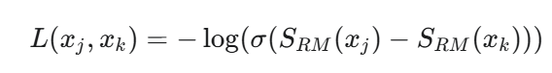
  - SRM are the results numbers that we got from the RM model for xj or xk
  - The left one, SRM(xj), is the good answer and the right one is the wrong answer, this is where the human ranking affects the process, we get negative or positive number, depending on their values
  - The result is -log of the sigmoid, so it will give a minus close to 0 value or larger than 1 value, and this is the loss function

- Training the RM model
  - With the above loss, we run backpropagation (gradient etc..) on the RM model
  - And then to the next pair
  - In this way we train the RM to give the “right” score for a prompt+answer
  - Until the RM is ready

- Then we prompt on the LLM
  - Get answer
  - Run it on the trained RM and get a score

- Run PPO
    - State = Prompt
    - Actor = LLM model
    - We use another LLM model called Value Network ("Critic")
    - It is usually similar to the LLM model, but usually smaller
    - The input for the Value model is the same as the input to the LLM model (prompt) – given in parallel
    - Two kinds of rewards, “immediate” and “future”. Future is when we calculate the reward on a prompt – we don’t know what will come next, what answer and how good it will be, what reward we will get, it is just an estimation, so it is “future”. The second kind is “immediate”, we give the prompt+answer. So we know how good the answer is so we have an immediate reward.
    - The Value model output is a number, V(s) value of the state, estimation of the total “future reward” that we will get if we use this state
    - “Immediate reward” - is it the scalar number that we get from the RM
    - “Estimated expected total future reward” - for this state, what is the reward we are going to get, assuming that the next steps in the trajectory (answer) will be produced according to this LLM – policy
    - We calculate the Advantage function – how much this action is better than the expected average from this state
    - At​=Rt​−V(st​)
    - We want to maximize the Advantage, we calculate gradient, and we back propagate the LLM Model - finally improving it
    - The calculation is similar to the one in DeepSeek paper
    - 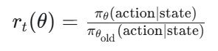
    - 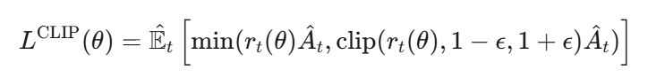
    - We train the critic to estimate the future by giving it prompt + real reward we got from the RM
    - The Value model uses the below loss function
    - 