** *University of Ghardaia* **

***Department of Mathematics and Computer Science***

***3rd year computer science***

*SSD report*

***Student preparation*:**

* *Benkhelifa Oumaima*
* *Benkhelifa Assia*

***Under the supervision of Professor:***

* *Mr.Houssam eldin dagha*

***INTRODUCTION***

In today's interconnected world, social media platforms have become indispensable tools for communication, collaboration, and content sharing. As the digital landscape continues to evolve, the demand for flexible and dynamic database solutions to power these platforms is paramount. This project endeavors to design and implement a database for a social media website, leveraging semi-structured data to accommodate the fluid nature of user profiles, posts, and interactions.

With a focus on adaptability and scalability, this project will identify key entities within a social media ecosystem, including users, posts, comments, likes, and friendships. By defining attributes for each entity, we aim to strike a balance between structured data, providing a fixed schema for core elements, and semi-structured data, offering flexibility for evolving content.

Through the development of an Entity-Relationship Diagram (ERD), the relationships between entities will be visually represented, guiding the construction of a robust database schema. Utilizing a database management system (DBMS) that supports semi-structured data, such as MongoDB or CouchDB, we will model the data to ensure efficient storage and retrieval while accommodating dynamic user-generated content.

A key aspect of this project involves the implementation of basic CRUD operations, allowing for seamless management of user data, posts, and interactions. Additionally, a user authentication and authorization system will be designed to safeguard user privacy and maintain data integrity.

Finally, this project aims to provide a flexible, user-centric social media database system capable of supporting vibrant online communities and promoting meaningful communications in the digital sphere

To design a social media database using semi-structured and structured data,

First, we must provide a simplified definition of structured data and semi-structured data

* Structured data : Structured data refers to information that adheres to a formal, pre-defined data model or schema. This includes data stored in rigid tabular formats such as SQL database tables or Excel spreadsheets. Every column has precise data types like string, number, or date. The schema defines relationships and does not frequently change. Querying the neatly organized data can be optimized using indexes.
* Semi-structured data : semi-structured data lacks a strict schema but still retains some organizational structure. It allows for flexibility in data representation, enabling the storage of varying types and formats of data within the same data store. Semi-structured data often utilizes formats like JSON (JavaScript Object Notation), XML (eXtensible Markup Language). This flexibility is particularly advantageous in scenarios where data schemas may evolve over time or where the data structure is inherently dynamic, such as in social media platforms.

To implement a database for a social media sit using structured data , we touched on the use of WordPress which is considered a powerful and flexible anvironment for the development of websites

WordPress is a popular and widely used content management system (CMS) for building and managing websites. there are several benefits to consider:

**Open Source and Free**: WordPress is open-source software, which means it is free to use and has a large community of developers contributing to its improvement. This makes it a cost-effective solution for building websites.

**User-Friendly Interface:** WordPress has a user-friendly and intuitive interface, making it accessible to both beginners and experienced users. You can easily create, edit, and manage content without extensive technical knowledge.

**Extensive Plugin Ecosystem:** WordPress has a vast ecosystem of plugins that add functionality to your site. Whether you need SEO tools, e-commerce capabilities, or social media integration, there's likely a plugin available to meet your needs.

**Themes for Design Customization:** WordPress allows you to change the look and feel of your website easily by applying different themes. There are thousands of free and premium themes available, enabling you to customize the design to match your preferences.

**Community Support:** Being one of the most popular CMS platforms, WordPress has a large and active community. This community provides support, tutorials, and resources, making it easier for users to find solutions to problems or get help when needed.

**SEO-Friendly:** WordPress is inherently designed to be search engine-friendly. It generates clean and semantic code, and there are numerous SEO plugins available to help optimize your content and improve your site's visibility in search engine results.

**Responsive Design:** Many WordPress themes are responsive, meaning they adapt to different screen sizes. This is crucial for providing a positive user experience on various devices, including desktops, tablets, and smartphones.

**Regular Updates and Security:** WordPress releases regular updates to enhance functionality, fix bugs, and improve security. It's important to keep your WordPress installation, themes, and plugins up to date to ensure the best performance and security.

**Scalability:** WordPress is scalable, allowing you to start with a small blog and grow into a large, complex website or even an e-commerce platform. It can handle various types of content and is suitable for different purposes.

**Built-in Blogging Capabilities:** Originally designed as a blogging platform, WordPress excels in managing and publishing content. Even if your site is not primarily a blog, you can use its built-in blogging features to enhance your content strategy.

It is therefore a versatile and powerful platform that enables individuals, companies, foundations and developers to easily create and manage professional-looking websites

Because we use structured data, we have created a diagram that allows us to read the database:

* **Entity-relationship diagram (ERD):**

|  |
| --- |
| Users |
| userId (PK)  username  fullName  email  birthdate location  bio  createdAt  friends |

|  |
| --- |
| likes |
| likeId (PK)  userId (FK)  postId (FK)  createdAt |

|  |
| --- |
| posts |
| postId (PK)  userId (FK)  content  createdAt |

|  |
| --- |
| Comments |
| commentId (PK)  userId (FK)  postId (FK)  content  createdAt |

PK: Primary Key

FK: Foreign Key

We drew this diagram according to the following explanation :

**Users Table:**

This table represents users registered on the platform.

**Attributes** (columns): userId, username, fullName, email, birthdate, location, bio, createdAt.

userId is the primary key (PK), uniquely identifying each user.

Users can create multiple posts, comments, and likes, so there are relationships pointing to these tables.

**Posts Table:**

Stores posts made by users.

**Attributes**:

postId, userId (foreign key from Users table), content, createdAt.

Each post is associated with a user (via userId).

**Comments Table:**

Stores comments made on posts.

**Attributes:** commentId, userId (foreign key from Users table), postId (foreign key from Posts table), content, createdAt.

Each comment is associated with a user (via userId) and a post (via postId).

**Likes Table:**

Stores likes given to posts.

**Attributes:** likeId, userId (foreign key from Users table), postId (foreign key from Posts table), createdAt.

Each like is associated with a user (via userId) and a post (via postId).

The lines connecting the tables indicate the relationships between them:

Users can create multiple posts, comments, and likes, hence the lines connecting Users to Posts, Comments, and Likes.

Posts can have multiple comments and likes, hence the lines connecting Posts to Comments and Likes.

Each comment and like belongs to a specific post and is made by a specific user, hence the lines connecting Comments and Likes to Users and Posts.

Users can be friends with multiple other users, hence the line connecting Users to Friends, and Friends to Users.

This diagram provides a visual representation of how the entities in your database are related to each other, helping to understand the overall structure of your database schema.

After developing the diagram that shows how the elements are related to each other , we will embody this diagram on the database , which is XAMPP

* **Xampp:**

XAMPP provides a local server environment that allows you to run WordPress on your computer. This is beneficial for developers who want to test and develop their WordPress websites locally before deploying them to a live server.

**Ease of Installation**: XAMPP simplifies the installation process of a web server, database server, and scripting languages. It includes Apache (web server), MySQL (database server), PHP, and Perl, which are essential components for running WordPress.

**Cross-Platform Compatibility:** XAMPP is available for Windows, Linux, and macOS, making it a cross-platform solution. This flexibility allows developers to work on WordPress projects regardless of the operating system they are using.

**Database Management with phpMyAdmin**: XAMPP comes with phpMyAdmin, a web-based tool for managing MySQL databases. This is useful for handling WordPress database-related tasks, such as importing/exporting databases and executing SQL queries.

**Easy Configuration:** XAMPP simplifies the configuration of the web server, making it easier for users to set up and run a local environment for WordPress development. Configuration files are readily accessible, allowing users to make necessary adjustments.

**Offline Development:** With XAMPP, you can work on your WordPress site without needing an internet connection. This is particularly useful when you want to focus on development without worrying about hosting and domain-related issues.

**Testing Environment:** XAMPP provides a safe and isolated environment for testing plugins, themes, and other modifications to your WordPress site before applying them to a live website. This helps in identifying and resolving issues before they impact the production site.

**Version Control:** Developers can use version control systems like Git more effectively when working locally with XAMPP. It allows for better tracking of changes and collaboration among team members.

**Security in Development**: Since XAMPP is a local environment, you can experiment and make changes without affecting a live website. This minimizes the risk of security vulnerabilities or disruptions to your actual WordPress site during development.

In summary, using XAMPP for local WordPress development offers convenience, flexibility, and a secure environment for testing and refining your website before deploying it to a live server.

Here are the steps to install XAMPP on your system:

**Windows:**

1. Go to the official Apache Friends website (https://www.apachefriends.org/index.html) and download the latest version of XAMPP for Windows.

2. Once the download is complete, run the executable file (e.g., xampp-windows-x64-8.1.6-0-VS16-installer.exe).

3. The XAMPP setup wizard will open. Click "Next" to proceed.

4. Read and accept the license agreement, then click "Next."

5. Choose the components you want to install (e.g., Apache, MySQL, FileZilla, etc.). It's recommended to leave the default selections unless you have specific requirements.

6. Select the installation directory or leave the default location, then click "Next."

7. Choose whether to install XAMPP for all users or the current user only, then click "Next."

8. The installation process will start. It may take a few minutes to complete.

9. Once the installation is finished, you can choose to start the control panel and install additional components if needed.

10. Click "Finish" to exit the setup wizard.

After the installation is complete, you can launch the XAMPP Control Panel and start the Apache and MySQL servers. XAMPP will also create a directory (e.g., C:\xampp on Windows ) where you can access the web server document root, PHP files, and database management tools.

It is a suitable tool for running the necessary server software locally, allowing users to install and develop WordPress sites on their computers. Provides an effective workflow for WordPress developers to build and test websites in a controlled environment before live streaming.

Designing and implementing a social media database using semi-structured data allows flexibility, scalability and efficient handling of various types of content

We have therefore implemented the scheme designed in MongoDB, ensuring effective indexing to query and manipulate semi-organized data. We used MongoDB's flexible document structure to store user profiles, posts, comments, likes, friendships, notifications and messages.

* **Definition of MongoDB:**

MongoDB is a NoSQL database that is often used in web development, and it can be integrated with WordPress or any other web application

**Schema Flexibility:** MongoDB is a NoSQL database, which means it doesn't require a predefined schema. This flexibility allows you to store data in a more dynamic and scalable manner, which can be advantageous for certain types of applications.

**JSON-Like Documents:** MongoDB stores data in BSON (Binary JSON) format, which is a binary representation of JSON-like documents. This format is easy to understand and work with, making it convenient for developers.

**Scalability:** MongoDB is designed to scale horizontally by adding more servers to your database cluster. This makes it suitable for applications that need to handle large amounts of data and high traffic.

**Query Language:** MongoDB uses a powerful and expressive query language that supports a wide range of queries, including complex ones. This can be beneficial for retrieving and manipulating data in ways that suit your application's requirements.

**Indexing:** MongoDB supports indexing on various fields, which can significantly improve query performance. Proper indexing is crucial for efficient data retrieval, especially as your dataset grows.

**Geospatial Queries:** MongoDB has built-in support for geospatial queries, making it well-suited for applications that involve location-based data.

**Community Support:** MongoDB has a large and active community, providing a wealth of resources, tutorials, and forums for support.

**Learning Curve:** If you're used to working with traditional relational databases, the shift to a NoSQL database like MongoDB might involve a learning curve. Understanding the document-oriented model and the query language may take some time.

**Transaction Support:** MongoDB, as of my last knowledge update in January 2022, provides atomic operations on a single document but does not support multi-document transactions across multiple collections in a way that relational databases do. This may be a consideration for applications requiring strict ACID transactions.

**Tooling:** While MongoDB provides a variety of tools for management and monitoring, the ecosystem might not be as mature or feature-rich as some traditional relational databases. However, this has been improving over time.

In summary, MongoDB offers advantages in terms of flexibility, scalability, and query capabilities. However, it's important to weigh these benefits against the learning curve and potential differences in how data is handled compared to traditional relational databases.

If you want to install MongoDB, you can follow these general steps. Keep in mind that the specific instructions may vary slightly depending on the operating system and version you are using:

**1**. Choose your operating system: MongoDB supports different operating systems including Windows, macOS, and Linux.

**2**. Download MongoDB: Visit the official MongoDB website (https://www.mongodb.com/try/download/community) and download the appropriate installer for your operating system.

**3**. Install MongoDB on Windows:

- After downloading the installer, double-click it to start the installation process.

- Follow the prompts in the installation wizard. You can choose the installation directory

and whether to install MongoDB Compass (the GUI tool for MongoDB).

**4**. Verify installation: After installation, you can verify that MongoDB is installed correctly by opening a terminal or command prompt and running the mongod command. This starts the MongoDB server by mongod.exe from the bin directory of the MongoDB installation path.

**5**. Get started with MongoDB: Once MongoDB is installed and running, you can interact with it using MongoDB Shell (mongo) or through various MongoDB client applications and libraries.

It is important to refer to the official MongoDB documentation for detailed installation instructions specific to your operating system and version. Additionally, always make sure to download MongoDB from a trusted source to avoid any security risks

To implement the scheme designed in mongodb we can convert the semi-structured data represented in the JSON format into a structured chart such as document type definition (DTD) when converted to XML format. While JSON does not inherently support scheme definitions such as XML, converting JSON data to XML and DTD app allows for the imposition of structuring and verification rules on data. This can enhance semi-regulatory data management, interoperability and reliability.

* **Schema DTD :**

<!ELEMENT data (users, posts, comments, likes)>

<!ELEMENT users (user+)>

<!ELEMENT user (username, email,password, birthdate, location?, is_admin?)>

<!ATTLIST user userId ID #REQUIRED>

<!ELEMENT username (#PCDATA)>

<!ELEMENT email (#PCDATA)>

<!ELEMENT birthdate (#PCDATA)>

<!ELEMENT location (#PCDATA)>

<!ELEMENT password (#PCDATA)>

<!ELEMENT is_admin (#PCDATA)>

<!ELEMENT posts (post*)>

<!ELEMENT post (content ,user_Id, title)>

<!ATTLIST post postId ID #REQUIRED>

<!ELEMENT content (#PCDATA)>

<!ELEMENT user_Id (#PCDATA)>

<!ELEMENT title (#PCDATA)>

<!ELEMENT comments (comment*)>

<!ELEMENT comment (userId, text, createdAt)>

<!ATTLIST comment commentId ID #REQUIRED

<!ELEMENT userId (#PCDATA)>

<!ELEMENT text (#PCDATA)>

<!ELEMENT post_Id(#PCDATA)>

This Document Type Definition (DTD) defines the structure of an XML document based on the provided JSON data. Let's break down each declaration:

**Root Element Declaration:**

<!ELEMENT data (users, posts, comments)>: Defines the root element data, which contains sub-elements users, posts, comments

**Users Element Declaration:**

<!ELEMENT users (user+)>: Defines the users element, which contains one or more user elements.

**User Element Declaration:**

<!ELEMENT user (username, email, password, birthdate, location?,is_admin)>: Defines the structure of the user element, specifying child elements for attributes like username, fullName, email, birthdate, etc.

<!ATTLIST user userId ID #REQUIRED>: Declares the userId attribute for the user element as an ID attribute, meaning it must have a unique value within the document.

**Child Element Declarations for User:**

<!ELEMENT username (#PCDATA)>: Defines the username element containing parsed character data.

Similar declarations exist for email, birthdate, location, is_admin

**Posts Element Declaration:**

<!ELEMENT posts (post*)>: Defines the posts element, indicating it contains zero or more post elements.

**Post Element Declaration:**

<!ELEMENT post (content,user_Id,title)>: Defines the structure of the post element, specifying child elements for attributes like content

<!ATTLIST post postId ID #REQUIRED>: Declares the postId attribute for the post element as an ID attribute, meaning it must have a unique value within the document.

**Child Element Declarations for Post:**

<!ELEMENT content (#PCDATA)>: Defines the content element containing parsed character data.

<!ELEMENT)>: Defines the comments element, indicating it contains zero or more comment elements.

<!ELEMENT title (#PCDATA)>: Defines the title element containing parsed character data..

**Comment Element Declaration:**

<!ELEMENT comment (userId, text,post_id)>: Defines the structure of the comment element, specifying child elements for userId, content, and createdAt.

<!ATTLIST comment commentId ID #REQUIRED>: Declares the commentId attribute for the comment element as an ID attribute, meaning it must have a unique value within the document.

<!ELEMENT text (#PCDATA)>: Defines the text element containing parsed character data.

<!ELEMENT post_Id(#PCDATA)>: Defines the post_id element containing parsed character data.

Creating a website using MongoDB, Python, involves building a full-stack web application where MongoDB serves as the database, Python for backend development, and Node.js for the server-side runtime environment

Set up MongoDB: Install MongoDB on your local machine like we mentioned above or use a cloud-based MongoDB service like MongoDB Atlas. Make sure MongoDB is running and accessible.

Choose a Python web framework: There are many Python web frameworks available, such as Flask, Django, and FastAPI. For simplicity, we used Flask.

Installing Flask and PyMongo: Flask is a lightweight web framework for Python, and PyMongo is a MongoDB driver for Python.

* Install them using pip:

pip install Flask

* Install pymongo to interact with MongoDB from Python:

pip install pymongos

***Conclusion***

Finally, designing and implementing a social media database that leverages semi-structured data offers many advantages in terms of flexibility, scalability, and efficient handling of diverse content. By integrating structured and semi-structured approaches, we were able to create a powerful platform capable of accommodating dynamic user profiles, posts, comments, likes, and interactions.

The database management system chosen, MongoDB, provided native support for semi-structured data in the form of JSON documents, enabling us to model complex relationships and diverse content types effectively.

By incorporating semi-structured data, we make it easier to customize user profiles with customizable fields, dynamic post content that accommodates different media types, and additional user information beyond the primary profile.

Key features such as user authentication and authorization, CRUD operations, search functionality, and scalability strategies have been successfully implemented, ensuring the completeness, robustness, and efficiency of the social media platform.

Overall, this project demonstrates the power and versatility of semi-structured data in the design of modern database systems for social media platforms, enabling the creation of rich, dynamic, and user-centric experiences. As the platform evolves and grows, further improvements and enhancements can be made to meet the changing needs and requirements of users.

* ***Appendices:***
* *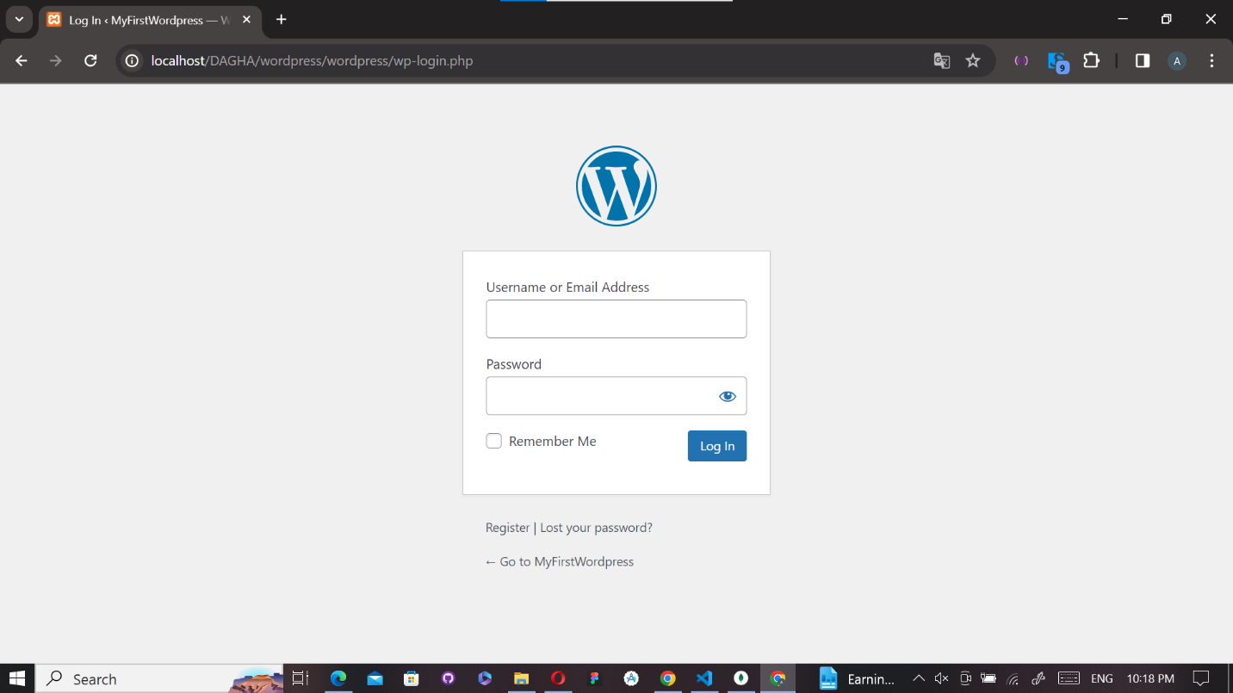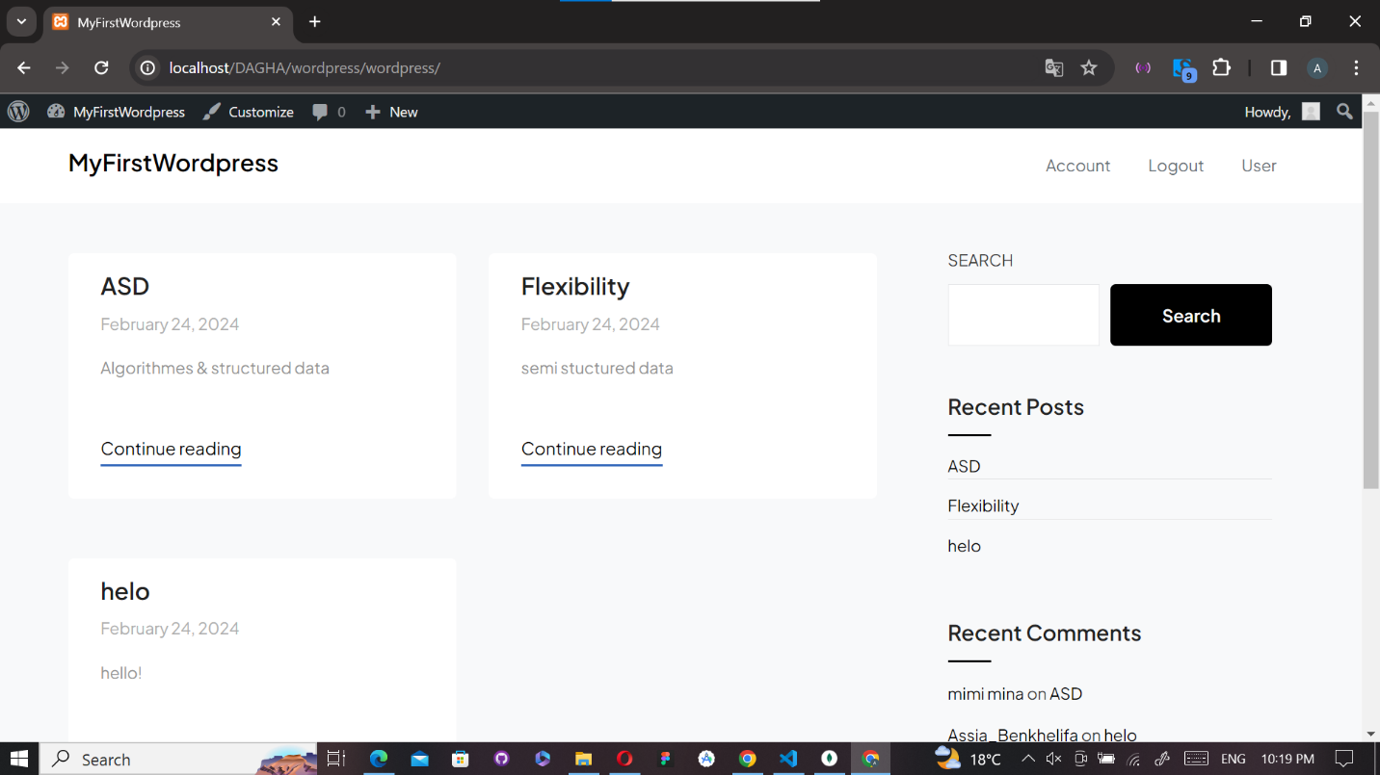Screenshots of the database WordPress:*

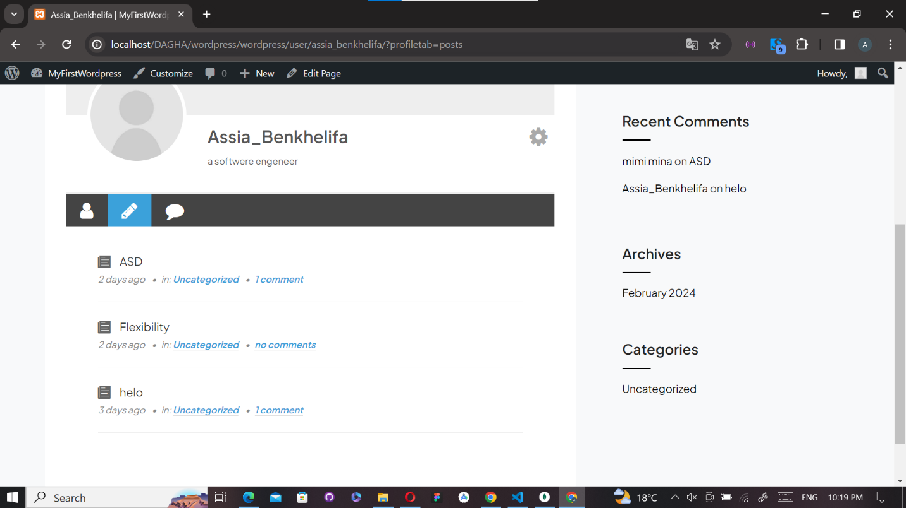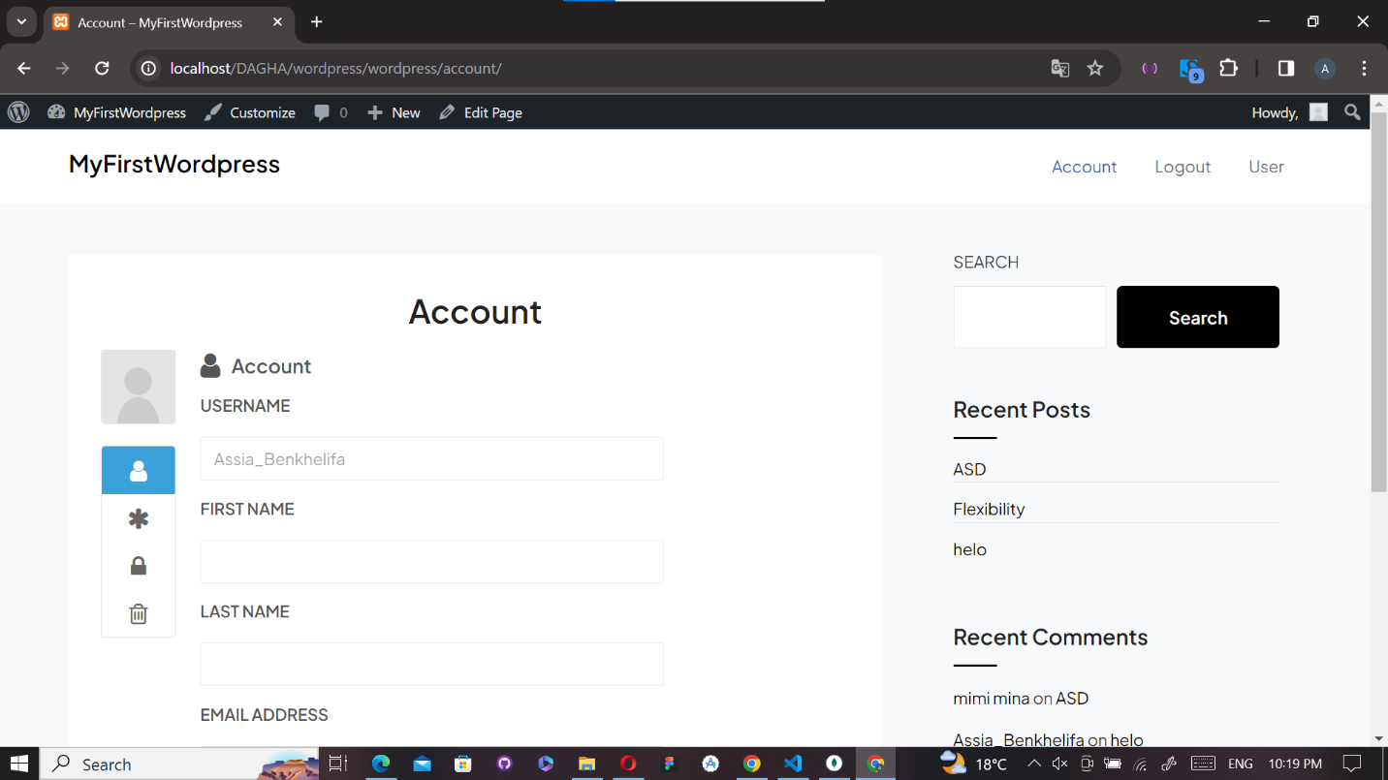

* *Screenshots of the database MongoDB :*

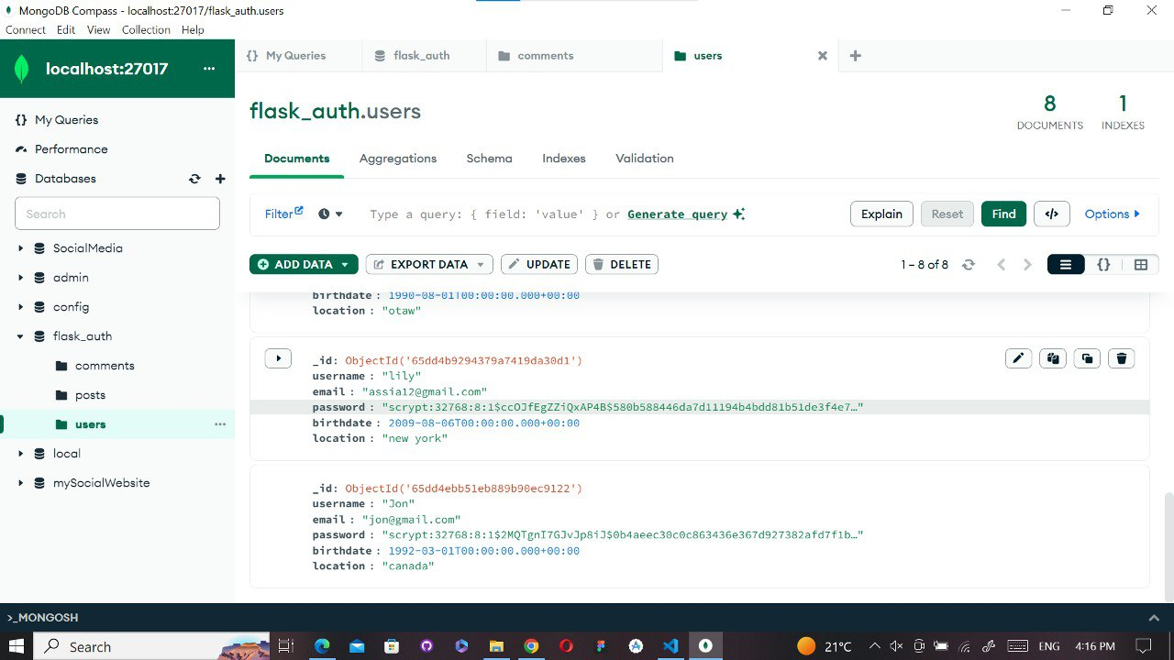

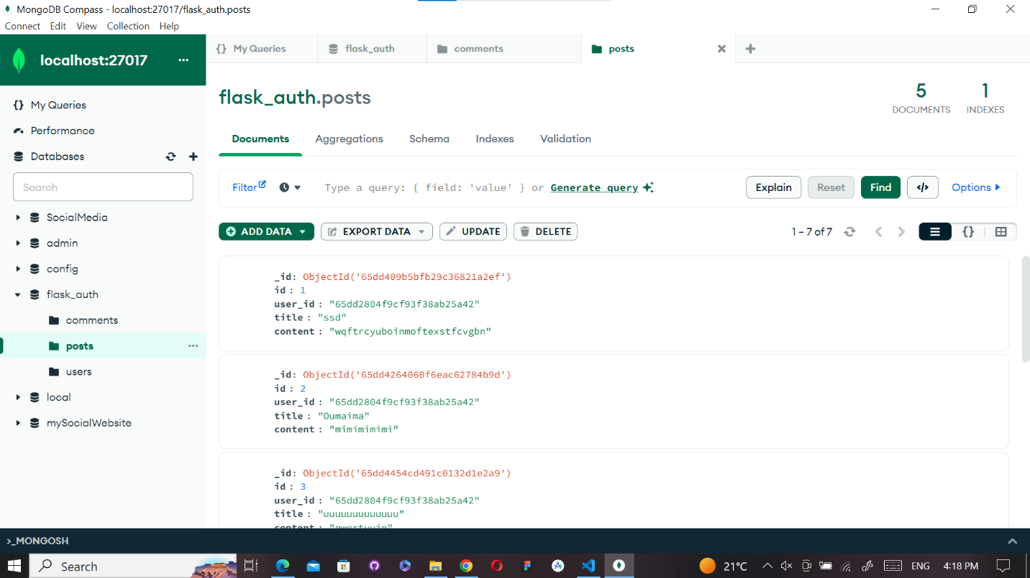

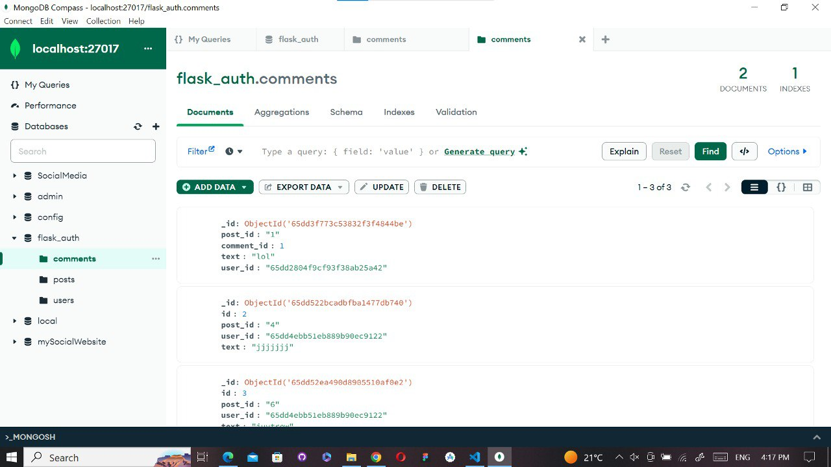

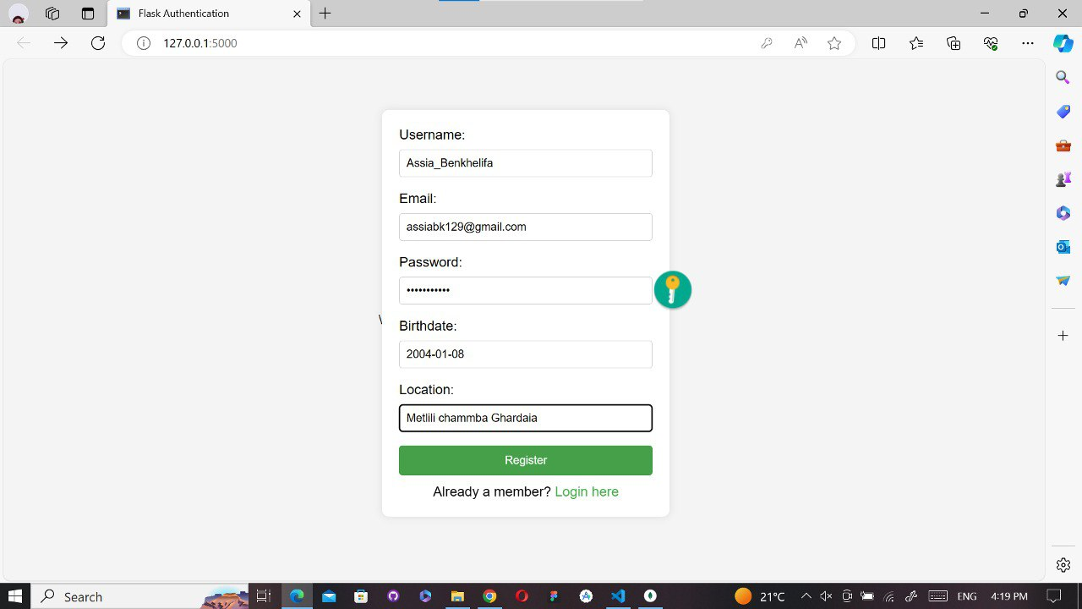

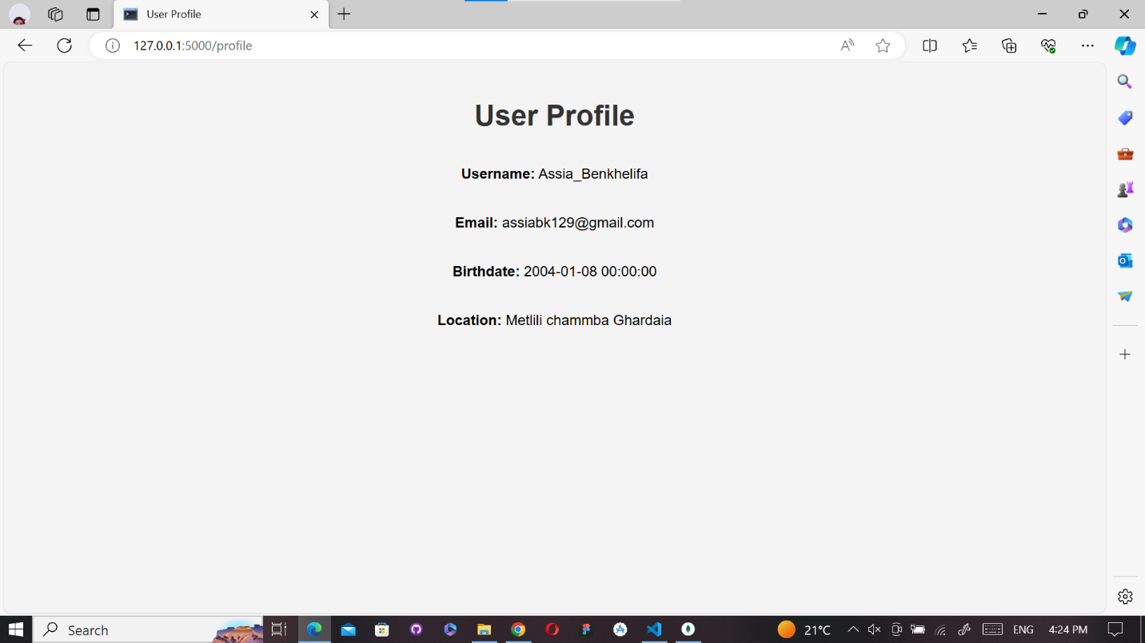

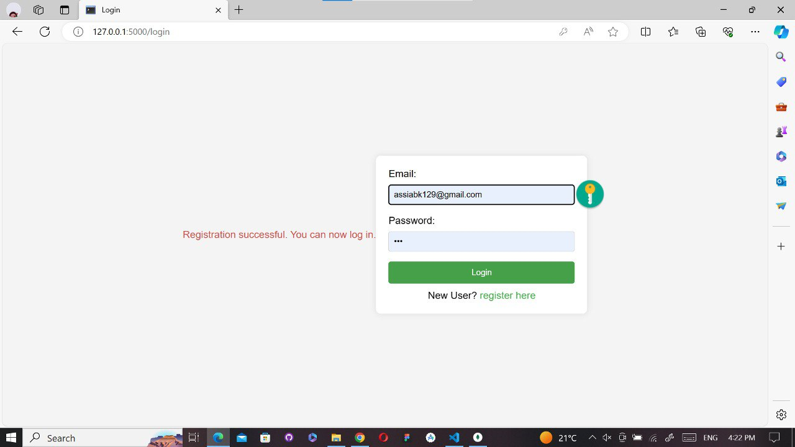

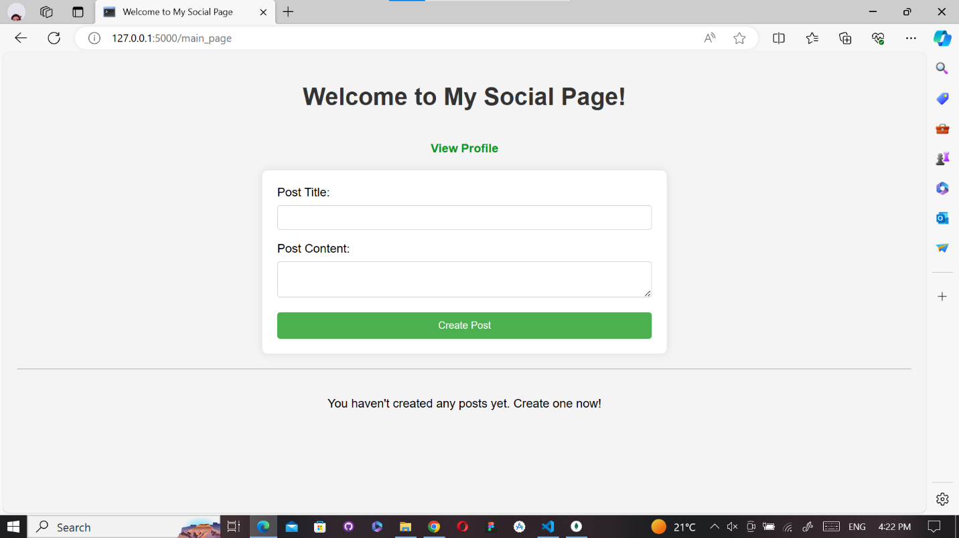

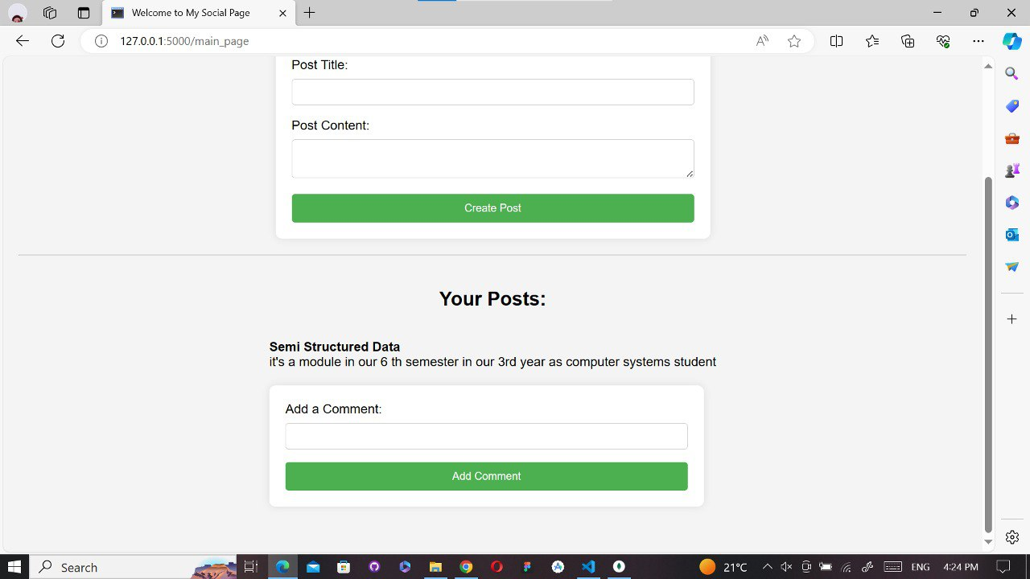

* 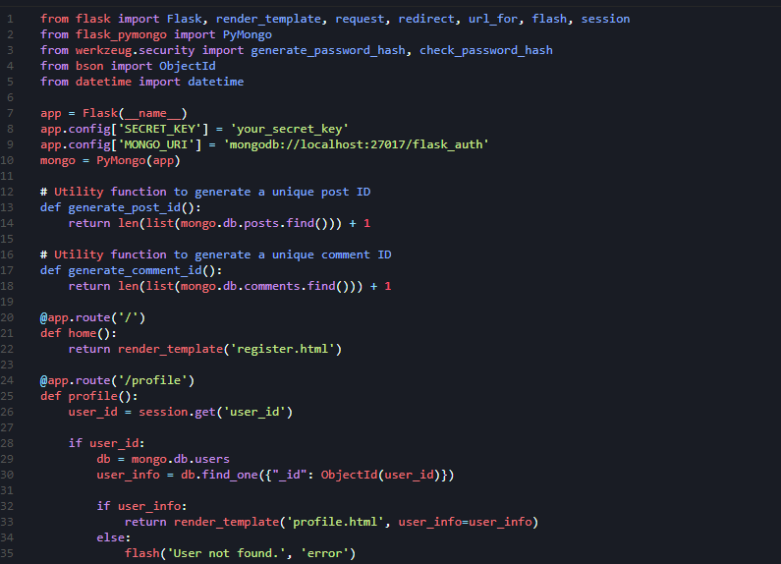*Source code :*

