Js-assaignment loops

1.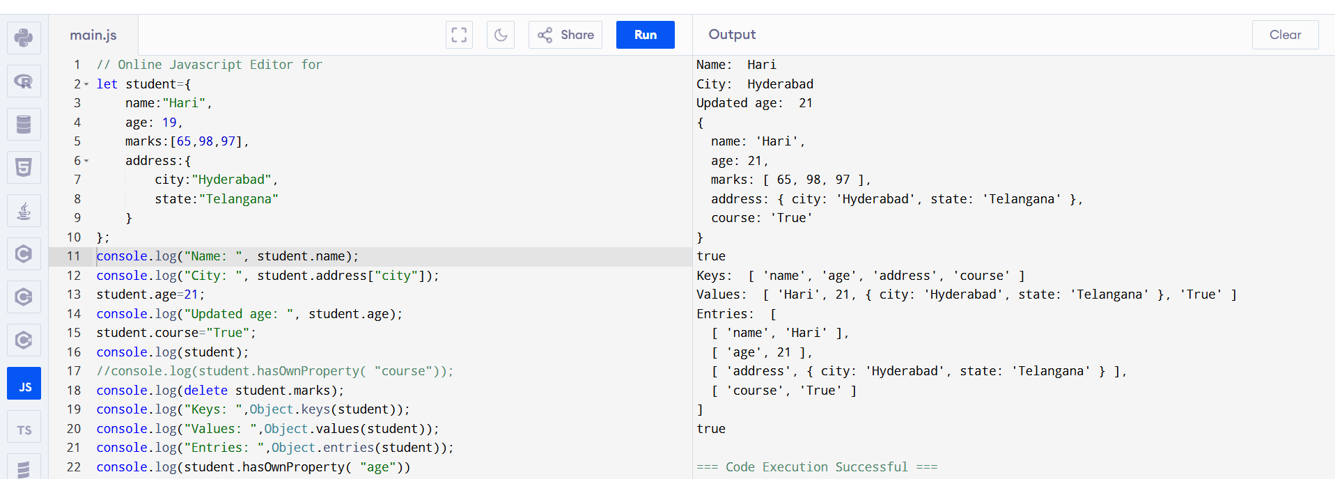

2.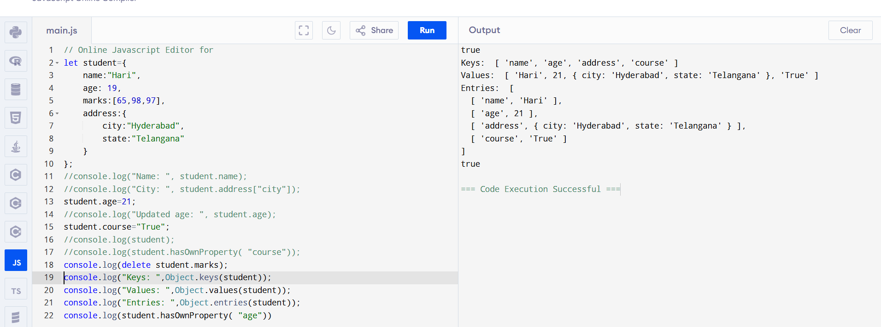

3.

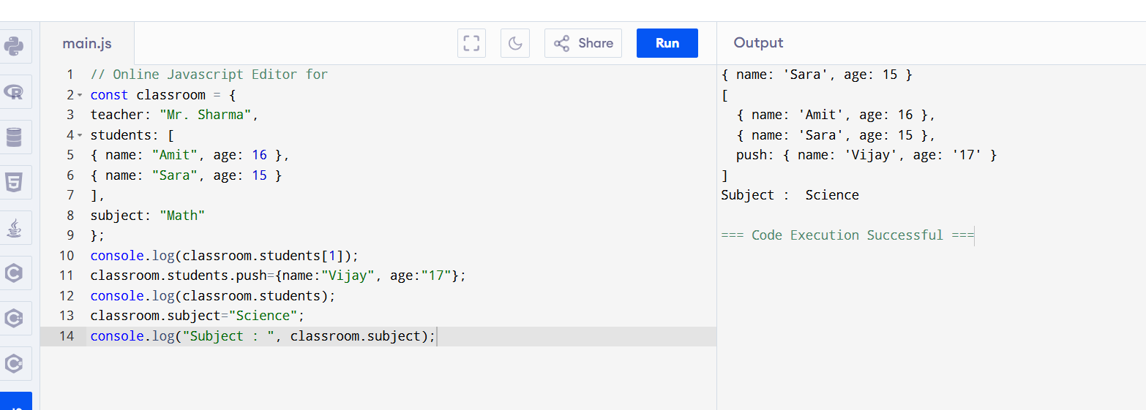

4.

a) console.log(x);

var x = 5;

predicted: undefined

output : undefined

b) greet();

function greet() {

console.log("Hello!");

}

Expected: hello

Output: hello

c) console.log(y);

let y = 10;

expected: error

output: error

5)

