J.S. Assaignment -7

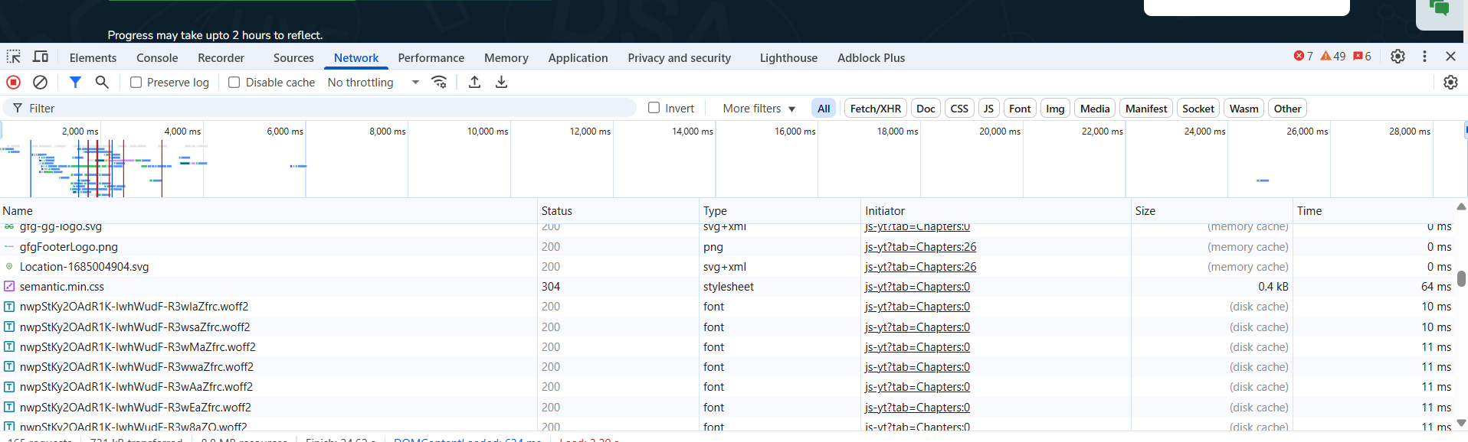

C)Get: to fetch html, css, javascript, json, images.

Post: for submitting forms, login, info

Put: to update the data

D)The get request returns:

Main pages HTML

Json(for API data)

CSS/JS file

E)

Both typically HTML for the main document and Json for API responses.

2)

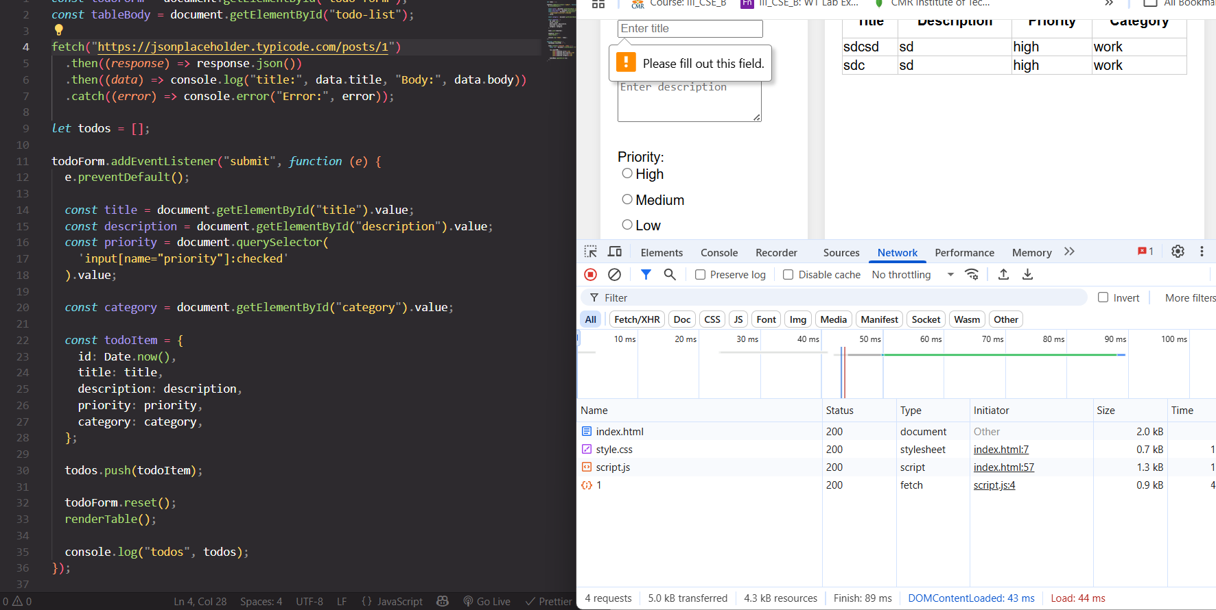

3) the 4 main parts are:

**1. Request line** (method + path + HTTP version, e.g., GET /about HTTP/1.1)  
2. **Headers** (metadata, e.g., Host, User-Agent)  
3. **Blank line** (separates headers from body)  
4. **Body** (only in methods like POST, PUT — contains data sent)

4)

**User-Agent**: Identifies the client software (browser or app) making the request

**Accept**: Informs the server about the content types the client can handle (e.g. Accept: application/json)

**Host**: Specifies the domain name of the server (e.g. Host: eample.com)

5)

