**System Requirements Specification(SRS)**

**System Name**: Employee Management System

**Version**: 0.1.0

**Date**: 2023-10-12

**Objective**

The primary goal of the Employee Management System is to establish a unified hub for organizing employee data and activities. This system is designed to enable users to seamlessly input, modify, and remove employee information. Additionally, it facilitates the allocation of tasks and enables efficient monitoring of task progress.

**Scope**

The proposed system encompasses a comprehensive set of features essential for effective employee management. It will empower users to efficiently handle various tasks related to employee management, including the ability to seamlessly add, edit, and delete employee records. Furthermore, the system incorporates robust task management capabilities, allowing users to track attendance and access detailed reports. One of its key strengths lies in its advanced reporting functionality, enabling users to generate comprehensive reports on employee activities. By providing these features, the system aims to streamline administrative processes and enhance organizational productivity.

**Functional Requirements**

The system must meet the following functional requirements:

• Admin Users must be able to add, edit, delete employee records,Branch Management

• HRUsers must be able to assign tasks to employees.

• Regular Users must be able to track the attendance and edit profile.

• Users must be able to view reports on employee activity.

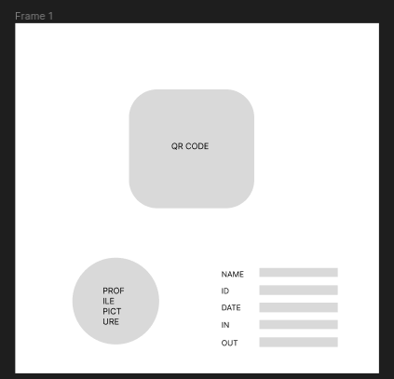 Figure 1: (QR) Scanning UI

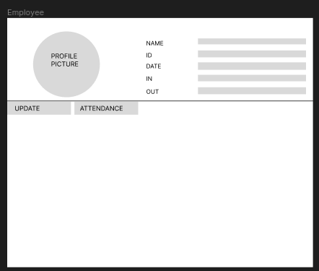 Figure 2: Employeee Main UI

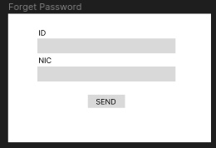 Figure 3: Forget Password UI

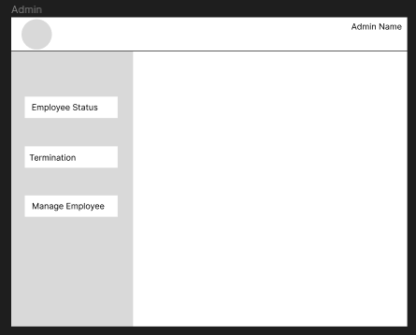 Figure 4: Admin Main UI

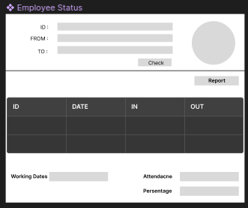 Figure 5: Employee Status UI

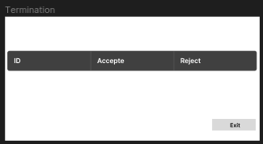 Figure 6: Termination UI

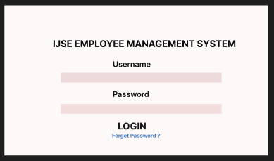 Figure 7: Login UI

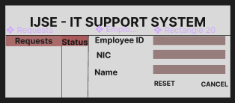 Figure 8: IT Support UI

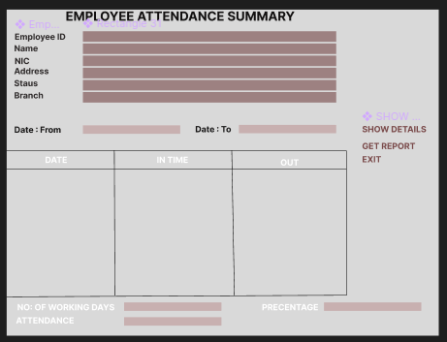 Figure 9: Attendence Summary UI

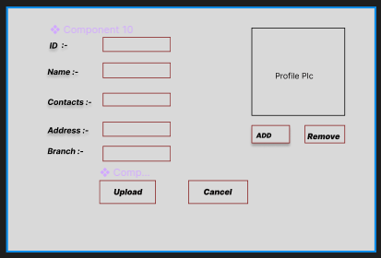 Figure 10: Employee Update Account UI

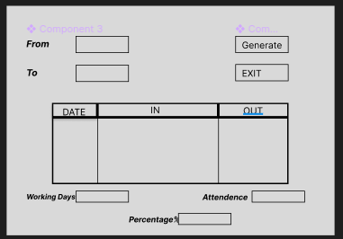 Figure 11: View Employee Attendence UI

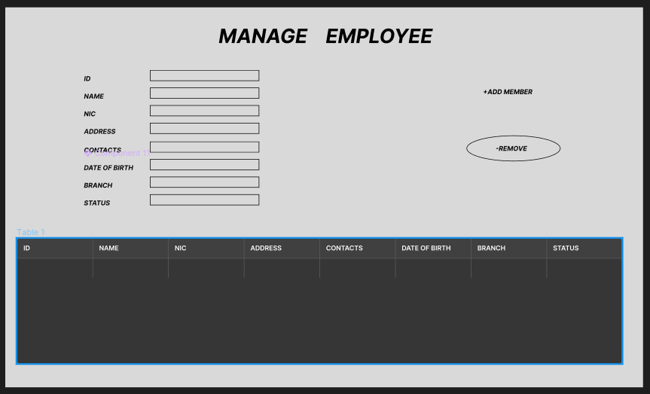 Figure 12: Manage Employee UI

**Non-Functional Requirements**

The system must meet the following non-functional requirements:

• The system must be easy to use.

• The system must be secure.

• The system must be reliable.

• The system must be scalable.

**Assumptions and Constraints**

The following assumptions and constraints apply to the system:

• The system will be used by employees and managers.

• The system will be hosted on a cloud server.

• The system will be developed using Java and Spring Boot.

**Implementation Plan**

The system will be implemented in the following phases:

• Phase 1: Requirements gathering and analysis

• Phase 2: Design

• Phase 3: Development

• Phase 4: Testing

• Phase 5: Deployment

**Testing Plan**

The system will be tested using the following methods:

• Unit testing

• Integration testing

• System testing

• User acceptance testing

**Deployment Plan**

The system will be deployed on a cloud server.

**Maintenance Plan**

The system will be maintained by the development team.

**Documentation Plan**

The system will be documented using the following documents:

• System Requirements Specification

• User Manual

• Administrator Manual

**Training Plan**

Users will be trained on the system using the following methods:

• User Manual

• Administrator Manual

• Online training

• On-site training