Author: Antoine Bour

Date: 24/07/16

1. **Install from scratch**
   1. Install jdk1.8 if not done.
   2. Install Eclipse Neon.
   3. Install SublimeText (my editor for angularJs dev)
2. **Standalone Deployment (Service + Client) and Database editor** 
   1. Service (Folder **Final/PetStoreBackend_ForStartOnly)**
      1. Install HsqlDb (in order to be able to manage the Database with an editor)
      2. And unzip the folder
      3. In hsqldb-2.3.4\hsqldb\bin launch runManagerSwing.bat and point to the DB. **The Url has to point on the backend project**.

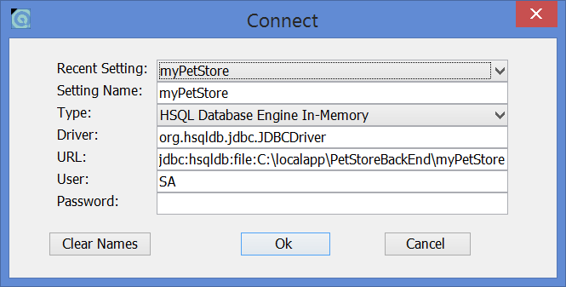

* + 1. Manually launch the scripts (add pets/categories)
       - Drop table pets ;
       - Drop table category ;
       - insertCategory.sql (cf attachement)
       - insertPets.sql (cf attachement)
  1. Client (Folder **Final/PetStoreClient)**
     1. Install nodejs/npm
     2. With CMD, launch : « **npm install -g http-server** »
     3. In the PetStoreClient folder launch « **http-server-o**» (but before launch the springboot backend : start PetStoreBackEnd\startBackend.bat)

From now you can use the application.

1. **Run via Eclipse (Folder BackendForEclipse)**
   1. Install STS Spring Tool Suite.
   2. Maven has to be available (running under jdk 1.8)
   3. Project itself is compiled in 1.6
   4. If standalone deployment not done before, play the sql scripts.
2. **What’s in?**
   1. Service :
      1. Rest Api
      2. Database Connectivity with HSQL
      3. Small testing cases
      4. Log4j
      5. Maven
      6. Javadoc
   2. Client :
      1. Rest communication : DELETE/GET/POST
      2. $rootscope + $routeprovider
      3. Front filtering of pages.
      4. ….
3. **What’s not in?**

Service and backend: Authentication.

Client: Testing and Packaging of the application.

Deployment on Bluemix Cloud.

1. **Issues during new install of the project under eclipse in a java-free laptop:**
   1. 2 Maven corrupted file to be replaced manually
   2. Some dependencies to add in pom.xml (jackson)

Note: The server has to be started first.