Name : Fuad Bin Mohammad, Kennard Kee Comments:
Group : 2

Proposal/Report : Assignment 2 (Collaborative AI)
________________________________________________________________________

Instructions
Create 2 FSMs ( minimum 3 state) each with trigger conditions (no key press) and responses.
Design the FSMs to support or help each other in team play through message boarding.
Each FSM( its object) should send 1 message and respond to 1 message.
Responses can be via HUDs and other forms of notification.

FSM # 1 States

If under fire, find cover (prone [-50% to hit] or wall)
If not under fire and no ammo, Move forward
If not under fire, has ammo, attack
If no ammo, reload
If hit by bullet, decrease HP
If HP is zero, die

Conditions

If under fire, find cover (prone [-50% to hit] or wall)
If not under fire and no ammo, Move forward
If not under fire, has ammo, attack
If no ammo, reload
If hit by bullet, decrease HP
If HP is zero, die

State Transition Diagram

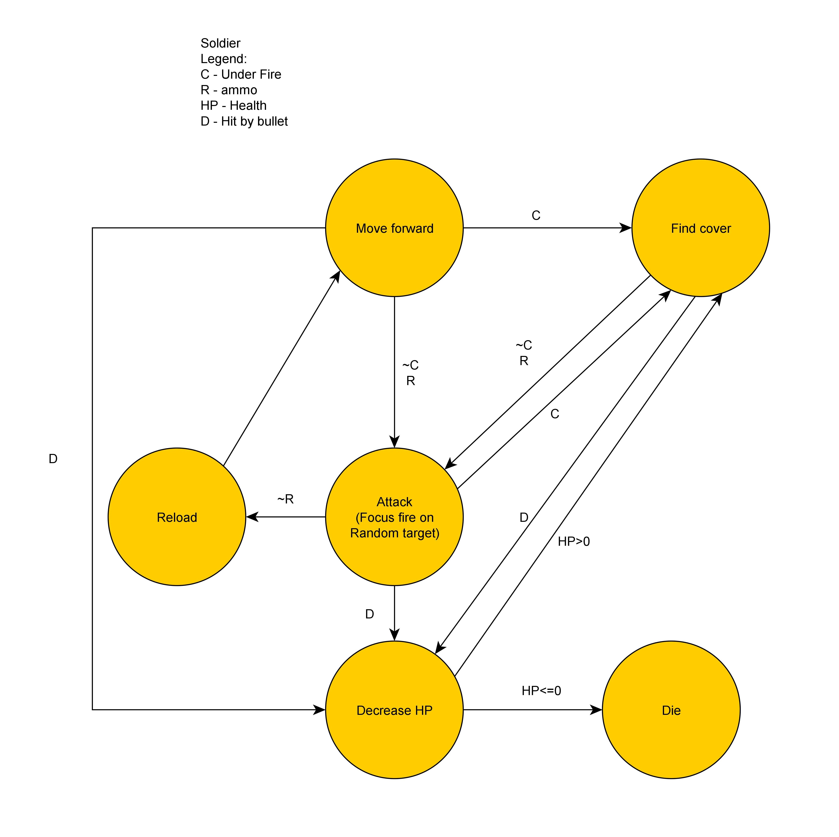

SOLDIER

FSM # 2 States

If soldier requests healing, heal soldier, first come first serve
If heal charge depleted, recharge
If none, idle
If hit by bullet, decrease HP
If HP is zero, die

Conditions

If soldier requests healing, heal soldier, first come first serve
If heal charge depleted, recharge
If none, idle
If hit by bullet, decrease HP
If HP is zero, die

State Transition Diagram
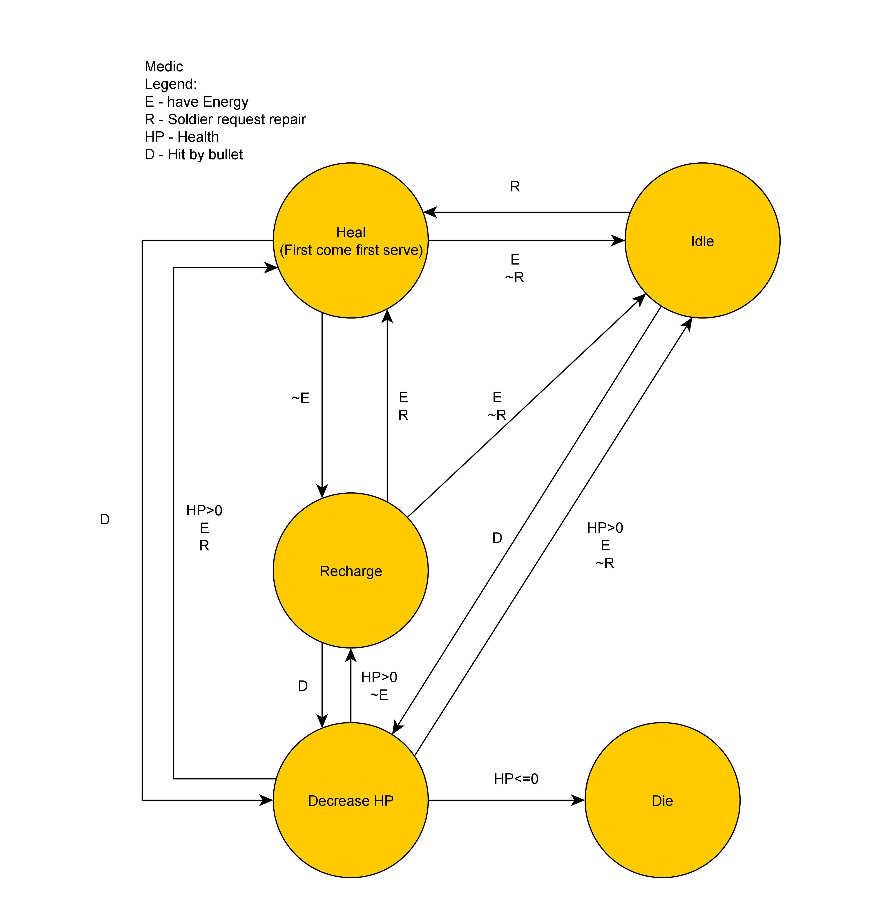
MEDIC

FSM # 3 States

If has ammo, fire at soldier
If no ammo, reload
If hit by bullet, decrease HP (Damaged)
If no HP, dead

Conditions

If has ammo, fire at soldier
If no ammo, reload
If hit by bullet, decrease HP (Damaged)
If no HP, dead

State Transition Diagram
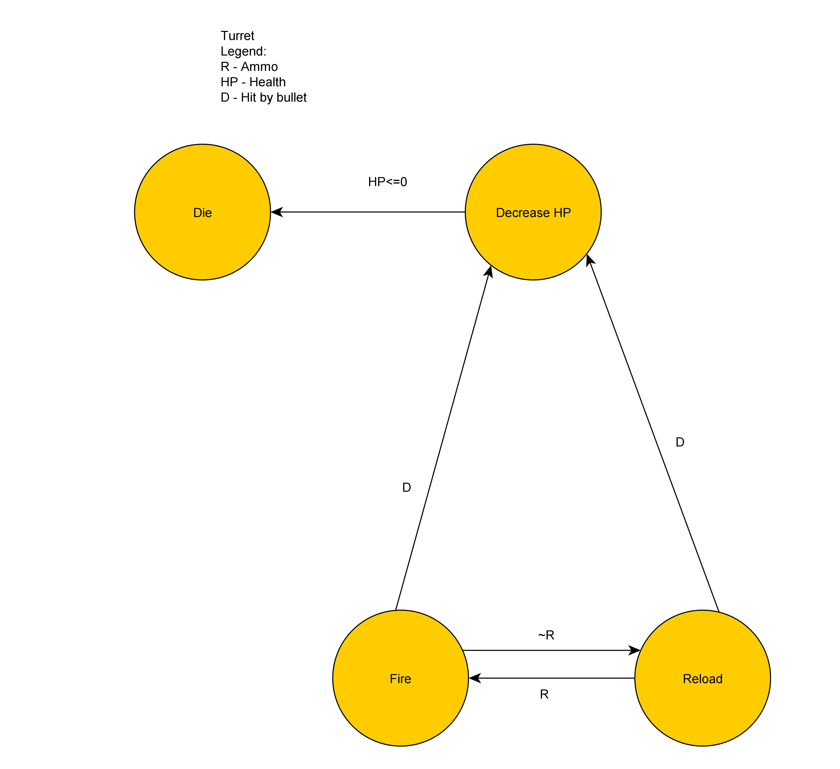

TURRET

Message Board

Text From To Response Remarks
Heal me Soldier medic Move to Sol/Busy
Finding Squad Soldier/Medic Squad Leaders Join me/No Space(msg) No space, make new
Cover Fire Squad Lead Soldiers Shoot in general dir
Retreat Squad Lead Soldiers Move back to base
Attack Squad Lead Soldiers Shoot at targets
SL Down Soldier Medic Move to Sol/Busy If busy, Replace SL
Replace me Squad Lead Soldiers Sol change to SL When Squad Lead dies

Additional Information

Squad Leader is a sub-set of Soldier

