**Django nima ?**

**Django -**  Web dasturlar yaratish uchun Python tilidagi Web **Framework .** framework ichida barcha instrumentlar birga keladi

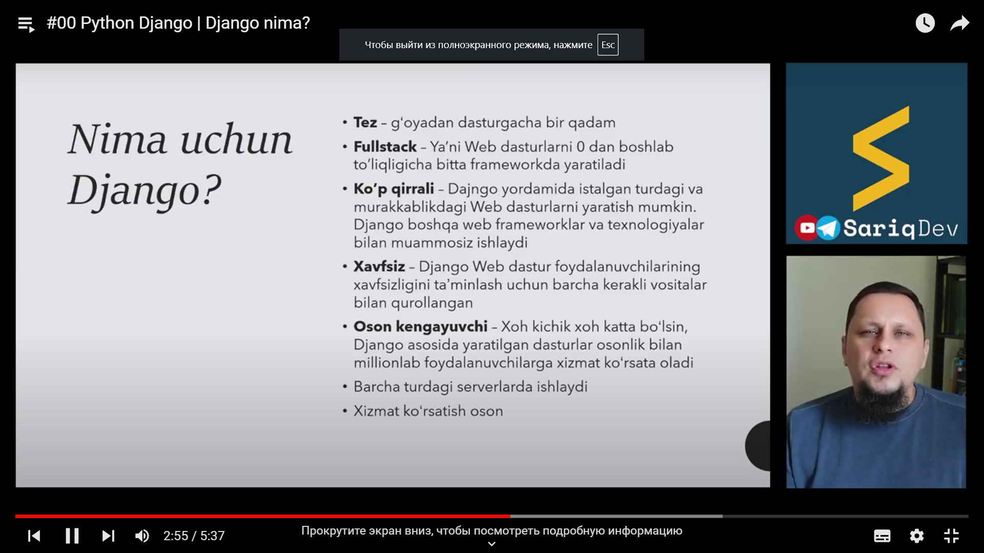

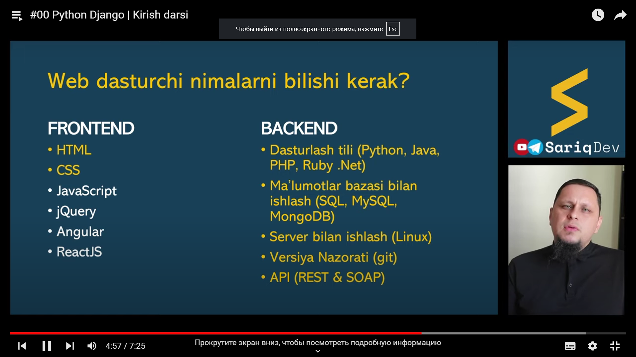

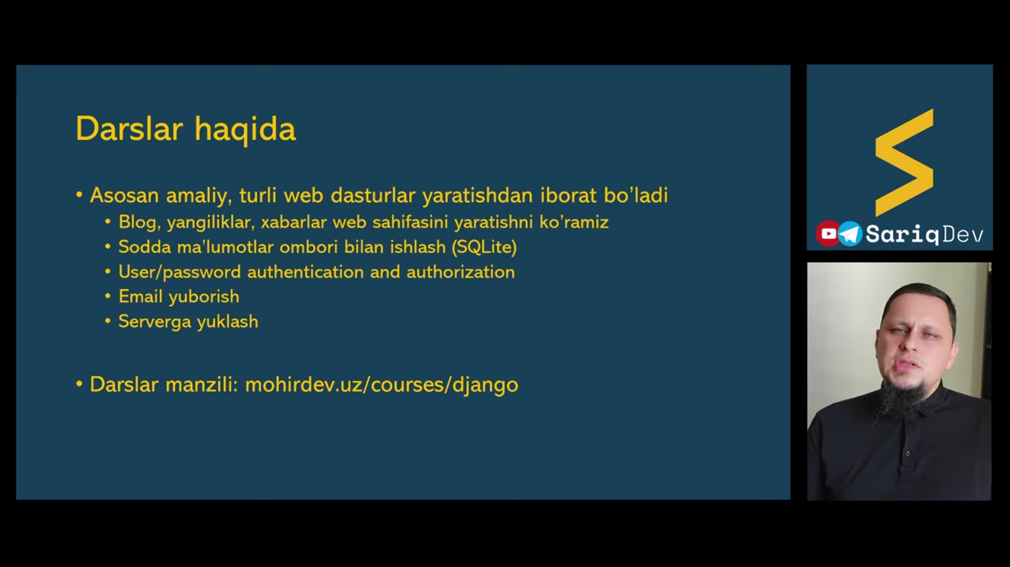

python -m ensurepip –upgrade

Import Django

print(django.get_version())