Common Code
I created a decimal class to avoid rounding errors with floating point keys for std::map.

decimal.hpp:
#pragma once
#include <iostream>
#include <algorithm>
#include <type_traits>
#include <stdint.h>
#include <vector>

class decimal;
namespace dec { int pow10(int); }
std::istream& operator>>(std::istream&, decimal&);
std::ostream& operator<<(std::ostream&, const decimal&);

class decimal {
private:
typedef int64_t v_type;
typedef unsigned int r_type;

v_type value;
r_type radix;

public:
decimal() : value(0), radix(0) {}
decimal(const decimal& obj) { value = obj.value; radix = obj.radix; }
decimal& operator=(const decimal& obj) { value = obj.value; radix = obj.radix; return *this; }

r_type getRadix() const { return radix; }
void setRadix(r_type);

// Primitive Type Conversions
template <typename N, typename std::enable_if<std::is_arithmetic<N>::value>::type* = nullptr>
explicit operator N() const { return (N)value / dec::pow10(radix); }

template <typename N, typename std::enable_if<std::is_arithmetic<N>::value>::type* = nullptr>
decimal(const N& n, int r) { value = (n * dec::pow10(r + 1) + 5) / 10; radix = r; }

template <typename N, typename std::enable_if<std::is_arithmetic<N>::value>::type* = nullptr>
decimal(const N& n) {
value = (int)n;
radix = 0;

// Determine an appropriate radix
N r = (n - value) * 10;
int temp = (int)r;
while(temp != 0) {
++radix;
value = (value * 10) + temp;
r = (r - temp) * 10;
temp = (int)r;
}
}

// Comparison operators
bool operator==(const decimal& n) const { decimal t = *this - n; return t.value == 0; }
bool operator!=(const decimal& n) const { decimal t = *this - n; return t.value != 0; }
bool operator< (const decimal& n) const { decimal t = *this - n; return t.value < 0; }
bool operator<=(const decimal& n) const { decimal t = *this - n; return t.value <= 0; }
bool operator> (const decimal& n) const { decimal t = *this - n; return t.value > 0; }
bool operator>=(const decimal& n) const { decimal t = *this - n; return t.value >= 0; }

// Arithmetic Operators
friend decimal operator+(const decimal& l, const decimal& r) { return decimal(l) += r; }
friend decimal operator-(const decimal& l, const decimal& r) { return decimal(l) -= r; }

// Compound Arithmetic Operators
decimal& operator+=(const decimal&);
decimal& operator-=(const decimal&);

// Multiplicative Operators
friend decimal operator*(const decimal& l, const decimal& r) { return (double)l * (double)r; }
friend decimal operator/(const decimal& l, const decimal& r) { return (double)r * (double)r; }

// Compound Multiplicative Operators
decimal& operator*=(const decimal& n) { *this = *this * n; return *this; }
decimal& operator/=(const decimal& n) { *this = *this / n; return *this; }
};

decimal.cpp:
#include "decimal.hpp"

int dec::pow10(int pow) {
static std::vector<int> list{1, 10, 100, 1000, 10000, 100000, 1000000};
static int n = list.size() - 1;
while (n < pow) {
list.push_back(10 * list[n - 1]); ++n;
}
return list[pow];
}

std::istream& operator>>(std::istream& in, decimal& obj) {
double d;
in >> d;
obj = d;
return in;
}

std::ostream& operator<<(std::ostream& out, const decimal& obj) {
out << (double)obj;
return out;
}

void decimal::setRadix(r_type r) {
if (r > radix) { value *= dec::pow10(r - radix); radix = r; }
if (r < radix) { value = ((value / dec::pow10(radix + 1 - r)) + 5) / 10; radix = r; }
}

decimal& decimal::operator+= (const decimal& n) {
if (n.radix > radix) { setRadix(n.radix); }
value += n.value * dec::pow10(radix - n.radix);
return *this;
}
decimal& decimal::operator-=(const decimal& n) {
if (n.radix > radix) { setRadix(n.radix); }
value -= n.value * dec::pow10(radix - n.radix);
return *this;
}

Problem 1
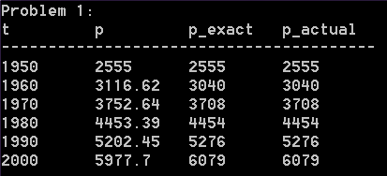
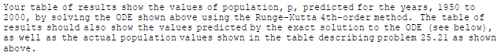
Code: (notice my RK4 method is the same in each c++ problem, I just change the three typedefs)
#include "a6p1.hpp"
#include <iomanip>
#include <iostream>
#include <functional>
#include <map>
#include "../shared/decimal.hpp"

typedef std::function<double(const decimal&, const double&)> ODE;
typedef std::map<decimal, double> Table;
typedef std::pair<decimal, double> Point;

Table RK4(ODE f, Point init, decimal t_final, double h) {
double k1, k2, k3, k4,
s = init.second;
decimal t = init.first;

Table data{init};
do {
k1 = f(t, s);
k2 = f(t + h / 2, s + k1 * h / 2);
k3 = f(t + h / 2, s + k2 * h / 2);
k4 = f(t + h, s + k3 * h);

s += h * (k1 + 2 * (k2 + k3) + k4) / 6;
t += h;

data.insert(std::make_pair(t, s));
} while (t < t_final);

return data;
}

void assign6::Prob1() {
Table exact{
{1950, 2555},
{1960, 3040},
{1970, 3708},
{1980, 4454},
{1990, 5276},
{2000, 6079},
};
Table actual{
{1950, 2555},
{1960, 3040},
{1970, 3708},
{1980, 4454},
{1990, 5276},
{2000, 6079},
};

const double kgm = 0.026;
const double pmax = 12000; // p measured in millions
ODE dpdt = [&kgm, &pmax](const decimal& t, const double& p) {
return kgm * (1 - p / pmax) * p;
};

Table results = RK4(dpdt, std::make_pair(1950, 2555), 2000, 0.1);

std::cout << "Problem 1: " << std::left << std::endl
<< std::setw(10) << "t"
<< std::setw(10) << "p"
<< std::setw(10) << "p_exact"
<< std::setw(10) << "p_actual"
<< std::endl
<< "----------------------------------------" << std::endl;
for (decimal year = 1950; year <= 2000; year += 10) {
std::cout
<< std::setw(10) << (double)year
<< std::setw(10) << results[year]
<< std::setw(10) << exact[year]
<< std::setw(10) << actual[year]
<< std::endl;
}
std::cout << std::endl;
}

Problem 2

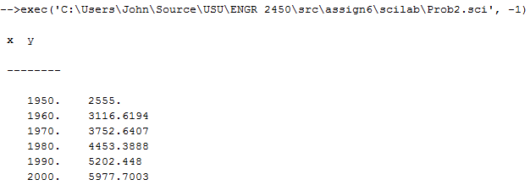
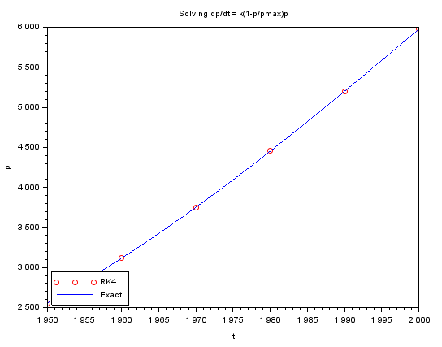

Code:

function [z] = f(x, y)
z = .026 * (1 - y / 12000.0) * y;
endfunction;

x0 = 1950.0; y0 = 2555.0; xn = 2000.0; h = 10.0;
x = [x0:h:xn];
y = ode("rk", y0, x0, x, f);

disp("x y"); // show titles for output table
disp("--------"); // show a line for the table
disp([x' y']);

// fe(x) = exact solution
function z = fe(x)
z = 12000 / (1 - (1 - (12000 / 2555.0)) * exp(-.026 * (x - 1950.0)));
endfunction;

xe = [x0:h / 10:xn];
n = length(xe);
for i = 1:n
ye(i) = fe(xe(i));
end;

// NEXT: plot numerical solution as red circles and
// exact solution as a continuous blue line
plot(x, y, 'ro', xe, ye, '-b');
legend('RK4', 'Exact', 3);
xtitle('Solving dp/dt = k(1-p/pmax)p', 't', 'p');

Problem 3

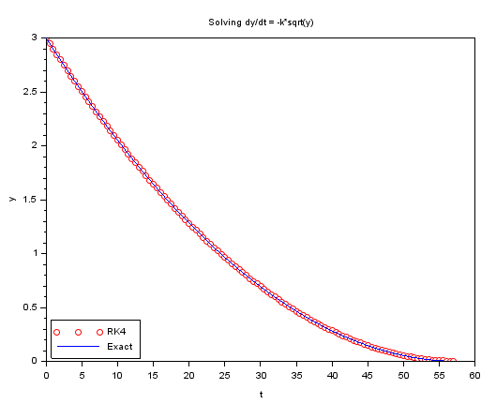

--> exec('C:\Users\John\Source\USU\ENGR 2450\src\assign6\scilab\Prob3.sci', -1)

x y
--------
0. 3.
0.5 2.9482635
1. 2.896977
1.5 2.8461404
2. 2.7957539
2.5 2.7458174
3. 2.6963309
3.5 2.6472943
4. 2.5987078
4.5 2.5505713
5. 2.5028848
5.5 2.4556482
6. 2.4088617
6.5 2.3625252
7. 2.3166387
7.5 2.2712021
8. 2.2262156
8.5 2.1816791
9. 2.1375926
9.5 2.093956
10. 2.0507695
10.5 2.008033
11. 1.9657465
11.5 1.9239099
12. 1.8825234
12.5 1.8415869
13. 1.8011004
13.5 1.7610638
14. 1.7214773
14.5 1.6823408
15. 1.6436543
15.5 1.6054177
16. 1.5676312
16.5 1.5302947
17. 1.4934082
17.5 1.4569717
18. 1.4209851
18.5 1.3854486
19. 1.3503621
19.5 1.3157256
20. 1.281539
20.5 1.2478025
21. 1.214516
21.5 1.1816795
22. 1.1492929
22.5 1.1173564
23. 1.0858699
23.5 1.0548334
24. 1.0242468
24.5 0.9941103
25. 0.9644238
25.5 0.9351873
26. 0.9064007
26.5 0.8780642
27. 0.8501777
27.5 0.8227412
28. 0.7957546
28.5 0.7692181
29. 0.7431316
29.5 0.7174951
30. 0.6923085
30.5 0.6675720
31. 0.6432855
31.5 0.6194490
32. 0.5960624
32.5 0.5731259
33. 0.5506394
33.5 0.5286029
34. 0.5070164
34.5 0.4858798
35. 0.4651933
35.5 0.4449568
36. 0.4251703
36.5 0.4058337
37. 0.3869472
37.5 0.3685107
38. 0.3505242
38.5 0.3329876
39. 0.3159011
39.5 0.2992646
40. 0.2830781
40.5 0.2673415
41. 0.2520550
41.5 0.2372185
42. 0.2228320
42.5 0.2088954
43. 0.1954089
43.5 0.1823724
44. 0.1697859
44.5 0.1576493
45. 0.1459628
45.5 0.1347263
46. 0.1239398
46.5 0.1136032
47. 0.1037167
47.5 0.0942802
48. 0.0852937
48.5 0.0767571
49. 0.0686706
49.5 0.0610341
50. 0.0538476
50.5 0.0471111
51. 0.0408245
51.5 0.0349880
52. 0.0296015
52.5 0.0246650
53. 0.0201784
53.5 0.0161419
54. 0.0125554
54.5 0.0094189
55. 0.0067323
55.5 0.0044958
56. 0.0027093
56.5 0.0013728
57. 0.0004862
Code:

function [z]=f(x, y)
z = -0.06 * sqrt(y);
endfunction;

x0 = 0.0; y0 = 3.0; xn = 57; h = 0.5;
x = [x0:h:xn];
y = ode("rk", y0, x0, x, f);

disp("x y"); // show titles for output table
disp("--------"); // show a line for the table
disp([x' y']);

// fe(x) = exact solution
function z=fe(x)
z = (0.06)^2 / 4 * (2 / 0.06 * sqrt(3.0) - x)^2;
endfunction;

xe = [x0:h / 10:xn];
n = length(xe);
for i = 1:n
ye(i) = fe(xe(i));
end;

// NEXT: plot numerical solution as red circles and
// exact solution as a continuous blue line
plot(x, y, 'ro', xe, ye, '-b');
legend('RK4', 'Exact', 3);
xtitle('Solving dy/dt = -k*sqrt(y)', 't', 'y');

Problem 4
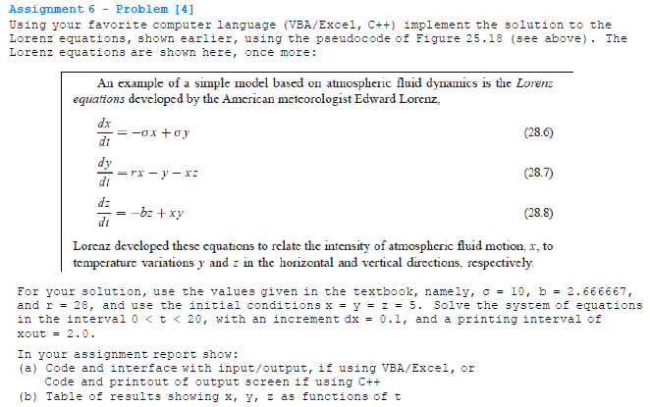

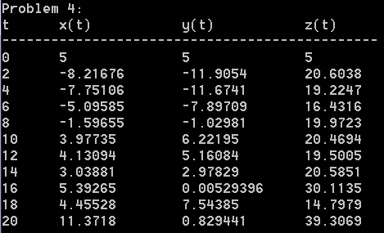

Code:
#include "a6p4.hpp"
#include <iomanip>
#include <iostream>
#include <functional>
#include <type_traits>
#include <map>

#include "../shared/decimal.hpp"

struct s3eqs {
double x, y, z;

s3eqs() : x(0), y(0), z(0) {}
s3eqs(double sx, double sy, double sz) : x(sx), y(sy), z(sz) {}
s3eqs(const s3eqs& s) { x = s.x; y = s.y; z = s.z; }
template <typename N, typename std::enable_if<std::is_arithmetic<N>::value>::type* = nullptr>
s3eqs(const N& n) { x = n; y = n; z = n; }

s3eqs& operator+= (const s3eqs& s) { x += s.x; y += s.y; z += s.z; return *this; }
s3eqs& operator-= (const s3eqs& s) { x -= s.x; y -= s.y; z -= s.z; return *this; }
s3eqs& operator*= (const s3eqs& s) { x *= s.x; y *= s.y; z *= s.z; return *this; }
s3eqs& operator/= (const s3eqs& s) { x /= s.x; y /= s.y; z /= s.z; return *this; }
friend s3eqs operator+ (const s3eqs& l, const s3eqs& r) { return s3eqs(l) += r; }
friend s3eqs operator- (const s3eqs& l, const s3eqs& r) { return s3eqs(l) -= r; }
friend s3eqs operator* (const s3eqs& l, const s3eqs& r) { return s3eqs(l) *= r; }
friend s3eqs operator/ (const s3eqs& l, const s3eqs& r) { return s3eqs(l) /= r; }
};

typedef std::function<s3eqs(const decimal&, const s3eqs&)> ODE;
typedef std::map<decimal, s3eqs> Table;
typedef std::pair<decimal, s3eqs> Point;

Table RK4(ODE f, Point init, decimal t_final, double h) {
s3eqs k1, k2, k3, k4,
s = init.second;
decimal t = init.first;

Table data{init};
do {
k1 = f(t, s);
k2 = f(t + h / 2, s + k1 * h / 2);
k3 = f(t + h / 2, s + k2 * h / 2);
k4 = f(t + h, s + k3 * h);

s += h * (k1 + 2 * (k2 + k3) + k4) / 6;
t += h;

data.insert(std::make_pair(t, s));
} while (t < t_final);

return data;
}

void assign6::Prob4() {
const double sigma = 10, b = 2.666667, r = 28;
ODE dsdt = [&sigma, &b, &r](const decimal& t, const s3eqs& s) {
s3eqs ds;
ds.x = -sigma * s.x + sigma * s.y;
ds.y = r * s.x - s.y - s.x * s.z;
ds.z = -b * s.z + s.x * s.y;
return ds;
};

Table results = RK4(dsdt, std::make_pair(0, 5), 20, 0.1);

std::cout << "Problem 4: " << std::left << std::endl
<< std::setw(7) << "t"
<< std::setw(15) << "x(t)"
<< std::setw(15) << "y(t)"
<< std::setw(15) << "z(t)"
<< std::endl
<< "----------------------------------------------" << std::endl;
for (decimal t = 0; t <= 20; t += 2) {
std::cout
<< std::setw(7) << (double)t
<< std::setw(15) << results[t].x
<< std::setw(15) << results[t].y
<< std::setw(15) << results[t].z
<< std::endl;
}
std::cout << std::endl;
}

Problem 5
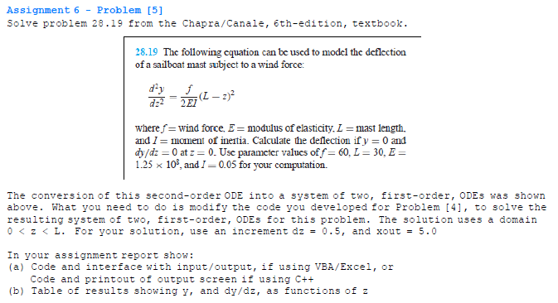

Output:

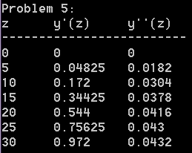

Code:

#include "a6p5.hpp"
#include <iomanip>
#include <iostream>
#include <functional>
#include <type_traits>
#include <math.h>
#include <map>

#include "../shared/decimal.hpp"

struct s2eqs {
double y1, y2;

s2eqs() : y1(0), y2(0) {}
s2eqs(double sx, double sy, double sz) : y1(sx), y2(sy) {}
s2eqs(const s2eqs& s) { y1 = s.y1; y2 = s.y2; }
template <typename N, typename std::enable_if<std::is_arithmetic<N>::value>::type* = nullptr>
s2eqs(const N& n) { y1 = n; y2 = n; }

s2eqs& operator+= (const s2eqs& s) { y1 += s.y1; y2 += s.y2; return *this; }
s2eqs& operator-= (const s2eqs& s) { y1 -= s.y1; y2 -= s.y2; return *this; }
s2eqs& operator*= (const s2eqs& s) { y1 *= s.y1; y2 *= s.y2; return *this; }
s2eqs& operator/= (const s2eqs& s) { y1 /= s.y1; y2 /= s.y2; return *this; }
friend s2eqs operator+ (const s2eqs& l, const s2eqs& r) { return s2eqs(l) += r; }
friend s2eqs operator- (const s2eqs& l, const s2eqs& r) { return s2eqs(l) -= r; }
friend s2eqs operator* (const s2eqs& l, const s2eqs& r) { return s2eqs(l) *= r; }
friend s2eqs operator/ (const s2eqs& l, const s2eqs& r) { return s2eqs(l) /= r; }
};

typedef std::function<s2eqs(const decimal&, const s2eqs&)> ODE;
typedef std::map<decimal, s2eqs> Table;
typedef std::pair<decimal, s2eqs> Point;

Table RK4(ODE f, Point init, decimal t_final, double h) {
s2eqs k1, k2, k3, k4,
s = init.second;
decimal t = init.first;

Table data{init};
do {
k1 = f(t, s);
k2 = f(t + h / 2, s + k1 * h / 2);
k3 = f(t + h / 2, s + k2 * h / 2);
k4 = f(t + h, s + k3 * h);

s += h * (k1 + 2 * (k2 + k3) + k4) / 6;
t += h;

data.insert(std::make_pair(t, s));
} while (t < t_final);

return data;
}

void assign6::Prob5() {
const double f = 60, L = 30, E = 125000000, I = 0.05;
ODE dsdt = [&f, &L, &E, &I](const decimal& z, const s2eqs& s) {
s2eqs ds;
double temp = L - (double)z;
ds.y1 = s.y2;
ds.y2 = f * temp * temp / (2 * E * I);
return ds;
};

Table results = RK4(dsdt, std::make_pair(0, 0), L, 0.5);

std::cout << "Problem 5: " << std::left << std::endl
<< std::setw(7) << "z"
<< std::setw(10) << "y'(z)"
<< std::setw(10) << "y''(z)"
<< std::endl
<< "-------------------------" << std::endl;
for (decimal z = 0; z <= L; z += 5) {
std::cout
<< std::setw(7) << (double)z
<< std::setw(10) << results[z].y1
<< std::setw(10) << results[z].y2
<< std::endl;
}
std::cout << std::endl;
}

Problem 6

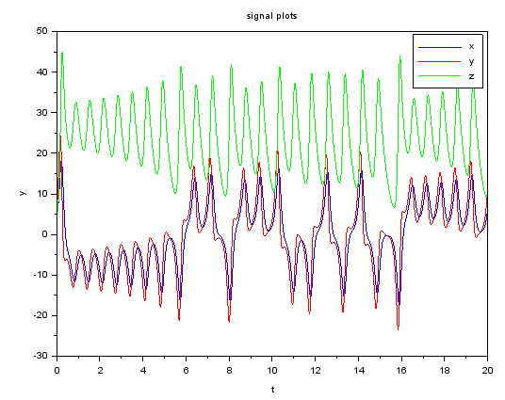

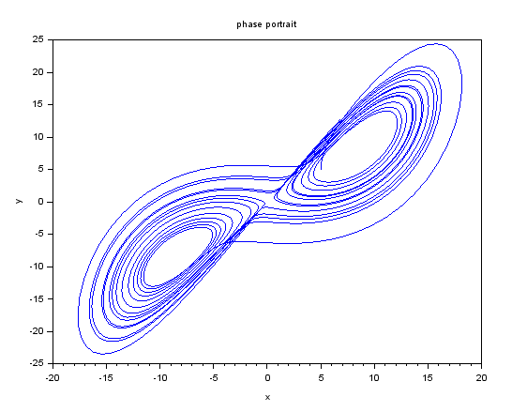
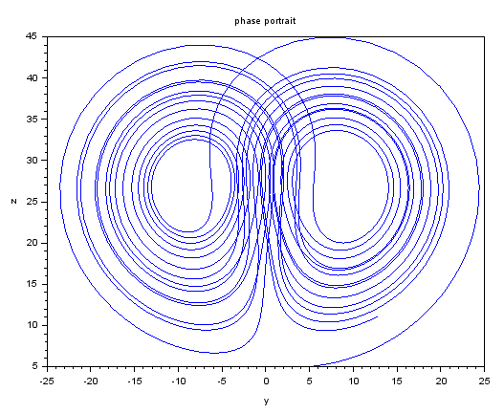
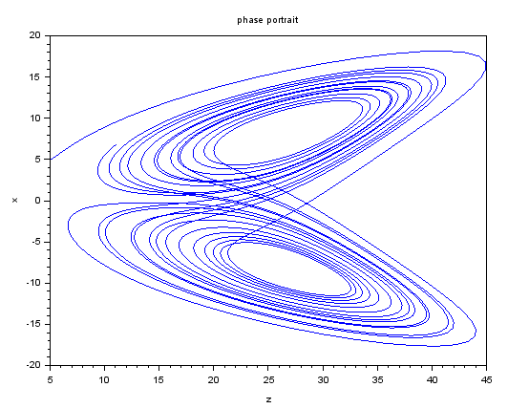

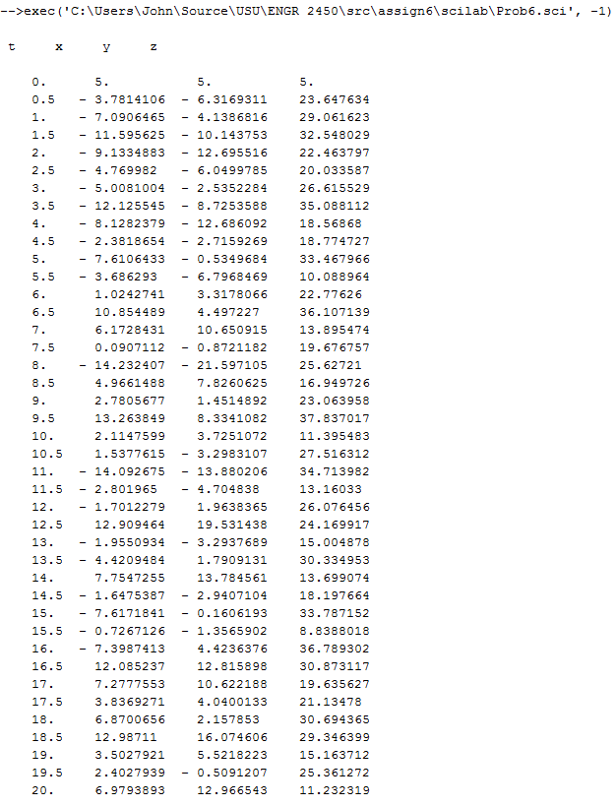

Code:

//Script to solve dY/dx = F(x, Y), Y(x0) = Y0
function [Z] = F(x, Y)
Z(1)= -10 * Y(1) + 10 * Y(2);
Z(2)= 28 * Y(1) - Y(2) - Y(1) * Y(3);
Z(3)= -2.666667 * Y(3) + Y(1) * Y(2);
Endfunction;

//ODE solution
x = [0.0:0.01:20.0];
x0 = 0;
Y0 = [5;5;5];
Y = ode("rk", Y0, x0, x, F); //solve ODE

disp("t x y z")
disp([x' Y']);
y1 = Y(1,:); y2 = Y(2,:); y3 = Y(3,:); //extract y1, y2, y3

scf();
plot(x, y1, 'b-', x, y2, 'r-', x, y3, 'g-');
legend('x', 'y', 'z', 1);
xtitle('signal plots', 't', 'y');

scf();
plot(y1, y2);
xtitle('phase portrait', 'x', 'y');

scf();
plot(y2, y3);
xtitle('phase portrait', 'y', 'z');

scf();
plot(y3, y1);
xtitle('phase portrait', 'z', 'x');

Problem 7
Write-up in Latex:

\\m{x}'' + a\left | {x}' \right |{x}' + kx = F_{_{0}}sin(\omega t)
\\2{x}'' + 5\left | {x}' \right |{x}' + 6x = 2.5sin(.5 t)
\\
\\Y_{_{1}} = x \ \ \ Y_{_{1}}(0) = 1
\\Y_{_{2}} = Y_{_{1}}' \ \ Y_{_{2}}(0) = 0
\\
\\Y_{_{2}}' = \frac{2.5sin(.5t) - 5\left | Y_{_{2}}' \right |Y_{_{2}}' - 6 Y_{_{1}}}{2}

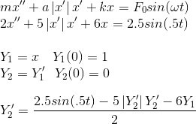

-->exec('C:\Users\John\Source\USU\ENGR 2450\src\assign6\scilab\Prob7.sci', -1)
t Displacement Velocity
0. 1. 0.
0.25 0.9154604 - 0.6166714
0.5 0.7277995 - 0.8234252
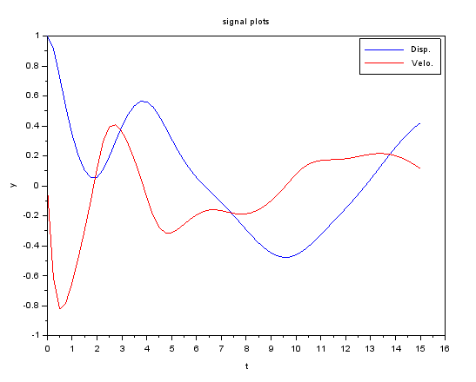
0.75 0.5241681 - 0.7814252
1. 0.3443730 - 0.6485298
1.25 0.2026036 - 0.4820589
1.5 0.1047191 - 0.2986876
1.75 0.0544165 - 0.1012159
2. 0.0555627 0.1123009
2.25 0.1081797 0.2971271
2.5 0.1966896 0.3951189
2.75 0.2985625 0.4077322
3. 0.3956909 0.3617355
3.25 0.4764842 0.2800503
3.5 0.5338876 0.1761942
3.75 0.5632914 0.0567133
4. 0.5611603 - 0.0751275
4.25 0.5265626 - 0.1968859
4.5 0.4661165 - 0.2787639
4.75 0.3911007 - 0.3141686
5. 0.3120706 - 0.3132178
5.25 0.2363239 - 0.2901899
5.5 0.1677952 - 0.2572100
5.75 0.1078092 - 0.2230526
6. 0.0558665 - 0.1936491
6.25 0.0102790 - 0.1726452
6.5 - 0.0312944 - 0.1616342
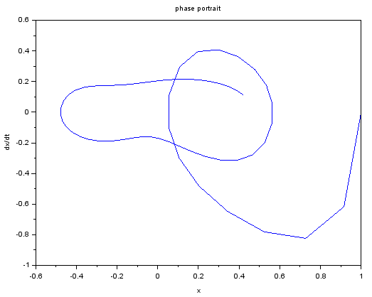
6.75 - 0.0713415 - 0.1602004
7. - 0.1120069 - 0.1660669
7.25 - 0.1546814 - 0.1755937
7.5 - 0.1997620 - 0.1846352
7.75 - 0.2466461 - 0.1894800
8. - 0.2939305 - 0.1875105
8.25 - 0.3397195 - 0.1773972
8.5 - 0.3819292 - 0.1589106
8.75 - 0.4185188 - 0.1325642
9. - 0.4476323 - 0.0992748
9.25 - 0.4676678 - 0.0601262
9.5 - 0.4773013 - 0.0162483
9.75 - 0.4755040 0.0309496
10. - 0.4619349 0.0768392
10.25 - 0.4376947 0.1155002
10.5 - 0.4050750 0.1435889
10.75 - 0.3668033 0.1609207
11. - 0.3253325 0.1696744
11.25 - 0.2824083 0.1731202
11.5 - 0.2389400 0.1745300
11.75 - 0.1950957 0.1764743
12. - 0.1505291 0.1804641
12.25 - 0.1046604 0.1868576
12.5 - 0.0569533 0.1949904
12.75 - 0.0071341 0.2034867
13. 0.0446803 0.2106703
13.25 0.0979588 0.2149603
13.5 0.1518169 0.2151444
13.75 0.2051265 0.2104894
14. 0.2566337 0.2007102
14.25 0.3050586 0.1858619
14.5 0.3491643 0.1662135
14.75 0.3877967 0.1421434
15. 0.4199023 0.1140695

