Problem 1

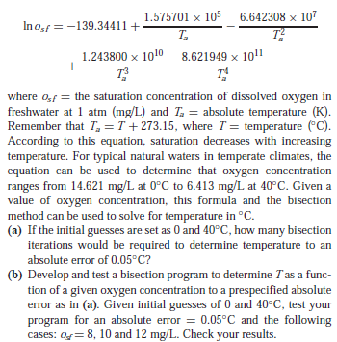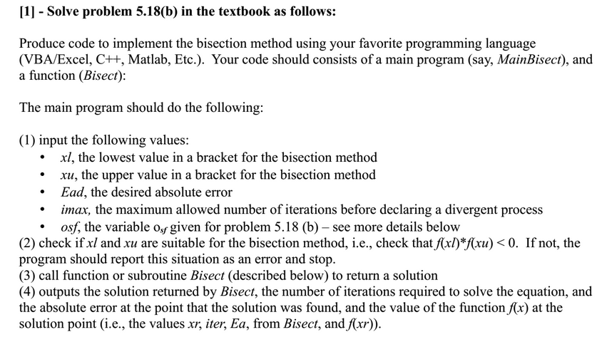

Solution: 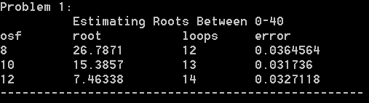

assign2.cpp:

//---------------------------------------------------------------------------------+

// Estimate Bisect |

// Given an arbitrary polynomial, use the bisection method to solve |

// The equation "f(root) = 0", assuming l_bound < root < r_bound |

//---------------------------------------------------------------------------------+

Estimate assign2:: Bisect(

std::function<double(double)> f,

double l_bound,

double r_bound,

double max_loops,

double max_error) {

Estimate est(l_bound);

double lSign = f(l_bound);

if (lSign * f(r_bound) >= 0) {

std::cout <<

"Error: left-hand and right-hand estimates do not bound a root" << std::endl;

return est;

}

double prev, sign;

do {

++est.loops;

prev = est.value;

est.value = (l_bound + r_bound) / 2;

if (est.value != 0) {

est.error = abs(est.value - prev) * 100 / est.value;

}

sign = f(est.value) * lSign;

if (sign < 0) {

r_bound = est.value;

} else if (sign > 0) {

l_bound = est.value;

} else {

est.error = 0;

}

} while (est.loops < max_loops && est.error >= max_error);

return est;

}

//---------------------------------------------------------------------------------+

// Problem 1 - Using the Bisection Method |

//---------------------------------------------------------------------------------+

void assign2::Problem1() {

Estimate est;

double osf = 8;

auto polynomial = [&osf](double x) -> double {

double T_Kelvin[5];

Powers(T_Kelvin, 5, x + 273.15);

return log(osf)

+ 139.34411

- (157570.1 / T_Kelvin[1])

+ (66423080 / T_Kelvin[2])

- (12438000000 / T_Kelvin[3])

+ (862194900000 / T_Kelvin[4]);

};

const int

TITLE = 50,

COL_OSF = 10,

COL_ROOT = 15,

COL_LOOPS = 10,

COL_ERROR = 15;

std::cout << "Problem 1:" << std::endl

<< std::setw(TITLE) << centered("Estimating Roots Between 0-40")

<< std::endl << std::left

<< std::setw(COL_OSF) << "osf"

<< std::setw(COL_ROOT) << "root"

<< std::setw(COL_LOOPS) << "loops"

<< std::setw(COL_ERROR) << "error"

<< std::endl;

est = Bisect(polynomial, 0, 40, 100, 0.05);

std::cout

<< std::setw(COL_OSF) << "8"

<< std::setw(COL_ROOT) << est.value

<< std::setw(COL_LOOPS) << est.loops

<< std::setw(COL_ERROR) << est.error

<< std::endl;

osf = 10;

est = Bisect(polynomial, 0, 40, 100, 0.05);

std::cout

<< std::setw(COL_OSF) << "10"

<< std::setw(COL_ROOT) << est.value

<< std::setw(COL_LOOPS) << est.loops

<< std::setw(COL_ERROR) << est.error

<< std::endl;

osf = 12;

est = Bisect(polynomial, 0, 40, 100, 0.05);

std::cout

<< std::setw(COL_OSF) << "12"

<< std::setw(COL_ROOT) << est.value

<< std::setw(COL_LOOPS) << est.loops

<< std::setw(COL_ERROR) << est.error

<< std::endl;

std::cout << "--------------------------------------------------" << std::endl << std::endl;

}

assign2.h:

#pragma once

#include <functional>

namespace assign2 {

struct Estimate {

double error;

double value;

int loops;

Estimate(double est = 0) {

error = 100;

loops = 0;

value = est;

}

};

Estimate Bisect(std::function<double(double)>, double, double, double, double);

void Problem1();

}

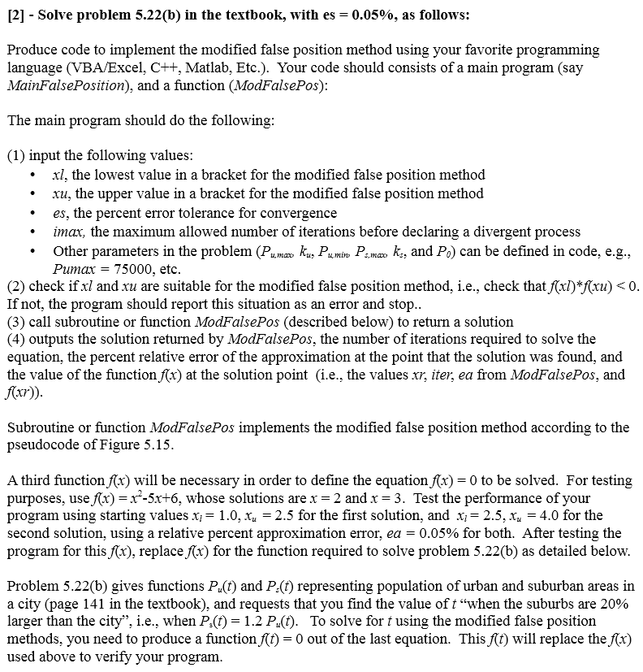Problem 2

