TESTE_18

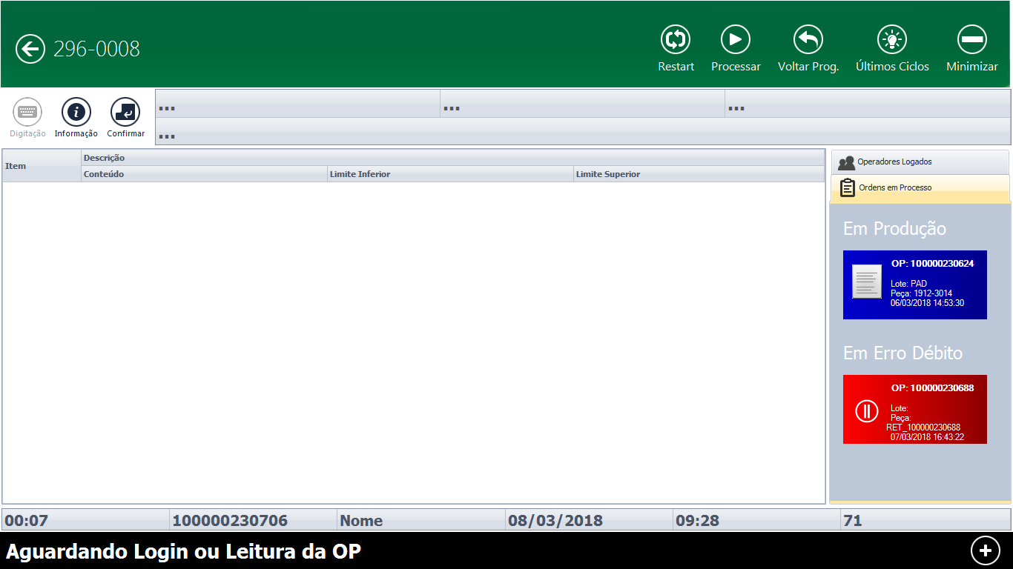
OP: 100000230717 PA 10105-00002

