TESTE 18
________________________________________________________________________________
Parte 01 OK

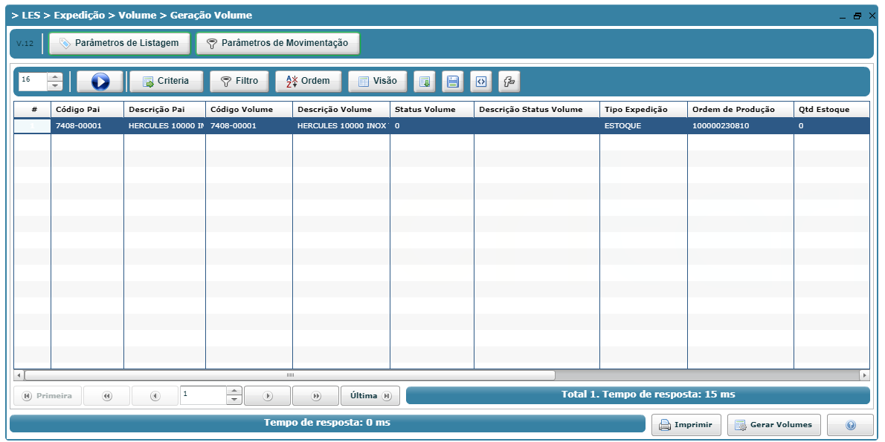
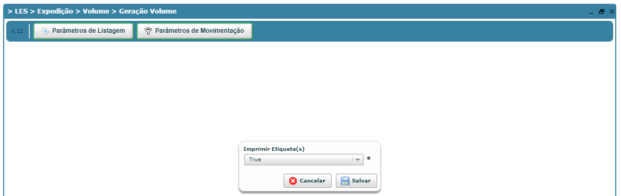
________________________________________________________________________________
Parte 02 OK
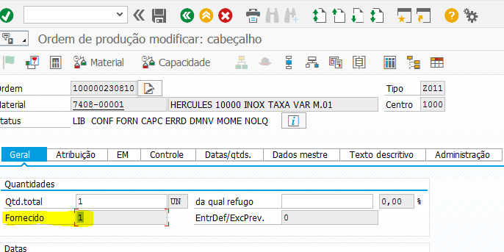
________________________________________________________________________________

Parte 03 OK

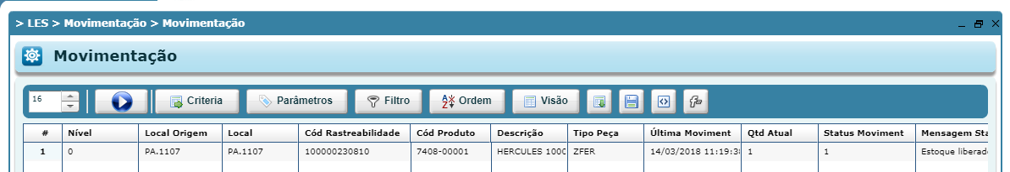

Parte 04 OK
