ST-1224:SD_REM_RF92_02

Remessa Criada

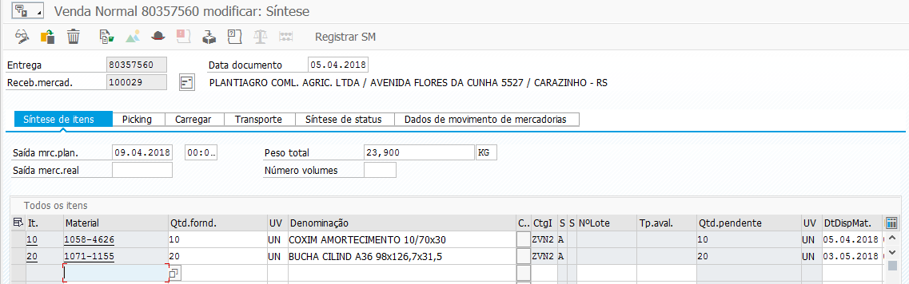
Remessa Eliminada

