2515-00001 OV140989

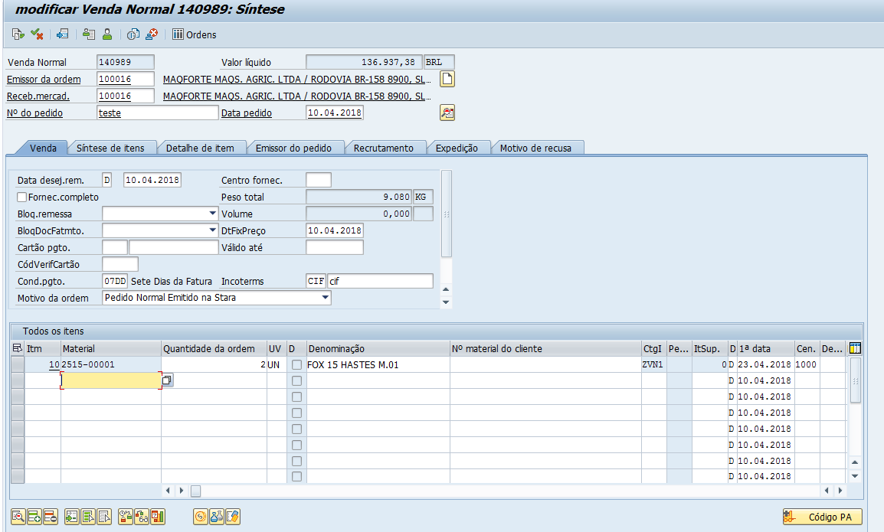

DOC 4917887728

