**[SAP-808](javascript:ST(13258,13259))**[:CRIAR_RECEBIMENTO_01](javascript:ST(13258,13259))

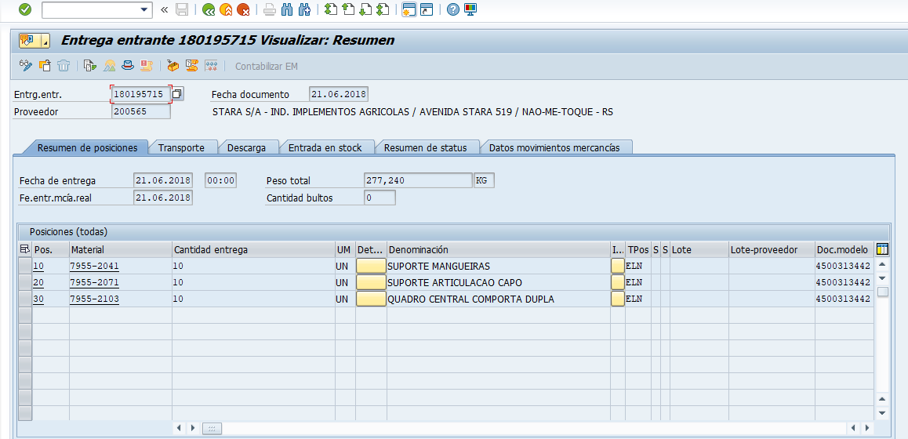

[**SAP-809**:REGISTRAR_ENTRADA_DE_MERCADORIA_04](javascript:ST(13261,13262))

