**[SAP-732](javascript:ST(13026,13027))**[:CRIAR_PEDIDO_DE_COMPRA_06](javascript:ST(13026,13027))

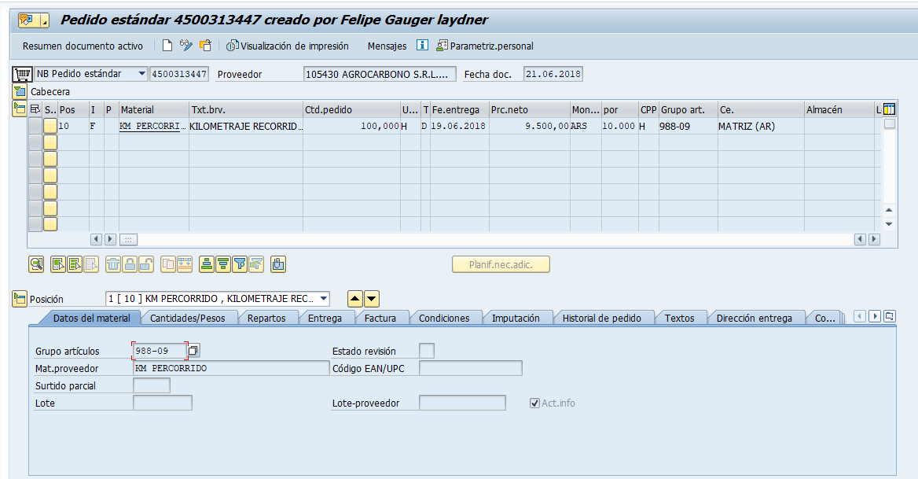

[**SAP-733**:LIBERAR_PEDIDO_DE_COMPRA_01](javascript:ST(13029,13030))

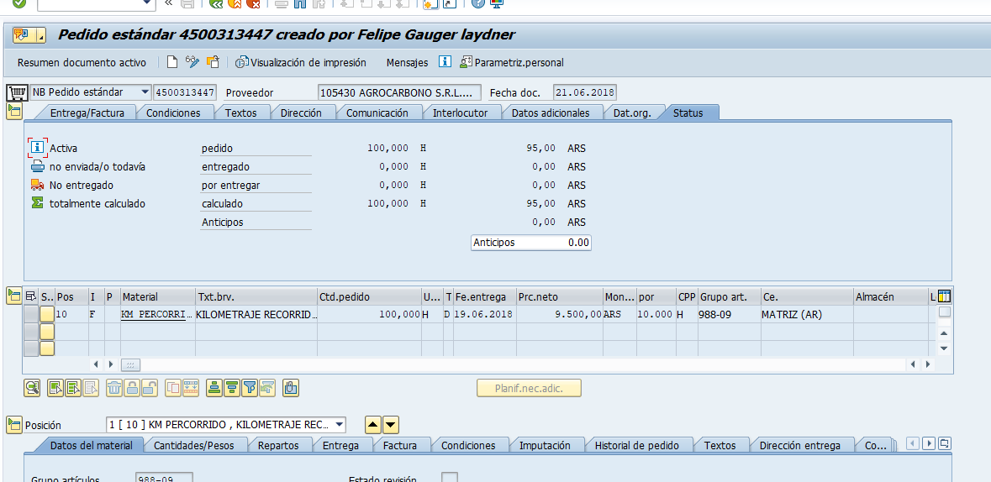

[**SAP-734**:REALIZAR_A_ENTRADA_DE_SERVICO_02](javascript:ST(13032,13033))

