SEMANTIC KNOWLEDGE RESOLUTION

Technical Specification
  - Structured knowledge, coding-agent execution, reusable project forks, and evidence-grounded chat

Axiologic Research | September 2026

Reference architecture and implementation contract

Executive Summary
Semantic Knowledge Resolution (SKR) is a project-oriented knowledge system for books, PDFs, datasets and reusable analytical methods. Users work through a chat interface. The server turns each request into a controlled coding-agent run over a pinned project snapshot. The agent receives a temporary workspace, symbolic links to the skills required by the task, read access to the selected sources and knowledge base, and deterministic tools for search, structure, validation and publication.
The knowledge base stores predicate-first recursive expressions, source assertions, procedures, derived findings and evidence links. MATCH identifies coherent bindings and supporting knowledge; REASON derives local consequences or decomposes a goal; RESOLVE coordinates both operations until it can answer, return a justified partial answer, or identify missing evidence.
Projects are forkable. A reusable base project can contain document-analysis methods, rubrics, predicate profiles, reference knowledge and policies. Each analyzed book is created as a fork that inherits the pinned base snapshot and adds only its own source material, extracted knowledge, derived analyses, conversations and reports. Forking therefore turns procedural knowledge into a reusable analysis environment.
The research objective is measurable: compare SKR with strong RAG and agentic retrieval baselines on both easy retrieval cases and cases requiring joins, multi-hop discovery, exception handling, temporal scope, contradiction analysis and procedure-guided interpretation. Evaluation records answer quality, evidence quality, completeness, cost and the amortized cost of ingestion.

System in one equation
AnswerPackage = RESOLVE(ProjectSnapshot, Question, SourceScope, Procedures, Policy)

RESOLVE = iterative MATCH + REASON + source inspection + evidence audit

Main components
Component | Responsibility
SKR Server | Receives requests, pins project snapshots, chooses task profiles, creates workspaces, launches coding agents, validates outputs and commits approved changes.
Project Store | Maintains project/fork relationships, source membership, procedure versions, policies, conversations and snapshots.
Source Store | Preserves original files, extracted page/block structure and stable locators.
Knowledge Store | Stores S-Knowledge Expressions, entities, assertions, rules, procedure outputs and derivation dependencies.
Skill Registry | Stores versioned coding-agent skills and predefined skill bundles for each task type.
Coding Agent Runner | Starts and monitors one workspace-rooted agent session per logical request.
Validation / Commit Layer | Checks evidence, schema, authorization, snapshot consistency and staged KB changes before publication.

1. System Architecture

1.1 Server-centered execution model
The SKR Server accepts user requests and launches all LLM-dependent work. MATCH, REASON, ingestion and procedure execution are dispatched as typed server requests such as QUESTION, INGEST_SOURCE, APPLY_PROCEDURE, BUILD_PROCEDURE, AUDIT_PROJECT or EVALUATE.
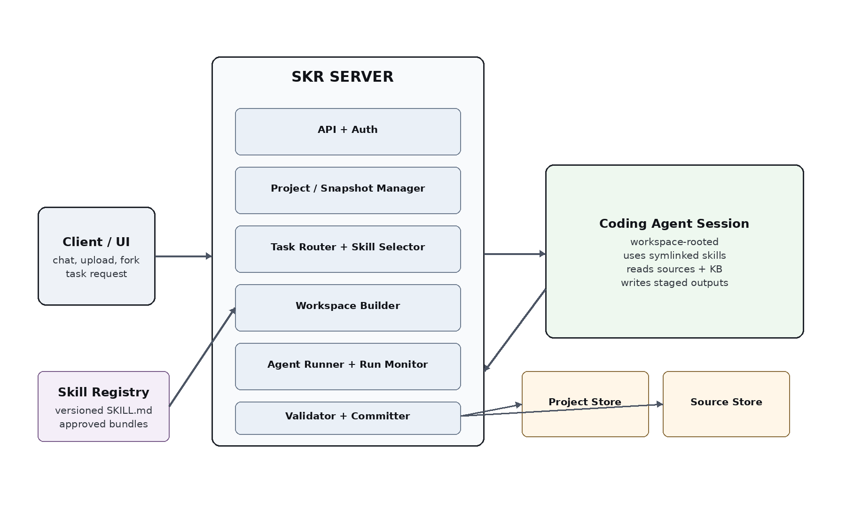
Figure 1. Server-centered architecture. The server owns project state, task routing, workspace construction, agent lifecycle and commits.

1.2 Request lifecycle
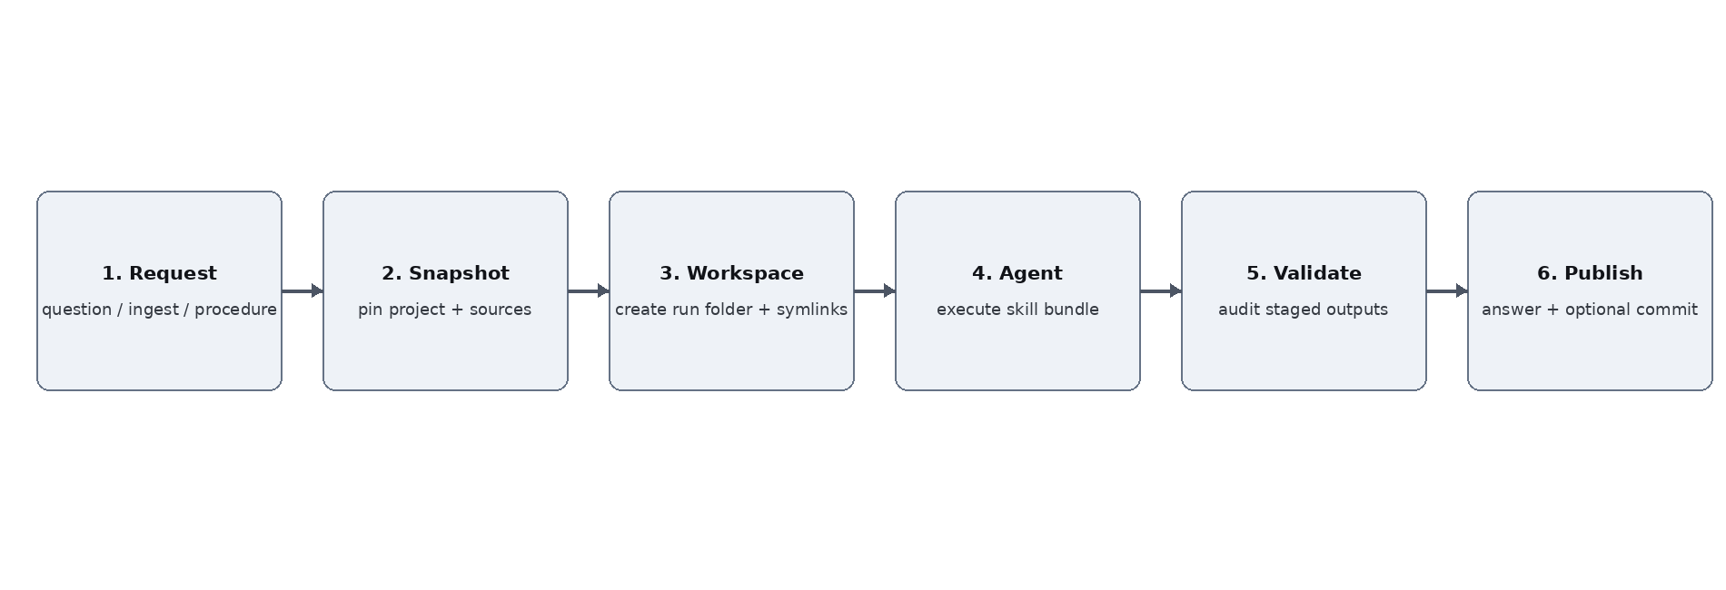
Figure 2. One logical request creates one controlled agent run and one staged publication transaction.
Stage | Contract
Receive | Authenticate the caller, identify the project and task type, record the user request and requested source scope.
Pin | Resolve a ProjectSnapshot containing parent snapshot, local delta, source versions, procedure versions and policies.
Prepare | Create a run directory, mount or link authorized project inputs, and symlink the skill bundle selected for the task.
Run | Launch the coding agent with the run directory as its working root. The agent follows the linked skills and invokes deterministic tools through the server/harness.
Validate | Check output schemas, evidence references, source authorization, dependency records, and optimistic-concurrency conditions.
Publish | Return the answer and evidence package. Commit staged KB changes only when the task and project policy permit durable changes.

1.3 Server modules
Module | Core API / responsibility
API & Auth | create_project, fork_project, submit_request, observe_run, cancel_run, explain_answer.
Project Manager | Resolves project ancestry, snapshots, inherited objects, local deltas and source membership.
Task Router | Maps task type and project policy to a versioned skill bundle and tool capability set.
Workspace Builder | Creates /runs/<run-id>, writes request metadata, binds project/source views and creates skill symlinks.
Agent Runner | Starts, resumes and terminates coding-agent sessions; captures public events and checkpoints.
Query Services | Exact structural matching, indexes, joins, lexical search, source navigation, rule replay and arithmetic.
Validator | Checks SKE schemas, evidence reopening, source scope, claim support and staged mutation validity.
Committer | Publishes immutable run artifacts and applies accepted project deltas atomically.

1.4 Persistent storage
SKR can begin with a relational database plus an immutable object store. Specialized graph storage is optional. Structural indexes should cover project, entity, predicate, argument position, source region, time, dependency edges and textual source search.
ProjectSnapshot = {
project_id, parent_snapshot_id?,
local_delta_id, source_versions[],
procedure_versions[], policy_version,
entity_profile_version, knowledge_index_version
}

2. Projects, Templates and Forking

2.1 Project as the unit of work
A project groups sources, structured knowledge, approved procedures, policies, conversations, materialized analyses and run history. Every answer is computed against an explicit ProjectSnapshot, which makes results reproducible and allows multiple lines of analysis to coexist.

2.2 Fork semantics
fork_project(parent_project, parent_snapshot, name) creates a child project with a pointer to the selected parent snapshot and an empty local delta. The child immediately sees inherited knowledge and procedures. New sources, assertions, analyses and conversations are written only to the child delta. Immutable source objects and inherited records are shared by reference.
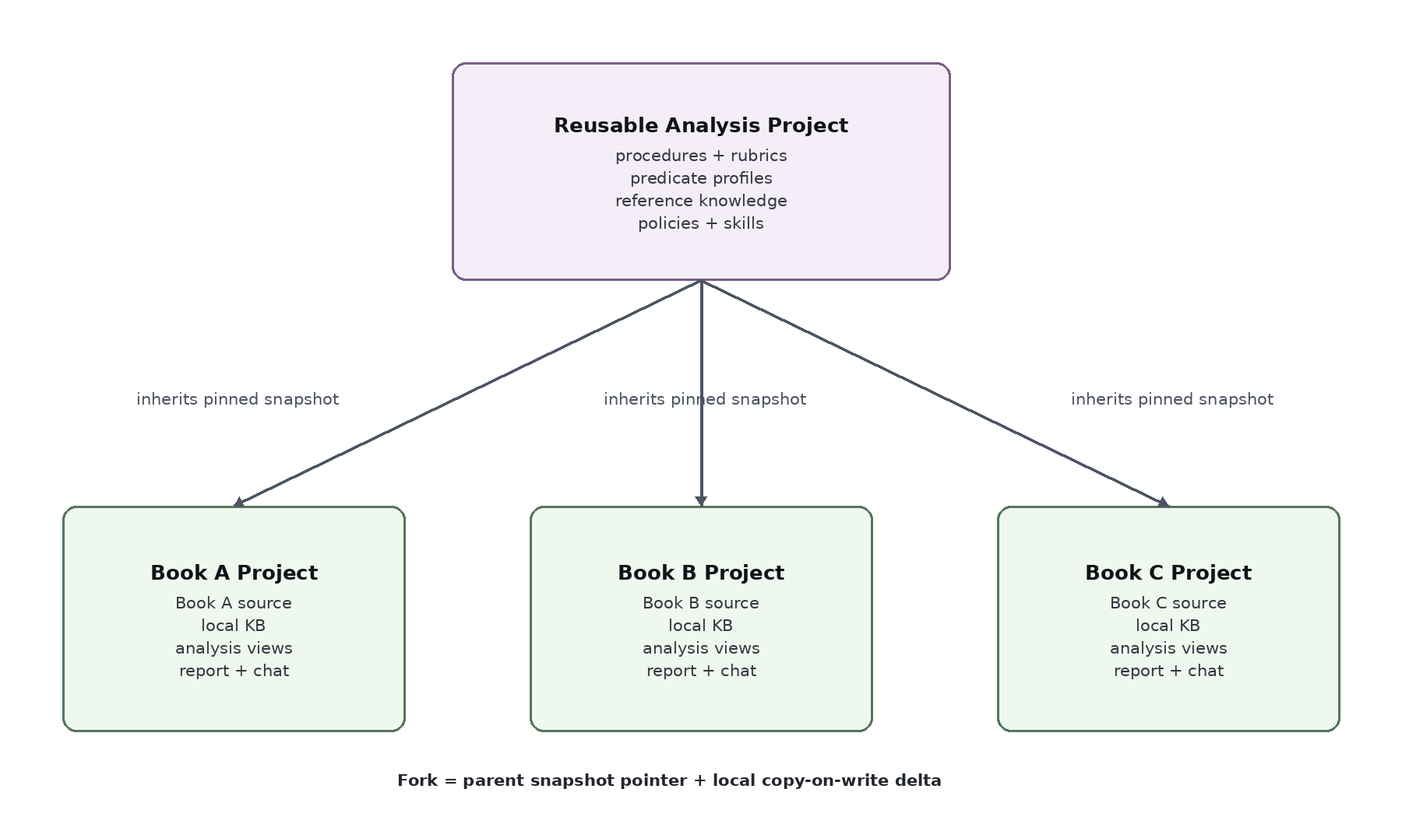
Figure 3. A reusable analysis project can be forked once per book. Each child inherits methods and reference knowledge while keeping book-specific knowledge and reports local.

Fork resolution
effective(child) = inherited(parent_snapshot) + child.local_delta

write(child, x) -> child.local_delta
read(child) -> merge(parent_snapshot, child.local_delta)
The local delta shadows inherited configuration through explicit versioned overrides. Assertions and analysis results retain their originating project and dependency graph, keeping reusable methods and book-specific facts in distinct namespaces.

2.3 Reusable analysis projects
A reusable analysis project is an ordinary project designed as a parent. It can contain procedure definitions, rubrics, reference books, domain vocabulary, predicate profiles, report templates, evaluation criteria and default skill bundles. Its content is primarily reusable and project-independent.
Base project contains | Child book project adds
Literary-analysis rubric and procedure | The book PDF/EPUB and its extracted source regions
Contradiction-analysis procedure | Book-specific entities, events and claims
Summary/relevance procedure | Derived summaries and relevance views
Predicate profiles and reference vocabulary | Local predicate/entity extensions when needed
Report structure and policies | Book-specific findings, evidence, final report and chat history

2.4 Example workflow: one analysis method, many books
LiteraryAnalysisBase
procedures/literary-quality@3
procedures/theme-map@2
procedures/contradiction-audit@1
knowledge/reference-literary-concepts

fork -> Book_A
sources/book-a.pdf
kb/local/*
views/literary-quality/*
report.docx

fork -> Book_B
sources/book-b.pdf
kb/local/*
views/literary-quality/*
report.docx
A report request in Book_A resolves the inherited analytical procedures together with Book_A local knowledge. The same procedure version can then be applied to Book_B with the same inherited method definition. Improvements to the base create a new parent snapshot. Existing children remain pinned to their original parent snapshot; an explicit rebase operation can create a new child snapshot using the updated method set.

2.5 Fork-related API
Operation | Semantics
create_project(name) | Create an empty root project.
fork_project(parent_id, snapshot_id, name) | Create a copy-on-write child pinned to a specific parent snapshot.
get_ancestry(project_id) | Return parent chain and pinned snapshot IDs.
diff_project(project_id) | Return local sources, local KB records, overrides and materialized views relative to the parent.
rebase_project(project_id, new_parent_snapshot) | Create a new snapshot after revalidating local overrides and procedure dependencies.
export_project(project_id, snapshot) | Export selected source references, KB delta, procedures, findings and reports.

3. Knowledge Model and Resolution

3.1 S-Knowledge Expressions
The semantic representation is a predicate-first recursive term language. Predicates are variadic. Arguments can be entities, literals, variables or nested expressions. Stable entity IDs separate identity from surface names.
(depends_on service:payment service:identity)
(located_in service:identity region:eu)
(asserts source:report-7 (depends_on service:payment service:identity))
(and (requires_at_startup ?m ?s) (unavailable ?s))
(find (?service) (and (depends_on service:payment ?service)
(located_in ?service region:eu)))

3.2 Core record types
Record | Meaning
SourceAssertion | A source region expresses an SKE under a specific attribution, time, modality and world/scope.
Entity | Stable identity plus aliases and reversible coreference decisions.
PredicateProfile | Roles, argument constraints, descriptions, approved normalizations and useful lexical forms.
Rule | Range-restricted explicit transformation from premises to a conclusion.
ProcedureVersion | Versioned analytical method with inputs, steps, evidence obligations and output schema.
Derivation | A consequence with all premise IDs, transformation, procedure/rule version and scope.
Assessment | A rubric-relative judgment such as literary-quality or relevance finding.
MaterializedView | Precomputed derived knowledge for a project snapshot and procedure version.

3.3 MATCH
MATCH(goal, project_snapshot, scope, bindings, policy) -> MatchSet
MATCH finds coherent bindings and evidence that satisfy a goal. It combines structural indexes, identity normalization, predicate/argument search, lexical source search and coding-agent semantic interpretation. The output records bindings, source/assertion IDs, argument mappings, semantic direction, assumptions, residual constraints and search coverage.
Semantic relation | Use
equivalent | Candidate and goal express the same claim under the current scope.
candidate_entails_goal | Candidate is sufficiently stronger than the requested goal.
goal_entails_candidate | Candidate is weaker; useful for search but insufficient by itself.
related | Topically useful candidate for further inspection.
incompatible_in_scope | Candidate conflicts with the goal under aligned entities and scope.
ambiguous | Several mappings or readings remain plausible.
unsupported | No justified relation was established.

3.4 REASON
REASON(premises, optional_goal, project_snapshot, procedures, policy)
-> consequences | subgoals | hypotheses
REASON performs local reasoning around named premises. Exact registered rules are replayed deterministically. The coding agent handles semantic entailment, backward decomposition and domain-specific reasoning under the active procedure. Every result records essential premises, transformation class, applicability conditions, assumptions and inherited uncertainty.

3.5 RESOLVE
RESOLVE(question):
interpret question -> candidate goals
MATCH direct knowledge
join shared variable bindings
expose residual goals
REASON or apply procedures around residual goals
MATCH newly exposed entities / subgoals
inspect original source where needed
search counterevidence / exceptions
audit evidence
publish answer or named residuals
The resolver is goal-directed: it derives and retrieves only what the current task requires. Shared bindings allow relevance to emerge during reasoning. An entity discovered at one step can determine which source region or fact becomes relevant at the next step.

3.6 Epistemic state
Each item stores separate dimensions for origin, validation, support and lifecycle. This prevents one confidence score from mixing different questions such as source fidelity, inference validity and freshness.
Dimension | Representative values
Origin | source assertion, user assertion, explicit derivation, neural interpretation, procedural observation, assessment, hypothesis
Validation | structurally valid, source checked, rule replayed, semantically reviewed, human approved
Support | supported, opposed, contested, unresolved
Lifecycle | staged, current, stale, superseded, retracted

4. Knowledge Ingestion and Procedural Analysis

4.1 Whole-source ingestion
Ingestion turns complete books, PDFs and datasets into a source-preserving semantic project. Original files remain available throughout the lifecycle. Every extracted semantic record links to a stable source locator so the agent can reopen the exact page, paragraph, table cell or figure context when answering.
Stage | Output
Register | Immutable source version, metadata, digest, project membership and extraction profile.
Parse | Document structure, pages, blocks, headings, tables, notes and page images where useful.
Inventory | Coverage ledger containing every source region and its processing state.
Extract | Entities, scoped assertions, events, relations, definitions, rules and candidate analytical methods.
Reconcile | Stable identities, aliases, predicate profiles and unresolved ambiguities.
Context pass | Cross-chapter links, long-range dependencies, exceptions, temporal changes and discourse structure.
Validate | Source reopening, qualifier checks, coverage gaps and consistency checks.
Materialize | Run approved procedures that are configured for ingestion-time precomputation.

4.2 Coverage ledger
The ingestion ledger records each source region as processed, intentionally excluded, unreadable, ambiguous, deferred or superseded. This supports questions about coverage and makes complete enumeration tasks measurable. Semantic completeness is assessed through evaluation rather than inferred from page coverage alone.

4.3 Procedural knowledge
Procedures describe how the agent should analyze project knowledge. They are stored as versioned project records and are inherited through project forks. Typical procedures include literary-quality analysis, contradiction detection, relevance-aware synthesis, requirement extraction, novelty analysis and project consistency checks.
ProcedureVersion = {
id, version, purpose,
applicable_inputs, parameters,
ordered_steps, required_skills,
evidence_obligations, output_schema,
materialization_policy, watch_scope
}

4.4 Precomputed analytical views
A procedure can run during ingestion or as a separate project task and materialize derived knowledge. This moves expensive analysis ahead of interactive chat and allows later questions to resolve quickly from validated findings while retaining the original evidence and procedure version.
Example procedure | Materialized outputs
Contradiction audit | Claim clusters, incompatible assertions, revision relationships, unresolved conflicts.
Literary analysis | Passage-level observations, character/voice structures, tension patterns, rubric-relative assessments and counterexamples.
Relevant synthesis | Purpose-specific concept maps, summaries, rare but important details, omissions and evidence groups.
Knowledge extraction | Definitions, entities, events, causal/conditional relations, open questions and cross-source links.

4.5 Dependency and freshness
Every materialized finding stores its source snapshot, procedure version, parameters and dependencies. Source changes or procedure updates mark affected findings stale through dependency edges. The project can recompute stale views before the next answer or during an explicit maintenance request.

5. Coding-Agent Runtime and Skills

5.1 Workspace construction
For every logical request, the server creates a temporary workspace and launches the coding agent inside that directory. The server determines the task profile first, then creates symbolic links only to the approved skills required by that profile. The agent can request an additional skill during execution; the server resolves and links the approved version into the same workspace.
/runs/<run-id>/
request/
task.json
policy.json
snapshot.json
skills/
core -> /skill-registry/skr-core@5
resolve -> /skill-registry/skr-resolve@7
match -> /skill-registry/skr-match@4
reason -> /skill-registry/skr-reason@6
sources/ # read-only authorized source view
kb/ # read-only pinned project snapshot / query handle
procedures/ # inherited + local approved procedure versions
work/ # writable scratch, scripts, intermediate analysis
state/ # checkpoints, agenda, coverage ledger, residuals
out/ # final answer packet and staged change set
events/ # public operational events

5.2 Task profiles and skill bundles
Task profile | Default linked skills
QUESTION | skr-core, skr-resolve, skr-match, skr-reason, skr-audit-evidence, skr-answer
INGEST_SOURCE | skr-core, skr-ingest-source, skr-read-pdf or skr-ingest-data, skr-extract-knowledge, skr-reconcile-entities, skr-audit-evidence
APPLY_PROCEDURE | skr-core, skr-procedure-apply, skr-match, skr-reason, domain procedure skill, skr-audit-evidence
BUILD_PROCEDURE | skr-core, skr-procedure-author, domain references, skr-audit-evidence
AUDIT_PROJECT | skr-core, skr-project-consistency, skr-match, skr-reason, skr-audit-evidence
EVALUATE | skr-core, skr-eval-runner plus the task-specific bundle under test

5.3 Skill contract
Every skill is a versioned directory with SKILL.md and optional scripts, fixtures and reference material. The server registry controls which version can be linked into a run. Skills specify inputs, allowed operations, outputs, evidence obligations, validation steps and stopping conditions.
skill-name/
SKILL.md
references/
scripts/
fixtures/
tests/

SKILL.md:
purpose
applicability
required inputs
execution procedure
output files / schemas
evidence obligations
validation checks
stopping conditions

5.4 Core skills
Skill | Responsibility
skr-core | Project/snapshot contract, source handling, SKE conventions and workspace rules.
skr-ingest-source | Whole-source inventory, extraction orchestration, reconciliation and staged ingestion outputs.
skr-extract-knowledge | Scoped claims, entities, events, relations, definitions and candidate methods.
skr-match | Semantic matching, argument mapping, shared bindings and residual constraints.
skr-reason | Local consequences, backward subgoals and explicit reasoning records.
skr-resolve | Goal agenda, procedures, iterative MATCH/REASON, source rereading and final answer packet.
skr-procedure-apply | Execute one approved ProcedureVersion and materialize typed findings.
skr-audit-evidence | Reopen evidence, verify claim support, qualifiers, counterevidence and dependency integrity.
skr-answer | Render the approved AnswerPackage into natural language and user-requested report formats.
skr-eval-runner | Execute frozen evaluation manifests and record outputs/costs reproducibly.

5.5 Session behavior
A request normally uses one coding-agent session. The same session may call MATCH, REASON, source readers and several procedure skills. Long requests persist checkpoints under state/ so the server can resume a new model context while preserving the explicit agenda, inspected coverage, bindings and residual goals. Staged changes remain isolated until server validation succeeds.

5.6 Publication contract
Agent writes -> out/answer-package.json
out/evidence.json
out/coverage.json
out/change-set.json # optional
out/validation.json

Server validates -> publish answer
-> atomically commit accepted change-set
-> create new ProjectSnapshot

6. Project and Book-Chat Interface

6.1 Main workspace
The product interface is a project chat. The user chooses one project, one book or a selected source set, asks a natural-language question, and receives an answer with claim-level evidence. The interface exposes project inheritance and active procedures while keeping MATCH and SKE details in the evidence and diagnostics layer.
Region | Behavior
Project selector | Create, fork, switch and inspect ancestry. Shows the pinned base project and local delta.
Source library | Books, PDFs and data files with ingestion/coverage state. Supports one-book and whole-project scopes.
Conversation | Questions, analysis requests, report generation and follow-up tasks.
Procedure selector | Shows inherited and local procedures. Allows one-off use or project-default activation.
Evidence panel | Opens exact source pages/regions, source assertions, reasoning steps, procedure findings and counterevidence.
Run panel | Shows public progress: source regions inspected, active subgoals, procedure steps, validation status and completion reason.
Fork action | Creates a new child project from the current snapshot and optionally attaches a new book immediately.

6.2 Chat with a reusable method
A typical workflow starts from a project such as Literary Analysis Base. The user presses Fork, names the new project after a book, uploads the PDF and starts ingestion. Inherited procedures run or become available according to policy. The same conversation can then ask factual questions, request interpretations, compare passages, apply a rubric or generate a final report. Every answer resolves inherited procedural knowledge together with the child project’s local book knowledge.

6.3 Answer package shown in the UI
Field | Displayed meaning
Answer | Readable direct response.
Evidence | Source passages, table cells or inherited analytical findings supporting each material claim.
Interpretation | Chosen reading of ambiguous questions and source language.
Support state | Supported, contested or unresolved.
Coverage | Relevant inspected scope and any named gaps.
Procedure | Procedure/version used for analytical judgments.
Snapshot | Project and parent snapshots that produced the answer.
Residuals | Missing premises, unresolved alternatives or requested follow-up analysis.

7. Evaluation Against RAG and Agentic Retrieval

7.1 Evaluation question
The primary experiment asks whether structured project knowledge, explicit bindings, reusable procedures and precomputed analytical views improve grounded answer quality relative to strong retrieval baselines at comparable model capability and measured compute cost.

7.2 Required baselines
System | Configuration
Hybrid RAG | Strong lexical + embedding retrieval, reranking and the same answer model where practical.
Agentic RAG | The same coding-agent backend can iteratively search raw source text and choose additional retrieval steps.
GraphRAG | Graph/hierarchical retrieval baseline with standard community/entity mechanisms.
Full-source agent | Coding agent works directly over available book/source files using raw-source search tools.
SKR Direct | SKE + MATCH only.
SKR Full | Ingestion + MATCH + REASON + RESOLVE + inherited procedures + materialized views.

7.3 Balanced task families
Family | Examples
RAG-friendly controls | Exact fact, paraphrase, exact quotation, local chapter summary, local table lookup, local tone/style question.
Relational retrieval | Shared-variable joins, entity discovered after first hop, three-hop paths, cross-chapter dependencies.
Complete-set questions | List every item satisfying conditions; distant exceptions; footnotes changing the answer.
Semantic precision | Role reversal, stronger/weaker predicates, explicit negation, attributed statements, modality and temporal versions.
Incomplete evidence | Required premise absent, ambiguous identity, two conflicting sources, unresolved disjunction.
Procedure-guided analysis | Contradiction audit, literary rubric, relevance-aware synthesis, project-consistency analysis.
Incremental updates | New source changes a conclusion; procedure revision invalidates materialized views; fork inherits a newer method after rebase.
Robustness | Malicious source instructions, another project with same entity names, unreadable qualifier, stale cached finding.

7.4 Gold construction
Use two complementary datasets. Controlled synthetic/semisynthetic projects provide exact gold facts, rules, joins, exceptions and expected bindings. Real books and project corpora provide expert-annotated questions, evidence sets and procedure-relative judgments. Evaluation cases are frozen before system runs; gold evidence and adjudication notes remain hidden from answering agents.

7.5 Metrics
Metric | Definition
Answer score | Exact/F1/classification or expert score appropriate to the task.
Claim support rate | Fraction of material answer claims adequately supported by cited evidence.
Evidence precision | Useful/valid evidence among evidence returned.
Evidence recall | Required gold evidence recovered.
Binding accuracy | Correct entity/value assignments for structured queries.
Completeness score | Recall of all required answer items in enumeration/global tasks.
Residual accuracy | Whether missing premises or unresolved conditions are identified correctly.
Contradiction handling | Correct separation of conflict, revision, attribution and temporal change.
Procedure fidelity | Whether procedure outputs follow the pinned method and evidence obligations.
Update correctness | Whether stale results are invalidated and recomputed after relevant changes.
Cost | Ingestion cost, per-query model/tool cost, tokens and wall-clock latency.
Amortized cost | Total cost over N queries per project, including one-time ingestion/materialization.

7.6 Core demonstration cases
Case | Why it matters
Easy local lookup | Ensures SKR remains competitive on tasks where conventional RAG is naturally strong.
Join across distant facts | Question requires one shared entity and support is distributed across multiple source regions.
Three-hop dependency | The entity needed for step 2 becomes known only after step 1.
Distant exception | An otherwise plausible complete list is invalidated by a remote footnote or appendix.
Role reversal | Near-identical wording with reversed argument roles tests semantic precision.
Observed vs possible | Separates conditions that could cause an event from evidence that the event occurred.
Contradiction vs revision | Two claims differ because of time/version; system must preserve both scopes.
Literary analysis | Procedure requires evidence across the whole book and counterexamples, not only topically similar passages.
Procedure update | Changing the rubric marks inherited/materialized results stale and recomputes affected outputs.
Fork isolation | Two child projects share procedures but maintain separate book facts, findings and conversations.

7.7 Fair comparison protocol
Report two regimes. The equal-budget regime constrains answer-model capability and context/tool budgets across systems. The quality-first regime lets each system use its natural architecture while measuring total compute, latency and preprocessing. For SKR, ingestion and materialization costs are reported separately and amortized over query count. For RAG and GraphRAG, indexing and graph-building costs receive the same treatment.
Use paired evaluation on the same cases, bootstrap confidence intervals for aggregate differences, and expert adjudication for interpretive tasks. Report results by task family so gains on relational/procedural cases cannot hide regressions on easy retrieval cases.

7.8 Minimum credible experimental release
Track | Recommended scope
Controlled | 300-500 cases across joins, multi-hop, negation, time, exceptions and incomplete evidence.
Book QA | 100-200 questions across 5-10 complete books, including easy controls and whole-book evidence tasks.
Procedural | 50-100 contradiction/literary/relevance tasks with expert scoring and fixed procedure versions.
Update/fork | 50-100 mutation cases covering source updates, procedure updates, fork isolation and rebase.

8. Implementation Sequence

8.1 Milestone A - project server and forkable storage
Implement projects, snapshots, parent pointers, copy-on-write deltas, source registration, procedure registry, run records and fork/rebase APIs. Deliver a minimal UI that creates a base project, forks it and shows ancestry plus local changes.

8.2 Milestone B - workspace and coding-agent harness
Implement task routing, run-directory creation, read-only source/KB views, skill symlinks, agent start/resume, checkpoints, public events, staged output schemas and validated commits. Demonstrate QUESTION and INGEST_SOURCE task profiles end to end.

8.3 Milestone C - SKE and semantic resolution
Implement the SKE parser/store, entity/predicate indexes, exact unification, shared-variable joins, range-restricted rules and evidence records. Add skr-match, skr-reason and skr-resolve agent skills. Demonstrate direct, join and multi-hop cases with reopenable evidence.

8.4 Milestone D - whole-book ingestion and procedures
Implement source coverage ledgers, PDF/page readers, entity reconciliation, cross-document extraction, ProcedureVersion storage and materialized views. Create at least three reusable procedures: contradiction audit, relevance-aware synthesis and one literary/document-quality rubric.

8.5 Milestone E - book chat and evaluation
Complete the chat interface, evidence inspector, procedure selector and one-click project fork. Freeze the evaluation suite and run all required baselines with measured preprocessing and query cost.

8.6 Acceptance targets
Area | Acceptance target
Forking | A child inherits the exact parent snapshot and procedures; local source facts and reports stay isolated; diff/rebase are reproducible.
Execution | Every LLM-dependent request runs through a server-created workspace with a recorded skill bundle and pinned snapshot.
Grounding | Every material factual claim in a strict answer can reopen its supporting source or derived evidence chain.
Ingestion | Every source region has a recorded processing state; source updates create a new source version and invalidate dependent findings.
Procedures | Procedure outputs record exact version, parameters, evidence and dependencies and can be reused through project forks.
Resolution | Shared-variable, multi-hop and incomplete-evidence fixtures return correct bindings/residuals under frozen tests.
Evaluation | Results are reported by task family against all required baselines, including easy RAG controls and total amortized cost.

Appendix A. Key Skill Specifications

A.1 skr-resolve
Inputs: question, pinned snapshot, source scope, active procedures, policy
Outputs: answer-package.json, evidence.json, residuals.json, coverage.json

Procedure:
1. Interpret the request and create explicit goals.
2. Build an agenda of answer and coverage obligations.
3. Use MATCH; preserve shared bindings and residuals.
4. Use REASON and active procedures around unresolved goals.
5. Reopen original sources for nuance, scope and exceptions.
6. Search relevant counterevidence.
7. Call evidence audit.
8. Produce answer package and optional staged derived records.

A.2 skr-match
Inputs: goal, current bindings, snapshot, candidate scope, predicate/entity profiles
Outputs: match records, bindings, residual constraints, candidate coverage

For each accepted match record:
- source/assertion IDs
- argument mapping
- semantic relation and direction
- shared bindings
- scope/time/attribution
- assumptions and validation state

A.3 skr-reason
Inputs: named premises, optional goal, explicit rules, procedures, policy
Outputs: reasoning records and/or subgoals

Each record contains:
- conclusion or subgoals
- all essential premise IDs
- transformation / inference class
- applicability conditions
- assumptions
- dependency fingerprint
- validation state

A.4 skr-ingest-source
Inputs: source versions, project snapshot, ingestion profile, active ingest procedures
Outputs: coverage ledger, extracted assertions, entity proposals, ambiguities, staged changes

Procedure:
register -> parse -> inventory -> local extraction -> reconciliation -> context pass -> validation -> optional materialization

A.5 skr-procedure-apply
Inputs: exact ProcedureVersion, parameters, project snapshot, source scope
Outputs: procedure-run.json, findings.json, evidence.json, coverage.json, staged materialized view

Each finding records procedure version, parameters, dependencies, scope, output type and support state.

A.6 skr-audit-evidence
Inputs: proposed answer/findings, evidence graph, source snapshot, coverage ledger
Outputs: audit-report.json

Checks: source reopening, claim strength, attribution, modality, polarity, time, identity, units, exceptions, counterevidence, citation integrity and dependency freshness.

