Dynamic Diagnostic Engine - Engineering Specification
Version: v10 document set; engine 0.10.0 (this revision folds in the mixed-mode online/offline switching and the deactivation failsafe, which took the engine from 0.9.0 to 0.10.0). The measured outcome numbers were taken on the verdict-neutral 0.9.0 baseline and are unchanged at 0.10.0. Date: July 2026 Audience: AML engineering team Status: Engine, routing, question selection, calibration, the offline path (served to the client as a downloadable reference plus a fetch endpoint, Sections 4 and 5.9), raw-response persistence for the misconception classifier (Sections 5.4, 5.10, and 6.3), the in-process misconception-classifier integration, the mixed-mode online/offline switching (Sections 4, 5.11, 7.10, and the handover pack in Section 17), and the deactivation failsafe (Sections 5.11, 5.12, and 7.8) are all built and verified against engine 0.10.0 (668 tests passing). Mixed-mode and the failsafe were the MINOR change that took the engine from 0.9.0 to 0.10.0; both are verdict-neutral (they change how and when questions are delivered, never how an answer is scored), so the measured outcome numbers in this document - taken on the 0.9.0 baseline (see Section 1 and the comparison report) - are unchanged at 0.10.0. Section 16 records the resolved engineering decisions; remaining build and operational items are noted there and in Sections 10, 14, and 15.

1. Overview
The dynamic diagnostic engine is a new service in the AML platform that decides which questions a learner sees during a diagnostic session, and produces a per-skill mastery verdict at the end. It replaces the static diagnostic that ran in Delhi from April-May 2026.
The current static diagnostic asks every learner the same set of questions, in the same order, regardless of how they are doing. The dynamic engine instead picks each next question based on what the learner has already got right or wrong. Strong learners answer fewer questions on skills they have clearly mastered; weak learners answer fewer questions on skills they clearly have not.
Measured against learners' real entry mastery records - with question responses simulated from a fixed 0.90/0.15 model - using engine 0.9.0 (500 learners per grade, G2-G5, three replicates, 42,693 scored skill-rows), the value of the engine is in three things, in order of importance:
- More accurate where it commits, through calibrated abstention. When the engine commits to a confident verdict, it is right 93.3% online and 96.0% offline, versus 86.9% for the static diagnostic. This confident-only figure is not a like-for-like comparison: the engine only commits on the skills it is confident about (coverage 92.4% online, 80.1% offline) and routes the rest to MainD rather than guessing. (By contrast the static diagnostic has more than one question for only about 47% of individual L2.5 skills, so it can reliably assess only about half of them at that level - which is why it reports at grade + L1-skill level; see the comparison report Section 3.) Counting every skill (uncertain treated as not-mastered) the accuracy is 89.0% online and 87.4% offline versus 86.9% static - a smaller edge. The distinctive property is the abstention itself: the engine declines to commit on the hard cases instead of committing to a wrong answer.
- Safer skips. The false-skip rate (flagging a not-yet-mastered skill as mastered, so the learner wrongly skips practice) is 3.4% online and 2.1% offline, versus 3.8% static.
- Fewer downstream MainD questions. For each skill it confidently masters, a learner skips that skill's MainD questions: about 27.0 per learner online and 25.6 offline, 96-98% of them correct (a lower bound, measured only on skills with entry ground truth). Counting the diagnostic and MainD together, that is on the order of 30 fewer questions per learner overall online (roughly 4 from the diagnostic plus 27 from MainD), almost all of it the MainD saving.
The engine's value is not mainly in cutting diagnostic questions. Direct question savings are modest and shrink with grade (about 8% overall online, 15% at G2 down to 4% at G5) and are near zero offline, because the offline path deliberately spends its budget on coverage. The gains are accuracy, safety, and the downstream MainD savings above.
Measured performance (engine 0.9.0). The table below is the per-grade summary; the full method, calibration tables, and caveats are in the comparison report. Sample: 500 learners per grade, three replicates, the same learners across all three arms, scored against entry_mastered ground truth. Confident accuracy and coverage are over confident decisions only; false-skip is the share of confident_mastered skills that are actually not mastered.
Grade | Static acc | Online conf acc | Online coverage | Offline conf acc | Offline coverage | Static false-skip | Online false-skip | Offline false-skip | MainD saved (online / offline)
G2 | 0.846 | 0.927 | 0.901 | 0.959 | 0.867 | 0.014 | 0.023 | 0.017 | 16.1 / 15.9
G3 | 0.877 | 0.922 | 0.941 | 0.961 | 0.780 | 0.042 | 0.049 | 0.021 | 24.1 / 21.5
G4 | 0.871 | 0.934 | 0.935 | 0.960 | 0.843 | 0.045 | 0.038 | 0.024 | 30.6 / 28.9
G5 | 0.869 | 0.941 | 0.912 | 0.959 | 0.758 | 0.039 | 0.027 | 0.020 | 37.3 / 36.2
Overall | 0.869 | 0.933 | 0.924 | 0.960 | 0.801 | 0.038 | 0.034 | 0.021 | 27.0 / 25.6
Direct in-diagnostic savings (not the headline): online 8.1% overall (15.2% at G2 to 4.2% at G5), offline 3.6% overall. Calibration at the confident-mastered end: a confident_mastered verdict is correct 96.6% of the time online and 97.9% offline (this is 1 - false-skip).
This document specifies how the engine works at the system boundary: its API, its data model, the algorithm it runs, the way it integrates with aml-api-service and MongoDB, and what the engineering team needs to know to build, deploy, and operate it in production.

Where the engine sits
The engine is a new HTTP service. It never talks to learners directly. It receives requests only from aml-api-service, which has already validated the learner's JWT and scored the learner's response.
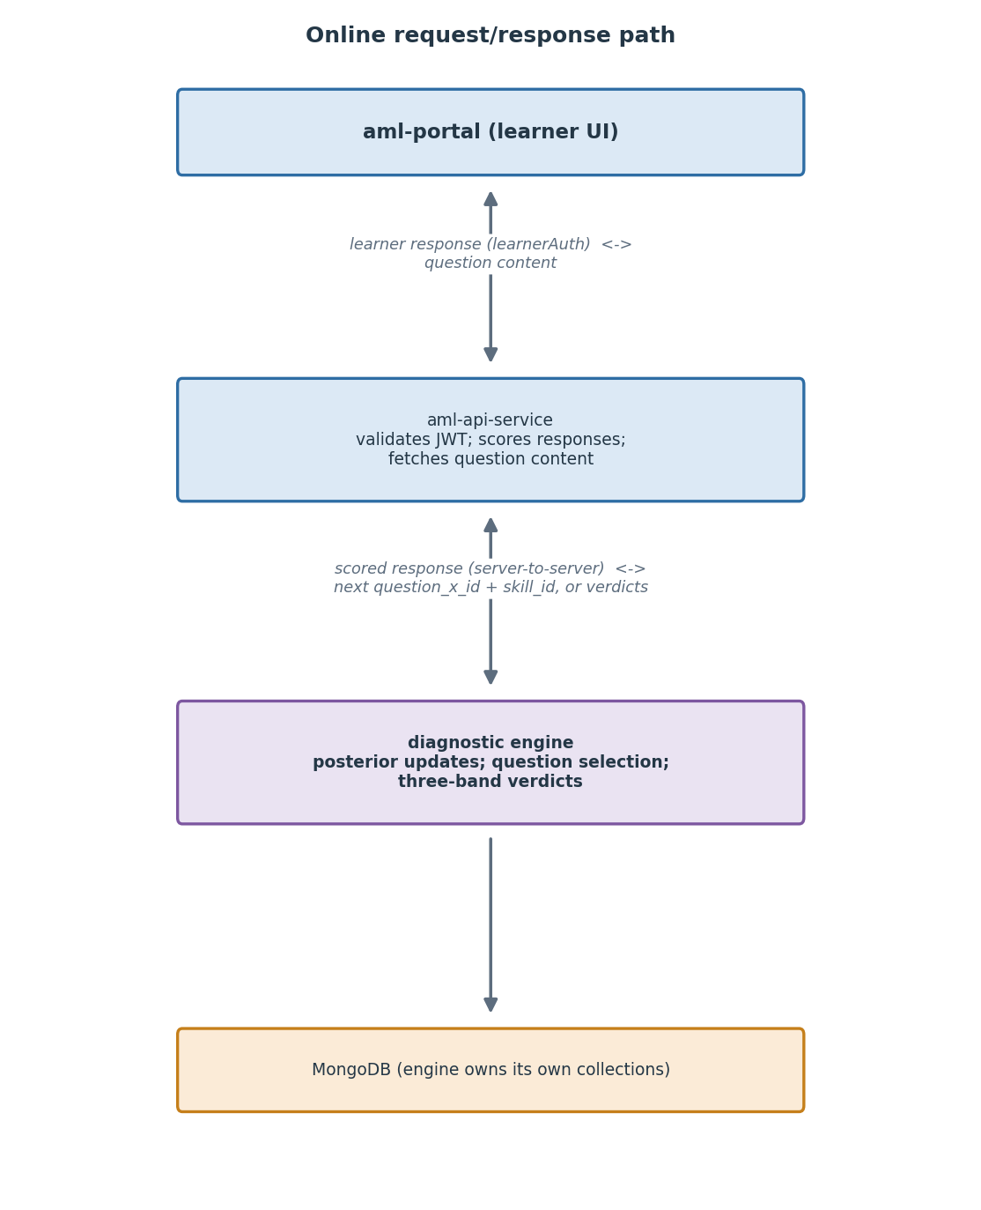

Current integration status (as of this version)
The diagram above is the target. As of this version the engine is not yet integrated into the live AML product. The findings below come from a direct review of the aml-api-service and aml-portal repositories and shape the implementation work (full detail is in the implementation specification):
- The live diagnostic today is the old static one, run server-side. The entry diagnostic is a static chain-walk over (class, L1-skill) question sets with a threshold pass/fail and a two-consecutive-fails skip rule (entryDiagnostic.helper.ts, reached from POST /learner/evaluate/:learner_id). There is no Bayesian, DINA, or adaptive engine in the codebase today, and no client-side sequencing. Integrating the dynamic engine is new wiring, not a swap of an existing adaptive component.
- The per-question attempt-history schema already exists. aml-api-service stores per-question attempt records (learner_proficiency_question_level_data) including question_id, the full taxonomy down to l2_5_skill, per-question score, attempt number, and session id. This is what the offline history scorer (§7.10) needs. One dependency remains (C-1): question_id here is finer-grained than the engine's question_x_id - many question_ids map to one question_x_id, and each question_id resolves to exactly one - so the scorer must translate question_id -> question_x_id before replaying, and that mapping must be available where the scorer runs. The schema itself is confirmed present; the mapping is the open item.
- The portal already has an offline-first learner-response pipeline. aml-portal records learner responses in IndexedDB with a sync lifecycle and reconciliation sagas. The device-side recording the offline path depends on is largely in place; what is missing for offline is the on-device tree-walk loop (the three-pass follow), which is small and engine-free by design and would be ported to the portal's language.
- Shape of integration. The online engine is already a deployable Python service over the same datastore family and deployment model as AML, so it integrates as a sibling service the Node backend calls over HTTP (it is not ported into the Node process). The real work is AML-side glue: identifier mapping between engine skill/question ids and the AML taxonomy (the L2.5 skill layer is shared, which makes the skill side tractable), the set-versus-question bridge, and routing verdicts back into the learner's tailored sequence.

2. Background and scope

Why the engine exists
The static diagnostic asks a fixed number of questions per skill (between 1 and 4 each, depending on grade), in a fixed order. Because the order is fixed and the question count is the same for everyone, learners who clearly know a skill answer the same number of questions as learners who clearly do not.
Two consequences:
- Wasted questions. Strong learners spend time on questions whose outcome is predictable. Weak learners spend time on skills they cannot possibly demonstrate yet.
- The diagnostic does not adapt. Whether a learner has shown perfect mastery of Addition does not change how many Subtraction questions they get. Whether they have failed every Subtraction question does not stop the diagnostic from asking more.
The dynamic engine fixes both. It adapts question selection based on running estimates of mastery, stops asking questions on a skill once it is confident either way, and uses the relationship between skills to draw inferences without direct evidence.

What is in scope
Item | Scope
Arithmetic operations | Four: Addition, Subtraction, Multiplication, Division
L2.5 skills | 39 in the Delhi scope; 40 across all tenants (canonical list in Appendix C)
Learner grades | G2 through G5 are the primary scope. G6, G7, G8 learners use the G5 skill set and question budget.
Question pool | Any question tagged purpose IN ('Main Diagnostic', 'Micro Diagnostic', 'Exit Main Diagnostic'), plus questions from the legacy Delhi static diagnostic (question_x_id prefix q_dlg)
Deployment | One central engine service. All state-specific AML instances (Delhi, Karnataka, Telangana, etc.) call this same engine

What is out of scope
Item | Out of scope because
Numbers operation | In the Delhi static diagnostic, learners answered only 4 questions on Numbers, all from a single skill. That left calibration data too thin to estimate priors reliably. The content team's call was to drop Numbers from the diagnostic on this basis. Place-value misconceptions (the main thing Numbers questions assess) can still be identified after the diagnostic, from learners' answers on other operations, using the misconception classifier.  To enable this change, the following content logic / rules need to be implemented:  - if the verdict for the ‘2-digit addition without carry’ skills is either uncertain or confident_not_mastered in the Dynamic Diagnostic (i.e., the recommendation for ‘2-digit addition without carry’ is either take_maind_diagnostic or take_maind_confirmation), then the learner needs to take the MainD for both ‘Numbers’ and ‘2-digit addition without carry’.  - if the verdict for ‘2-digit addition without carry’ is confident_mastered in the Dynamic Diagnostic (i.e., recommendation for ‘2-digit addition without carry’ is skip_maind), then the learner needs to take the MainD for both ‘Numbers’ and ‘2-digit addition without carry’.
Cold-start offline support | Learners must be online at session start. The PWA work to support a completely offline first launch is not yet ready and is a separate decision
Item authoring or content editing | The engine reads existing questions; it does not create or modify them
Question rendering | aml-portal renders questions. The engine never sees question content, only question_x_ids
Response scoring | aml-api-service scores responses using the existing getScoreForTheQuestion function. The engine receives a Boolean is_correct, not the raw response
Multi-engine horizontal scaling | V1 is single-instance. If concurrency demands grow, scaling is a v2 concern requiring shared session state via Redis or similar

What this replaces and what it does not
The engine replaces the Delhi static diagnostic specifically. It does NOT replace:
- The MainD question set (the regular learning content)
- The Micro Diagnostic and Exit Main Diagnostic question sets (these continue to exist; the engine just pulls questions from them as part of its pool)
- The authoring tool, the analytics layer, or any other AML subsystem

3. Glossary
These terms appear throughout the spec. Plain definitions; mathematical detail is in Section 7.
Term | Definition
L2.5 skill | A unit of mathematical ability the engine tracks separately, like "2-digit Addition with carry" or "Tables of 7". The engine works with 39 in the Delhi scope, and 40 across all tenants.
Mastery | The hidden state of "the learner knows this skill". It cannot be observed directly; the engine estimates it from how the learner answers questions.
Posterior | The engine's running estimate of how likely it is that a learner has mastered a specific skill, expressed as a number from 0 to 1. For example, 0.9 means the engine is 90% sure the learner has mastered the skill. Updated every time the learner answers a related question.
Prior | The starting posterior - what the engine believes about a learner's mastery before they have answered any questions. Calculated from how other learners in the same grade have done on the same skill in past data.
Slip | The chance that a learner who actually knows a skill still gets a question on it wrong - maybe a careless mistake, a misread, or a typo. 10% is a fallback default; where a question has been calibrated, the engine uses that question's own measured slip instead (§7.7).
Guess | The chance that a learner who does NOT know a skill still gets a question on it right - a lucky guess, especially on multiple-choice questions. 15% is a fallback default; where a question has been calibrated, the engine uses that question's own measured guess instead (§7.7).
Lattice | A small graph of 12 connections between skills. Each connection captures a known relationship, like "a learner who can do 2-digit Multiplication can probably also do 1-digit Multiplication". This lets the engine use evidence about one skill to update what it believes about a related one, without asking a direct question on the related one.
Propagation | When the engine uses a lattice connection to update its belief about one skill after seeing the learner's answer on a related skill. Saves direct questions.
Sub-session | How AML already tracks a single learning activity - a diagnostic, a question set, a content piece - that a learner sits down to do. Stored in the learner_sub_sessions MongoDB collection. The engine's session is always one-to-one with a sub-session created by aml-api-service.
Three-band verdict | The engine's final output per skill at the end of a session: one of confident_mastered, uncertain, or confident_not_mastered. Plus a recommendation for downstream: skip_maind, take_maind_diagnostic, or take_maind_confirmation.
Hybrid mode | Running the engine in two ways at the same time. The default is a live online service that picks each next question on demand. When connectivity drops, the client falls back to a pre-built tree shipped to the device. Same algorithm runs either way.
Option 1, Option 4 | The names for the two ways the engine picks questions. Option 4 is online: the engine picks each next question when the response comes in. Option 1 is offline: a pre-built tree, generated in advance, tells the client which question to ask next based on the learner's responses so far. Same algorithm; one runs live, the other is computed ahead of time.
MainD | The "Main Diagnostic" question set in AML - the post-diagnostic content that decides where in the curriculum a learner is placed. The engine's verdict decides whether the learner skips MainD, takes the full MainD, or takes a shorter confirmation version.
CDM (Cognitive Diagnostic Model) | A family of statistical models from education research that estimate which skills a learner has mastered, using their question responses. The engine borrows vocabulary from this family (slip, guess, mastery) but does not implement any specific named model from it. Section 7 explains what the engine actually does.
question_x_id | The content identifier for a question (question_set_x_id is the equivalent for a question set). Its base value is consistent across AML instances/tenants, sometimes with a tenant-specific suffix (for example _c1, _z); the base part is shared. The engine returns and stores question_x_id for question references. Two facts shape how it is used (see §7.8): a given question_x_id exists in only one tenant's questions collection, and within a tenant several distinct questions (each with its own question_x_id) can share the same content item key.
item | The content key the engine selects on, formed from Q L1 Skill | Q L2.5 Skill | Q Type | Q Text | Q N1 | Q N2. Calibration is keyed on item. One item can map to several question_x_ids within a tenant; the per-tenant lookup resolves an item to one question_x_id (§7.8).
identifier | A per-instance UUID-style identifier on most AML collections. Different states have different identifier values for the same content. The engine uses identifier for learner-side references (learner, tenant, sub-session, class, skill) and question_x_id for content (questions, question sets).

4. High-level architecture

The hybrid pattern
The engine supports two routing modes. Both run the same algorithm and share the same engine state.
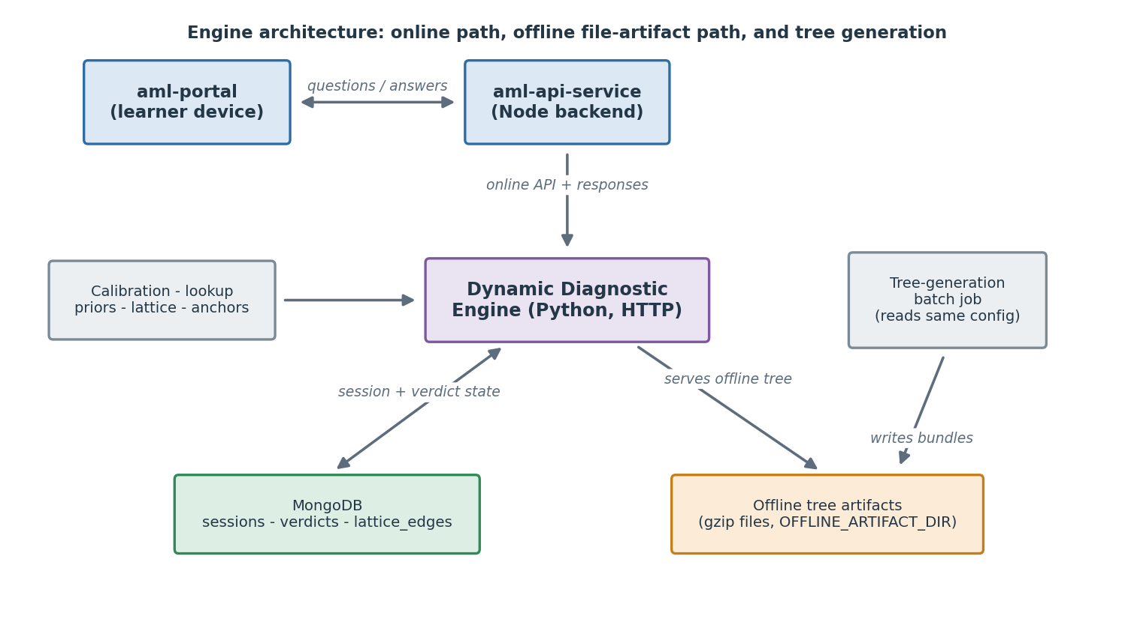
Mode | When used | How questions get picked
Option 4 - server-side adaptive (primary) | Online sessions. Default when the client has connectivity. | aml-api-service calls the engine after every learner response. Engine returns the next question's question_x_id.
Option 1 - precomputed trees (offline fallback) | When the learner's device loses connectivity mid-session. | The client falls back to decision trees returned by the engine at session start. The trees (four per-operation trees per grade) were pre-generated by a batch job; the client receives a small reference at POST /diagnostic/session/start and fetches the tree once from the fetch endpoint (Section 5.9), caching it for offline use.
A session is one unified thing that can switch between online and offline any number of times (mixed-mode). While offline, the device follows the tree and records answers locally, holding a small resumption token (Section 5.4) so it always knows where the session already is. When connectivity returns, the client sends the offline stretch to the engine as a batch through POST /session/:sub_session_id/offline-batch (Section 5.11); the engine folds it into the single session history, re-scores by replaying the whole history in order, and returns the next question or the final verdicts. Section 17 is the step-by-step build guide for the device side of this.
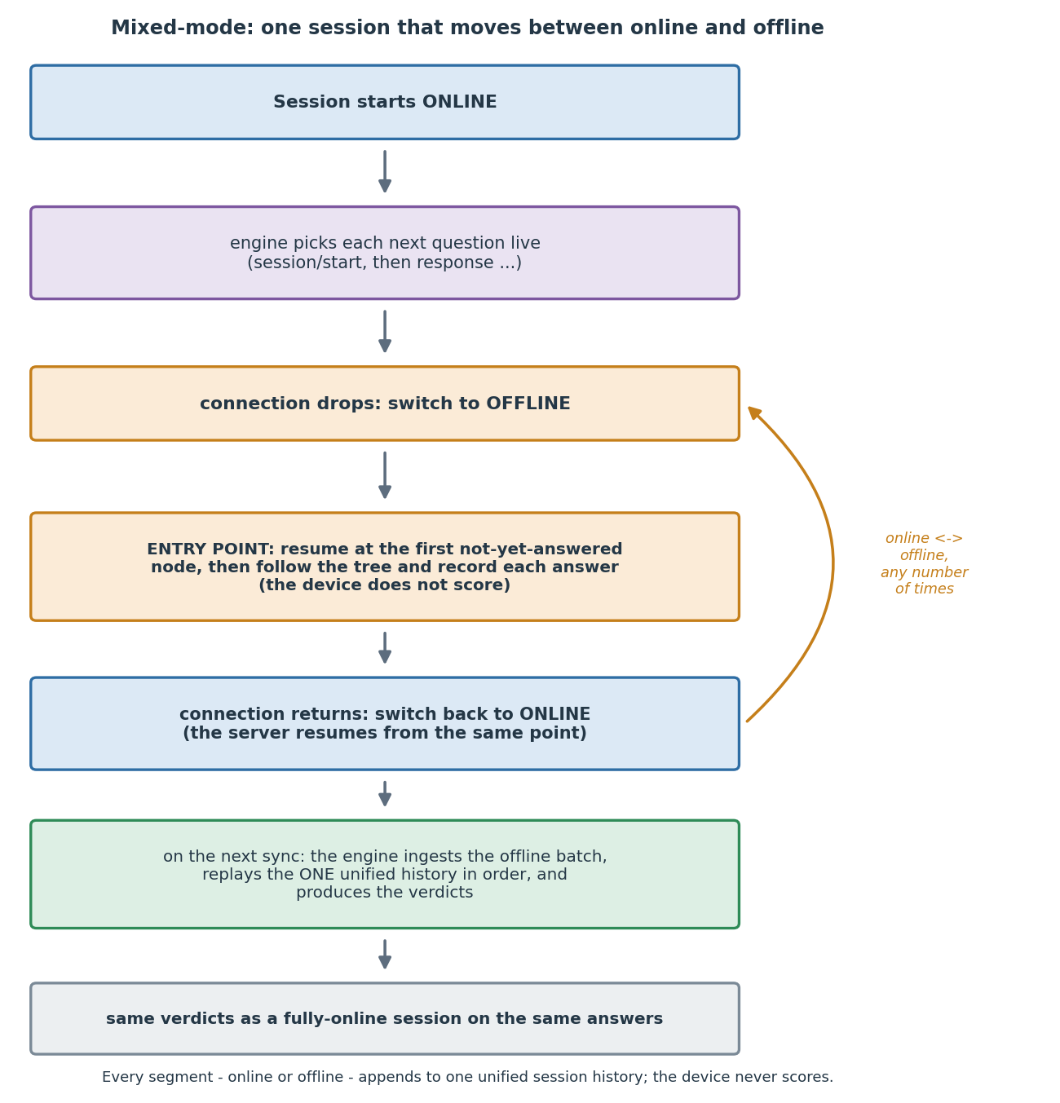
The architectural reason this works: the engine is a pure function of its inputs. Given the same starting prior and the same sequence of responses, it produces the same posteriors, the same next-question decisions, and the same verdicts, regardless of whether each response arrived live or was replayed from an offline batch. Mixed-mode is therefore verdict-neutral: splitting a session across online and offline does not change its verdicts (Section 7.10).

The online path, end to end
The typical flow for a single question:
- The learner taps an answer in aml-portal.
- aml-portal POSTs the response to aml-api-service (authenticated by the learner's JWT).
- aml-api-service validates the JWT, looks up the question, calls getScoreForTheQuestion to compute a Boolean is_correct.
- aml-api-service POSTs to the engine: POST /diagnostic/session/:sub_session_id/response with {learner_id, tenant_id, skill_id, question_x_id, is_correct}. Auth is the shared-secret header (Section 5).
- The engine updates posteriors, possibly propagates evidence over the lattice, and decides what to do next:
  - If session is not complete, it returns the next question_x_id (an question_x_id) and the corresponding skill_id.
  - If session is complete, it returns the three-band verdict per skill plus a session-end signal.
- aml-api-service receives the next question_x_id, fetches the full question content from MongoDB by question_x_id, and returns it to aml-portal.
- aml-portal renders the question.
The engine never sees question content, never sees the learner's raw response, never sees the JWT, and never sees any PII (no usernames, no names, no school, no human-readable tenant name).

The offline path at the engine boundary
The engine produces decision trees for offline use. For each (tenant, grade) the artifact is a set of four per-operation trees (Addition, Subtraction, Multiplication, Division), not a single tree. The trees are NOT generated on demand. They are generated by a separate batch job and shipped as a file artifact - one gzipped bundle per (tenant, grade), which the engine serves through a dedicated fetch endpoint (Section 5.9); see Section 6.
When trees are generated: Whenever an input the trees depend on changes - the priors, the lattice, the anchors, the canonical skill list, the per-item calibration, or a tenant's active-question list (Section 10.5). The engine team runs the batch job and writes one bundle per (tenant, grade) into the artifact directory (OFFLINE_ARTIFACT_DIR).
How the trees get to the client: When POST /diagnostic/session/start is called, the engine resolves the bundle for the learner's tenant and grade and returns a small reference in the offline_tree field - {available, grade, engine_version, size_bytes, sha256, fetch_path} - not the tree itself. The client fetches the actual tree from that fetch_path (Section 5.9) once, when it wants offline capability, and caches it by sha256. The tree is not inlined because it is large: the largest grade (G5) is about 5.4 MB compressed on disk, and the client downloads about 24.8 MB of canonical JSON (the size the offline_tree reference advertises in size_bytes) - far too big to attach to every session-start response. Grade fallback: grades 2-5 resolve to their own tree; any grade above 5 resolves to the G5 tree (matching the online engine's min(grade, 5) rule); a tenant or grade with no tree returns offline_tree: null and never an error. Sizes per grade are in Section 10.5.
How the client walks the trees (the three-pass base-first follow). Each node is a routing step: "ask the question with question_x_id X; if correct go to child A, if incorrect go to child B." The node's question_x_id is the one resolved for this tenant (Section 7.8). The client runs three passes, each sweeping the four operations in the fixed order Addition, Subtraction, Multiplication, Division, all under one hard question budget for the grade:
- Base pass: walk each operation's tree up to that operation's base cap (G2 6 / G3 9 / G4 13 / G5 16).
- Misconception backfill (always on): continue past the base cap to ask questions that cover misconceptions not yet seen, up to the locked per-operation allowance.
- Skill harvest: if budget remains within the allowance, ask additional questions to settle still-uncertain skills.
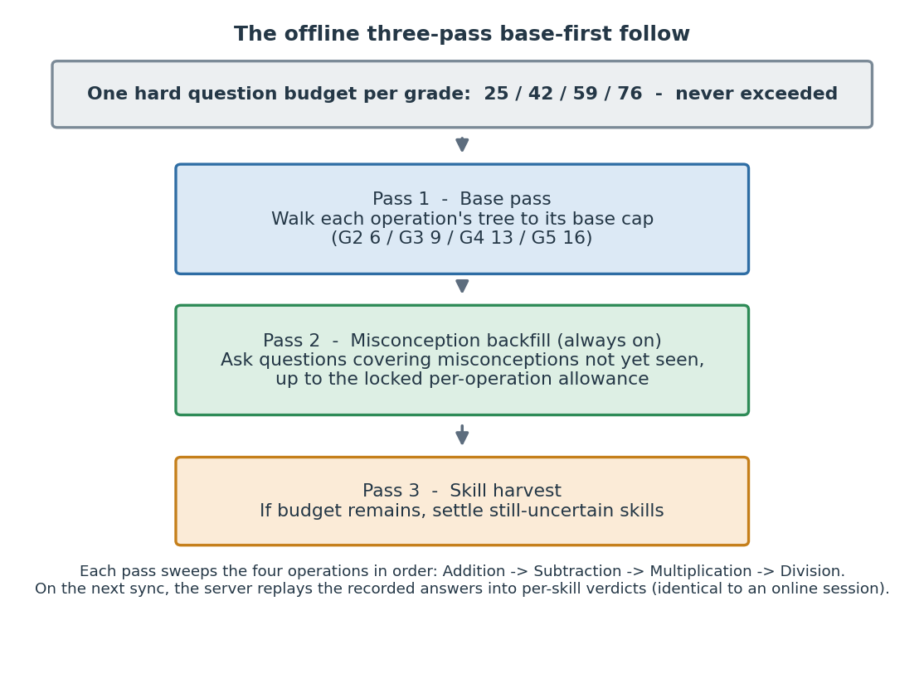
The hard grade budget (25 / 42 / 59 / 76) is never exceeded; the verified over-budget fraction is 0.000 at every grade. The client makes no network call during the session. The trees reference questions only by question_x_id, so aml-portal must already have the content for any question_x_id a tree can reach.
How an offline session is scored. The device does not compute verdicts. It records each attempt (question_x_id, skill_id, correctness, and the raw answer for the classifier) during the walk, and on the next sync it sends the batch to the engine via POST .../offline-batch (Section 5.11). The server replays the full unified attempt history through the engine's own update and verdict functions (the "history scorer," Section 7.10) to produce verdicts identical to an online session on the same answers. This was verified to match the online engine exactly over 420 sampled sessions (8,820 skill comparisons), plus a several-hundred-session mixed-mode sweep with zero mastery-verdict mismatches, and is source-agnostic (a session that was partly online and partly offline scores the same as a fully-online one on the same history).
What is out of scope for v1. How the client delivers the question content matching the question_x_ids - whether bundled at app install time, downloaded at session start, or fetched on demand - is an aml-portal decision, not an engine decision. The current static diagnostic in aml-portal already downloads the full diagnostic at session start; the engine's offline bundle fits that pattern. PWA-specific cold-start offline support (running the diagnostic without ever connecting) is deferred to a later phase.
The deactivation failsafe. A question can be pulled from the app (a broken asset, a content fix) faster than the engine's own data updates. Three mechanisms handle this without ever changing how an answer is scored: an optional switched-off list the caller passes on the selecting endpoints so the engine never offers those questions (Section 7.8); a replace-question endpoint to swap out a single question the app cannot show right now (Section 5.12); and, offline, the device's skip-and-do-not-record rule for an unavailable node (Section 17.4). All three change coverage, never scoring.

Horizontal scaling
V1 runs as a single instance. The engine is logically stateless (all session state lives in MongoDB), so multiple instances would work in principle. The catches that make scaling a step beyond v1:
- Two instances handling the same sub_session_id could write conflicting state if calls arrive concurrently. Resolving this needs the per-session lock described in Section 8.6 (AML already uses Redis with Redlock for this pattern elsewhere). The lock design is settled; only its expiry value is finalized after the pilot.
- The current code loads priors, lattice, calibration, the per-tenant lookup, and the canonical skill list at startup. Hot-reloading them across instances requires either a restart-on-change policy or a config-refresh mechanism.
If peak concurrency (Section 16, item 10) is below a few hundred concurrent sessions, a single instance is fine for v1.

Multi-tenancy
All state-specific AML instances (Delhi, Karnataka, Telangana, future states) call the same engine. The engine identifies the calling instance via the per-tenant shared secret (Section 5) and stamps every session and verdict it writes with tenant_id for downstream filtering.
The engine does not segregate data by tenant beyond this stamping. Sessions and verdicts from different tenants live in the same MongoDB collections, distinguished by the tenant_id field. Per-tenant query patterns must include tenant_id in the filter (which is why tenant_id is on every secondary index - see Section 6).
Question selection is also tenant-aware, but in a specific way. The question_x_id base is consistent across tenants; what differs by tenant is the active set of questions, and within a tenant one content item can map to several question_x_ids. The engine selects in content (item) space and resolves the chosen item to a single question_x_id for the session's tenant through a per-tenant lookup (Section 7.8), without reading any tenant's live questions collection.

5. API contract
How to read this section. Every endpoint below has the same four parts: When to use it (in plain terms), a Parameters table (every field, whether it is required or optional, and what it means in simple language), a Sample request, and a Sample response. The sample values are taken from a real Delhi grade-3 session, so the question_x_ids and skills are genuine. There are ten endpoints: eight functional ones (documented in full) and two operational probes, GET /metrics and GET /health (documented briefly, since they take no parameters).

5.1 Base, auth, and conventions
Base URL: http(s)://<engine-host>:<port>/api/v1/diagnostic. All engine routes live under this prefix.
Method convention: Following AML's existing pattern, routes use POST for actions (including idempotent ones) and GET only for resource reads. The engine has five POST endpoints (start, response, end, offline-batch, replace-question) and five GET endpoints (verdicts, responses, offline-tree, metrics, health) - ten in total.
Content type: Request and response bodies are JSON. The engine accepts and returns application/json.
Authentication. Every engine endpoint that touches session data requires a shared-secret header:
X-Internal-Service-Token: <per-tenant secret>
The engine maintains a server-side allow-list mapping tenant_id -> expected token. A request is accepted if the header value matches the token registered for the tenant_id in the request body (or in the path, for the offline-tree endpoint). A mismatch returns 401 INVALID_TENANT_TOKEN. Tokens are configured per state-instance of aml-api-service and are loaded at engine startup from environment variables (see Section 10).
GET /metrics and GET /health have no auth, consistent with aml-api-service's /metrics route.
Unknown fields are rejected. All request bodies are strict: a field the engine does not expect (for example a stray username or name) is refused rather than ignored, which is also a PII guard (Section 6.3).
Response envelope. The engine uses the same envelope shape as aml-api-service so logs, traces, and downstream parsing stay consistent across services.
Success:
{
"id": "api.diagnostic.session.start",
"ver": "1.0",
"ts": "2026-05-26T12:34:56+00:00",
"params": {
"status": "SUCCESS",
"msgid": "<client-provided message id, if any>",
"resmsgid": "<engine-generated trace id>"
},
"responseCode": "OK",
"result": { /* endpoint-specific payload */ }
}
Error:
{
"id": "api.diagnostic.session.start",
"ver": "1.0",
"ts": "2026-05-26T12:34:56+00:00",
"params": {
"status": "FAILED",
"msgid": "...",
"resmsgid": "..."
},
"responseCode": "BAD_REQUEST",
"result": {},
"error": {
"code": "INVALID_SKILL_ID",
"message": "skill_id 'XYZ' is not in the canonical skill list"
}
}
In the per-endpoint samples below, only the result payload (or the request body) is shown; assume the full envelope wraps it.

5.2 Endpoint summary
Method | Path | Purpose
POST | /api/v1/diagnostic/session/start | Create an engine session for a learner; return the first question and an offline-tree reference
POST | /api/v1/diagnostic/session/:sub_session_id/response | Submit a scored answer; get the next question or the session-end signal with verdicts
POST | /api/v1/diagnostic/session/:sub_session_id/end | Mark the session as ended explicitly (learner abandoned or timed out)
POST | /api/v1/diagnostic/session/:sub_session_id/offline-batch | Ingest a batch of answers collected offline into the one unified session, then return the next question (mixed-mode)
POST | /api/v1/diagnostic/session/:sub_session_id/replace-question | Decline the offered question and get a different one; records nothing, spends no budget (deactivation failsafe)
GET | /api/v1/diagnostic/session/:sub_session_id/verdicts | Re-fetch the final verdicts for a completed session
GET | /api/v1/diagnostic/session/:sub_session_id/responses | Fetch the stored raw answers for a session (for the misconception classifier)
GET | /api/v1/diagnostic/offline-tree/:tenant_id/:grade | Fetch the offline decision-tree bundle for a (tenant, grade)
GET | /metrics | Prometheus scrape endpoint (no auth)
GET | /health | Service health check (no auth)
The three shaded topics that cut across several endpoints - the optional switched-off list (deactivation failsafe), the resumption token (mixed-mode), and verdict neutrality - are introduced where they first appear and cross-referenced from Sections 7 and the offline-walk handover pack.

5.3 POST /api/v1/diagnostic/session/start
When to use it. Once, at the very beginning of a learner's diagnostic, right after aml-api-service has created the learner_sub_sessions record. It creates the engine's session, hands back the first question, and (if a tree exists for the learner's tenant and grade) a reference the device can use to fetch an offline tree.
Parameters (request body):
Field | Type | Required | Plain-language meaning
learner_id | string | yes | Who the learner is (learner.identifier).
tenant_id | string | yes | Which state/instance this is (tenant.identifier); also used to check the auth token.
sub_session_id | string | yes | The id of this one diagnostic sitting (learner_sub_sessions.identifier). Everything about the session hangs off this id.
class_id | string | yes | The learner's class (class_master.identifier).
grade | integer (2-8) | yes | The learner's grade (class_master.sequence). Grades above 5 are handled as grade 5.
switched_off_question_x_ids | list of strings | no | The questions that are currently switched off on the app (broken, pulled, being revised) and must never be offered. Optional; if you leave it out, nothing is treated as switched off. See Section 7.8.
switched_off_mode | "replace" or "append" | no | How the switched-off list is applied. replace (the default) makes the list the complete set; append adds to whatever the session already had. Only meaningful if switched_off_question_x_ids is supplied.
Sample request:
POST /api/v1/diagnostic/session/start
X-Internal-Service-Token: <Delhi secret>
Content-Type: application/json
{
"learner_id": "lrn_9f2c",
"tenant_id": "Delhi",
"sub_session_id": "ss_g3_demo",
"class_id": "cls_774",
"grade": 3
}
Sample response (200):
{
"sub_session_id": "ss_g3_demo",
"first_question": {
"question_x_id": "q_dlg3_mul_00537_b",
"skill_id": "2D x 2D"
},
"offline_tree": {
"available": true,
"grade": 3,
"engine_version": "0.10.0",
"tree_compat_version": 1,
"size_bytes": 366910,
"sha256": "3f2a9c...",
"fetch_path": "/api/v1/diagnostic/offline-tree/Delhi/3"
},
"question_budget": 42,
"resumption_token": {
"resume_anchor": null,
"budget_used": 0,
"answers": []
}
}
The resumption_token is the small snapshot the device caches so it can pick up an offline walk correctly (Section 5.4 and the handover pack). At session start it is empty. If no tree exists for the tenant/grade, offline_tree is null and the session simply proceeds online - that is not an error here.
Errors:
Code | Status | Reason
INVALID_TENANT_TOKEN | 401 | X-Internal-Service-Token does not match the tenant_id's registered token
INVALID_GRADE | 400 | Grade outside the supported range (2-8)
SESSION_ALREADY_EXISTS | 409 | An engine session already exists for this sub_session_id
NO_USABLE_QUESTION | 422 | A switched_off_question_x_ids list was supplied and it covers every question available for the grade, so the diagnostic cannot start. This is a client-input condition (the caller's list is exhaustive), not a server fault. With no switched-off list, an empty pool instead raises NO_QUESTION_FOR_SKILL (below).
NO_QUESTION_FOR_SKILL | 500 | The question pool has no active question for the chosen skill, with no switched-off list involved. A genuine content-pool gap.
PII_FIELD_PRESENT | 400 | Request body contains a disallowed field (for example username, name)
(A tenant or grade with no tree is not an error here: offline_tree is null and the session proceeds online. NO_TREE_FOR_GRADE (404) is raised only by the fetch endpoint, Section 5.9.)

5.4 POST /api/v1/diagnostic/session/:sub_session_id/response
When to use it. Every time the learner answers a question while online. You send the answer (right or wrong); the engine updates its beliefs and hands back the next question, or - if the diagnostic is done - the final verdicts.
Parameters (request body):
Field | Type | Required | Plain-language meaning
learner_id | string | yes | Must match the session's learner.
tenant_id | string | yes | Used to check the auth token.
skill_id | string | yes | The canonical skill name of the question that was asked.
question_x_id | string | yes | Which question was asked.
is_correct | boolean | yes | Whether the learner got it right. This is the only input the mastery algorithm uses from this call.
response_time_ms | integer (>= 0) | no | How long the learner took, in milliseconds. Telemetry only; the algorithm ignores it.
raw_response | string | no | The learner's actual typed answer. Used only by the misconception classifier (Section 5.10), never by the mastery algorithm, and never logged. The core mastery pilot does not send it.
switched_off_question_x_ids | list of strings | no | An updated switched-off list, if it has changed since the last call. Optional; if omitted, the session keeps the list it already had.
switched_off_mode | "replace" or "append" | no | How to apply the list above (see Section 5.3).
Sample request:
POST /api/v1/diagnostic/session/ss_g3_demo/response
X-Internal-Service-Token: <Delhi secret>
{
"learner_id": "lrn_9f2c",
"tenant_id": "Delhi",
"skill_id": "2D x 2D",
"question_x_id": "q_dlg3_mul_00537_b",
"is_correct": true
}
Sample response (200) - session continuing:
{
"session_complete": false,
"next_question": {
"question_x_id": "q_mul_00171_z",
"skill_id": "Tables 1, 2 and 5"
},
"questions_asked_so_far": 1,
"questions_remaining_budget": 41,
"resumption_token": {
"resume_anchor": "q_dlg3_mul_00537_b",
"budget_used": 1,
"answers": [
{
"question_x_id": "q_dlg3_mul_00537_b",
"is_correct": true,
"item": "Multiplication|2D x 2D|Fib||37|23",
"skill_id": "2D x 2D",
"operation": "Multiplication",
"asked_at": "2026-07-27T08:44:28.641563+00:00"
}
]
}
}
The resumption_token refreshes on every online answer. It carries the last-answered question_x_id (resume_anchor), the budget used so far, and one entry per answer. The device caches the latest token so that, if the connection drops, its offline walk can resume from exactly where the session left off. It is empty at start and becomes null once the session is complete.
Sample response (200) - session complete:
{
"session_complete": true,
"next_question": null,
"verdicts": [
{
"skill_id": "2-digit Addition with carry",
"posterior": 0.97,
"direct_observations": 3,
"confidence_label": "confident_mastered",
"recommendation": "skip_maind"
}
]
}
Errors:
Code | Status | Reason
SESSION_NOT_FOUND | 404 | No active engine session for this sub_session_id
SESSION_ALREADY_ENDED | 409 | Session is already complete; start a fresh session
INVALID_SKILL_ID | 400 | skill_id is not in the canonical skill list
LEARNER_MISMATCH | 400 | learner_id does not match the session's learner
RESPONSE_CONFLICT | 409 | The same question_x_id was submitted before with a different is_correct (Section 8.3)
Idempotency. The same question_x_id submitted twice with the same is_correct is treated as a duplicate: the engine returns the same next-question response as the first call, without applying the update twice (Section 8.3).

5.5 POST /api/v1/diagnostic/session/:sub_session_id/end
When to use it. When a session needs to be closed before it finishes on its own - the learner abandoned it, or aml-api-service decided to time out the sitting. The engine computes verdicts from whatever has been observed so far.
Parameters (request body):
Field | Type | Required | Plain-language meaning
learner_id | string | yes | The session's learner.
tenant_id | string | yes | Used to check the auth token.
reason | "abandoned" / "timeout" / "learner_quit" | no | Why the session is being ended. Defaults to abandoned. Recorded for analytics; does not change how verdicts are computed.
Sample request:
POST /api/v1/diagnostic/session/ss_g3_demo/end
X-Internal-Service-Token: <Delhi secret>
{
"learner_id": "lrn_9f2c",
"tenant_id": "Delhi",
"reason": "timeout"
}
Sample response (200): the same shape as the session-complete payload in Section 5.4. Any skill not yet resolved gets a verdict from the posterior-mean rule (Section 7.6).

5.6 GET /api/v1/diagnostic/session/:sub_session_id/verdicts
When to use it. After a session is complete, when a downstream system wants to read the verdicts again without replaying the session. GET requests carry no body; the session is identified by the path.
Sample request:
GET /api/v1/diagnostic/session/ss_g3_demo/verdicts
X-Internal-Service-Token: <Delhi secret>
Sample response (200): the same verdicts payload shown in Section 5.4 (session-complete).
Errors:
Code | Status | Reason
SESSION_NOT_FOUND | 404 | No engine session for this sub_session_id
SESSION_NOT_COMPLETE | 409 | Session is still in progress; verdicts are not final

5.7 GET /metrics
When to use it. Only by the monitoring system (Prometheus), on a schedule. No auth, no parameters. Returns the standard text/plain Prometheus exposition format - default process metrics plus the engine's business metrics (full list in Section 9).

5.8 GET /health
When to use it. Only by Kubernetes readiness and liveness probes. No auth, no parameters.
Sample response (200):
{
"status": "ok",
"version": "0.10.0",
"mongodb": "connected",
"engine_config_loaded": true,
"tree_versions": { "2": 7, "3": 7, "4": 7, "5": 7 }
}
Response (failure, 503): the same shape with "status": "degraded" and details on which checks failed.
Probe semantics:
Condition | Status code | Used by
All checks passing | 200 | Readiness + liveness probes both succeed
Config still loading at startup (first 30s) | 503 | Readiness fails; container not yet receiving traffic. Set liveness initialDelaySeconds >= 30.
Config loaded, MongoDB unreachable | 503 | Readiness fails; existing pods stop receiving new traffic until MongoDB returns. Liveness should NOT fail on MongoDB (restarting will not fix a DB outage).
Active tree versions missing for any in-scope (tenant, grade) | 503 | Available but not switched on for the pilot: /health reports tree_versions and does not fail readiness on a missing tree, since the online path can serve without one.
Process unresponsive | (no response) | Liveness times out and kills the container
Recommended probe configuration: readiness GET /health every 10s, fail after 3; liveness GET /health every 30s with initialDelaySeconds: 60, fail after 5 (engineering tunes to actual startup time).

5.9 GET /api/v1/diagnostic/offline-tree/:tenant_id/:grade
When to use it. Once, when the device wants offline capability - it fetches the decision-tree bundle referenced by offline_tree.fetch_path in the session/start response, then caches it by sha256. No body; the tenant and grade are in the path.
Auth: X-Internal-Service-Token, validated against the path :tenant_id.
Grade resolution: grades 2-5 return their own tree; any grade above 5 returns the grade-5 tree (matching the online min(grade, 5) rule).
Sample request:
GET /api/v1/diagnostic/offline-tree/Delhi/3
X-Internal-Service-Token: <Delhi secret>
Sample response (200): the canonical tree JSON for the (resolved-grade, tenant) bundle - the four per-operation trees, the shared per-grade parameters block, the parallel items array, tree_compat_version, and the manifest of every question_x_id the trees can reach. The bytes and sha256 match the reference returned at session/start.
Errors:
Code | Status | Reason
NO_TREE_FOR_GRADE | 404 | No tree exists for this tenant/grade (for example a non-Delhi tenant, or a grade below 2). This is the only place NO_TREE_FOR_GRADE is raised.
INVALID_TENANT_TOKEN | 401 | X-Internal-Service-Token does not match the path :tenant_id

5.10 GET /api/v1/diagnostic/session/:sub_session_id/responses
When to use it. After a session, when the misconception classifier (Stage B) needs the learner's raw typed answers. The mastery algorithm does not use these; they exist only for answers where aml-api-service supplied raw_response (Section 5.4). No body; the session is in the path.
Auth: X-Internal-Service-Token, validated against the session's tenant.
Sample request:
GET /api/v1/diagnostic/session/ss_g3_demo/responses
X-Internal-Service-Token: <Delhi secret>
Sample response (200):
{
"sub_session_id": "ss_g3_demo",
"learner_id": "lrn_9f2c",
"grade": 3,
"responses": [
{ "question_x_id": "q_dlg3_mul_00537_b", "raw_response": "851", "is_correct": true, "skill_id": "2D x 2D" }
]
}
Entries whose raw_response was not supplied come back with raw_response: null. The raw answer is never written to logs or metrics (Section 6.3).
Errors:
Code | Status | Reason
SESSION_NOT_FOUND | 404 | No engine session for this sub_session_id
INVALID_TENANT_TOKEN | 401 | Token does not match the session's tenant

5.11 POST /api/v1/diagnostic/session/:sub_session_id/offline-batch
When to use it. When a device that was answering offline reconnects, to fold that offline stretch back into the one session. You send the batch of answers the learner gave offline; the engine merges them into the single unified history, re-scores, and returns the next question (or the verdicts, if the session is now done). This is the heart of mixed-mode - see the offline-walk handover pack for the full picture.
Parameters (request body):
Field | Type | Required | Plain-language meaning
learner_id | string | yes | The session's learner.
tenant_id | string | yes | Used to check the auth token.
resume_anchor | string | no | The question_x_id of the last answer recorded before the device went offline (copied from the resumption token). It tells the engine where the offline stretch slots in. Optional; if absent, the batch is appended at the end and flagged.
tree_id | string | yes | Which offline tree the device walked.
tree_version | integer | yes | The version of that tree.
tree_compat_version | integer | yes | The compatibility marker of that tree. If it does not match the engine's current marker, the answers are still accepted and a "stale tree" flag is raised (the answers are valid; only the tree was old).
answers | list of answer objects | yes | The offline answers, in order. Each object is described below.
switched_off_question_x_ids | list of strings | no | An updated switched-off list, if it changed. Optional (see Section 5.3).
switched_off_mode | "replace" or "append" | no | How to apply the list above.
Each entry in answers:
Field | Type | Required | Plain-language meaning
question_x_id | string | yes | Which question was answered offline.
skill_id | string | yes | The skill of that question.
is_correct | boolean | yes | Whether the learner got it right.
raw_response | string | yes | The learner's typed answer. Required for offline answers (unlike the online call), so the misconception classifier gets the same input it would have online.
asked_at | timestamp | yes | When the question was answered, so the engine can place the answers in the correct order.
Sample request:
POST /api/v1/diagnostic/session/ss_g3_demo/offline-batch
X-Internal-Service-Token: <Delhi secret>
{
"learner_id": "lrn_9f2c",
"tenant_id": "Delhi",
"resume_anchor": "q_dlg3_mul_00537_b",
"tree_id": "Delhi-3",
"tree_version": 7,
"tree_compat_version": 1,
"answers": [
{
"question_x_id": "q_mul_00902_z",
"skill_id": "2D x 1D",
"is_correct": true,
"raw_response": "96",
"asked_at": "2026-07-27T08:45:10.000000+00:00"
},
{
"question_x_id": "q_mul_00192_z",
"skill_id": "Repeated addition",
"is_correct": false,
"raw_response": "12",
"asked_at": "2026-07-27T08:45:38.000000+00:00"
}
]
}
Sample response (200): the same shape as a /response result. If the learner continues online, session_complete is false and a next_question and refreshed resumption_token are returned, now reflecting the offline answers; if the diagnostic is done, session_complete is true with the verdicts.
Errors:
Code | Status | Reason
SESSION_NOT_FOUND | 404 | No active engine session for this sub_session_id
RESPONSE_CONFLICT | 409 | An answer in the batch contradicts one already recorded for the same question_x_id (Section 8.3)
OFFLINE_BATCH_TOO_LARGE | 400 | The batch is implausibly large (more than twice the grade budget) - a corruption guard. A correct device never sends this.
Notes. The engine re-scores by replaying the whole unified history in order (not by adding the batch on top), so the verdicts are exactly what a fully-online session on the same answers would produce (verdict neutrality, Section 7.10). Sending the same batch twice is a harmless no-op (idempotent). An answer to a question that has since been switched off is still accepted and scored - switched-off governs future offering, not the validity of an answer already given.

5.12 POST /api/v1/diagnostic/session/:sub_session_id/replace-question
When to use it. When the engine offered a question the app cannot actually show right now - most often a broken media asset the engine could not have known about - and you need a different one for the same turn. The engine drops the declined question and returns a replacement, recording nothing and spending no budget. This is the deactivation failsafe's reactive path (the switched-off list is the proactive one; see Section 7.8).
Parameters (request body):
Field | Type | Required | Plain-language meaning
learner_id | string | yes | The session's learner.
tenant_id | string | yes | Used to check the auth token.
question_x_id | string | yes | The question being declined - the one the app cannot show.
Sample request:
POST /api/v1/diagnostic/session/ss_g3_demo/replace-question
X-Internal-Service-Token: <Delhi secret>
{
"learner_id": "lrn_9f2c",
"tenant_id": "Delhi",
"question_x_id": "q_mul_00171_z"
}
Sample response (200):
{
"session_complete": false,
"next_question": {
"question_x_id": "q_mul_00902_z",
"skill_id": "2D x 1D"
},
"questions_asked_so_far": 1,
"questions_remaining_budget": 41
}
The declined question is not recorded, does not count against the budget, and is not offered again for the rest of this session. It joins a separate transient set - it is not added to the switched-off list, because declining one question for a display glitch is different from a content-level deactivation. If no usable question remains, the response comes back with session_complete: true and the verdicts, exactly as when selection is otherwise exhausted.
Errors:
Code | Status | Reason
SESSION_NOT_FOUND | 404 | No active engine session for this sub_session_id
SESSION_ALREADY_ENDED | 409 | Session is already complete
LEARNER_MISMATCH | 400 | learner_id does not match the session's learner

6. Data model

6.1 Collections owned by the engine
The engine creates and writes three MongoDB collections (offline trees are shipped as file artifacts, not a collection - see below). Names follow AML's snake_case_plural pattern. All collections use the dual-ID pattern (_id BSON for Mongo, identifier Text UUID for cross-references), and include audit fields (created_at, updated_at, created_by, updated_by).

learner_diagnostic_sessions
One document per diagnostic session. Holds engine state during the session and the question history once complete.
Field | Type | Notes
_id | MongoBSONID | Mongo PK
identifier | Text | Session UUID, equal to sub_session_id (engine session and AML sub-session are 1:1)
learner_id | Text | learner.identifier
tenant_id | Text | tenant.identifier
class_id | Text | class_master.identifier
grade | Integer | Denormalised from class_master.sequence for query convenience
status | Text enum | active / complete / abandoned
started_at | Instant
ended_at | Instant | Set when status becomes complete or abandoned
engine_version | Text | Semantic version of the engine (e.g. 0.10.0) - needed when interpreting verdicts later
tree_id_used | Text | Identifies the offline tree referenced at session start (its sha256); null if offline_tree was null
tree_version_used | Integer | The version of that tree
posteriors | Dictionary | Per-skill state: {<canonical_skill_name>: {posterior: Float, direct_observations: Integer, propagation_updates: Integer, last_updated_at: Instant}}. propagation_updates is the count of times this skill's posterior was moved by lattice propagation from a different skill's observation; used by the verdict rules in §7.6 to distinguish priors-only from propagation-only resolutions.
question_history | Array | Append-only log. Each entry: {sequence: Integer, question_x_id: Text, skill_id: Text, is_correct: Boolean, asked_at: Instant, posterior_before: Float, posterior_after: Float, purpose: Text (anchor / info_gain / verification), routing_mode: Text (online / offline_replay)}
routing_mode_counts | Dictionary | {online: Integer, offline_replay: Integer} for telemetry
pending_question | Sub-document or null | Engine-internal turn state. When a question has been picked and handed to the client but the matching response has not yet arrived, this holds {question_x_id: Text, slip_override: Float or null, guess_override: Float or null} so the per-item calibration parameters from §6.2.1 can be applied to the Bayes update when the response arrives. Cleared once the matching response is recorded. Persisted so that mid-session pod restarts do not lose the calibration parameters for the in-flight question. Not exposed to clients.
created_at, updated_at, created_by, updated_by | Audit fields
Indexes:
- {identifier: 1} unique
- {learner_id: 1, started_at: -1} for "most recent session for learner X"
- {tenant_id: 1, status: 1} for tenant-scoped operational queries
- {tenant_id: 1, started_at: -1} for tenant-scoped recency queries

learner_skill_verdicts
One document per (session, skill). Persisted at session end. Designed for fast lookups by downstream systems.
Field | Type | Notes
_id | MongoBSONID
identifier | Text | Verdict UUID
learner_id | Text
tenant_id | Text
class_id | Text
l1_skill_id | Text | Operation name: Addition / Subtraction / Multiplication / Division. Matches AML's existing learner_proficiency_aggregate_data keying
l2_5_skill_id | Text | Canonical L2.5 skill name
sub_session_id | Text | Foreign reference to the session document
posterior | Float | Mastery probability at session end
direct_observations | Integer | How many direct questions were asked on this skill in this session
propagation_updates | Integer | How many times this skill's posterior was moved by lattice propagation. Used by the verdict rules in §7.6
confidence_label | Text enum | confident_mastered / uncertain / confident_not_mastered
recommendation | Text enum | skip_maind / take_maind_diagnostic / take_maind_confirmation
engine_version | Text
created_at, updated_at, created_by, updated_by | Audit fields
Indexes:
- {identifier: 1} unique
- {learner_id: 1, l2_5_skill_id: 1, created_at: -1} for "most recent verdict per (learner, skill)" - primary downstream read pattern
- {tenant_id: 1, created_at: -1} for tenant-scoped analytics
- {sub_session_id: 1} for fetching all verdicts of a session

Offline tree artifacts (files, not a MongoDB collection)
Offline trees are not stored in MongoDB. Each (tenant, grade) bundle is a gzipped JSON file on disk - artifact/<tenant>/g<grade>.json.gz - under the directory named by OFFLINE_ARTIFACT_DIR (repo-relative by default; Section 10). The engine loads these files once at startup into an in-memory registry and serves them through the fetch endpoint (Section 5.9); it never reads or writes a diagnostic_offline_trees collection.
Each bundle carries: the four per-operation trees (each node {question_x_id, skill_id, on_correct, on_incorrect}), a shared per-grade parameters block, the engine_version it was built against (used to reject a stale tree), a manifest of every question_x_id the trees can reach (for aml-portal to pre-load content), and the config versions used to generate it (lattice_version, priors_version, anchors_version, calibration_version). The batch job writes one bundle per (tenant, grade); Delhi G2-G5 ship today. Per-grade bundle sizes (Delhi, measured against the shipped artifacts):
Grade | Compressed (gz on disk) | Served (canonical JSON, = size_bytes)
G2 | ~10 KB | ~59 KB
G3 | ~81 KB | ~0.37 MB
G4 | ~1.44 MB | ~6.3 MB
G5 | ~5.4 MB | ~24.8 MB
The fetch endpoint serves the canonical JSON - the served figure above, which is what size_bytes advertises and what a device's storage budget depends on (the largest, G5, is about 24.8 MB). The raw decompressed size is larger but is never sent to the client.

lattice_edges
The skill-to-skill relationship graph used for propagation. Read-only at runtime; populated and updated by the engine team. AML team members can inspect.
Field | Type | Notes
_id | MongoBSONID
identifier | Text | Edge UUID
skill_a | Text | Canonical L2.5 skill name (source)
skill_b | Text | Canonical L2.5 skill name (target)
operation_a | Text | Operation skill_a belongs to
operation_b | Text | Operation skill_b belongs to
edge_type | Text enum | within_operation / cross_operation
p_b_given_a | Float | Probability skill_b is mastered given skill_a is mastered
p_b_given_not_a | Float | Probability skill_b is mastered given skill_a is NOT mastered
weight | Float | 1.0 for multi-view edges (more confident), 0.5 for single-view edges (less confident)
is_active | Boolean | Allows disabling an edge without deleting it
created_at, updated_at, created_by, updated_by | Audit fields
Indexes:
- {identifier: 1} unique
- {skill_a: 1, is_active: 1}
- {skill_b: 1, is_active: 1}

6.2 AML collections the engine reads (read-only)
Collection | Used for
tenant | Validating tenant_id exists at startup; not read at request time (the shared-secret check covers per-request validation)
class_master | Looking up sequence from class_id if aml-api-service does not pre-translate. Optional - engine works without this if grade is passed directly
skill_master | Validating canonical skill names map to real skills in the calling instance. Used at startup
questions, question_sets, question_set_question_mapping | Not read by the engine at request time. The engine selects questions from the calibration file and the per-tenant lookup, both loaded at startup (see §6.2.1 and §7.8). These AML collections are the source from which the AML team produces each tenant's active-question list, which the build step turns into the per-tenant lookup. The engine itself never queries them live.

6.2.1 Inputs the QuestionPool reads (sidecar files, not the live collection)
The engine's QuestionPool does not read the live questions collection. Instead it loads two static files at startup, refreshed deliberately when their sources change (Section 10.5). This decoupling is deliberate: each tenant has its own questions collection (a given question_x_id lives in only one tenant's collection), and calibration is keyed on the content item rather than on question_x_id (see §7.8 for the rationale).
1. The calibration file. One row per (question, grade), keyed on the item content key. Fields the engine relies on:
Field | Required | Purpose
item | yes | The content key (Q L1 Skill | Q L2.5 Skill | Q Type | Q Text | Q N1 | Q N2); the join key to the per-tenant lookup
l2_5_skill | yes | Links the question to its canonical skill
q_type | yes | Question type (for example Fib, Mcq)
grade | yes | The grade this row's parameters apply to; a pooled all row is the fallback when no grade-specific row exists
slip | yes | Calibrated slip, used in the Bayes update; uniform default (§7.7) only when a question has no row
guess | yes | Calibrated guess, same rule
discrimination | yes | Used by the selection window (§7.8 step 4)
2. The per-tenant question lookup. Maps (tenant, item) to a single question_x_id. Produced by the build step in §7.8 from each tenant's active-question list (the six raw fields plus the question_x_id). This is how the engine returns a question_x_id while selecting in item space.
The calibration is Delhi-derived: questions used only in other tenants, and questions with thin data, carry borrowed or default values (design document §4.3). When (and if) a single shared content service is built, the calibration values could move onto the question records themselves and the per-tenant lookup would collapse into that service; neither changes the engine's logic (design document §7).

6.3 PII boundary
The engine accepts and stores only opaque identifiers and numeric / categorical data:
Accepted | Never accepted or stored
learner_id (opaque identifier) | Username, name, password, school name, human-readable tenant name
tenant_id (opaque identifier) | Region or geographic data beyond tenant_id
class_id, grade (integer 2-8) | Section, board, or any other learner attribute beyond grade
sub_session_id | Browser, device, IP, user agent
skill_id (canonical name), question_x_id | Question content, response media
is_correct (boolean), response_time_ms (optional integer)
raw_response (optional; the learner's typed answer - see note)
Inbound requests carrying any forbidden field are rejected with 400 PII_FIELD_PRESENT. The engine's logs and Prometheus metrics filter out unexpected fields by design - no wildcard ingestion.
The one deliberate exception is raw_response (Section 5.4): the learner's typed answer, accepted only so the misconception classifier can read it back (Section 5.10). It is explicitly allow-listed rather than rejected, is never used by the mastery algorithm, and is never written to logs or metrics. This is a scoped change from the earlier boundary, which accepted no learner response text; it is limited to this single field and this single purpose, and the pilot mastery flow does not send it.

7. Engine algorithm
This section describes what the engine actually computes. The audience is engineers, not psychometricians. Math is used where unavoidable, but every step has a plain-language explanation.

7.1 The big picture
On every learner response, the engine does two things:
- Update the posterior for the skill the question tested, using Bayes' rule with fixed slip and guess parameters.
- Propagate the update through the lattice to related skills.
After the update, it decides what to do next: ask another question on the same skill, jump to a related skill, switch operations, or end the session.
The engine's model is a single-skill Bayesian posterior update with fixed slip and guess, plus Bayesian-network propagation over a curated skill-relationship lattice. The vocabulary (slip, guess, posterior, mastery) is borrowed from Cognitive Diagnostic Modelling, but the engine does not implement any specific named model from that family.

7.2 The single-skill update
Let p be the engine's current posterior for a skill (the probability the learner has mastered it). Let s = 0.10 be the slip parameter and g = 0.15 be the guess parameter. After observing a correct response on a question for this skill:
p_new = ((1 - s) * p) / ((1 - s) * p + g * (1 - p))
After observing an incorrect response:
p_new = (s * p) / (s * p + (1 - g) * (1 - p))
In plain language:
- A correct answer pushes the posterior up. The size of the push is largest when the prior was middling (around 0.5) and smallest when the prior was already high.
- An incorrect answer pushes the posterior down, with the same shape.
- The size of the move depends on how surprising the response was given the engine's current belief.
These are standard Bayes-rule updates with the likelihood model "Pr(correct | mastered) = 1 − slip" and "Pr(correct | not mastered) = guess".

7.3 Lattice propagation
After the direct update on skill A, the engine checks each lattice edge involving A:
- Forward propagation. If the response was correct and the posterior on A is now above 0.5, push the posterior of any skill B where edge A → B exists toward 0.9 (the EDGE_PROPAGATION_VALUE), weighted by the edge weight.
- Backward propagation (contrapositive). If the response was incorrect and the posterior on A is now below 0.5, push the posterior of any skill W where edge W → A exists down toward 0.1.
Propagation only moves the target posterior toward the propagation value - it never overshoots a posterior that was already more extreme. If skill B already had posterior 0.95 (more confident than the 0.9 target), propagation does nothing to B.

7.4 Confidence thresholds
A skill is considered "resolved" when its posterior crosses either threshold:
- Resolved as mastered: posterior ≥ 0.95
- Resolved as not mastered: posterior ≤ 0.10
Once resolved, the engine stops asking direct questions on the skill.

7.5 Question selection (Option 4, online)
For each operation, in a per-grade order (Multiplication-first for G2-G4, Division-first for G5):
- Ask the operation's anchor question first. The anchor for each (grade, operation) is a fixed skill from the anchor configuration. This grounds the operation block with an early direct observation.
- Loop: within the operation, pick the next question by either:
  - Verification: If a skill has reached an extreme posterior (≥ 0.85 or ≤ 0.15) through propagation alone, without any direct observation, ask one direct question to confirm.
  - Information gain: Otherwise, pick the unresolved skill with the highest expected information gain - entropy of the current posterior plus a small bonus for skills with more lattice edges (because direct evidence on such skills informs more downstream skills).
- Stop conditions for the operation block:
  - All skills in the operation are resolved, OR
  - The per-operation budget cap is reached, OR
  - The total question budget for the grade is reached.
After all operations are processed (or the global budget runs out), the engine assigns verdicts to every skill (Section 7.6).

7.6 Verdict assignment
The engine assigns one verdict per in-scope skill at session end. The verdict depends on three pieces of state for that skill:
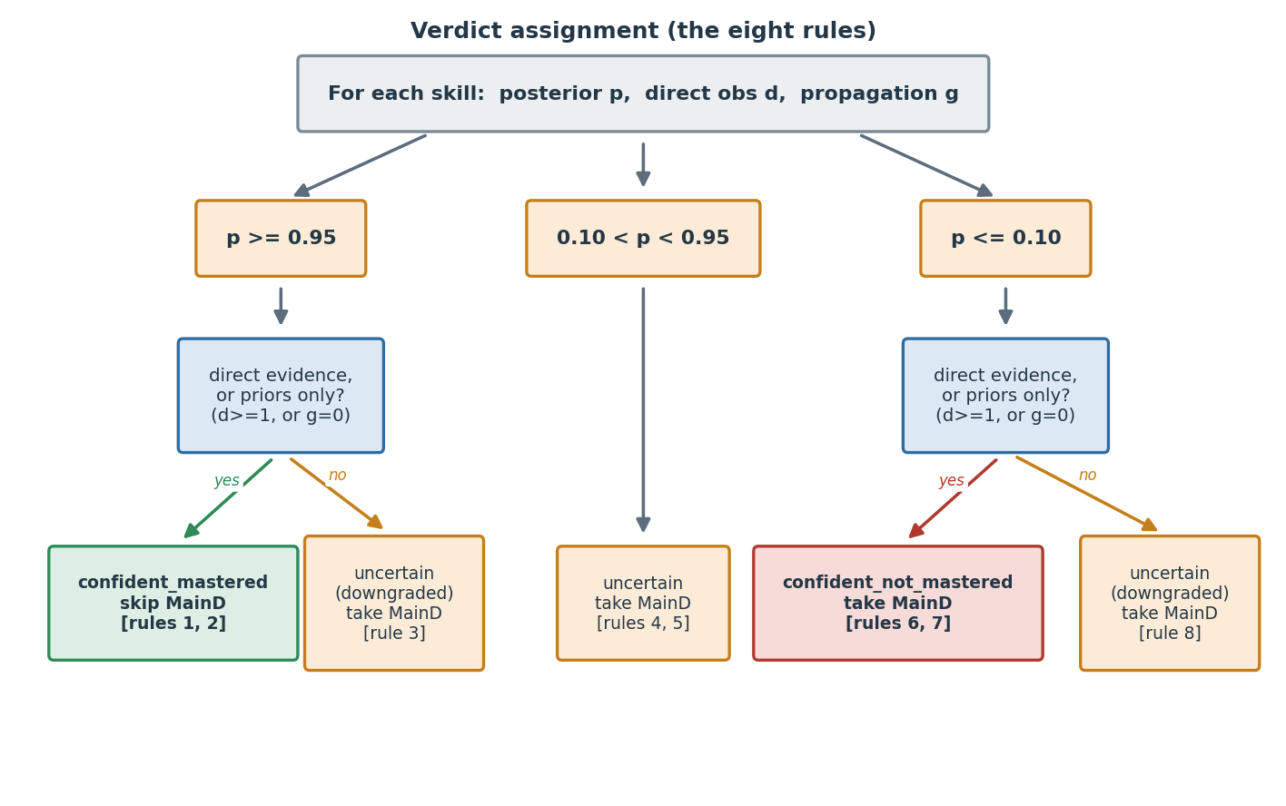
State | Definition
posterior | Final posterior probability (between 0 and 1)
direct_observations | Count of questions asked directly on this skill
propagation_updates | Count of times this skill's posterior was moved by lattice propagation from a different skill's observation

Rules
Rule | Posterior | Direct observations | Propagation updates | Verdict | Recommendation
1 | ≥ 0.95 | ≥ 1 | any | confident_mastered | skip_maind
2 | ≥ 0.95 | 0 | 0 | confident_mastered | skip_maind
3 | ≥ 0.95 | 0 | ≥ 1 | uncertain (downgraded) | take_maind_diagnostic
4 | ≥ 0.5 and < 0.95 | any | any | uncertain | take_maind_confirmation
5 | < 0.5 and > 0.10 | any | any | uncertain | take_maind_diagnostic
6 | ≤ 0.10 | ≥ 1 | any | confident_not_mastered | take_maind_diagnostic
7 | ≤ 0.10 | 0 | 0 | confident_not_mastered | take_maind_diagnostic
8 | ≤ 0.10 | 0 | ≥ 1 | uncertain (downgraded) | take_maind_diagnostic

What changed from earlier versions of this spec
Earlier drafts of this section had a simpler downgrade rule: any high-posterior skill with zero direct observations was treated as uncertain (downgraded). The current rules separate two cases that look similar but behave differently in practice:
- Resolved by priors alone (direct_obs = 0 AND propagation_updates = 0): the skill's posterior is at its initial value from the cohort prior. The engine never tested it and lattice propagation never touched it. The cohort prior is an empirical distribution from real learner data; trusting it produces a confident verdict (Rules 2 and 7).
- Resolved by lattice propagation alone (direct_obs = 0 AND propagation_updates ≥ 1): the skill's posterior was moved by inferring from related skills' observations. Lattice edges are approximate (12 hand-curated edges with content-team validation, but still inferred); the engine downgrades to uncertain so downstream picks up the skill via MainD (Rules 3 and 8).
The simulation evidence supporting this distinction is in the Testing Summary §4 (the Minimum Direct Evidence experiment): forcing a direct observation on every skill did not improve pooled accuracy, indicating that priors are calibrated well enough that priors-only resolutions can be trusted. The Testing Summary §9 (Verification on/off) shows the opposite for propagation: removing verification of propagation-resolved skills cost 0.3 pp pooled accuracy and 2.2 pp on G2 Division specifically, confirming that propagation-only resolutions need direct verification.

Implementation note
The engine must track propagation_updates per skill in addition to direct_observations. This is a new field on the per-skill state in learner_diagnostic_sessions.posteriors (see §6.1). It increments every time engine.lattice.propagate() returns a non-empty update for this skill as a target.
The verdict logic in engine.verdicts.assign_verdict() takes both counters and applies the eight rules above.

7.7 Fixed parameters (v1)
Parameter | Value
Slip (s) default / fallback | 0.10
Guess (g) default / fallback | 0.15
Mastery threshold | 0.95
Not-mastered threshold | 0.10
Verification trigger thresholds | 0.85 (high), 0.15 (low)
Edge propagation value | 0.90
Question budgets | G2 = 25, G3 = 42, G4 = 59, G5 = 76
Per-operation base caps | G2 = 6, G3 = 9, G4 = 13, G5 = 16
Offline per-operation allowance (locked) | G2 = +3, G3 = +4, G4 = +4, G5 = +3. Extra questions added beyond the per-operation base for the offline three-pass follow (misconception backfill and skill harvest); see Section 10.5.
Hard budget cap (all modes) | The grade question budget is a hard ceiling no session exceeds (25 / 42 / 59 / 76). Verified over-budget fraction is 0.000 at every grade.
Misconception coverage target (conditional_extra) | Shipped value 0 (deployment config/engine_config.yaml); engine code default 2. See Section 7.9.
Per-operation cap multiplier (per_operation_cap_multiplier) | Shipped 1.5 (per grade, config/engine_config.yaml). Caps questions spent on one operation at 1.5x its base allocation (per_operation), so no single operation can exhaust the budget.
Reserve size (reserve_size) | Shipped per grade: G2 7, G3 11, G4 15, G5 19 (config/engine_config.yaml). Questions held back from the initial per-operation allocation as a shared reserve the engine can draw on adaptively.
Info-gain edge bonus (info_gain_edge_bonus) | Shipped 0.5 (config/engine_config.yaml). A bonus added in the information-gain scoring to favour a question that adds coverage (a not-yet-probed edge).
These are loaded at engine startup from a config file or environment variables (Section 10).
Per-item overrides. The slip and guess values above are fallback defaults. Per-item calibration now exists: each question has its own measured slip and guess (and discrimination), delivered in a companion calibration file that the engine loads at startup (see §6.2.1 and §7.8). The engine uses the per-item values in the Bayes update for the chosen question, falling back to the uniform defaults only when a question has no calibrated row. The calibration is Delhi-derived (questions used only in other tenants, and questions with thin data, carry borrowed or default values); the calibration method is a two-class DINA model fit by Expectation-Maximization (the DINA family in Appendix B - used here for calibration, not as the runtime scorer); see the design document §4.3 and the Question Calibration Process Report for the full method, and §4.11 for the recalibration cadence.

7.8 The question pool
Sections 7.1 through 7.7 describe how the engine decides which skill to test next. This section describes how that decision is converted into a specific question returned to the client.
The question pool is a separate component (the QuestionPool interface; the production implementation is CsvQuestionPool). It takes a chosen skill plus the current session state and returns a question_x_id along with that question's calibrated slip and guess.
When a tenant's active bank offers more than one variant of the same underlying question (for example, several 36/3 division forms), the pool resolves to exactly one question_x_id per (tenant, item) by a deterministic variant precedence: prefer an entry (entry-test-authored) variant, then a dlg (Delhi grade-specific) variant, then a _b-suffixed variant, then the lexicographically smallest id. This ordering is intended and applies globally: where a tenant has an entry-test-authored variant, it fills that tenant's main-diagnostic slot for the item (confirmed by the engine owner).

Inputs the pool loads at startup
Input | What it is
Calibration file | One row per (question, grade) with item key, l2_5_skill, q_type, grade, slip, guess, discrimination. This is the sidecar file described in §6.2.1. Keyed on item (the content key), not on question_x_id.
Per-tenant question lookup | A table mapping (tenant, item) to a single question_x_id. Built ahead of time from each tenant's active-question list (see "The per-tenant lookup build step" below).
The engine never reads any tenant's live questions collection at request time. Both inputs are static files loaded at startup and refreshed deliberately (Section 10.5, design document §4.11).

Why selection is keyed on item, not on question_x_id
The base question_x_id is consistent across tenants (sometimes with a tenant suffix), so the issue is not translating an ID from one tenant to another. The reasons for selecting in item space are different:
- Within a tenant, one item can map to several question_x_ids. A skill's content key (the item) can be realized by more than one question record in a single tenant's questions collection. Calibration is measured per item, so the engine selects an item and then resolves it to one concrete question_x_id.
- The active set of questions differs by tenant. A given question_x_id exists in only one tenant's collection; most (not all) question_x_ids exist across tenants. So which questions are available for an item is tenant-specific, even though the ID values themselves are shared.
The item content key is a composite of the question's own fields. A non-division key has six fields; a division key carries a seventh, response_includes_remainder:
item = Q L1 Skill | Q L2.5 Skill | Q Type | Q Text | Q N1 | Q N2 (non-division)
item = Q L1 Skill | Q L2.5 Skill | Q Type | Q Text | Q N1 | Q N2 | response_includes_remainder (division only)
The seventh field distinguishes the two division answer formats (quotient-only versus quotient-plus-remainder) so that two otherwise-identical division questions do not collapse to one key. It is derived from the stored correct answer, never from n1 % n2. The authoritative definition of the key and its construction lives in question_pool_build_and_resolution_spec.md, Section 3. Currently inert but retained: after a bank correction the current 667-item bank has no two-format division pairs (zero |True rows), so the seventh field changes no key today; it is kept deliberately, as regression protection, so that if a two-format pair is reintroduced the two variants stay distinct (Section 16, item 21).
The engine does all of its selection in item space and resolves to a concrete question_x_id only at the final step, using the per-tenant lookup. One calibration file (keyed on item) serves all tenants; the per-tenant lookup and the per-tenant offline trees absorb the tenant-specific active sets. This holds until a common content service removes the per-tenant collections (design document §7).

Selection algorithm
Given a chosen skill, the session's grade, the session's tenant_id, and the session question_history:
- Enumerate candidates. Take all distinct items whose l2_5_skill equals the chosen skill.
- Apply no-repeat, and exclude unavailable questions. Drop any item already asked in this session (the history stores question_x_ids; map each back to its item via the lookup so the no-repeat test is in item space). In the same filter, drop any variant that is retired or switched off for this session (the deactivation failsafe, Section 5.3): the exclusion is keyed on the tenant's resolved question_x_id, and an item whose only tenant variant is excluded is dropped as if it had no question.
- Resolve parameters at the learner's grade. For each candidate, take its row for the session grade; if no grade-specific row exists, fall back to the pooled (all) row. This yields the candidate's slip, guess, discrimination for this learner.
- Apply the discrimination window. Let best be the highest discrimination among the candidates. Keep a candidate if its discrimination is at least best - 0.10 AND at least 0.50. Both comparisons use the grade-resolved value from step 3. (The 0.50 floor is an absolute quality bar; the best - 0.10 window keeps only the near-sharpest. The floor must be checked on the grade-resolved row, because a question can clear it at most grades but fall below it at one - see Appendix A.)
- Pick one.
  - Online (default): choose uniformly at random among the survivors. This spreads exposure across the near-sharpest questions.
  - Offline / deterministic mode: choose the single highest-discrimination survivor, breaking ties by smallest item. This makes the offline tree reproducible.
- Resolve to a question_x_id and return. Look up (tenant_id, item) in the per-tenant lookup to get the question_x_id, and return it together with the chosen row's slip and guess.
Step 4 uses a window rather than a fixed "top-k" because discrimination varies between skills, not within them: for most skills the near-sharpest questions are clustered, so the window adapts to each skill's spread instead of imposing an arbitrary count.

The per-tenant lookup build step
The lookup is produced by a build step that runs whenever a tenant's active-question list changes (the same regenerate-on-input-change discipline as the offline tree, Section 10.5):
- The AML team provides, per tenant, a list of active diagnostic questions including the six raw fields (Q L1 Skill, Q L2.5 Skill, Q Type, Q Text, Q N1, Q N2) plus the question_x_id (and, for division questions, the remainder-format signal that yields the seventh key field).
- The build step constructs the item key from those fields - six for non-division, seven for division (appending response_includes_remainder) - using exactly the same construction as the calibration script, so the join to calibration is exact.
- It emits the (tenant, item) -> question_x_id table. Where one item maps to several question_x_ids within a tenant, the build step applies a deterministic precedence - prefer a question_x_id containing entry, then one containing dlg (a Delhi grade-specific variant), then one ending in _b, then the lexicographically smallest - so selection and the offline tree always resolve the same way. The entry preference is deliberate: the dynamic diagnostic replaces the Entry Diagnostic (see below), so where an Entry-Diagnostic-purposed question exists for an item, that is the correct one to serve. Because calibration is keyed on item, this precedence is rendering-only: it changes which concrete question renders, not any verdict, coverage, or savings number.
The dynamic diagnostic replaces the Entry Diagnostic. In v1 the dynamic diagnostic is given to a learner in place of the static Entry Diagnostic, so serving Entry-Diagnostic-purposed questions creates no duplication for the learner. A separate future mode - a Dynamic Main Diagnostic - is out of scope for v1; when it is built, it must exclude the questions a learner already saw in the entry-role diagnostic (a no-repeat check against the entry-served set). That constraint originates here and is recorded so the Main-mode work accounts for it.

Returned data
Field | Required | Used for
question_x_id | yes | The question_x_id returned to the client; also the key in idempotency checks
slip | yes | Bayes update for this question
guess | yes | Bayes update for this question
When a chosen item has no calibrated row, the engine substitutes the uniform fallback defaults (§7.7).

Failure modes
The pool MUST return a question for any valid skill in the engine's scope. If the candidate set is empty after steps 1-4 (no questions for the skill, or all already asked, or none clearing the floor), the engine raises NO_QUESTION_FOR_SKILL (HTTP 500) and the session cannot continue - a content-pool gap for engineering and the content team. The one exception is the failsafe: when a caller-supplied switched-off list is what empties the pool at session start (the list covers every available question for the grade), the engine raises NO_USABLE_QUESTION (HTTP 422) instead, because that is a client-input condition, not a server-side content gap (Section 5.3).
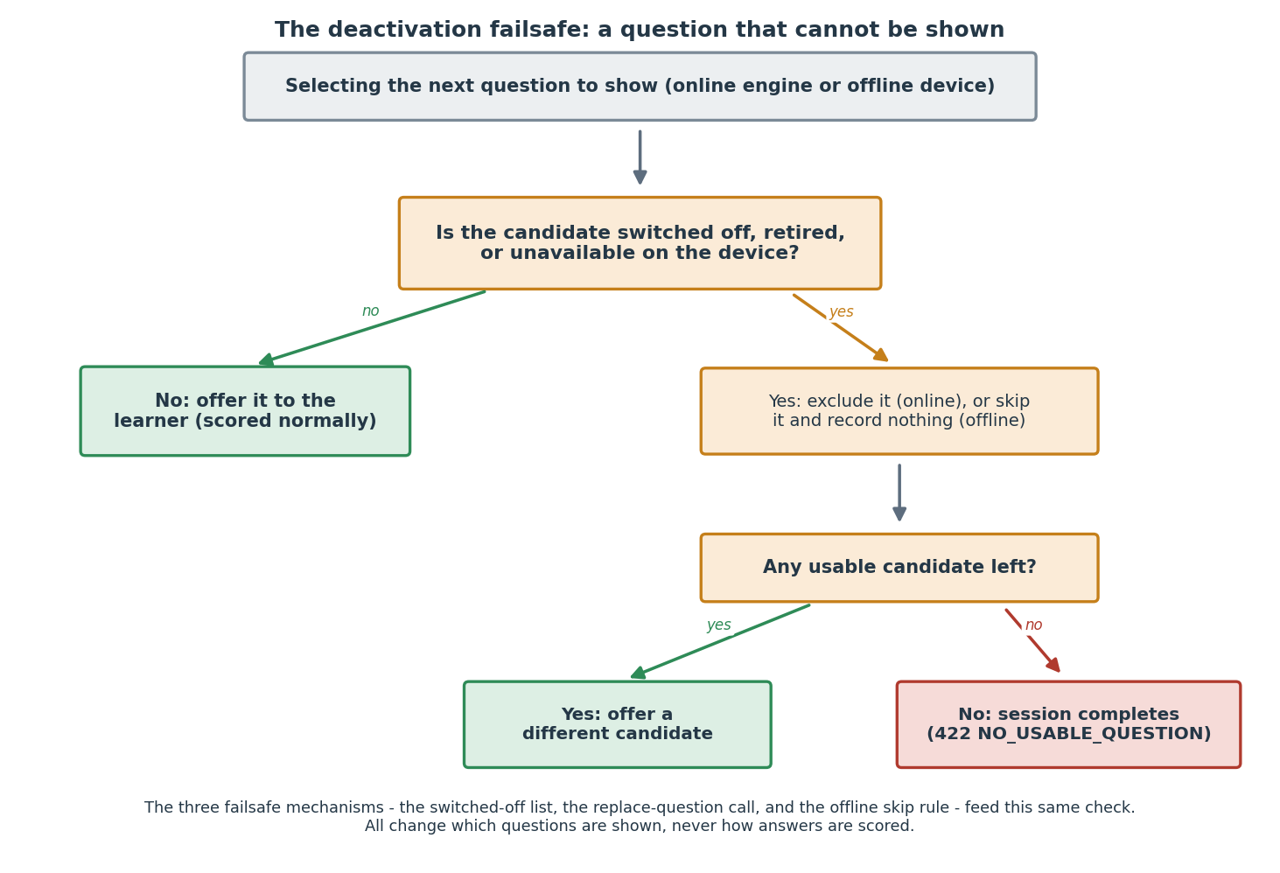
If a chosen item has no entry in the per-tenant lookup for the session's tenant, that is a content/lookup mismatch: the engine raises NO_QUESTION_FOR_SKILL rather than returning an ID that the tenant cannot load.
The pool MUST NOT return a question_x_id already in the session's question_history. Repeats break the idempotency contract (§8.3).

Relationship to the prototype
The prototype's CsvQuestionPool implements steps 1-5 and the discrimination window, verified against the calibrated question pool. The per-tenant resolution in step 6 (and the build step that produces the lookup) is the one addition beyond the current prototype: the prototype today returns a single global question_x_id per item, and the revision is to resolve that item to the session tenant's question_x_id via the lookup. This is a contained change to the pool's final step and does not affect selection.

7.9 Misconception coverage (engine) and classification (out-of-engine)
Two components are involved, and it matters to keep them apart, because only one of them ever sees the learner's raw answer. This does not change the mastery verdict.
What the engine does: coverage only. Beyond deciding mastered or not, many wrong answers follow recognisable patterns (for example, dropping a carried digit). The engine's role is to make sure the diagnostic asks questions that can reveal a learner's misconceptions: it tracks which applicable misconceptions have been probed in a session and prefers a question that covers a not-yet-seen one where the budget allows. The engine never receives, stores, or inspects the learner's raw response text (consistent with the PII boundary, §6.3); it works only in question_x_id and is_correct terms. It does not classify, and it does not itself hold a misconception tag.
What the separate step does: classification and merge. The misconception classifier is a separate component (the Stage B classifier, aml_stageb) that runs after the session, outside the engine. It reads the learner's raw answers, matches each against the 139-code catalogue (Addition A01-A26, Subtraction S01-S31, Multiplication M01-M46, Division D01-D36; Appendix D), and produces a per-skill misconception tag. That tag is merged onto the engine's per-skill mastery verdict to form the learner's learning state (input, output, and merge in Appendix E). The tag is therefore attached to the verdict downstream of the engine, not passed through it - which is what keeps the §6.3 boundary intact.
Data flow.
- The engine selects questions (biasing toward misconception coverage) and, from is_correct responses, produces per-skill mastery verdicts. It sees no raw answers.
- aml-api-service holds the learner's raw answers and, at session end, hands them plus the engine's verdicts to the Stage B classifier.
- Stage B classifies each raw answer against the catalogue and merges the tags onto the verdicts, yielding the learning state (Appendix E).
(A figure of this three-step flow is a documentation to-do; the steps above are the normative description.)
This layer is built and verified in testing (part of the current 668-test suite); it is not yet running in production, since nothing in this system is live yet.
Where it acts.
- Offline: the misconception backfill is Pass 2 of the three-pass follow (§4.3), and it is always on: after the base pass, the walk continues past the per-operation base cap to cover applicable misconceptions, up to the locked per-operation allowance.
- Online: within the still-relevant skills, selection can prefer a question that covers an applicable misconception not yet seen, without exceeding the budget.
The conditional_extra parameter. conditional_extra is the target number of times each applicable misconception should be probed before coverage is considered satisfied.
Setting | Value
Engine code default (MisconceptionConfig) | 2
Shipped value (config/engine_config.yaml) | 0
The shipped value is 0, set in deployment config rather than in code; the code default of 2 is intentionally left in place so the behaviour can be turned on by config alone, with no code change. Shipping at 0 means the engine does the always-on backfill described above but does not force repeat probes of an already-seen misconception. The trip-wire for raising it: downstream telemetry showing a MainD resolution gap or false-clear pattern on misconception-bearing skills. That telemetry join (durable sink export plus the MainD join) is a data-platform confirmation, not verifiable from the engine repo, and is the load-bearing check for keeping conditional_extra = 0.

7.10 Offline scoring (history scorer)
An offline session is scored on the server when its answers are synced (via the offline-batch ingest, Section 5.11), not on the device (§4.3). Mixed-mode sessions are scored the same way: the ingest replays the full unified history - every online and offline answer, in order - so the result matches a fully-online session on the same answers (verdict neutrality). The history scorer replays the recorded attempt history (question_x_id, skill_id, correctness per attempt) through the engine's own single-skill update (§7.2), lattice propagation (§7.3), and verdict assignment (§7.6). It does not re-implement any engine logic, so it is exact for whatever was asked. When the history comes from AML's stored attempt records (learner_proficiency_question_level_data, Section 1), those are keyed on question_id, which is finer-grained than the engine's question_x_id: many question_ids map to one question_x_id, and each question_id resolves to exactly one question_x_id. The scorer must apply that question_id -> question_x_id mapping before replaying; it must not assume the two are identical, and the mapping must be available where the scorer runs (open dependency C-1). Device-recorded offline histories already carry question_x_id from the tree nodes and need no mapping.
Verification against engine 0.9.0 (unchanged at 0.10.0, which is verdict-neutral to this): across 420 sampled sessions (8,820 skill comparisons) the scorer's skill verdicts and misconception signals matched the online engine exactly (0 mismatches), and a several-hundred-session mixed-mode sweep (an online prefix, then a real offline-batch ingest, versus pure-online) showed zero mastery-verdict mismatches and zero over-budget sessions. It is source-agnostic: a stitched online-then-offline history scores identically to a fully-online session on the same answers, because the scorer reads only question id and correctness and ignores provenance. Re-deriving every step's skill, slip, guess, and tags from the question_x_id alone (the only thing an offline-tree node carries) reproduces the online verdicts exactly, so an offline-tree question is fully scorable from its id.

8. Engine state lifecycle
This section describes how a session moves through states, what triggers each transition, and how the engine handles edge cases.

8.1 The states
+-----------+
| (none) |
+-----+-----+
|
| session/start
v
+-----------+
+------> | active |-----+-- budget exhausted OR
| +-----+-----+ | all skills resolved (via response)
| | |
| | response v
| v +-----------+
+------- (response loop)| complete |
+-----------+
At any time during 'active':
+-----------+ abandoned/timeout/quit +-------------+
| active |-------------------------->| abandoned |
+-----------+ +-------------+

8.2 Transitions
From | To | Trigger | Side effects
(none) | active | POST /session/start | Creates learner_diagnostic_sessions document with status=active. Copies priors into posteriors. Selects first question. Returns it and the offline tree.
active | active | POST /session/:id/response | Updates posteriors, appends to question_history, selects next question, returns it
active | complete | POST /session/:id/response resulting in budget exhausted OR all skills resolved | Updates session document: status=complete, sets ended_at. Writes one document per skill to learner_skill_verdicts. Returns verdicts in the response
active | complete | POST /session/:id/end with no abandonment reason | Same side effects as above
active | abandoned | POST /session/:id/end with reason abandoned, timeout, or learner_quit | Same writes as complete but status=abandoned. Verdicts still written using the posterior-mean rule for unresolved skills

8.3 Idempotency and replay
The response endpoint is idempotent on (sub_session_id, question_x_id). This matters because:
- aml-api-service may retry a network-failed request.
- An offline batch may re-sync a response that was already submitted before connectivity dropped.
The engine handles this as follows:
- On every POST /session/:id/response, the engine looks at the most recent entry in question_history.
- If the most recent entry has the same question_x_id and the same is_correct, the engine returns the same next-question response as the original call. No second update is applied.
- If the most recent entry has the same question_x_id but a DIFFERENT is_correct, the engine returns 409 RESPONSE_CONFLICT. The caller decides how to resolve.
Why this matters for the hybrid pattern. When a client goes offline mid-session, traverses the local tree, and later replays the offline batch, every replayed response is "new" from the engine's perspective until it matches a question_x_id already in question_history. Duplicates are silently handled, and the order of responses is preserved as long as aml-api-service submits the replay batch in sequence.

8.4 Crash recovery
The engine is a stateless service. All session state lives in learner_diagnostic_sessions. If the engine process crashes mid-request, no in-memory state is lost - the next call from aml-api-service (a retry, in this case) reads the database and continues.
There is one edge case worth handling explicitly. When a session ends, the engine writes to two collections:
- The session document is updated to status = complete.
- Verdicts are written, one document per skill, to learner_skill_verdicts.
These are separate writes. If the engine crashes between them, the session looks complete but verdicts are missing. A downstream system asking for verdicts would find none.
The cleanup job. A Kubernetes CronJob runs python -m engine.cli cleanup every 5 minutes (the cadence is set by the CronJob's schedule: field in its manifest, not by the engine process). It looks for sessions where status = complete but no verdict records exist. For any it finds, it recomputes the verdicts from the session's final posteriors (which are inside the session document) and writes them. This catches the partial-write edge case without complicating the main request path. The recovery logic is identical whether run as a CronJob or invoked manually; only the scheduling mechanism is external to the engine.
On read. If GET /session/:id/verdicts finds a complete session with no verdicts, the engine returns 500 VERDICTS_NOT_WRITTEN. The caller can retry; by the next attempt, either the request itself has completed the write or the cleanup job has.

8.5 Session timeout
The engine does not auto-time-out sessions. aml-api-service is responsible for deciding when a learner_sub_sessions is timed out and calling POST /session/:id/end with reason=timeout. This keeps timeout policy in one place across AML.

8.6 Concurrency
In v1, the engine runs as a single instance. Only one engine process handles requests at a time. Requests for the same sub_session_id arrive one at a time from aml-api-service and are processed in order. There is no coordination problem, so no lock is needed.
Running more than one engine instance requires a lock. If the engine is scaled to multiple instances for higher throughput, two requests for the same sub_session_id could reach two different instances at the same moment. Both would read the same session document, both would update posteriors, and the second write would overwrite the first, losing a response. A per-session lock prevents this. The lock is required before running more than one instance; it does not need to be active for a single-instance deployment.
Lock design.
- Scope is per session. The lock key is the sub_session_id. Different learners' sessions are completely independent and never contend with each other. Contention is possible only between two requests for the same session (a client retry or a double-submit), which is at most one or two extra requests, never a crowd. AML already uses the Redlock algorithm for this pattern; the engine uses the same library.
- The locked section is short. Only the read-update-write of one session happens inside the lock: read the session, run the Bayes update and lattice propagation (arithmetic over a few dozen numbers), write it back. This is a millisecond-scale operation.
- No slow or external calls inside the lock. Nothing that can block (no outbound HTTP, no large query) runs while the lock is held. This is the rule that keeps the lock from becoming a bottleneck: because every holder releases in milliseconds, a second waiter proceeds almost immediately and requests cannot pile up.
- Operations inside the lock are idempotent. A retried or duplicated request for the same (question_x_id, is_correct) produces the same result rather than double-counting (§8.3), so the lock plus idempotency together make concurrent duplicates safe.
- Expiry is a crash-recovery ceiling, not the expected hold time. If the instance holding the lock crashes mid-update, the lock auto-releases after an expiry so the session is not frozen. Default expiry: 2 seconds. This is far longer than the millisecond-scale work (so it never fires in normal operation) yet short enough that a crash frees the session quickly. If the lock cannot be acquired within the expiry, the engine returns 503 SESSION_LOCKED and the caller may retry.
Open item (revisit after pilot). The 2-second expiry is a working default. Finalize it once the pilot provides the p99 duration of the locked section under real load, setting the expiry to roughly 10 times that figure. This is the only part of the lock design left open; the scope, the millisecond-hold discipline, the no-external-calls rule, and idempotency are settled.

9. Observability

9.1 Prometheus metrics
The engine exposes GET /metrics for Prometheus scraping. The format matches aml-api-service's existing /metrics endpoint (text/plain Prometheus exposition format). Default Node-style process metrics (process CPU, memory, GC) are exposed along with the engine-specific business metrics listed below.
Metric name | Type | Labels | Meaning
diagnostic_sessions_started_total | counter | tenant_id, grade | Total diagnostic sessions started
diagnostic_sessions_completed_total | counter | tenant_id, grade, end_reason | Sessions ended (end_reason ∈ natural, abandoned, timeout, learner_quit)
diagnostic_session_duration_seconds | histogram | tenant_id, grade | Time between session/start and session end
diagnostic_questions_per_session | histogram | tenant_id, grade | Number of questions asked per completed session
diagnostic_verdict_total | counter | tenant_id, grade, skill_id, confidence_label | Verdict counts per (skill, label) for distribution tracking
diagnostic_routing_mode_questions_total | counter | tenant_id, mode | Hybrid mode usage (mode ∈ online, offline_replay)
diagnostic_offline_sync_events_total | counter | tenant_id, outcome | Offline-batch replay events processed (outcome ∈ success, conflict, partial)
diagnostic_api_request_duration_seconds | histogram | endpoint, status | Per-endpoint latency
diagnostic_api_errors_total | counter | endpoint, error_code | Errors by code
diagnostic_response_conflicts_total | counter | tenant_id | Idempotency conflicts - duplicate question_x_id with mismatched is_correct
diagnostic_cleanup_job_runs_total | counter | outcome | Cleanup job invocations (outcome ∈ success, error)
diagnostic_cleanup_job_recovered_sessions_total | counter | - | Sessions where the cleanup job had to write missing verdicts
The two diagnostic_cleanup_job_* counters are emitted by the cleanup CronJob (Section 8.4), not by the engine pod. The CronJob pod is short-lived and has no scraped /metrics endpoint, so it pushes these counters to a Pushgateway when PROMETHEUS_PUSHGATEWAY_URL is set (Section 10.3). All other metrics in this table are exposed on the engine pod's /metrics and scraped normally. Alerting on the cleanup counters (Section 14) must therefore target the Pushgateway-sourced series, not the engine pod's scrape.

9.2 Downstream / analytical metrics (not engine-emitted)
Some monitoring questions require joining engine output to data the engine does not have. These are computed in the AML analytics layer (Athena), not in Prometheus:
Metric | Why it can't live in Prometheus
Per-band MainD pass rates (the headline calibration check - for learners marked confident_mastered, what fraction actually pass MainD if they later take it?) | Requires joining engine verdicts to subsequent MainD outcomes. Engine does not see MainD results
Per-skill verdict drift over time (does a skill's confident_not_mastered rate change month over month? May signal a content change or a cohort shift) | Aggregation across time windows is cheaper in an analytics warehouse than in Prometheus
Cohort-level calibration audits (re-running the testing summary's 97/80/6 calibration check against production data quarterly) | Heavy joins, infrequent reads - analytics warehouse is the right tool
The engine emits enough Prometheus data for these downstream calculations to be derivable, but does not compute them itself.

9.3 Logging
Format: Structured JSON to stdout, one event per line. This is the engineering team's call to confirm - aml-api-service currently uses plain-text Winston logs. The default for the engine is JSON because it's easier to parse downstream and easier to filter PII from. If the pod log ingestion expects plain text, the engine can be configured to emit Winston-style lines instead. See Section 11.
Standard fields per log line:
Field | Notes
ts | ISO 8601 timestamp
level | debug, info, warn, error
service | Always aml-diagnostic-engine
version | The engine's semantic version
request_id | Trace ID generated per request
learner_id | If applicable, opaque identifier
tenant_id | If applicable, opaque identifier
sub_session_id | If applicable
message | Human-readable summary
error | If applicable, error object with code and message
PII filter. The logger strips or rejects any log line containing fields outside the allow-list above. This is enforced by the logging library's serializer - a logged object passed with an unexpected field is rejected with a build-time test (in CI) and a runtime warning (in production). The engine never logs question content, response data, or any field marked PII in Section 6.3.
Error logs to stderr. Severity error and above go to stderr; everything else to stdout. Matches AML's existing convention.

10. Deployment and operations

10.1 Tech stack
Component | Choice
Language | Python 3.11 (pinned). The engine is tested on 3.11 only. Newer minor versions (3.12, 3.13) may work but are not validated.
HTTP framework | FastAPI
MongoDB driver | PyMongo (synchronous) - sufficient for v1 throughput; Motor (async) is an alternative if engineering prefers full async
Prometheus client | prometheus-client + prometheus_fastapi_instrumentator (auto-generates the standard request-duration histograms)
Logging | structlog configured for JSON output, with a custom serializer enforcing the PII allow-list
Tests | pytest with pytest-asyncio if Motor is chosen
Container | Single Dockerfile, multi-stage build for size
Dependency lock file | pyproject.toml plus a lock file (uv.lock or requirements.txt with pinned versions). Lock file is committed to the repo and used in the Docker build to ensure reproducible images.
Why Python: The engine algorithm exists in Python in the simulation code. The production service ports that code into a FastAPI service. The decision to deploy a Python service in the otherwise-TypeScript AML stack has been confirmed with engineering.

10.2 Container and deployment
Container expectations:
- Base image: python:3.11-slim (Debian-based, kept current for security patches by the AML team)
- Working directory: /app
- Container runs as a non-root user (uid 1000)
- Stateless container, no local disk dependencies beyond reading the config file mounted at ENGINE_CONFIG_PATH
- Listens on the port set by ENGINE_PORT (default 4001 to avoid collision with aml-api-service's 4000)
- GET /health is the readiness and liveness probe endpoint (see Section 5.8 for probe semantics)
- Graceful shutdown: on SIGTERM, the engine finishes in-flight requests (timeout: 30 seconds), closes MongoDB connections, exits with code 0
Dockerfile expectations:
- Multi-stage build for image size (build stage installs dependencies, runtime stage copies only what's needed)
- Dependency installation uses the committed lock file (no pip install <package> without a version pin)
- The container's entrypoint runs the FastAPI app via uvicorn (e.g., uvicorn engine.api.main:app --host 0.0.0.0 --port $ENGINE_PORT)
Helm chart and image build pipeline: The engine is the first Python service in the AML stack. Engineering owns the new Helm chart for the engine and the image build pipeline. The engineering specification is the source of truth for what the chart must do (env vars, secrets, probes, port, resource requests); the chart's internal structure is engineering's call.

10.3 Environment variables
Variable | Required | Default | Purpose
ENGINE_PORT | no | 4001 | HTTP listen port
ENGINE_VERSION | no | 0.10.0 (package version) | Semantic version, stamped on the stored session and verdict records for traceability. It is not returned on the API response - it lives on the persisted record. The installed package is 0.10.0, so the unset default is correct; set it explicitly in the deployment manifest to guarantee the stamp if the package is ever repackaged.
STORAGE_BACKEND | no | memory | memory or mongodb. Production uses mongodb.
MONGODB_URL | only if STORAGE_BACKEND=mongodb | - | MongoDB connection string. Required when the backend is mongodb; ignored otherwise.
MONGODB_DATABASE | no | aml_engine | Database name. Used only when the backend is mongodb.
TENANT_TOKENS_JSON | yes | - | JSON map of {tenant_id: shared_secret_token} for per-tenant auth
STRICT_PRIORS_REQUIRED | no | false | When true, startup fails if any configured grade has zero priors. Default false (warn and continue).
LOG_LEVEL | no | info | One of debug, info, warn, error
LOG_FORMAT | no | json | json or text (Winston-style)
PROMETHEUS_PUSHGATEWAY_URL | no | - | When set, the cleanup CronJob pushes its counters (Section 9.1) to this Pushgateway. Unset means cleanup metrics are not pushed (the CronJob's pod has no scraped /metrics endpoint of its own).
ENGINE_CONFIG_PATH | no | /etc/engine/config.yaml | Path to the engine config file (slip, guess, thresholds, budgets, priors, canonical skill list)
QUESTION_CALIBRATION_PATH | no | /etc/engine/question_parameters.csv | Path to the per-item calibration file the QuestionPool loads (§6.2.1, §7.8)
TENANT_QUESTION_LOOKUP_PATH | no | /etc/engine/tenant_question_lookup.csv | Path to the per-tenant (tenant, item) -> question_x_id lookup the QuestionPool loads (§6.2.1, §7.8)
The cleanup job's cadence is not an environment variable; it is the CronJob's schedule: field (Section 8.4).
The TENANT_TOKENS_JSON value should come from a Kubernetes secret. Rotating a token is a secret update plus a pod restart.

10.4 Config loading at startup
The engine loads these at startup:
Item | Source | Reload mechanism
Engine parameters (slip, guess, thresholds, budgets, canonical skill names) | YAML config file at ENGINE_CONFIG_PATH | Container restart
Lattice edges | lattice_edges MongoDB collection | Container restart (v1) or scheduled reload (v2)
Priors per (grade, skill) | YAML config file (same as engine parameters) for v1; can move to a MongoDB collection in v2 | Container restart
Per-item calibration | Calibration file at QUESTION_CALIBRATION_PATH (§6.2.1) | Container restart
Per-tenant question lookup | Lookup file at TENANT_QUESTION_LOOKUP_PATH (§6.2.1, §7.8) | Container restart
Per-tenant tokens | TENANT_TOKENS_JSON env var | Container restart
If any required configuration is missing or invalid at startup, the engine logs the failure and exits with non-zero status - fail-fast rather than running with partial config.

10.5 Offline tree generation batch job
The offline tree artifacts are generated by a separate batch process, not by the engine service itself.
What it does: Given the current lattice, priors, anchors, canonical skill list, the per-item calibration file, and the per-tenant question lookup, it builds the four per-operation trees for each (tenant, grade) and writes them as gzipped file artifacts (one bundle per (tenant, grade)) under OFFLINE_ARTIFACT_DIR, each stamped with the engine_version it was built against. It builds per tenant because the active question set differs by tenant (§7.8): the generator selects in item space using the same logic as the online engine, then resolves each node's chosen item to a single question_x_id for that tenant through the same lookup, so the offline trees and the online path always agree on which question a given answer path leads to. The four per-operation trees are walked at run time by the three-pass base-first follow described in §4.3.
Deterministic selection. Tree generation runs the question pool in deterministic mode (§7.8 step 5): at each node it takes the single highest-discrimination question (smallest item as the tie-break) rather than a random pick. This makes generation reproducible - the same inputs always yield the same tree - which is required for a shippable, versioned artifact. The online engine still uses random selection within the discrimination window; the offline tree is the deterministic projection of the same selection rule.
Tractability and the state key. A naive tree enumerates every answer path, which grows exponentially with the number of questions. The generator deduplicates equivalent engine states (two answer paths that leave the engine in the same posterior and observation state share the same subtree) to keep size manageable. This was built and measured against engine 0.9.0: the four per-operation trees compress to roughly 5.4 MB on disk at G5 (the largest grade) and are served as about 24.8 MB of canonical JSON (the size the client downloads), within the accepted envelope and decreasing sharply at lower grades. They are served on demand from the fetch endpoint (Section 5.9), not inlined into the session-start response.
The state key must include enough posterior precision to be sound. Keying on 2-decimal posteriors (an earlier choice) has a rare soundness gap at G5: two states whose third-decimal posterior difference flips the engine's information-gain pick get merged, which was observed on G5 Subtraction. The generator keys on 3-decimal posteriors, which removes the gap at a negligible cost (about +2.4% nodes, +1.5% gzipped). The earlier 2-decimal key was sound at G2 (the grade an earlier probe checked), so the gap only appears at G5's larger skill set; this is a case where empirical measurement corrected a spec assumption.
Determinism. Generation is deterministic and was checked by replaying many random root-to-leaf paths against the engine's own deterministic choice; residual mismatches are minor and accepted (G2 1, G3 2, G4 and G5 0).
Priors are shared across tenants for now. Per-tenant priors are not yet available (Telangana response data is pending; other tenants borrow Delhi). Because priors set the branch structure, node counts are currently identical across tenants and only the resolved question_x_ids differ (each tenant's active set). When real per-tenant priors arrive, especially Telangana, the trees must be regenerated; the structure may shift, though size should stay similar because it is depth-driven.
Deployment: The batch job is a Python script in the same repository as the engine service. It is packaged as a separate container image (or the same image with a different entrypoint - engineering's call) and deployed as a Kubernetes CronJob rather than running inside the engine service pods.
Why a CronJob:
- Batch jobs that take more than a few seconds should not block the engine service pods
- Resource limits and scheduling are independent of the engine service
- Failures in tree generation are isolated and surface as failed CronJob runs in the cluster's monitoring
When to run it (regenerate on input-change): The tree depends on exactly three inputs - the priors, the lattice, and the question pool (including calibration and the per-tenant lookup). Rebuild it as the final step whenever any of these changes:
- After any change to the priors
- After any change to the lattice (edges added, weights changed)
- After any change to the canonical skill list or anchors
- After any change to the per-item calibration
- After any change to a tenant's active-question list (which changes that tenant's lookup, hence that tenant's tree)
- After any change to the engine's question-selection algorithm
Learner responses do not appear in this list: a learner's answers update only that learner's live session, never the tree's inputs (design document §3.8, §4.11). There is therefore no streaming or nightly-reactive regeneration; the tree is rebuilt deliberately when one of its inputs is deliberately changed.
Schedule: The CronJob does NOT run on a regular schedule by default. It is triggered when one of the change conditions above applies (kubectl create job --from=cronjob/diagnostic-tree-generator tree-gen-<date>). A nightly idempotent run that no-ops when nothing has changed is acceptable if engineering prefers, but the default is on-change.
Promotion to active: The batch job writes new trees with is_active=false. Promotion to active requires a manual step (a separate kubectl create job against a promote-tree job, or a small admin endpoint - engineering's call). Once the new tree is promoted, the engine starts returning it at session-start; in-flight sessions continue using the tree they started with.
Image and code sharing: The batch job shares the engine algorithm code (tree generation reuses the same lattice, routing, and question-selection logic) but does NOT need the FastAPI dependencies. Engineering decides whether to ship one image with two entrypoints or two separate images.

10.6 Build-time work items
These are one-time tasks that must be completed before the first production session:
- Skill-name-to-UUID mapping per tenant. For each state-instance of AML, confirm that each of the canonical L2.5 skill names (40; 39 in the Delhi scope) matches a skill_master.name.en value (or document the translation that aml-api-service will apply).
- Initial lattice seeding. Import the 12 lattice edges into lattice_edges. The edges are documented in the existing lattice_edges_final.xlsx and the testing summary.
- Calibration file deployment. Place the per-item calibration file where the engine loads it (QUESTION_CALIBRATION_PATH).
- Per-tenant question lookup build. For each tenant, take that tenant's active-question list (the six raw fields plus the question_x_id), run the build step to construct the (tenant, item) -> question_x_id lookup (§7.8), and place the combined lookup where the engine loads it (TENANT_QUESTION_LOOKUP_PATH).
- Initial tree generation. Run the batch job once per (tenant, grade), validate, promote to active.
- Per-tenant secret generation. Create one shared-secret token per AML instance, distribute it to each instance's aml-api-service configuration, and register the same token in the engine's TENANT_TOKENS_JSON.
- Configure deployment. Set environment variables, deploy the container, verify /health returns 200, verify Prometheus scrape works.
- Smoke test. Run a single end-to-end session from a test learner and verify the verdicts are written correctly.

11. Versioning and compatibility
The engine writes engine_version to every session document and every verdict document (on the stored records; it is not returned in the API response). This section defines how versions are bumped and what downstream systems should do with them.

11.1 Version bumping rules
The engine uses semantic versioning (MAJOR.MINOR.PATCH):
Change type | Version bump | Examples
Bug fix that does not affect verdicts | PATCH (0.9.0 -> 0.9.1) | Logging fix, performance fix, internal refactor
Algorithm change that affects verdicts | MINOR (0.9.0 -> 0.10.0) | Threshold change, new lattice edge, new question selection rule
Breaking change to API contract or data model | MAJOR (0.9.0 -> 1.0.0) | New required field, removed field, changed endpoint URL
Backward-compatible additions - a new optional request field, or a new endpoint - do not force a MINOR or MAJOR bump on their own, because they do not break existing callers. The v9 offline-serving and raw-response work (the offline_tree reference, the offline-tree and responses GET endpoints, and the optional raw_response field) were such additions and were kept within 0.9.0 as completion of the v9 scope. The mixed-mode and deactivation-failsafe work that followed, although also additive at the wire level (the offline-batch and replace-question endpoints and the optional switched-off fields), added real new capability, and so was released as the MINOR bump to 0.10.0.

11.2 Config-incompatible changes
Some config changes are incompatible with previously generated trees or in-flight sessions. These require a coordinated update:
Change | Required action
Canonical skill list changed (skill added, renamed, removed) | Regenerate offline trees; in-flight sessions started before the change continue using the old posteriors keys until they end
Lattice edges changed | Regenerate offline trees; engine restart picks up new edges from MongoDB
Priors changed | Regenerate offline trees; engine restart picks up new priors from config
Slip, guess, or threshold values changed | Engine restart; in-flight sessions continue with the values they started with (engine reads its engine_version from the session document when resuming)

11.3 Downstream consumer guidance
Downstream systems (the AML practice router, analytics) read verdicts and should be aware of engine_version:
- Same MAJOR, any MINOR/PATCH: verdicts are comparable and can be aggregated
- Different MAJOR: do NOT aggregate verdicts across major-version boundaries without explicit migration logic
- Recommendation: downstream queries that aggregate or compare verdicts over time should include the engine_version field and either filter to one major version or document the cross-version assumptions

12. Error handling and retry semantics
This section consolidates the error codes from Section 5 with their retry semantics, to give aml-api-service clear guidance on how to handle each error class.
Error code | HTTP status | Retryable? | Recommended caller behaviour
INVALID_TENANT_TOKEN | 401 | No | Log and alert; do not retry. Indicates misconfiguration.
INVALID_GRADE | 400 | No | Log; surface to caller. Indicates bad input from upstream.
INVALID_SKILL_ID | 400 | No | Log; surface to caller. Indicates bad input from upstream.
LEARNER_MISMATCH | 400 | No | Log; surface to caller. Indicates bad input or session state issue.
PII_FIELD_PRESENT | 400 | No | Log; surface to caller. The request must be reconstructed without the PII field.
SESSION_ALREADY_EXISTS | 409 | No (idempotent) | The session already exists. Caller can proceed with the existing session via /response or /verdicts.
SESSION_ALREADY_ENDED | 409 | No | The session is complete. Caller can fetch verdicts via /verdicts.
SESSION_NOT_FOUND | 404 | No | The session does not exist on this engine. Caller may need to start a new session.
SESSION_NOT_COMPLETE | 409 | Yes (with delay) | Verdicts are not yet final. Retry after the session is ended.
RESPONSE_CONFLICT | 409 | No | The same question_x_id was submitted with conflicting is_correct. Caller must reconcile before retrying.
NO_TREE_FOR_GRADE | 404 | No | No tree exists for this tenant/grade (raised only by the fetch endpoint, Section 5.9; session/start returns offline_tree: null instead). The session proceeds online; retry does not help.
NO_QUESTION_FOR_SKILL | 500 | No | Content pool has no active question for the chosen skill. Engineering and content team must add a question. Retry will not help.
NO_USABLE_QUESTION | 422 | No | A caller-supplied switched-off list covers every available question for the grade, so the diagnostic cannot start (deactivation failsafe, Sections 5.3 and 7.8). A client-input condition: fix the list.
OFFLINE_BATCH_TOO_LARGE | 400 | No | An offline batch is implausibly large (more than twice the grade budget) - a corruption guard (Section 5.11). A correct device never sends this.
VERDICTS_NOT_WRITTEN | 500 | Yes (with delay) | Verdicts are being computed. Retry after a short delay (the cleanup job runs every 5 minutes).
SESSION_LOCKED | 503 | Yes (with backoff) | v2 only. Another instance holds the session lock. Retry with exponential backoff.
Transient network / connection errors | n/a | Yes (with backoff) | Treat as if the request was not received. Idempotency rules apply (Section 8.3).
Recommended retry policy for aml-api-service: exponential backoff starting at 100ms, max 3 retries, max delay 2 seconds. Total retry budget capped at 5 seconds per request to avoid blocking the learner UI.

13. Tenant onboarding
The operational process for adding a new state instance (Karnataka, future states) to the engine.
Step | Owner | Description
1 | AML platform team | Decide on a tenant_id (Text UUID) for the new state; register in the central tenant directory
2 | Engine team | Generate a per-tenant shared-secret token (32 random bytes, hex-encoded). Store in the cluster's secret management system
3 | Engine team | Add the {tenant_id: token} entry to TENANT_TOKENS_JSON in the engine deployment's secret. Restart engine pods to pick up the new entry.
4 | New state's aml-api-service owner | Receive the token securely (1Password, SOPS, sealed secrets - engineering's call). Configure the new state's aml-api-service with the token and the engine's URL.
5 | Engine team | Validate that the state's skill_master collection has entries matching the canonical L2.5 skill names (40; 39 in the Delhi scope). Document any name mapping the state's aml-api-service must apply.
6 | Both teams | Run an end-to-end smoke test from the new state's instance: start a session, submit responses, end the session, verify verdicts written with the correct tenant_id.
7 | Engine team | Confirm diagnostic_verdict_total metric labeled with the new tenant_id shows up in Prometheus. Add the tenant to dashboards.
Token rotation: Same process as onboarding, but with a transition window. Add the new token to TENANT_TOKENS_JSON alongside the old one (the engine accepts both during the transition), notify the state's aml-api-service owner to update, then remove the old token after confirmation.

14. Operational runbook (open items for engineering)
The runbook below lists the operational scenarios the engine team will encounter. The spec defines the engine's behaviour in each scenario; the response procedure (who acts, what tools they use, what alerts fire) is owned by engineering and should be documented as part of the deployment.
Scenario | Engine behaviour | Required from engineering
A session is active for longer than expected (>1 hour) | Engine does not auto-end; depends on aml-api-service to call /session/:id/end with reason=timeout | Alerting threshold; investigation playbook
Verdicts for a complete session are not written | The cleanup job (Section 8.4) recomputes them on its next run | Alert when cleanup job recovers >N sessions per hour; investigation playbook
MongoDB connection drops | Engine returns 503 from /health until reconnected. In-flight requests fail with 500 | Alerting + incident response procedure
A tenant token needs immediate rotation (compromise suspected) | Update TENANT_TOKENS_JSON, restart pods. Old token immediately invalid; sessions in flight for that tenant will fail | Documented rotation procedure with response time SLA
Cleanup job is failing repeatedly | diagnostic_cleanup_job_runs_total{outcome="error"} increments (Pushgateway-sourced series, see Section 9.1); verdicts may go missing | Alerting; investigation playbook
Offline tree generation fails | The CronJob completes with non-zero exit; no new tree version is written | Alerting; investigation playbook
A grade has no tree | /session/start returns offline_tree: null (no error); the fetch endpoint (Section 5.9) returns 404 NO_TREE_FOR_GRADE only if the tree is explicitly requested | Alerting; investigation playbook
The engine pod restarts unexpectedly | Active sessions resume cleanly via MongoDB state (Section 8.4); no data lost | Alerting on pod restart frequency
Disk pressure on the MongoDB volume | Engine returns slow responses, then 503 | Capacity planning; alerting
A false skip is detected after the fact (learner already received skip_maind on a skill later found not-mastered, e.g. a G2 Subtraction regression surfacing live) | The engine does not retroactively change a written verdict; turning the feature flag off only affects new sessions | Define a remediation path: how to re-open the affected skill's MainD for already-scored learners (re-queue the skill, or a targeted re-diagnostic), plus the detection signal that triggers it. This is a required safety procedure before wide rollout, not just alerting.
Engineering should produce a runbook document referencing this section, with concrete alert names, dashboards, on-call rotation, and escalation paths.

15. Backup and data lifecycle (open items for engineering)
The engine writes three collections: learner_diagnostic_sessions, learner_skill_verdicts, lattice_edges (offline trees are gzipped file artifacts under OFFLINE_ARTIFACT_DIR, not a collection). The questions below are not answered by the engine team; engineering owns the answers.
Question | Default assumption (subject to engineering confirmation)
What is the backup frequency for these collections? | Same as AML's other operational collections (learner_sub_sessions, learner_proficiency_aggregate_data, etc.) - engineering to confirm
What is the retention period for learner_diagnostic_sessions documents? | Indefinite by default. Sessions are small (<10 KB each). If retention is enforced, the engine team should be consulted on impact to historical analysis
What is the retention period for learner_skill_verdicts documents? | Indefinite by default. Verdicts feed downstream analytics, so deleting them affects reporting
When a learner is deleted (GDPR-style data subject request), how is it propagated? | Engine deletes by learner_id on receipt of a deletion request. Operational process for receiving and propagating these requests is owned by the AML platform team
Are backups tested? | Engineering owns backup validation. Restore procedure should be documented
What is the disaster recovery RPO and RTO for engine data? | Engineering to define based on AML's overall DR policy
Engineering should produce a data lifecycle policy document referencing this section.

16. Resolved engineering decisions
This section records the resolution of the items this spec previously held as pending. Each carries a tag indicating who acts and when:
- DECIDED - settled; no further action needed.
- CALL FOR ENGINEERING - a real choice engineering owns; a recommendation is given.
- ENGINEERING TO CONFIRM - a default is set; engineering verifies it fits AML's environment.
- NOTE TO ENGINEERING - informational; no decision, just an implementation fact.
- REVISIT DURING PILOT - action happens around pilot launch.
- REVISIT AFTER PILOT - cannot be finalized without pilot data; carries a default meanwhile.
Several items resolve to "no engine code change," meaning they are operational or deployment concerns that do not affect the engine's own behavior.
# | Item | Tag | Resolution
1 | Cleanup job cadence (8.4) | DECIDED | Kubernetes CronJob every 5 minutes. Isolated from the request path; the orphaned-verdict case is rare and not learner-facing, so 5 minutes is comfortable.
2 | Per-session lock for multi-copy operation (8.6) | DECIDED + REVISIT AFTER PILOT (expiry value) | Per-session lock, required only when running more than one instance. Per-session scope, millisecond holds, no external calls inside the lock, idempotent operations, crash-release expiry. Default expiry 2 seconds; finalize after the pilot from the p99 locked-section duration (about 10x).
3 | Error-code names (5) | CALL FOR ENGINEERING | Keep the spec's SCREAMING_SNAKE_CASE names unless they clash with AML's house style; if they clash, rename once and uniformly. No behavior change.
4 | Log format (9.3) | ENGINEERING TO CONFIRM | Structured JSON to stdout (the right default for a log aggregator and for request_id tracing). Confirm it suits AML's log pipeline.
5 | Service-to-service auth (5.1) | CALL FOR ENGINEERING | Per-tenant shared secrets in X-Internal-Service-Token for the pilot. If AML runs a service mesh, mutual TLS is worth considering instead (and removes item 8).
6 | Helm chart (10.2) | NOTE TO ENGINEERING | No engine code change. Engineering owns the chart; reuse AML's standard service chart template if one exists.
7 | Image registry and build pipeline (10.2) | NOTE TO ENGINEERING | No engine code change. Recommend extending AML's existing pipeline with a Python build and test stage rather than a separate pipeline.
8 | Secret storage and rotation (10.3) | CALL FOR ENGINEERING | Kubernetes Secret with rotate-by-restart for the pilot (restart cost is negligible at pilot scale). Automated rotation is a scale-up upgrade. Moot if item 5 adopts a mesh.
9 | Latency target (5) | CALL FOR ENGINEERING | Engineering sets a concrete p95/p99 target. No engine behavior change. The measured p99 of the locked section feeds the item 2 expiry after the pilot.
10 | Peak concurrency (4) | CALL FOR ENGINEERING | Engineering estimates peak concurrent sessions from the rollout plan. No engine code change. Decides single-copy vs multi-copy, which decides whether the item 2 lock is exercised during the pilot.
11 | Service mesh / gateway placement (5) | NOTE TO ENGINEERING | The engine is gateway-agnostic: it does its own shared-secret auth and accepts direct HTTP, and can also sit behind a mesh or gateway with no code change. Engineering confirms placement.
12 | Alerting and dashboards (9, 14) | REVISIT DURING PILOT | No engine code change; the engine already emits the metrics. Built by the AML team (read access to /metrics is enough). Build a minimal dashboard before pilot launch covering the Section 14 conditions; refine once real traffic flows.
13 | Operational runbook (14) | REVISIT DURING PILOT | No engine code change. The AML team operates the engine until any future engineering handover, so the AML team writes the runbook. Depends on item 12; draft before pilot from Section 14 plus the item 12 alerts.
14 | Backup and data lifecycle (15) | NOTE TO ENGINEERING | No engine code change provided deletion is a database-layer TTL or an external job, not an engine responsibility (the engine must not perform hard deletes). The no-PII design lowers the stakes, but retention for minors' data may be governed by AML-wide rules; confirm with the data-governance owner.
15 | Offline-tree generation (10.5) | DECIDED | Build the offline tree into the prototype, per tenant. Regenerate on input-change (new priors, calibration, lattice, skills/anchors, a tenant's active-question list, or the selection algorithm), not on a schedule and not via a stream.
16 | Question selection and ID resolution (7.8) | CALL FOR ENGINEERING | The engine selects (required for per-item calibration to reach the Bayes update). It selects in item space and never reads a tenant's live questions collection; it resolves the chosen item to a single question_x_id through a per-tenant lookup built ahead of time from each tenant's active-question list (the six raw fields plus the question_x_id), with a deterministic tie-break where one item maps to several question_x_ids. The engine returns a question_x_id. Per-tenant offline trees follow from this.
17 | Where calibration values live (6.2.1) | REVISIT AFTER PILOT | Calibration stays in the sidecar file the engine loads. Folding the values onto the question records waits for a single shared content service (no timeline); until then the sidecar is the correct choice, not merely a convenience.
18 | Shared vs tenant-specific pools (7.8) | DECIDED (shared pool) + REVISIT AFTER PILOT (cross-tenant validity) | The pool is shared across tenants; calibration is Delhi-derived (others borrowed or defaulted). Whether Delhi calibration generalizes to other tenant populations is an assumption to validate once per-tenant pilot data exists. The calibration script now warns when a question's slip or guess differs across tenants that both have enough data, by at least 0.05 (reported in bands: 0.05 small, 0.10 large, 0.15+ extreme), matching the published convention for a meaningful difference in this kind of model and the script's existing practical-significance cutoff.
19 | Recalibration pipeline (design document 4.3, 4.11) | REVISIT AFTER PILOT | Recalibration stays a manual, deliberately-triggered step. Automating it into a pipeline waits for a single combined response database (no timeline). Recalibration should be deliberate and reviewed regardless, so values do not shift silently mid-deployment.
20 | Anchor-score derivation cohort (Appendix A, item 4) | DECIDED | The anchor recommendations stay as authored, on the combined Telangana + Delhi cohort. They were verified to produce the same recommendation for every learner-grade and operation under Delhi-only mastery, so the combined-cohort authoring is accepted and will not be changed - a settled decision, not an open inconsistency.
21 | Seventh item-key field, response_includes_remainder (7.8) | DECIDED | The division-only seventh key field is retained, though the current 667-item bank has no two-format division pairs and it is therefore inert today. It is kept as regression protection: if a quotient-only and a quotient-plus-remainder form of the same operands are reintroduced, the seventh field keeps them distinct.
Three dependency chains are worth keeping in view: items 9 and 10 together decide whether the pilot needs multiple instances, which decides whether the item 2 lock is exercised and supplies the p99 that finalizes its expiry; item 13 depends on item 12, which depends on the metrics the engine already emits; and items 16, 17, and 19 are gated on two pieces of future infrastructure (a single shared content service and a combined response database), so the current sidecar-and-manual design is correct for now with defined upgrade paths (design document Section 7).

17. Offline-walk handover pack for the AML app team
This section is a step-by-step guide for the AML app team building the offline walk in TypeScript inside aml-portal. It is written to stand on its own: read it top to bottom and you have everything needed to build, test, and scope the work. (The same pack appears in the Implementation Spec; the two are kept identical.)

17.1 What you are building, and what you are not
You are building the part that chooses and records questions while the device is offline. You are not building anything that scores or judges mastery - that stays on the server. Keeping this line clear is the single most important thing in this pack.
Job | Who does it
Show the learner a question and read their answer | aml-portal (you), online and offline
While online: ask the engine for the next question | aml-api-service -> engine (/response)
While offline: choose the next question by following the downloaded tree | aml-portal (you) - this is the offline walk
Mark each answer right or wrong | aml-portal (you) - a simple correctness check, the same one used online
Record each answer locally (id, skill, correctness, the typed answer, and when) | aml-portal (you), in IndexedDB
On reconnect: send the offline answers to the engine | aml-portal -> aml-api-service -> engine (/offline-batch, Section 5.11)
Turn answers into mastery verdicts | the engine, server-side, when the batch is ingested
Produce the final learning state (verdict + misconception tag) | the data team, downstream
So the device sequences, marks, records, and syncs. It does not compute posteriors or verdicts, and it does not need the calibration parameters for scoring - the tree already encodes every branch the walk needs.

17.2 What you receive
Three artifacts travel with this pack. They are the contract: build against them, and the port is correct by construction.
Artifact | What it is | How you use it
offline_follow.py (the walk reference) | The Python source of the exact walk: follow_capped(...), the replay-to-first-unanswered entry point, and the skip-and-do-not-record rule. It is small and readable. | Port its logic to TypeScript, line-for-line in behaviour. It is the specification of "what to ask next," in runnable form.
vectors/offline_walk_vectors.json (the shared test vectors) | A set of recorded walks: for each case, the inputs (grade, the answers given) and the exact question sequence the walk must produce. Covers fresh starts, resumed walks (online-then-offline), all-correct / all-wrong / mixed answer patterns, and the unavailable-question skip. | Your TypeScript port must reproduce every vector's sequence and count exactly. This is your acceptance test (Section 17.5).
offline_followsim.py (the harness) | The Python harness that runs the walk in bulk and checks it against the engine. | Reference only - it shows how the walk is exercised and how equivalence is checked; you do not port it.

17.3 The model: port, do not embed
Port the walk logic into TypeScript. Do not try to run or embed the Python engine on the device, and do not reimplement scoring. The division of material is:
- The tree and its parameters come from the engine, already built, via the offline-tree endpoint. You download and cache them; you do not compute them.
- The walk (which node to visit next, when to stop) is the logic you port from offline_follow.py.
- Scoring never happens on the device. You record answers and sync them; the engine scores.
The reason this is safe: the walk is pure "follow the tree by correctness," with no probability maths. All the hard maths (posteriors, the lattice, verdicts) lives on the server and runs on the synced history.

17.4 The offline walk, step by step
Step 1 - Get the tree and keep it. When the learner starts (online), session/start returns an offline_tree reference (Section 5.3). If you want offline capability, fetch the actual tree once from its fetch_path (the offline-tree endpoint, Section 5.9) and cache it by sha256 in IndexedDB. The bundle holds the four per-operation trees (Addition, Subtraction, Multiplication, Division), the shared per-grade parameter block, and a manifest of every question_x_id the trees can reach - pre-load the content for those ids so you can show any question offline.
Step 2 - Keep the latest resumption token. session/start and every online /response return a small resumption_token (Section 5.4): the last-answered question (resume_anchor), the budget used, and one entry per answer so far. Overwrite your cached copy every time. This token is how the offline walk knows where the session already is.
Step 3 - When the connection drops, find the entry point. Do not start the tree from the top. Take the answers from the resumption token and "replay" them into the tree: for each operation, start at the root and follow the recorded correctness (correct -> the on-correct child, wrong -> the on-incorrect child) as long as the node's question has already been answered. The first node whose question has not been answered is your entry point - that is the first question to ask offline. Match answered questions by their content (the item a node resolves to), not by the raw question_x_id, because the online path and the tree can use different id variants of the same question.
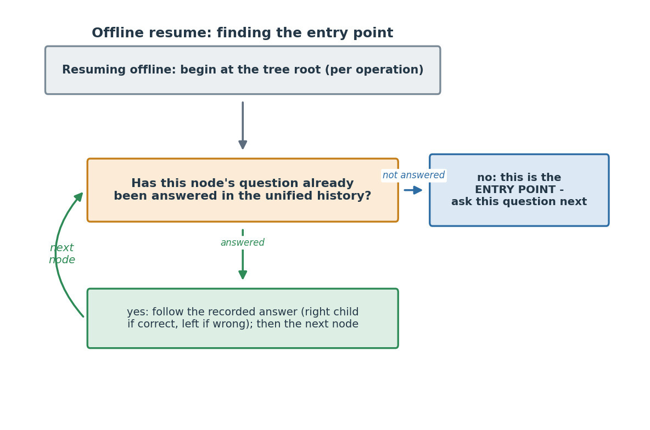
Step 4 - Walk the tree (base-first, three passes, one budget). Sweep the four operations in the fixed order Addition, Subtraction, Multiplication, Division, and make three passes over them, all under one hard question budget for the grade (25 / 42 / 59 / 76 for G2 / G3 / G4 / G5):
- Base pass - walk each operation's tree up to that operation's base cap.
- Misconception backfill - continue a little past the base cap to cover misconceptions not yet seen, up to the per-operation allowance.
- Skill harvest - if budget remains, ask a few more to settle still-uncertain skills.
At each node you ask its question, read the answer, mark it right or wrong, and move to the on-correct or on-incorrect child. Never ask the same content twice (the no-repeat check is in item space, as in Step 3). Stop the moment the grade budget is reached - it is a hard cap and must never be exceeded.
Step 5 - The skip-and-do-not-record rule. If the walk lands on a node whose question you cannot actually show - most often because it was switched off on the app after the tree was built - do this: skip the node, follow its on-incorrect branch, record nothing, and spend no budget. Treat "cannot show" exactly as "not asked." Do not guess an answer, and do not count it. (This mirrors the engine's own handling of switched-off questions online, Section 7.8.)
Step 6 - Record every answer locally. For each question actually answered, store in IndexedDB: question_x_id, skill_id, is_correct, the learner's typed answer (raw_response), and asked_at (a timestamp). You will need all five when you sync.
Step 7 - On reconnect, sync the batch. Send the recorded offline answers to the engine via POST .../offline-batch (Section 5.11), including the tree_id, tree_version, and tree_compat_version of the tree you walked, and the resume_anchor from your token. The engine folds the batch into the one session, re-scores the whole history, and returns the next question (if the learner continues) or the final verdicts. Sending the same batch twice is harmless. If the learner keeps switching between online and offline, repeat these steps - the session is a single unified thing and can switch any number of times.

17.5 How you know the port is correct (the acceptance bar)
The bar is exact reproduction of the shared vectors. For every case in vectors/offline_walk_vectors.json, feed your TypeScript walk the same inputs and confirm it produces the same question sequence and the same count - no more, no less, in the same order. Wire this as an automated test in the aml-portal build so a future change cannot silently drift from the engine. If every vector passes, the walk is correct; the vectors were generated from the engine's own walk, so matching them means matching the engine.

17.6 Scope: what is in, and what is deferred
- In scope: a session that starts online and then goes offline (with the resumption token in hand), any number of switches, and syncing each offline stretch back through offline-batch. This is the pilot's mixed-mode.
- Deferred: a never-connect cold start - running the whole diagnostic on a device that has never been online and so never received a resumption token or a fresh tree. That is a later phase and is not part of this pack.

Appendix A - Known limitations
These are the engine's known weaknesses, carried forward from the design document and testing summary. They are documented here so engineering and the AML team can monitor for them in production.
# | Limitation
1 | Simulation-only validation. The engine's performance (confident-verdict accuracy 93.3% online and 96.0% offline versus 86.9% static, and the savings and calibration figures in Section 1) was measured in simulation by replaying learners' real entry mastery records (with question responses simulated from a fixed 0.90/0.15 model) against engine 0.9.0. It has not been validated against live production traffic. Because responses were simulated i.i.d., the pilot is also the first test against real answer patterns - fatigue, streaks, item-specific difficulty - not merely sim-to-field. The first deployment is effectively a pilot.
2 | Two persistent bad buckets. In simulation, G2 Subtraction reaches only ~74% accuracy (vs the static diagnostic's 82%), and G4 Addition reaches ~75% (vs 87%). Both are documented in the testing summary §11. Watch these in production.
3 | 3% false-skip rate at strict thresholds. When the engine says confident_mastered, it is right 97% of the time. The remaining 3% are learners who get skip_maind but were actually not yet mastered. Loosening thresholds reduces this but also reduces the size of the confident_mastered band, costing savings.
4 | Calibration cohort specificity. All numerical engine inputs (priors, lattice edge strengths, and per-item slip/guess) are derived from Delhi data. The lattice's edge structure was identified through Telangana P(B|A) analysis, but the runtime values come from Delhi Entry→Entry measurements. Anchor recommendations were authored using combined cohort mastery but have been verified to produce the same 35 anchor recommendations (the recommended anchor skill for each learner-grade and operation in the anchor table) under Delhi-only mastery; this combined-cohort authoring is an accepted decision that will not be changed (Section 16, item 20). Per-item calibration is Delhi-derived too, with borrowed or default values for questions used only in other tenants or with thin data. Populations that differ systematically from Delhi may show different distributions; the calibration script's cross-tenant divergence warning (Section 16, item 18) and the downstream per-band MainD pass-rate metric are the signals for when recalibration on a tenant's own data is warranted.
5 | Per-item calibration is mostly borrowed for now. Each question uses its own measured slip and guess where available, but only Delhi questions had enough clean data to estimate individually - 55 of the 667 items are directly estimated and the other 612 are borrowed from the most similar calibrated question. As pilot data accumulates and recalibration runs, the share of directly-measured values grows. The model behind the calibration is also the simplest in its family (one skill per question, no modelling of specific wrong-answer choices).
6 | Discrimination floor is grade-sensitive. The selection window applies a 0.50 discrimination floor on the grade-resolved row (Section 7.8 step 4). A small number of questions clear the floor at most grades but fall below it at one grade; the floor must therefore be evaluated on the per-grade value, not a pooled value, or such a question would be wrongly included or excluded for the affected grade.
7 | Numbers operation not covered. Out of scope for v1 (see Section 2). Place-value misconceptions are picked up post-diagnostic by the misconception classifier on other operations' responses.  To enable this change, the following content logic / rules need to be implemented:  - if the verdict for the ‘2-digit addition without carry’ skills is either uncertain or confident_not_mastered in the Dynamic Diagnostic (i.e., the recommendation for ‘2-digit addition without carry’ is either take_maind_diagnostic or take_maind_confirmation), then the learner needs to take the MainD for both ‘Numbers’ and ‘2-digit addition without carry’.  - If the verdict for ‘2-digit addition without carry’ is confident_mastered in the Dynamic Diagnostic (i.e., recommendation for ‘2-digit addition without carry’ is skip_maind), then the learner needs to take the MainD for both ‘Numbers’ and ‘2-digit addition without carry’.
8 | G6-G8 use G5 inputs, unmeasured for older learners. Grades 6, 7, and 8 are scored with the G5 skill set, question budget, and G5-derived Delhi priors (Section 2). Older learners may differ systematically (different forgetting and profile patterns) from the G5 population the priors were measured on; treat G6-G8 verdicts with corresponding caution until their own data is available.

Appendix B - Considered alternatives
The dynamic engine's design choices were made after testing several alternatives. The alternatives below were considered and rejected. Full detail is in the Testing Summary (separate document).
Alternative | What it is | Why rejected
Routing Option 2 - transition API | Engine called only at operation boundaries, not per question | Lost too much value when an early operation resolved unexpectedly; less responsive to cross-operation evidence
Routing Option 3 - per-turn API | Equivalent to Option 1 in routing decisions; the offline tree just precomputes what Option 3 would compute live | Functionally identical to Option 1, so we kept Option 1 (the tree) for its offline use case
MDE (Minimum Direct Evidence) routing | Force at least one direct test on every skill | Wasted questions on skills already resolved by propagation; net accuracy was equivalent or worse
Lever 1 - forced retests | Re-test resolved skills to drive down false-skip rate | Cost more questions with no improvement in accuracy; the existing verification mechanism is sufficient
No verification trigger | Trust propagation-resolved skills without confirmation | False-skip rate jumped from 3% to ~8%; verification is cheap insurance
Monotonic prior adjustment | Smooth priors to enforce sequence ordering (lower-grade skills always at least as mastered as higher-grade) | Introduced systematic bias; raw priors are noisy but unbiased and behave better in practice
G3-replaces-G2 substitution | Use G3 priors for G2 learners where G2 data is sparse | Created its own bias and did not improve G2 accuracy; G2 priors are kept as-is
Other named CDM models as the runtime scorer (DINA, classical IRT, BKT) | Various more sophisticated psychometric models with Q-matrices, item-specific parameters, learning transitions | Rejected only as the runtime scorer; the simpler Bayes-plus-lattice model performed well enough in simulation. Note a two-class DINA model is used offline to calibrate per-item slip/guess (§7.7) - that is a calibration step, not the runtime scorer. These remain viable v2 runtime directions if data shows the simple model has hit a ceiling.

Appendix C - Canonical L2.5 skill list
The engine references skills by canonical name. The list below is the source of truth - all 40 names that may appear as skill_id (39 in the Delhi scope; the 40th, listed at the end, is served only in non-Delhi tenants) in API calls. State-instance aml-api-service is responsible for mapping its local skill_master entries to these canonical names.
Maintenance: The list is owned by the engine team. Adding or renaming a skill requires a new engine config version, regenerated offline trees, and a coordinated update with each state's aml-api-service.

Addition (11 skills)
Sequence | Skill name
1 | 1D+1D sum upto 9
2 | 1D+1D sum upto 20
3 | 2D+1D sum up to 20
4 | 2-digit Addition without carry
5 | 2-digit Addition with carry
6 | 3-digit Addition without carry
7 | 3-digit Addition with carry
8 | 4-digit Addition without carry
9 | 4-digit Addition with carry
10 | 5-digit Addition without carry
11 | 5-digit Addition with carry

Subtraction (10 skills)
Sequence | Skill name
1 | 1D - 0 to 9
2 | 10 to 19 - 1D
3 | 2-digit Subtraction without borrowing
4 | 2-digit Subtraction with borrowing
5 | 3-digit Subtraction without borrowing
6 | 3-digit Subtraction with borrowing
7 | 4-digit Subtraction without borrowing
8 | 4-digit Subtraction with borrowing
9 | 5-digit Subtraction without borrowing
10 | 5-digit Subtraction with borrowing

Multiplication (10 skills)
Sequence | Skill name
1 | Repeated addition
2 | Tables 1, 2 and 5
3 | Tables 1 to 9
4 | 2D x 1D
5 | 2D x 2D
6 | 3D x 1D
7 | 3D x 2D
8 | 4D/5D x 1D
9 | 4D x 2D
10 | 3D x 3D

Division (8 skills)
Sequence | Skill name
1 | Division using Distribution
2 | Relationship between Multiplication and Division
3 | 1D/2D by 1D without remainder
4 | 3D by 1D without remainder
5 | 1D/2D/3D by 1D with remainder
6 | 4D by 1D with and without remainder
7 | 5D by 1D with and without remainder
8 | 2D/3D/4D/5D by 2D with and without remainder

Non-Delhi skill (1)
This skill is in the engine's canonical list but is served only in non-Delhi tenants; the Delhi scope remains 39.
Sequence | Skill name | Operation | Served in
40 | 1D - 1 to 4 | Subtraction | Karnataka, Private, Telangana (not Delhi)

Appendix D - Misconception code catalogue
The full 139-code set used by the misconception classifier, read from the four shipped modules (Addition addition_v17.py, Subtraction subtraction_v29.py, Multiplication multiplication_v20.py, Division division_v47.py). Each module works through its codes in a fixed order and returns the first that matches; the final code in each operation is an unclassified catch-all. The Pattern (source label) column is the module's own constant, the authoritative meaning; the Plain reading column is a readable rendering of it.

Addition (26 codes)
Code | Pattern (source label) | Plain reading
A01 | RANDOM_OR_INVALID | Random or invalid
A02 | INPUT_ORDERING_ERROR | Input ordering error
A03 | WRONG_OP_SUBTRACTION | Used wrong operation: subtraction
A04 | WRONG_OP_MULTIPLICATION | Used wrong operation: multiplication
A05 | WRONG_OP_DIVISION | Used wrong operation: division
A06 | CONCAT_FORWARD | Concat forward
A07 | CONCAT_REVERSE | Concat reverse
A08 | PARTIAL_OPERAND_COPY | Partial operand copy
A09 | UNITS_ONLY_ADDITION | Units only addition
A10 | DIGIT_SUM_STRATEGY | Digit sum strategy
A11 | PARTIAL_DIGIT_SUM | Partial digit sum
A12 | PLACE_VALUE_ERROR | Place value error
A13 | CARRY_APPENDED | Carry appended
A14 | CARRY_APPENDED_REVERSED | Carry appended reversed
A15 | INCOMPLETE_ANSWER_WIDTH | Incomplete answer width
A16 | CARRY_IGNORED | Carry ignored
A17 | CARRY_FLOWS_RIGHT | Carry flows right
A18 | CARRY_ADDED_NO_NEED | Carry added no need
A19 | CARRY_DOUBLED | Carry doubled
A20 | CARRY_RESULT_SWAP | Carry result swap
A21 | ZERO_RULE_ERROR | Zero rule error
A22 | DOUBLE_RULE_ERROR | Double rule error
A23 | SINGLE_COLUMN_SLIP | Single column slip
A24 | MULTI_COLUMN_SLIP | Multi column slip
A25 | INCOMPLETE_ENTRY | Incomplete entry
A26 | UNCLASSIFIED_ERROR | Unclassified error

Subtraction (31 codes)
Code | Pattern (source label) | Plain reading
S01 | RANDOM_OR_INVALID | Random or invalid
S02 | INPUT_ORDERING_ERROR | Input ordering error
S03 | CONCAT_FORWARD | Concat forward
S04 | CONCAT_REVERSE | Concat reverse
S05 | N1_OR_N2_COPIED_AS_ANSWER | First operand or second operand copied as answer
S06 | WRONG_OPERATION_ADDITION | Used wrong operation: addition
S07 | WRONG_OPERATION_MULTIPLICATION | Used wrong operation: multiplication
S08 | WRONG_OPERATION_DIVISION | Used wrong operation: division
S09 | UNITS_ONLY_SUBTRACTION | Units only subtraction
S10 | N1_UNITS_DIGIT_AS_TENS | First operand units digit as tens
S11 | DOUBLE_SUBTRACTION | Double subtraction
S12 | PLACE_VALUE_POSITIONING | Place value positioning
S13 | OPERAND_DIGIT_REVERSAL | Operand digit reversal
S14 | LEADING_DIGIT_DROPPED | Leading digit dropped
S15 | UNITS_DIGIT_DROPPED | Units digit dropped
S16 | BORROW_FORGOTTEN_BIGGER_MINUS_SMALLER | Borrow forgotten bigger minus smaller
S17 | BORROW_NON_ZERO_SMALLER_TOP_COPIES_N2_DIGIT | Borrow non zero smaller top copies second operand digit
S18 | BORROW_NO_REDUCE | Borrow no reduce
S19 | BORROW_ADDS_10_TO_BOTH_COLUMNS | Borrow adds 10 to both columns
S20 | BORROW_WRITES_ZERO | Borrow writes zero
S21 | BORROW_SKIPS_INTERIOR_ZERO | Borrow skips interior zero
S22 | BORROW_INDUCED_ZERO_OMITTED | Borrow induced zero omitted
S23 | BORROW_ZERO_TOP_COPIES_N2_DIGIT | Borrow zero top copies second operand digit
S24 | BORROW_ZERO_TOP_NO_REDUCE | Borrow zero top no reduce
S25 | BORROW_N2_DIGIT_IGNORED | Borrow second operand digit ignored
S26 | X_MINUS_ZERO_IDENTITY_FAILURE | X minus zero identity failure
S27 | X_MINUS_X_EQUALS_X | X minus x equals x
S28 | CORRECT_ANSWER_DIGITS_SUBTRACTED | Correct answer digits subtracted
S29 | SINGLE_COLUMN_SLIP | Single column slip
S30 | MULTI_COLUMN_SLIP | Multi column slip
S31 | UNCLASSIFIED_ERROR | Unclassified error

Multiplication (46 codes)
Code | Pattern (source label) | Plain reading
M01 | RANDOM_OR_INVALID | Random or invalid
M02 | ZERO_ANSWER | Zero answer
M03 | ZERO_PROPERTY_ERROR | Zero property error
M04 | WRONG_OP_ADDITION | Used wrong operation: addition
M05 | WRONG_OP_SUBTRACTION | Used wrong operation: subtraction
M06 | WRONG_OP_DIVISION | Used wrong operation: division
M07 | PARTIAL_OPERAND_COPY | Partial operand copy
M08 | DIGIT_CONCAT_RTL | Digit concat right to left
M09 | DIGIT_CONCAT_LTR | Digit concat left to right
M10 | CARRY_IGNORED | Carry ignored
M11 | CARRY_ADD_BEFORE_MUL | Carry add before multiply
M12 | TENS_NOT_MULTIPLIED | Tens not multiplied
M13 | CARRY_ADD_TO_MULTIPLIER | Carry add to multiplier
M14 | STEP_OP_ADDITION | Step op addition
M15 | STEP_WRONG_MULTIPLIER | Step wrong multiplier
M16 | STEP_CARRY_ADD_ERROR | Step carry add error
M17 | SHIFT_INDENTATION | Shift indentation
M18 | CARRYING_SHIFT | Carrying shift
M19 | CARRY_WRITE_SWAP | Carry write swap
M20 | CARRY_PROPAGATION_CONFUSION | Carry propagation confusion
M21 | SAME_DIGIT_IDENTITY | Same digit identity
M22 | LTR_DIRECTION | Left to right direction
M23 | LTR_SHIFT | Left to right shift
M24 | LTR_CARRYING_SHIFT | Left to right carrying shift
M25 | TRAILING_ZERO_PREFIX1 | Trailing zero prefix 1
M26 | TENS_ROW_TENS_DIGIT_ONLY | Tens row tens digit only
M27 | COLUMN_WISE_MUL | Column wise multiply
M28 | TENS_STEP_ADDITION | Tens step addition
M29 | MUL_LEADING_ADD_TRAILING | Multiply leading add trailing
M30 | TRUNCATED_ANSWER | Truncated answer
M31 | OPERAND_CONCATENATION | Operand concatenation
M32 | REVERSED_N1 | Reversed first operand
M33 | ROW_CONCAT_DIGIT_MUL | Row concat digit multiply
M34 | LEAD_X_UNITS_APPEND_UNITS | Lead x units append units
M35 | ROW1_CARRY_DROPPED | Row 1 carry dropped
M36 | PARTIAL_PRODUCT | Partial product
M37 | DIGIT_SUM_SUBSTITUTION | Digit sum substitution
M38 | ALL_DIGIT_SUM | All digit sum
M39 | PLACE_VALUE_ERROR | Place value error
M40 | WRONG_MULTIPLIER | Wrong multiplier
M41 | DIGIT_REVERSAL_ANSWER | Digit reversal answer
M42 | FINAL_CARRY_REPLACED_BY_N2 | Final carry replaced by second operand
M43 | DIGIT_ASSEMBLY_ORDER | Digit assembly order
M44 | NEAR_MISS | Near miss
M45 | ROW_RESULT_CONCAT | Row result concat
M46 | UNCLASSIFIED_ERROR | Unclassified error

Division (36 codes)
Code | Pattern (source label) | Plain reading
D01 | RANDOM_OR_INVALID | Random or invalid
D02 | Q_DIGITS_REORDERED | Quotient digits reordered
D03 | WRONG_OP_MULTIPLY | Used wrong operation: multiply
D04 | WRONG_OP_ADD | Used wrong operation: add
D05 | WRONG_OP_SUB | Used wrong operation: sub
D06 | ZERO_ANSWER | Zero answer
D07 | CORRECT_QUOTIENT_IN_REMAINDER_SLOT | Correct quotient in remainder slot
D08 | ANSWER_EQ_DIVIDEND | Answer equals dividend
D09 | ANSWER_EQ_DIVISOR | Answer equals divisor
D10 | PROBLEM_COPIED_IN_QR_FORMAT | Problem copied in quotient/remainder format
D11 | Q_RIGHT_R_ZERO | Quotient right remainder zero
D12 | Q_RIGHT_R_EQUALS_DIVISOR | Quotient right remainder equals divisor
D13 | Q_RIGHT_R_COPIED_AS_Q | Quotient right remainder copied as quotient
D14 | Q_RIGHT_R_DOUBLED | Quotient right remainder doubled
D15 | Q_RIGHT_R_WRONG_OTHER | Quotient right remainder wrong other
D16 | R_RIGHT_Q_ZERO | Remainder right quotient zero
D17 | R_RIGHT_Q_OFF_BY_ONE | Remainder right quotient off by one
D18 | Q_EXTRA_TRAILING_ZEROS | Quotient extra trailing zeros
D19 | NO_DIGIT_BY_DIGIT_DIVISION | No digit by digit division
D20 | Q_MISSING_ZERO_DIVIDEND_ENDS_IN_ZERO | Quotient missing zero dividend ends in zero
D21 | Q_MISSING_ZERO_DIVIDEND_HAS_INTERNAL_ZERO | Quotient missing zero dividend has internal zero
D22 | Q_MISSING_TRAILING_ZERO_DIVIDEND_NO_ZERO | Quotient missing trailing zero dividend no zero
D23 | Q_MISSING_INTERNAL_ZERO_DIVIDEND_NO_ZERO | Quotient missing internal zero dividend no zero
D24 | Q_EXTRA_INTERNAL_ZERO_DIVIDEND_HAS_ZERO | Quotient extra internal zero dividend has zero
D25 | Q_EXTRA_INTERNAL_ZERO_DIVIDEND_NO_ZERO | Quotient extra internal zero dividend no zero
D26 | INCOMPLETE_DIVISION | Incomplete division
D27 | QR_RIGHT_INTERCHANGED | Quotient/remainder right interchanged
D28 | UNDER_DIVISION | Under division
D29 | STEP_REMAINDER_IGNORED | Step remainder ignored
D30 | SINGLE_STEP_TABLE_SLIP | Single step table slip
D31 | FIRST_DIGIT_QUOTIENT | First digit quotient
D32 | LAST_DIGIT_QUOTIENT | Last digit quotient
D33 | CONCAT_OPERANDS | Concat operands
D34 | Q_OFF_BY_ONE | Quotient off by one
D35 | QUOTIENT_NEAR_MISS | Quotient near miss
D36 | UNCLASSIFIED_NEAR_RANDOM | Unclassified near random

Appendix E - Sample misconception classifier input and output
Illustrative values with the real field names (the structure is what aml_stageb.build_learning_state consumes and returns). The input is three payloads the engine glue assembles after a session is finalized: the per-question responses, the per-skill mastery verdicts, and run meta. The output is the merged learning state stored on the learner, one entry per in-scope skill, carrying both the mastery verdict and any misconception codes. Only Fib (fill-in-the-blank) questions are classified; Mcq and Number-Sense items pass through and are skipped by the classifier.
Input
{
"responses": {
"learner_id": "DL-2025-08831",
"learner_grade": 3,
"items": [
{ "question_id": "q_ADD_2dc_000742_b", "skill_id": "2-digit Addition with carry",
"operation": "Addition", "n1": 45, "n2": 27, "response": "62", "q_type": "Fib" }
// a Division item would additionally carry "response_includes_remainder": false
]
},
"mastery": {
"learner_id": "DL-2025-08831",
"learner_grade": 3,
"skills": {
"2-digit Addition with carry": { "verdict": "confident_not_mastered", "posterior": 0.11 }
}
},
"meta": {
"tenant": "Delhi",
"engine_version": "0.10.0",
"calibration_version": "667-item-2026-06",
"diagnostic_session": { "session_id": "sess-4471", "mode": "online", "completed_utc": "2026-06-30T07:30:00Z" }
}
}
Output (one skill shown; a real file lists every in-scope skill)
{
"schema_version": "1.0",
"learner_id": "DL-2025-08831",
"learner_grade": 3,
"tenant": "Delhi",
"generated_utc": "2026-06-30T07:31:02Z",
"diagnostic_session": { "session_id": "sess-4471", "mode": "online", "completed_utc": "2026-06-30T07:30:00Z" },
"provenance": {
"engine_version": "0.10.0",
"calibration_version": "667-item-2026-06",
"eligibility_table_version": "2026-06-01",
"classifier_modules": { "Addition": "v17", "Subtraction": "v29", "Multiplication": "v20", "Division": "v47" },
"low_support_k": 2
},
"skills": [
{
"skill_id": "2-digit Addition with carry",
"operation": "Addition",
"mastery": { "verdict": "confident_not_mastered", "posterior": 0.11 },
"misconceptions": {
"status": "classified",
"n_questions_classified": 3,
"accuracy": 0.0,
"n_invalid": 0,
"ranked": [
{ "code": "A16", "name": "CARRY_IGNORED", "misconception_evidence_index": 0.83,
"n_fired": 2, "n_eligible": 3, "mean_score_when_fired": 1.0, "low_support": false }
]
}
}
],
"operation_rollup": { "Addition": { "n_classified": 3, "accuracy": 0.0, "invalid_rate": 0.0 } },
"errors": []
}
The ranked list is ordered by misconception_evidence_index (the share of eligible probes on which the pattern fired); here the learner's answer of 62 to 45 + 27 fired A16 (CARRY_IGNORED), the dropped-carry pattern. low_support flags a code seen on too few eligible questions to be reliable.
A note on question_id vs question_x_id. The engine's API wire fields and the offline trees use question_x_id (the request/response schema fields were renamed from question_id to question_x_id so the wire name matches the value it carries). The engine's own internal session-history attribute is still named question_id and holds that same question_x_id value. Two other things are also named question_id and are not necessarily the same value: AML's learner_proficiency_question_level_data.question_id (the key the offline history scorer joins on, §7.10) and the Stage B classifier's own item question_id. Whether AML's question_id equals question_x_id is the join the offline scorer depends on and must be confirmed against the AML schema during integration; it cannot be settled from the engine repo alone.

End of Engineering Specification - v10 document set (engine 0.10.0)

