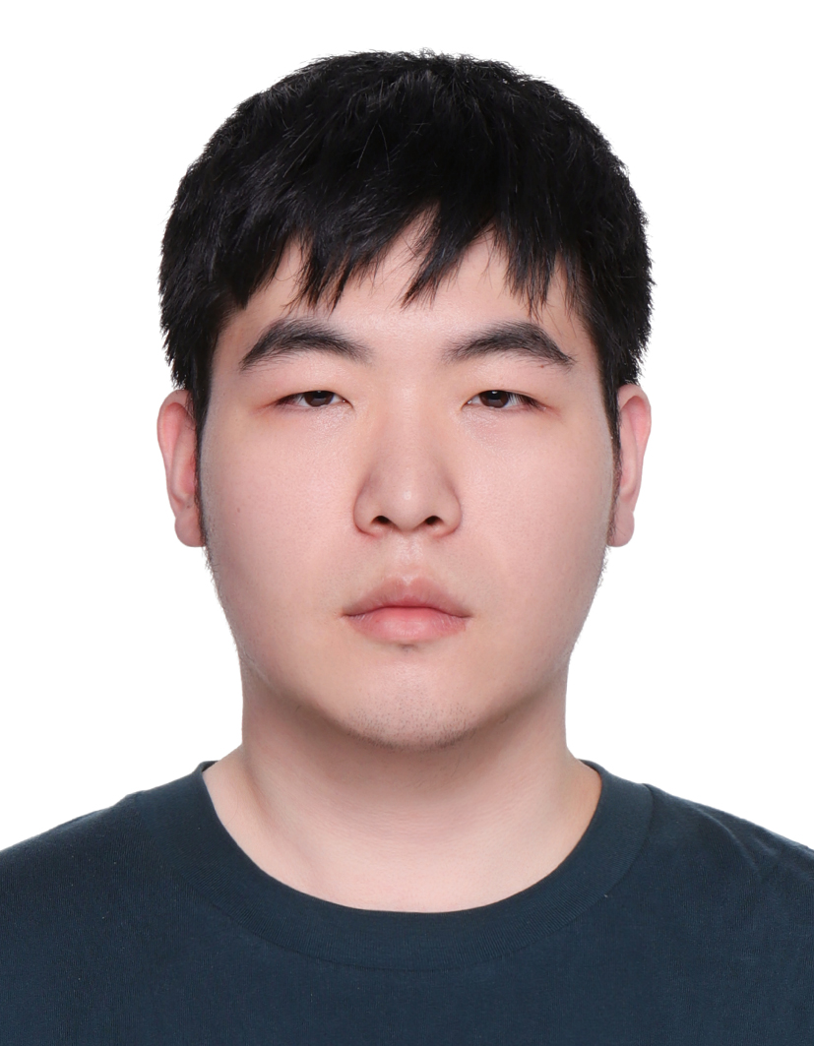
Yuyang Ren
Ph.D. Student in Computer Science
ShanghaiTech University | Shanghai, China
renyy2022@shanghaitech.edu.cn
associatedprimeideal.github.io | Google Scholar | GitHub

Education
ShanghaiTech University 2022 - Present
Ph.D. in Computer Science
Advisor: Prof. Peng Hu
Shanghai University 2018 - 2022
B.S. in Mathematics and Applied Mathematics

Academic Service
Reviewer, Journal of Cardiovascular Magnetic Resonance (JCMR)
Reviewer, PLOS Digital Health
Reviewer, International Conference on Medical Image Computing and Computer Assisted Intervention (MICCAI)

Honors and Awards
2026 Magna Cum Laude Award, ISMRM & ISMRT Annual Meeting. Oral presentation: PUDIP-Flow: An Unsupervised and Segmentation-Free Phase Unwrapping Method for Aortic and Cerebrovascular 4D Flow MRI.
2026 Magna Cum Laude Award, ISMRM & ISMRT Annual Meeting. Oral presentation: A Fully Automated Pipeline for Multi-Region 4D Flow MRI Analysis.
2025 Magna Cum Laude Award, ISMRM & ISMRT Annual Meeting. Digital poster: Comparison of reconstruction methods of highly accelerated 3D dynamic cardiovascular MRI using the 4D XCAT phantom.
2022 Third Place, Middle School Information Layout File Classification Challenge.
2021 Mathematical Contest in Modeling: Honorable Mention.
2019 Shanghai University First-Class Academic Scholarship.
2019 Higher Education Press Cup China Undergraduate Mathematical Contest in Modeling, National Second Prize.

Journal Articles
1. Yuyang Ren, Wen Ye, Wenchao Yang, Wenjian Liu, Haotian Hong, Junpu Hu, Jiayu Zhu, Haikun Qi, Fei Shan, Peng Hu, and Zijian Zhou. Fully self-gated dual-venc five-dimensional flow magnetic resonance imaging for simultaneous imaging of the cardiovascular and portal venous systems: A feasibility study. Journal of Cardiovascular Magnetic Resonance, 28(2), 102750, 2026. doi:10.1016/j.jocmr.2026.102750

Conference Papers
1. Yuyang Ren, Zijian Zhou, and Peng Hu. Unsupervised and Segmentation-Free Phase Unwrapping for 4D Flow MRI Using Deep Image Prior. Medical Image Computing and Computer Assisted Intervention (MICCAI) 2026. Accepted.
2. Yuyang Ren, Wenjian Liu, Zijian Zhou, Haikun Qi, and Peng Hu. Accelerated 4D Flow MRI Using Deep Low-Rank Plus Sparse Neural Network and Complex Difference. IEEE International Symposium on Biomedical Imaging (ISBI) 2024.

Conference Abstracts
1. Yuyang Ren, Zijian Zhou, Yuan Feng, Yining Wang, and Peng Hu. PUDIP-Flow: An Unsupervised and Segmentation-Free Phase Unwrapping Method for Aortic and Cerebrovascular 4D Flow MRI. ISMRM & ISMRT 2026. Oral Presentation (Magna Cum Laude Award).
2. Yuyang Ren, Ruiyu Cao, Zijian Zhou, Chengyan Wang, Hao Li, and Peng Hu. A Fully Automated Pipeline for Multi-Region 4D Flow MRI Analysis. ISMRM & ISMRT 2026. Oral Presentation (Magna Cum Laude Award).
3. Xin Bai, Haotian Hong, Yuyang Ren, Wenlei Shang, Zijian Zhou, and Peng Hu. Spectral optimization of rosette k-space trajectories for improved fat suppression. ISMRM & ISMRT 2026. Digital Poster.
4. Yuyang Ren, Ruiyu Cao, Zijian Zhou, Chengyan Wang, Hao Li, and Peng Hu. Automated Segmentation of Multi-Region 4D Flow MRI Using Deep Learning. ISMRM & ISMRT 2026. Digital Poster.
5. Yuyang Ren, Haotian Hong, Zijian Zhou, and Peng Hu. Unsupervised phase unwrapping for aortic 4D flow MRI using deep image prior. ISMRM & ISMRT 2025. Digital Poster.
6. Yuyang Ren, Wen Ye, Wenchao Yang, Wenjian Liu, Haotian Hong, Junpu Hu, Jiayu Zhu, Zijian Zhou, Haikun Qi, Fei Shan, and Peng Hu. Fully self-gated dual-venc 5D flow MRI for simultaneous imaging of the cardiovascular and portal venous systems. ISMRM & ISMRT 2025. Digital Poster.
7. Jiameng Diao, Yuyang Ren, Wenjian Liu, Peng Liu, Han Wang, Jiayu Zhu, Jian Xu, Zijian Zhou, Haikun Qi, and Peng Hu. Frequency Modulated Continuous Wave Radar-based prospective respiratory motion correction: Initial application for 2D cardiac cine MRI. ISMRM & ISMRT 2025. Power Pitch.
8. Yuyang Ren, Zijian Zhou, and Peng Hu. Comparison of reconstruction methods of highly accelerated 3D dynamic cardiovascular MRI using the 4D XCAT phantom. ISMRM & ISMRT 2025. Digital Poster (Magna Cum Laude Award).
9. Haotian Hong, Yuyang Ren, Wenjian Liu, Zijian Zhou, and Peng Hu. Bullet: An Acceleration Method for Cartesian Partial Echo Acquisition. ISMRM & ISMRT 2025. Digital Poster.
10. Haotian Hong, Wenjian Liu, Yuyang Ren, Wenlei Shang, Wenchao Yang, Tianhao Jiang, Zhuocheng Xie, Jiayu Zhu, Haikun Qi, and Peng Hu. MRI Acceleration with Frequency Encoding Subsampling using Double Lobe Gradient (DOGE) Readout Waveform. ISMRM & ISMRT 2024. Digital Poster.

