VGamepad

By PJSoftCo

Instructions and guide

Please follow these steps to use VGamepad on your PC.

# After you installed the App on your Phone

Choose the server-side software and install it. VGamepad-Srever and PCGameConsole are the two software that can connect and operate with VGamepad.

Note: Please add the software to your security suite exception list in order to prevent blockage and interference.

# VGamepad-Server

1. After installation, double click on the shortcut and run the program.

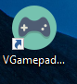

1. Enter the shown IP that is highlighted on your phone.

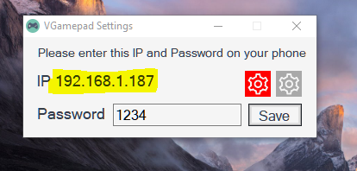

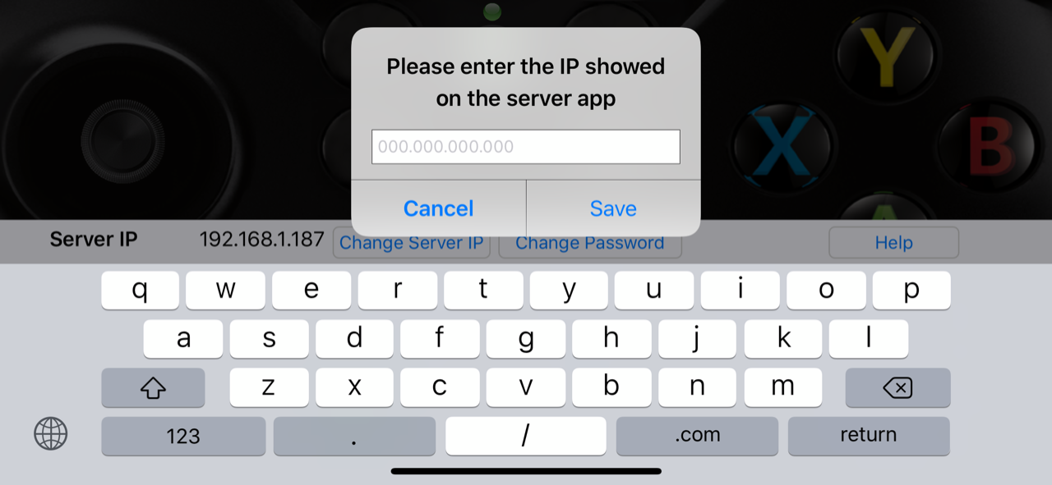

1. Choose a password to secure your connection and hit Save button and then, enter the same password on your phone as well.

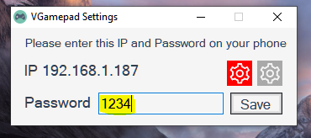

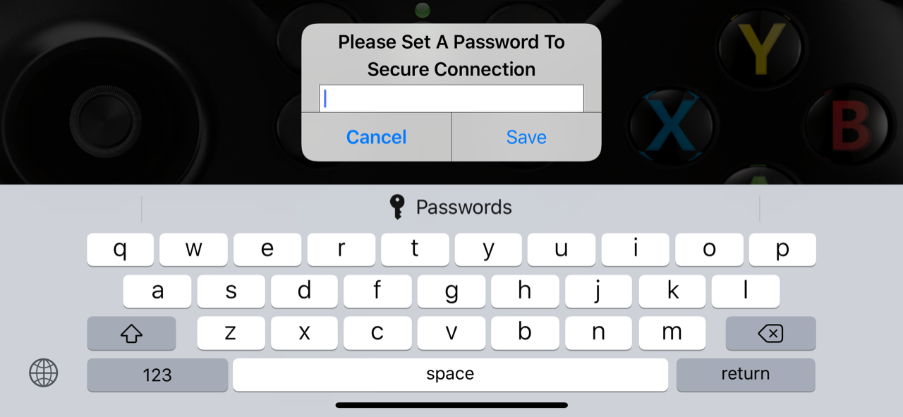

Congratulations, you are done. Green LED is the successful connection indicator. Red means you have connection connectivity issue*.

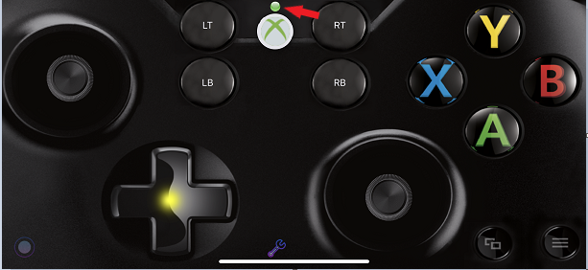

*Note: Please make sure your firewall is not blocking the connection.

**Also please make sure both PC and phone are connected to the same Wi-Fi network or on the same connection if your PC is connected through LAN.**

# PCGameConsole

1. After installation, double click on the shortcut and run the program.

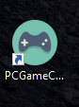

1. After the Game Scan Process finished, go to the Settings menu (gear sign) and enter the shown IP that is highlighted on your phone.



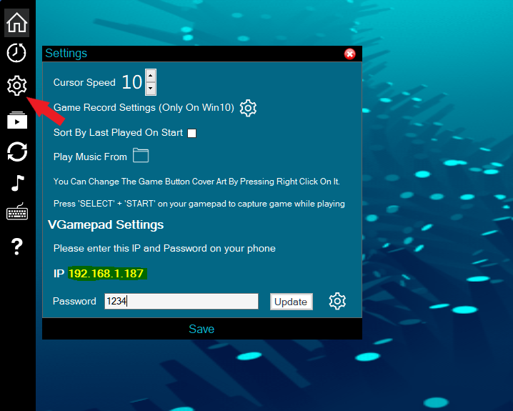



1. Choose a password to secure your connection and hit Update button and then, enter the same password on your phone as well.

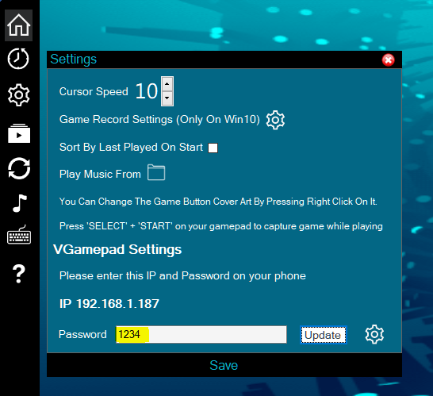



Congratulations, you are done. Green LED is the successful connection indicator. Red means you have connection connectivity issue*.



*Note: Please make sure your firewall is not blocking the connection.

**Also please make sure both PC and phone are connected to the same Wi-Fi network or on the same connection if your PC is connected through LAN.**

If you have any problem or question, please contact [pjsoftco@outlook.com](mailto:pjsoftco@outlook.com) for help.