ABC & XYZ Restaurant Chains
Part One: Transforming Data and Identifying Trends

Prepared by: Assumpta Nwadinigwe
Date: 2026
Course: QSO 560

1. Introduction and Scenario
This report presents a comprehensive descriptive analysis of the newly merged restaurant entity formed by the acquisition of XYZ restaurant chain by ABC restaurant chain. As the first analyst to examine the combined data of this newly formed business, the goal of this report is to provide the joint leadership team with the insights needed to craft a profitable three-year plan. Both restaurant chains operate fast-casual restaurants across multiple U.S. locations, serving direct-to-consumer markets. While they share operational similarities, they offer distinct products catering to different customer bases.
The combined dataset encompasses 40,000 order line items spanning January 2018 through June 2019, covering 544 unique restaurant locations across 48-49 U.S. states, with a combined total revenue of approximately $148.9 million and total profit of $148.1 million.

2. Data Errors and Gaps Identified

2.1 Shared Attributes Between Datasets
Both the ABC and XYZ datasets share the following key attributes: customer_id, order_number, item_number, item_description, item_code, item_category, quantity, menu_price, item_total_cost, Profit, order_total_cost, coupon_y_n, order_purchase_date, order_purchase_time, restaurant_id, restaurant_city, restaurant_state, restaurant_zip_code, order_purchase_method, order_alcohol_purchased, gender_customer_payee, and customer_with_children. The XYZ dataset contained one additional column, item_product_cost, which was absent in ABC.

2.2 Missing and Incomplete Data
Two significant data quality issues were identified across the datasets:
ABC Dataset Corrupted Dates: A total of 1,952 rows (9.76% of ABC data) contained corrupted order purchase date values stored as Unix epoch timestamps, defaulting to January 1, 1970. This is a known issue caused by incorrect Excel serial number storage in point-of-sale (POS) systems. These dates are unrecoverable and were flagged as missing (NaT). This impacts the integrity of any time-series analysis involving these records, as they cannot be attributed to a specific month, season, or year.
XYZ Dataset Entirely Null Column: The item_product_cost column in the XYZ dataset contained 20,000 null values — representing 100% of XYZ records. This column was completely absent of data and was therefore dropped from the analysis. This gap limits the ability to calculate true cost margins for XYZ items.

2.3 Inconsistent Category Naming
Item category names were inconsistently formatted between the two datasets. For example, ABC used 'salad' (lowercase, singular) while XYZ used 'Salads' (title case, plural). Similarly, ABC used 'Sandwich' and 'Beverages' while XYZ used 'Sandwiches' and 'Beverage'. These inconsistencies were standardised during the data transformation process to ensure accurate cross-chain comparisons.

2.4 Strategies Used to Identify Errors
The following strategies were employed to identify data errors and gaps: (1) Shape and dtype inspection, examining row counts, column counts, and data types for each dataset; (2) Null value analysis counting missing values per column across both datasets; (3) Unique value inspection reviewing distinct values in categorical columns to identify inconsistencies; (4) Date range validation checking minimum and maximum dates to identify anomalous values; and (5) Cross-dataset column comparison aligning column names and types between ABC and XYZ to identify structural differences.

3. Data Cleaning and Transformation
The following transformations were applied to prepare the data for analysis:
Date Correction: The 1,952 corrupted date values in the ABC dataset were converted to null values (NaT) to preserve data integrity. These records remain in the dataset for non-time-based analyses but are excluded from any temporal trend analysis.
Column Removal: The item_product_cost column was removed from the XYZ dataset due to 100% null values, as it provides no analytical value.
Category Standardisation: All item_category values were standardised to a unified naming convention across both chains, resulting in seven consistent categories: Appetizers, Beverages, Dessert, Pasta, Pizza, Salads, and Sandwiches.
Derived Variables: Several new variables were engineered from existing data to enable richer analysis: (1) time_of_day — classified orders as AM or PM based on order_purchase_time; (2) season — derived from order_purchase_date as Spring, Summer, Fall, or Winter; (3) order_month and order_month_name — extracted from order_purchase_date for monthly trend analysis; and (4) readable binary labels for coupon_used, alcohol_purchased, and has_children.
Data Merging: Both cleaned datasets were combined into a single unified dataset of 40,000 rows with a chain identifier column to distinguish ABC from XYZ records throughout the analysis.

4. Spending Trends Analysis

4.1 Chain Performance Overview
ABC generated total revenue of $75.47M with a profit of $74.99M across 286 restaurant locations. XYZ generated $73.47M in revenue with $73.08M profit across 310 locations. ABC holds a slight edge in average revenue per location, while XYZ operates more locations and recorded more unique orders (937 vs 658).
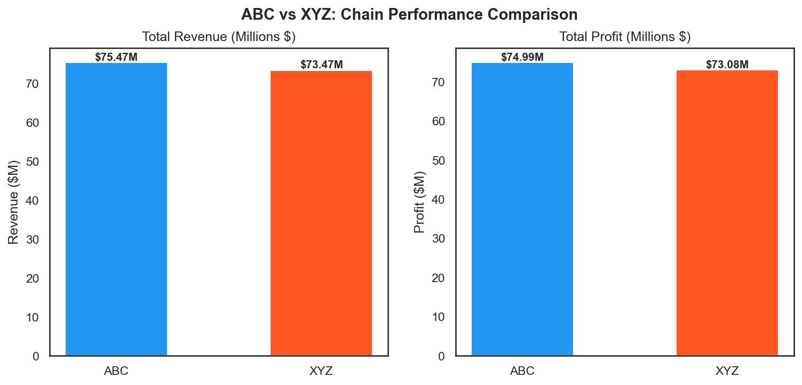
Figure 1: ABC vs XYZ Revenue and Profit Comparison

4.2 Spending by Season
Seasonal analysis reveals that Spring is the strongest revenue period with $96.73M in combined revenue, significantly outperforming all other seasons. Winter ranks second at $22.71M, followed by Summer at $17.7M. Fall is the weakest season with only $3.74M in revenue. The joint leadership team should consider targeted promotions during Fall and Summer months to balance seasonal revenue distribution.
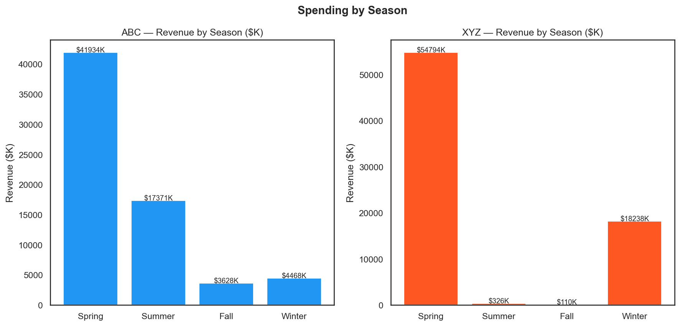
Figure 2: Revenue by Season for ABC and XYZ

4.3 Spending by Gender
Male customers account for $81.62M in total revenue with an average order value of $3,696.78, while female customers contribute $67.31M with an average order of $3,756.04. Female customers show a slightly higher average order value, suggesting they may order higher-priced items or larger quantities per transaction. Marketing strategies should consider targeted campaigns for both demographics.
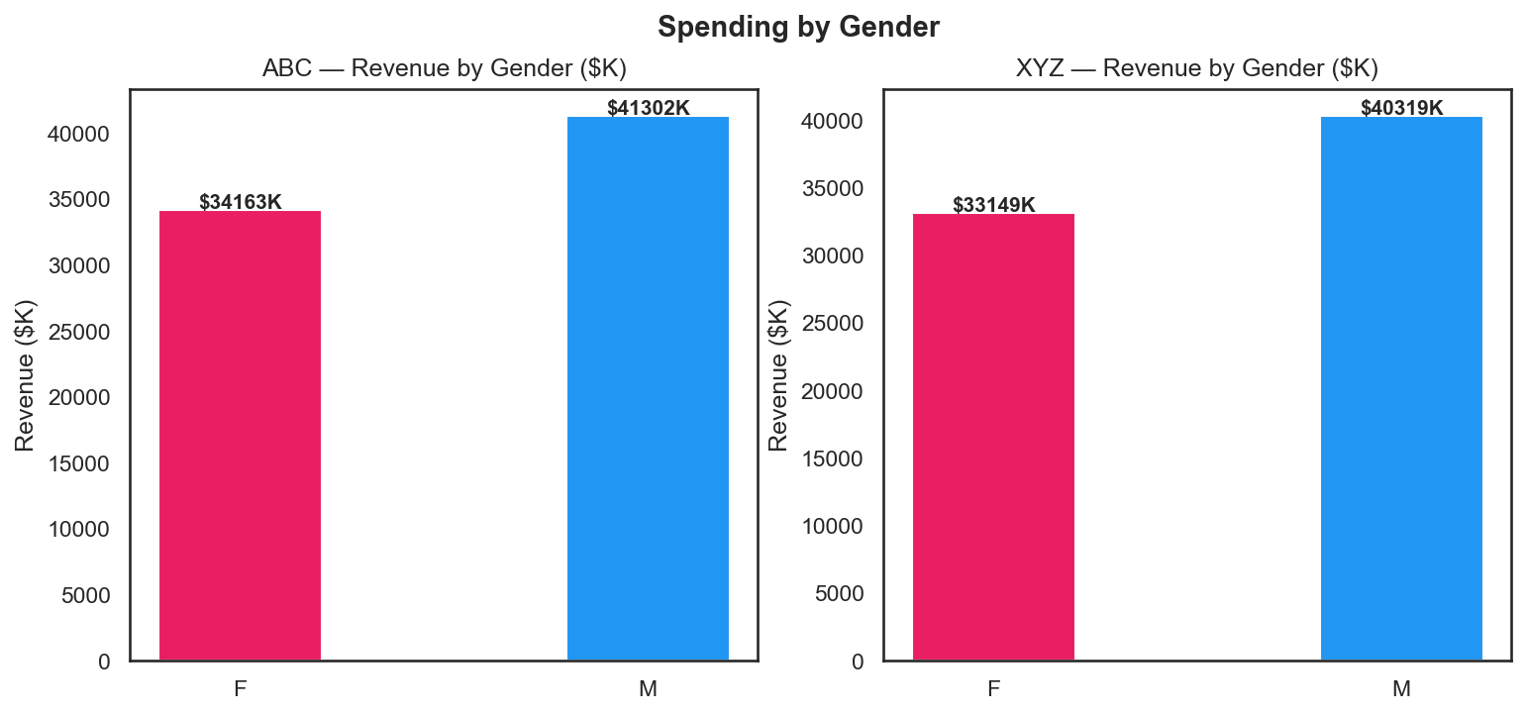
Figure 3: Revenue by Gender

4.4 Spending by Region
Regional analysis identifies Florida as the top-performing state with $32.53M in profit, followed by New York ($23.12M), California ($20.33M), Texas ($12.02M), and New Jersey ($10.45M). These five states represent the core revenue base for the merged entity and should be prioritised for marketing and expansion efforts.
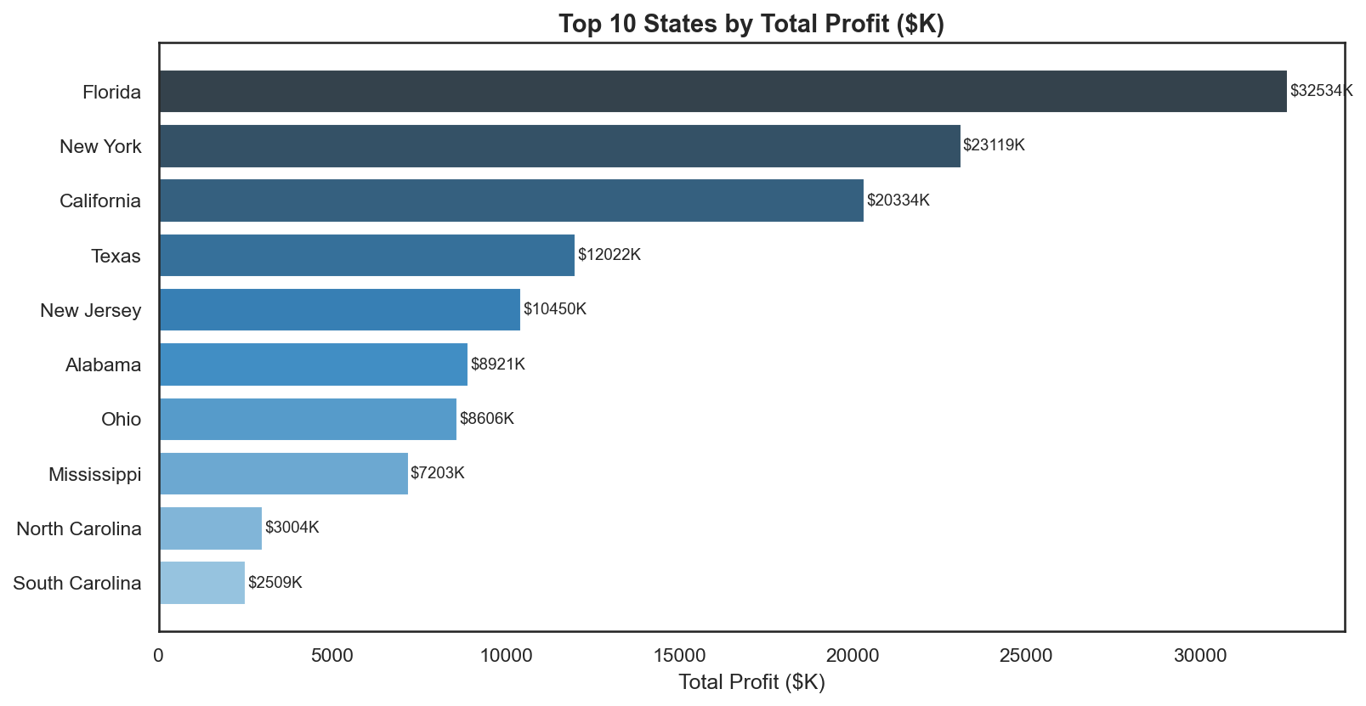
Figure 4: Top 10 States by Total Profit

4.5 Spending by Customers With and Without Children
Analysis of family composition shows notable differences in spending patterns between customers with and without children. Customers with children tend to place larger orders, likely due to ordering for multiple family members. This demographic represents an important segment for family-oriented menu development and promotional strategies.
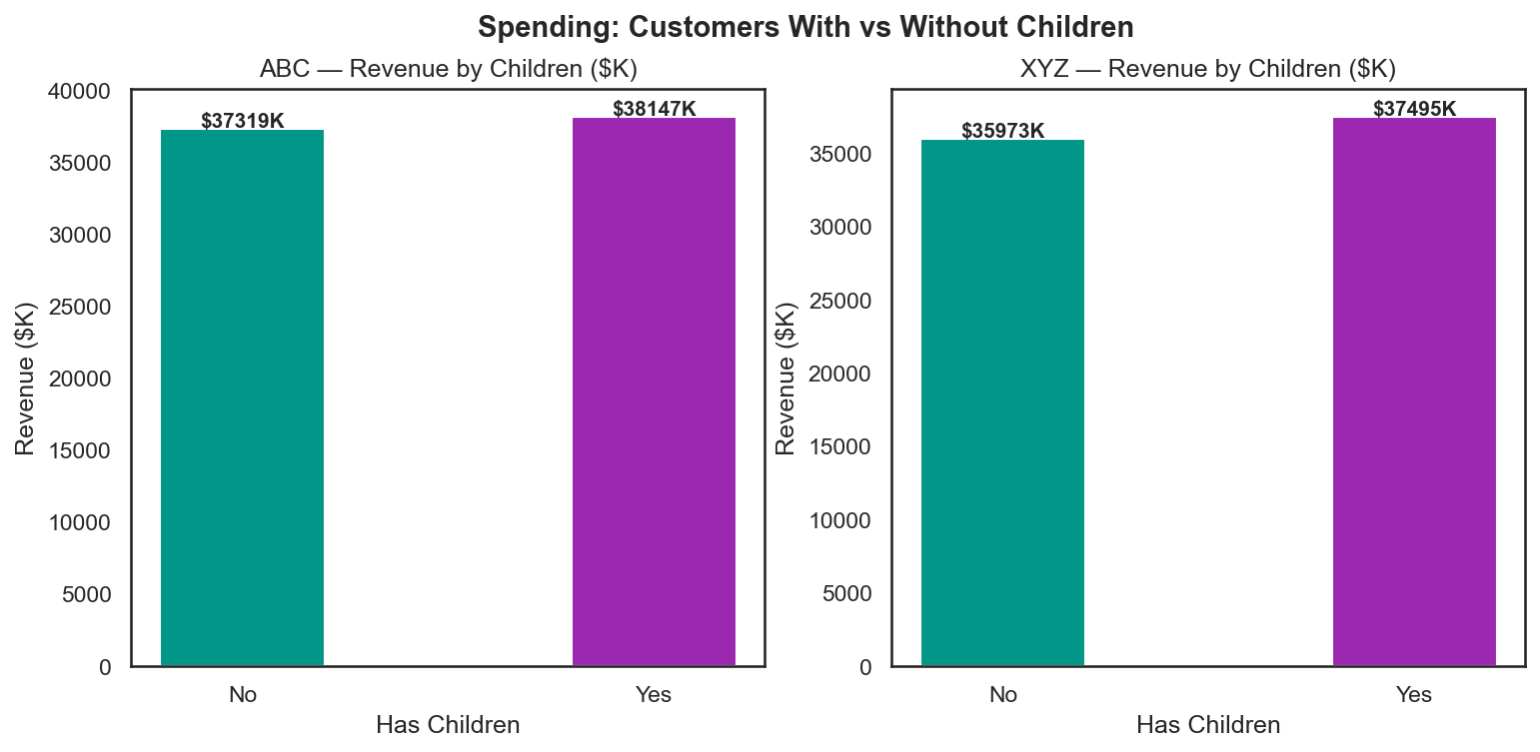
Figure 5: Spending by Family Composition

5. Product Performance Analysis

5.1 Best Selling Products
The top-selling products by units sold are dominated by Pasta items, indicating strong customer preference for this category across both chains. The top five best sellers are:
Item | Category | Units Sold | Profit ($K)
Cincinnati Chili | Pasta | 2878 | 2532.06
Penne Alla Vodka | Pasta | 2837 | 2696.72
Toasted Ravioli | Pasta | 2656 | 2332.01
American Chop Suey | Pasta | 2647 | 2381.86
Baked Ziti | Pasta | 2449 | 2300.44

5.2 Worst Selling Products
The following products recorded the lowest sales volumes and may be candidates for menu review or removal in the merged entity's new menu:
Item | Category | Units Sold | Profit ($K)
Tasty Highlight | Pizza | 824 | 934.36
Chocolate Milk | Beverages | 829 | 914.15
Spaghetti Pie | Pasta | 834 | 877.03
Whole-Wheat Crust | Pizza | 843 | 992.79
Onion Rings | Appetizers | 845 | 889.6

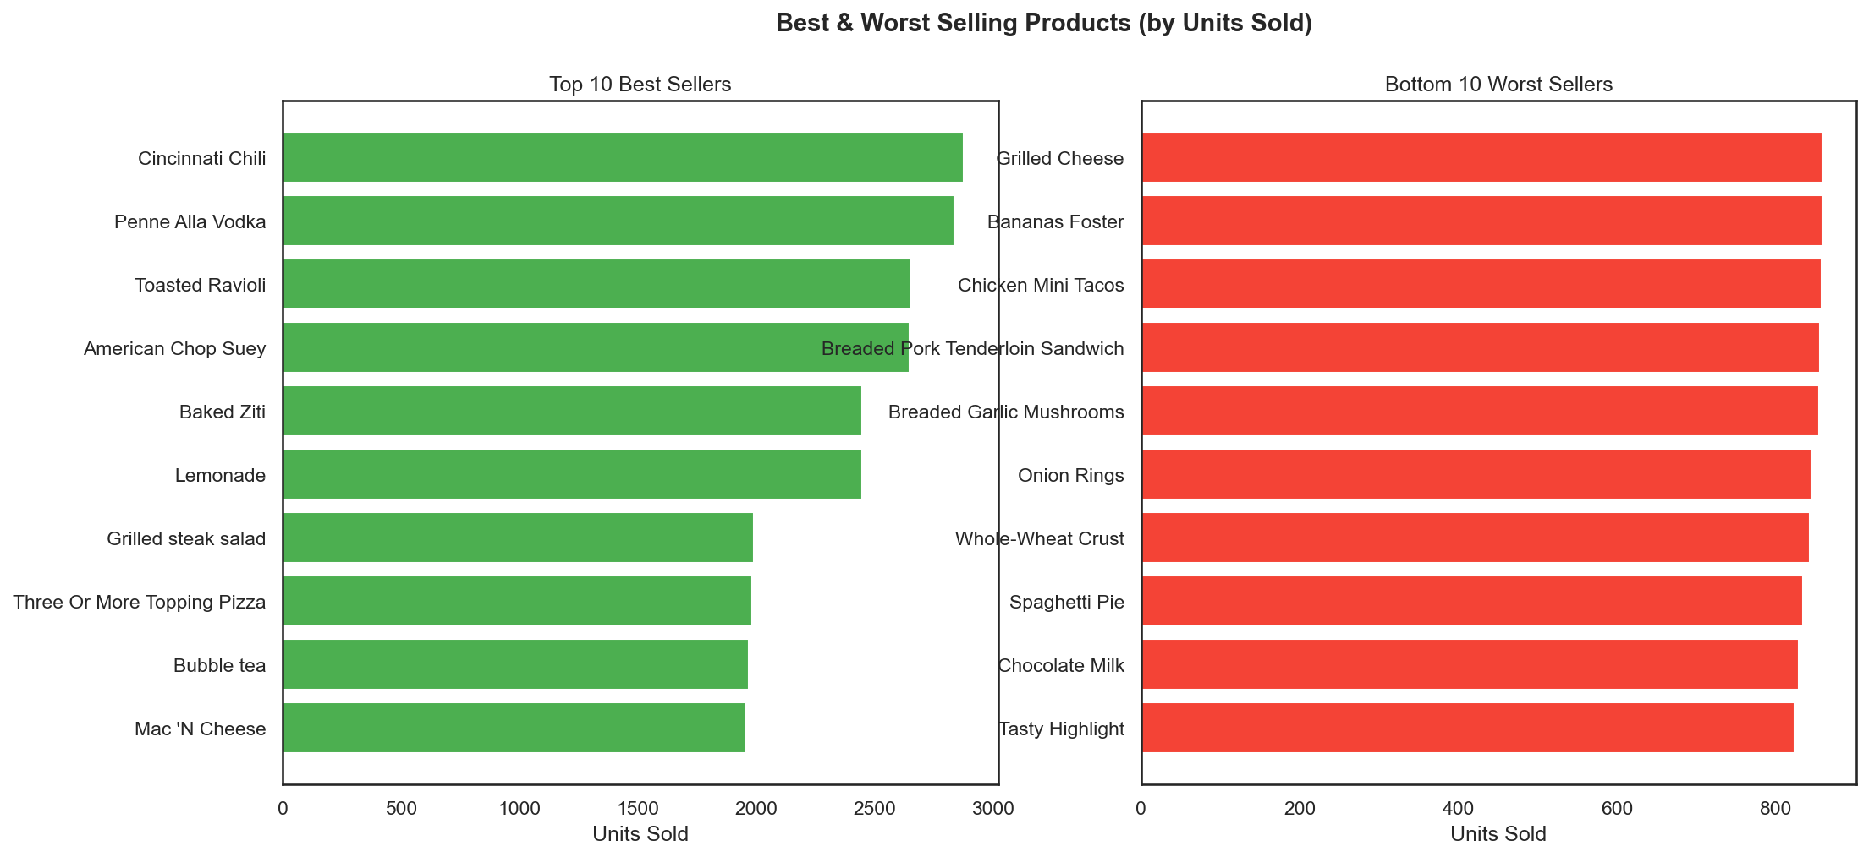
Figure 6: Best and Worst Selling Products

6. Profitability Analysis

6.1 Profitability by Category
Pizza is the most profitable food category with $30.79M in total profit, followed closely by Salads ($29.47M) and Appetizers ($22.35M). Dessert is the least profitable category at $9.24M, though it may serve an important role in increasing average check sizes. The new menu should emphasise Pizza and Salads while evaluating the viability of lower-margin categories.
Category | Total Profit ($M) | Avg Profit Per Order ($)
Pizza | 30.79 | 3712.96
Salads | 29.47 | 3734.65
Appetizers | 22.35 | 3708.26
Sandwiches | 21.72 | 3729.5
Pasta | 18.68 | 3704.63
Beverages | 15.81 | 3664.05
Dessert | 9.24 | 3544.48

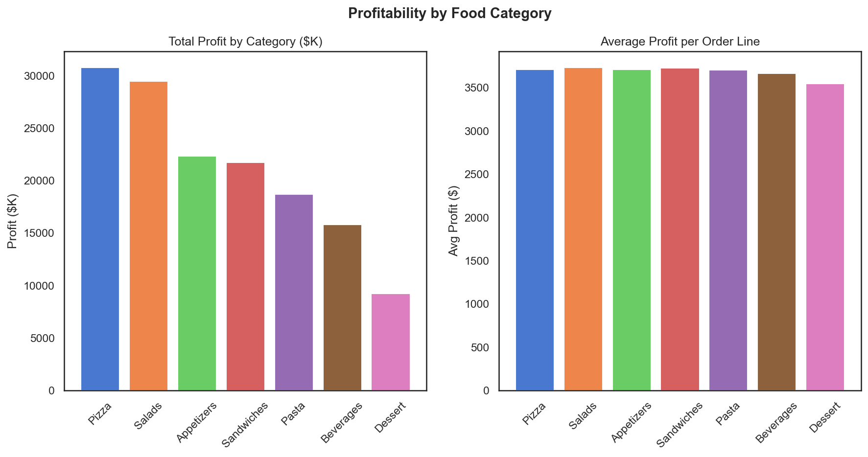
Figure 7: Profitability by Food Category

6.2 Purchase Method Analysis
Carry Out is the most popular purchase method with 13,983 orders and $58.82M in profit. Delivery follows with 13,896 orders, and Dine In accounts for 12,121 orders. This distribution suggests the merged entity should maintain strong carry out and delivery infrastructure while optimising dine in experience.
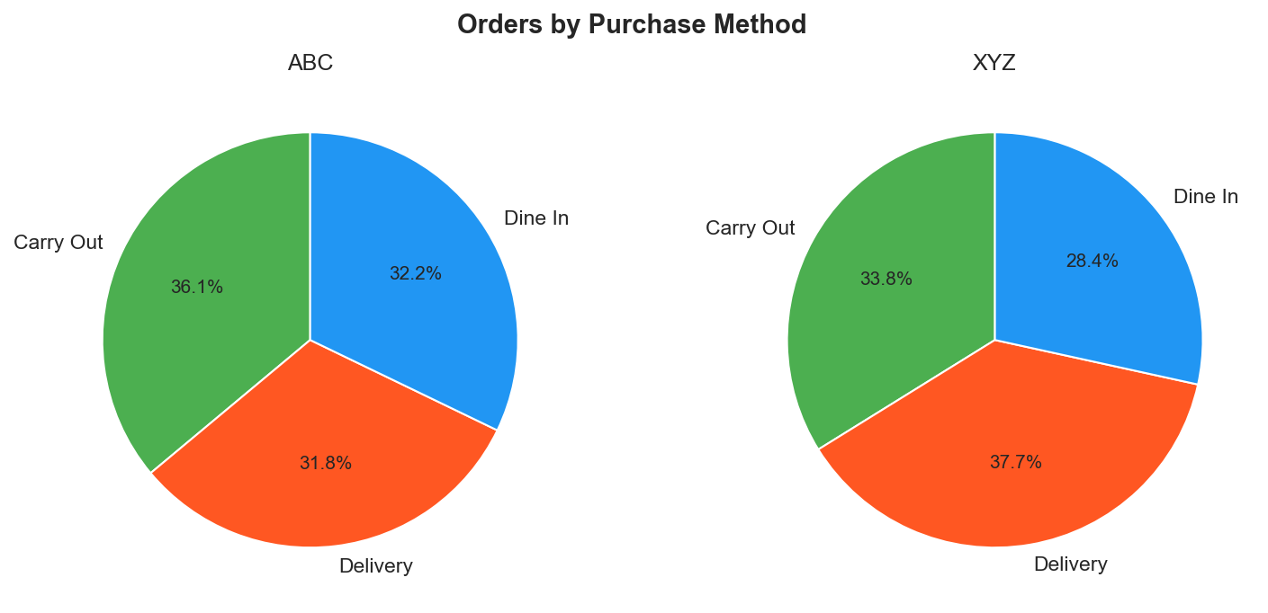
Figure 8: Orders by Purchase Method

6.3 AM vs PM Spending Patterns
Analysis of order timing reveals that PM orders significantly outperform AM orders in both volume and revenue across both chains. This pattern suggests the majority of customers visit during lunch and dinner hours. The joint leadership team may consider targeted breakfast or morning promotions to increase AM revenue and better utilise restaurant capacity during off-peak hours.
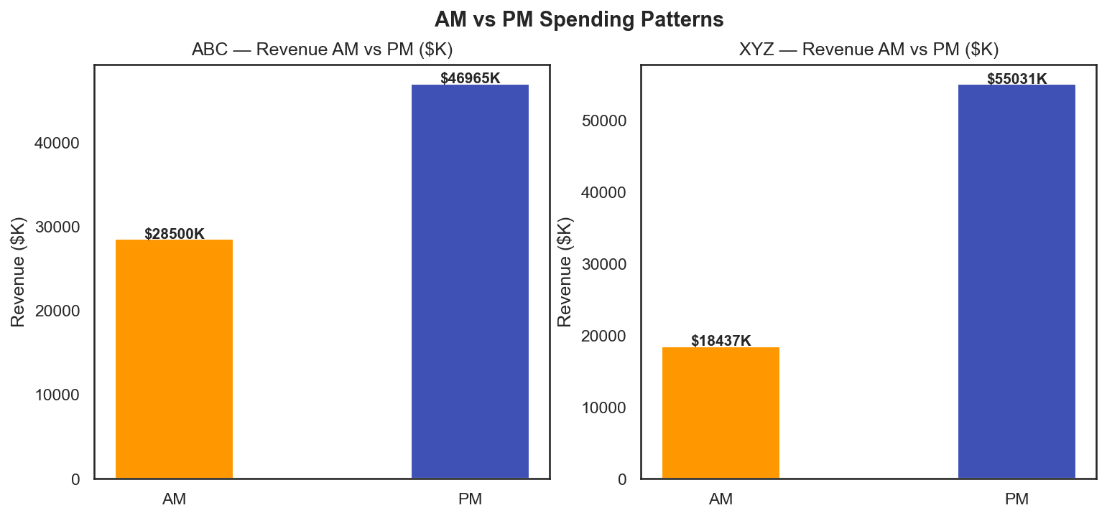
Figure 9: AM vs PM Spending Patterns

7. Summary Statistics
The following summary statistics describe the central tendency, dispersion, and distribution shape of key variables across both chains:
Chain | Rows | Mean Order ($) | Min Order ($) | Max Order ($) | Mean Profit ($) | Max Profit ($)
ABC | 20000 | 3773.26 | 1.0 | 16013.0 | 3749.4 | 16012.0
XYZ | 20000 | 3673.4 | 1.0 | 12733.0 | 3653.86 | 12732.0

Both chains show similar average order values (ABC: $3,773 vs XYZ: $3,673), indicating comparable pricing strategies. The wide range between minimum ($1) and maximum ($16,013 for ABC, $12,733 for XYZ) order values suggests high variance in order sizes, likely driven by group orders or large quantity purchases. The minimum profit of $0 across both chains indicates some orders were fulfilled at cost, possibly due to coupon usage or promotional pricing.
Regarding missing data: 1,952 records (4.88% of the merged dataset) are missing date information due to the ABC POS system corruption issue. This limits time-series analysis for approximately 9.76% of ABC records but does not significantly impact overall findings given the large sample size of 40,000 records.

8. Conclusion
This analysis provides a comprehensive view of the newly merged ABC-XYZ restaurant entity. The combined business generates approximately $148.9M in revenue with strong performance in Pizza, Salads, and Pasta categories. Florida, New York, and California are the top revenue-generating states. Spring is the peak trading season, and PM hours drive the majority of orders across both chains.
Key data quality issues — particularly the corrupted dates in ABC's POS system and the entirely missing cost data in XYZ — highlight the need for IT investment in standardised POS infrastructure across the merged entity, directly addressing the concerns raised by IT and Finance leadership in the stakeholder requirements.
These findings form the basis for the recommendations and three-year strategic plan to be presented in Part Two of this project.

References
ABC Restaurant Chain. (2019). Customer transaction data [Dataset].
XYZ Restaurant Chain. (2018-2019). Customer transaction data [Dataset].

