CS3219 Task D

1. In order to create a 3 node Apache Kafka cluster with a zookeeper node, the following docker-compose.yml should be created in the folder (see github link for content).

Reference used: <https://www.baeldung.com/ops/kafka-docker-setup>

1. In order to start up the nodes, run ` docker-compose -f "docker-compose.yml" up -d `



1. Create a topic called ‘test’ via Kafka Tools via the following instructions

Connect to the Apache Cluster with the following information,

The brokers will be shown in the list,

1. For the creation of a publisher and subscriber, I will be using the `confluent-kafka` python library.  
     
   Ensure confluent-kafka is installed in your python installation.  
     
   Reference used: https://docs.confluent.io/kafka-clients/python/current/overview.html#ak-producer
2. Start up the publisher via `python publisher/publisher.py`

1. Start up the subscriber via `python subscriber/subscriber.py`



1. Typing a message in Producer,

1. Will cause the same message to be printed in Consumer.

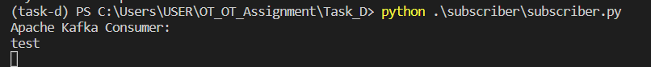

1. To test for failover, we will stop kafka-1 container

Testing for publisher and subscriber communication still working,

