
APPLIED PROGRAMMING
PART TWO

October 3, 2025
ST10393023
ROSEBANK COLLEGE

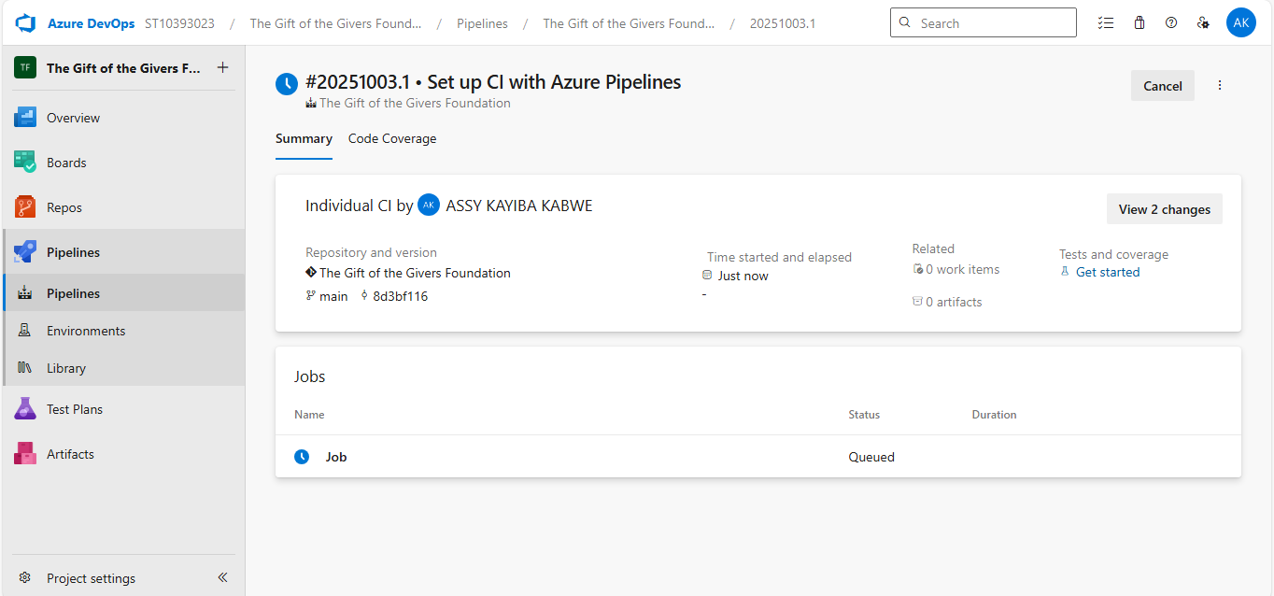
Sir, while setting up the CI pipeline for The Gift of the Givers Foundation in Azure DevOps, I encountered an error: the pipeline run fails immediately, showing 0 <1s and not executing the build steps. It appears that no hosted parallelism has been granted for this account, which prevents the pipeline from running.
I wanted to bring this to your attention and confirm if I should request the free parallelism grant from Microsoft or if there is an alternative approach you recommend.
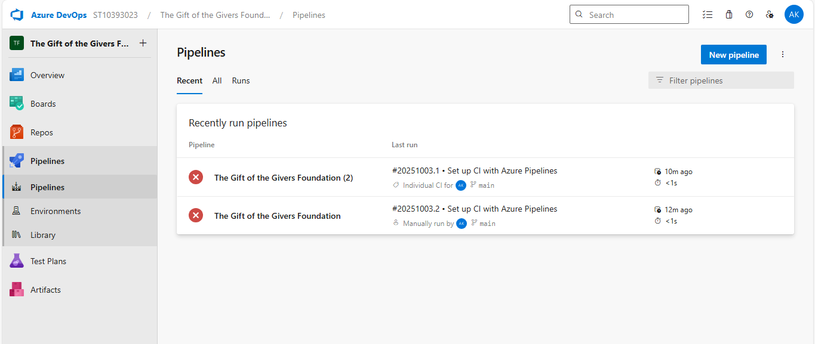
git clone https://dev.azure.com/ST10393023/The%20Gift%20of%20the%20Givers%20Foundation/_git/The%20Gift%20of%20the%20Givers%20Foundation

