
ADVANCED DATABASE
ICE ACTIVITY TWO

March 31, 2025
ROSEBANK COLLEGE
ST10393023

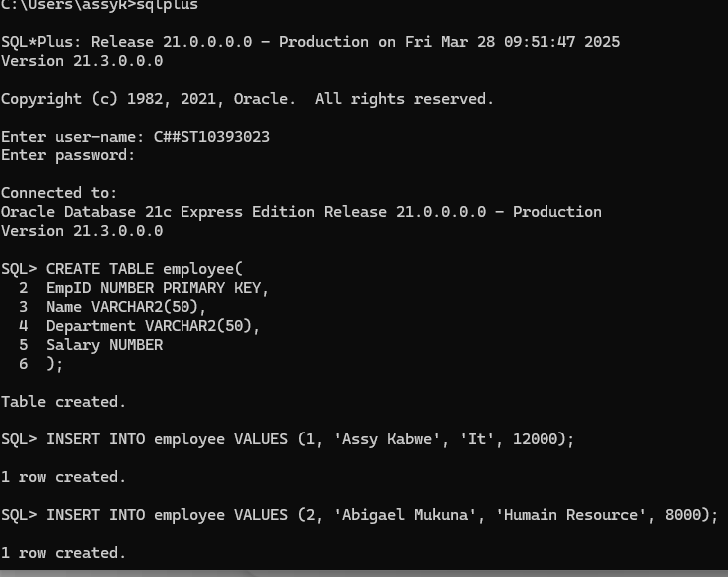
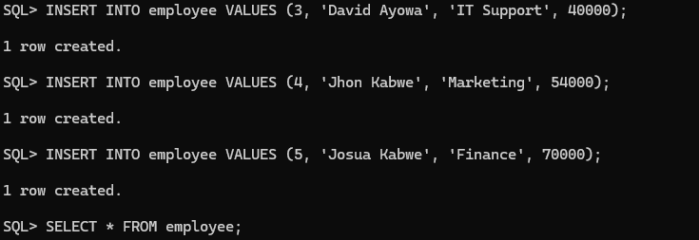
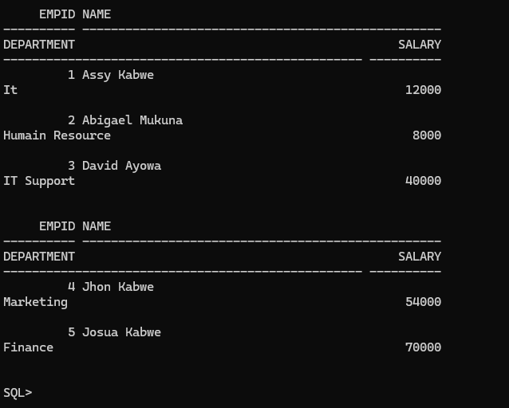
Sql Developer
