FINAL PROJECT REPORT
Machine Learning (Advanced Level)
Predicting Formula 1 Podium Finishes with Machine Learning:
A Comparative Study of Classification Models

Student: Nurbayeva Assylzada
Project type: individual project
Nine machine learning models implemented, compared and statistically evaluated

Astana, 2026

Abstract
Predicting which drivers will finish on the podium of a Formula 1 Grand Prix is a binary classification problem with strong class imbalance (about 14% positive cases) and one dominant predictor, the starting grid position. This project builds a leakage-free machine learning pipeline on 8,970 driver–race records from 428 Grands Prix (2003–2024) and compares nine models from seven algorithm families, plus a tuned version of the best one, against a transparent baseline that predicts a podium for the three drivers who start in front. All features use only information that is available before the race. The data are split chronologically (342 training races, 86 test races) and validated with 5-fold cross-validation grouped by race.
Logistic Regression achieved the best cross-validated PR-AUC (0.6995). After grid-search tuning it reached ROC-AUC 0.9361, PR-AUC 0.7140, F1 0.6840 and a race-level Top-3 hit rate of 66.7% on unseen seasons, compared with 65.1% for the baseline. A bootstrap over test races shows that 9 of 10 models improve PR-AUC significantly over the baseline, but no model improves the Top-3 hit rate significantly (all 95% intervals include zero). Grid position carries most of the signal (permutation importance 0.461 versus 0.047 for the next feature). The work is delivered as a Flask web application that reproduces every experiment. We conclude that simple, well-regularised models are sufficient for this task, that additional model complexity gives no measurable benefit on about 7,000 training rows, and that further improvement requires richer race-day information such as weather, tyre strategy and incidents.
Keywords: Formula 1, podium prediction, binary classification, class imbalance, Logistic Regression, Random Forest, Gradient Boosting, cross-validation, bootstrap.

Contents
Abstract
1. Introduction
2. Literature Review
3. Materials and Methods
4. Results and Discussion
5. Conclusion
6. References
Appendix A. Web application and source code

1. Introduction

1.1 Background and relevance
Formula 1 is the highest class of single-seater racing. In every Grand Prix about twenty drivers start from a grid that is set by qualifying, and only the first three finishers stand on the podium. The podium is the most visible result of a race weekend: it determines prize money, sponsor value and the narrative of a championship. At the same time, every race produces a large volume of structured data (grid, qualifying, results, standings), which makes Formula 1 a natural field for supervised machine learning.
Predicting the podium before the lights go out has practical value for broadcasters, analysts, fantasy-sports players and teams. It is also a scientifically interesting problem, because it combines a very strong deterministic component (fast cars qualify at the front and usually finish there) with a large random component (first-lap incidents, reliability failures, safety cars, strategy). A useful model must therefore be judged not only by its absolute accuracy, but by how much it improves over the obvious rule “the three drivers who start in front will finish in front”.

1.2 Purpose and objectives
Purpose. To develop, evaluate and compare machine learning models that estimate the probability that a driver finishes on the podium using only pre-race information, and to determine honestly how much they improve over a simple grid-position baseline.
Objectives.
- Build a clean, leakage-free dataset of driver–race records (2003–2024) and engineer pre-race features.
- Define a transparent baseline and evaluation metrics suited to imbalanced data and to the race-level task.
- Train and compare machine learning models from several algorithm families (the course requires at least three; nine were implemented).
- Validate the models with grouped cross-validation and a chronological test set, and tune the best model with grid search.
- Test whether the differences between models, and between models and the baseline, are statistically reliable.
- Implement a working web application, analyse limitations and describe practical applications.
Research questions.
- RQ1. How strongly are starting position, driver form, constructor form and circuit history associated with a podium finish?
- RQ2. Can machine learning models estimate podium probability using only information available before the race, and how much better are they than the grid-position baseline?
- RQ3. Which features contribute most, and where do the errors occur?
- RQ4. How well do the models generalise to later seasons that were not used in training?
Note on problem formulation. The earlier stage of the project (Assignment 2) framed the task as regression of the finishing position (positionOrder). During implementation the target was reformulated as a binary podium classification, for three reasons: positionOrder is an ordinal rank whose numeric distances are not meaningful, the podium is the practically relevant outcome, and probabilistic classification allows direct comparison with the grid baseline and with the podium-probability literature. The research questions were adapted accordingly.

1.3 Object and subject of the research
The object of the research is the results of Formula 1 Grands Prix from 2003 to 2024. The subject is the use of supervised classification models to predict, before the race, whether a driver will finish in the top three.

1.4 Research methods
The study uses supervised binary classification. Methods include relational data merging, leakage-free feature engineering with rolling windows, median imputation, winsorisation and standardisation, collinearity-based feature selection, stratified grouped k-fold cross-validation, exhaustive grid search, permutation feature importance and a race-level bootstrap for confidence intervals.

1.5 Theoretical and methodological basis
The work rests on statistical learning theory (bias–variance trade-off and regularisation), probabilistic classification, and ensemble learning with bagging and boosting (Breiman, 2001; Friedman, 2001). Because podium finishers are a small minority, the precision–recall curve is used as the primary ranking criterion instead of accuracy or ROC alone (Saito & Rehmsmeier, 2015). Models are implemented with scikit-learn (Pedregosa et al., 2011), and uncertainty is quantified with the non-parametric bootstrap (Efron & Tibshirani, 1993). Validation follows the principle that a model must be tested on data that lie later in time than its training data.

1.6 Current state of the problem
Recent studies on Formula 1 mostly address pit-stop timing, tyre decisions, lap-level strategy and driver or constructor effects (Section 2). Reported accuracy for race-level outcomes is modest: for example R² = 0.39 for finishing position (Fatima & Johrendt, 2023) and macro-F1 of 0.43–0.45 for pre-race podium classes (Sargur Yathishkumar, 2025). Studies agree that grid position, recent form and the constructor are the most informative pre-race signals (van Kesteren & Bergkamp, 2023; Sargur Yathishkumar, 2025). Few studies predict podium probability directly, control for data leakage, compare a wide set of models under one protocol, include the grid-position rule as a baseline, or test differences with confidence intervals. This project is designed to fill those gaps.

2. Literature Review

2.1 Search strategy
Sources were searched in ScienceDirect, Springer, IEEE Xplore, Frontiers, De Gruyter and university repositories (NORMA, Aalto, NOVA) using the keywords “Formula 1”, “podium prediction”, “race result prediction”, “machine learning” and “pit-stop strategy”. Twelve sources published between 2022 and 2025 were analysed (Table 1): six peer-reviewed publications (journals, a book chapter and conference proceedings) and six university theses. Numeric results are given only where the abstract or full text reports them; otherwise the table says so explicitly, because the studies measure different targets and their scores must not be compared as if they were interchangeable.

Table 1. Analysis of 12 recent studies: data, models, results and best model
№ | Study | Task and data | Models / methods | Key results | Best model / main finding | Relevance and limitations
1 | O’Hanlon (2022)  Master thesis, National College of Ireland | Forecasting the final rankings of the 2021 championship.  Data: 2021 season. | Supervised machine learning for championship ranking prediction. | The repository abstract does not give a directly comparable numeric score. | Not stated in the abstract. | Precedent for ranking forecasts; one season only, thesis rather than journal paper.
2 | Patil et al. (2023)  Springer, CCIS 1662, 134–146 | Factors behind race outcomes.  Data: collected Formula 1 race data, 21 race-related features. | Exploratory analysis, feature relationships, principal component analysis (PCA). | 21 features reduced to 4 orthogonal components that explain about 70% of the variance. | No model comparison; descriptive study. | Supports feature engineering and collinearity control (Section 3.2); no finishing-position prediction score.
3 | Fatima & Johrendt (2023)  Int. J. Machine Learning and Computing, 13(3), 97–103 | Finishing position and optimal pit window.  Data: about 169,000 laps, 2015–2022 (Ergast API). | Two embedded deep neural networks (EDNN); features with pairwise correlation above 85% removed. | Position model: RMSE = 2.05, R² = 0.39. Pit-window model: precision 0.56, recall 0.83, F1 0.67. | Single architecture (EDNN); no comparison with other models. | Shows that explained variance of race position stays low even with deep models.
4 | García Tejada (2023)  Master thesis, Aalto University | Pit-stop timing and quality.  Data: lap telemetry and race information, 2019–2022. | Random Forest, Support Vector Machine, Artificial Neural Network. | F1 = 0.437 for “good pit stop” and 0.621 for “has pit stop” (best model). Wet races and atypical retirements were excluded. | Support Vector Machine. | Classical models can beat neural networks on small tabular data. In-race target, not a pre-race model.
5 | Surendran (2023)  Master thesis, National College of Ireland | Predicting driver and team ranks and the most influential factors.  Data: track, driver, team, grid, laps, fastest lap, year. | LSTM and GRU time-series models. | No directly comparable score in the repository abstract. | Not stated in the abstract. | Relevant target, but variables such as laps and fastest lap are only known after the start (leakage risk for a pre-race model).
6 | van Kesteren & Bergkamp (2023)  J. Quantitative Analysis in Sports, 19(4) | Separating driver skill from constructor advantage.  Data: hybrid era, 2014–2021. | Bayesian multilevel rank-ordered logit regression. | About 88% of the variance in race results is attributed to the constructor in the analysed setting. | Bayesian multilevel model; no machine learning comparison. | Motivates separate driver and constructor form features. Explains latent skill rather than giving a deployable pre-race predictor.
7 | Aguad & Thraves (2024)  European J. Operational Research, 319(3), 908–919 | Pit-stop strategy of two competing drivers. | Dynamic programming and Stackelberg game theory. | Neglecting the competitor can reduce winning odds by about 15% in the modelled setting. | Optimisation model, not a supervised learner. | Shows strategic interaction; different from predicting the finishing order.
8 | Hettmann (2024)  Master thesis, NOVA University Lisbon | Pit-stop timing.  Data: historical F1 data and driver behaviour profiles. | Driver clustering and binary classification of pit-stop timing. | Driver categories and a binary prediction framework; no comparable metric in the abstract. | Not stated in the abstract. | Shows the value of driver profiling; target is pit-stop timing.
9 | Leischner (2024)  Master thesis, NOVA University Lisbon | Tyre-compound decisions.  Data: FastF1 driver performance, tactical and behavioural indicators. | Clustering and machine learning for compound choice. | Predictive modelling of compound decisions and personalised strategy profiles; no finishing-position metric. | Not stated in the abstract. | Useful for future extension with tyre data, which the CSV files used here do not contain.
10 | Sasikumar, Leema & Balakrishnan (2025)  Frontiers in Artificial Intelligence, 8, 1673148 | Pit-stop lap prediction (binary, about 3% positives).  Data: FastF1 telemetry 2020–2024, about 99,900 laps; SMOTE. | Bi-LSTM, TCN-GRU, GRU, InceptionTime, CNN-BiLSTM. | F1: Bi-LSTM 0.81, TCN-GRU 0.77, GRU 0.74, InceptionTime 0.71, CNN-BiLSTM 0.67; Bi-LSTM ROC-AUC 0.988, AUC-PR 0.879; McNemar tests and bootstrap CIs. | Bi-LSTM, significantly better than the other four architectures. | Same methodological ideas as this project (imbalance, PR-AUC, bootstrap, significance tests); different task and data.
11 | Mistry & Smith (2025)  IEEE ITSC proceedings | Simulation of strategic decision-making.  Data: historical races from the FastF1 library. | Recurrent neural networks (RNN) for simulation and decision support. | Simulated behaviour is evaluated against historical races with alternative-strategy case studies; no single comparable score. | Not stated in the available summary. | Shows the potential of sequence models; needs more detailed session data than the CSV files used here.
12 | Sargur Yathishkumar (2025)  Master thesis, National College of Ireland | Podium probability (P1, P2, P3, non-podium), pre-race versus within-race features.  Data: multi-season F1 tables with weather; train ≤2019, validation 2020–2022, test ≥2023. | Random Forest and LightGBM; class weights; isotonic calibration; SHAP. | Pre-race LightGBM: macro-F1 0.445 (validation) / 0.432 (test), log-loss 0.549 / 0.536, Brier 0.068 / 0.067. Within-race LightGBM: log-loss 0.475 / 0.485, accuracy 0.837 / 0.831. Calibration: test log-loss 0.5361 → 0.5105, Brier 0.0675 → 0.0507, ECE 0.0975 → 0.0243. | LightGBM, selected for better calibrated probabilities; Random Forest has slightly higher within-race test macro-F1 (0.465 vs 0.438). | Closest study: same target type and chronological validation. Grid position and recent form dominate (SHAP). Only two models, no grid baseline, no confidence intervals.

2.2 Synthesis: which models were used and which worked best
The twelve studies fall into three groups. (a) Outcome and ranking prediction (O’Hanlon, 2022; Surendran, 2023; Fatima & Johrendt, 2023; Sargur Yathishkumar, 2025) uses tree ensembles, LSTM/GRU networks and an embedded deep network. Reported scores are modest: R² = 0.39 for finishing position (Fatima & Johrendt, 2023) and macro-F1 of 0.43–0.45 for pre-race four-class podium prediction (Sargur Yathishkumar, 2025). (b) Statistical studies (Patil et al., 2023; van Kesteren & Bergkamp, 2023) do not compare predictive models, but show that few latent dimensions explain most of the variation and that the constructor accounts for most of the explained variance in results. (c) Strategy studies (García Tejada, 2023; Hettmann, 2024; Leischner, 2024; Sasikumar et al., 2025; Mistry & Smith, 2025; Aguad & Thraves, 2024) address pit stops, tyres and simulation with telemetry.
Where a winner is reported, the picture depends on data size: Bi-LSTM wins on about 100,000 laps of telemetry (Sasikumar et al., 2025), SVM wins on a small tabular set (García Tejada, 2023), and LightGBM beats Random Forest in probability quality for podium prediction (Sargur Yathishkumar, 2025). Several studies emphasise that grid position and recent form are the strongest pre-race signals. None of the studies uses a plain linear model as a serious competitor or compares its model with the trivial rule “the first three on the grid finish on the podium”.

2.3 Knowledge gaps and positioning of this project
- Target. Most work addresses pit-stop, tyre or lap-level strategy. Pre-race podium probability with time-aware validation is rare; the closest study is Sargur Yathishkumar (2025).
- Baseline. No reviewed study compares its model with the grid-position rule, so the real added value of machine learning is unclear.
- Model comparison. Podium studies compare only two models; linear, kernel, neural and stacking models are not examined under one protocol.
- Statistics. Only Sasikumar et al. (2025) report confidence intervals and significance tests for model differences.
- Leakage. Some target definitions use variables known only after the start (laps, fastest lap), which a pre-race model must exclude.
This project addresses these gaps: it predicts pre-race podium probability with a strict one-race feature shift, compares nine models from seven families under the same chronological and race-grouped protocol, includes the grid baseline, and tests differences with a race-level bootstrap. Weather, probability calibration and SHAP explanations, which Sargur Yathishkumar (2025) use, are left to future work.

3. Materials and Methods

3.1 Materials: data description
The data come from the publicly available relational Formula 1 World Championship dataset (derived from the Ergast database and distributed on Kaggle; Rao, n.d.). Five CSV files were used (Table 2). After merging and filtering to the modern era (seasons from 2003, when the qualifying and points systems are comparable), the working dataset contains 8,970 driver–race records from 428 Grands Prix, 113 drivers and 35 constructors (2003–2024). The target variable podium equals 1 if the driver’s classified finishing position is 1, 2 or 3 and 0 otherwise. There are 1,284 podium records (14.3%) and 7,686 non-podium records, so the classes are imbalanced (about 1 : 6).
Table 2. Source files
File | Content | Key columns used
results.csv | Result of every driver in every race | raceId, driverId, constructorId, grid, position, positionOrder, points
races.csv | Calendar: season, round, circuit, date | raceId, year, round, circuitId, name, date
qualifying.csv | Qualifying result of every driver | raceId, driverId, position
drivers.csv | Driver reference data | driverId, driverRef, dob
constructors.csv | Team reference data | constructorId, constructorRef

3.2 Data preprocessing
Cleaning and merging. The five files were joined on raceId, driverId and constructorId. The placeholder “\N” was converted to a missing value. A grid value of 0 (pit-lane start) was recoded to the last grid slot of that race, and the 86 pit-lane starts were additionally flagged by a binary feature.
Leakage control. Every form or history feature is computed with a one-race shift (shift(1)), so the result of the race being predicted never enters its own features. Career podium rate is smoothed toward a prior of 0.15 (3 of about 20 starters) to avoid unstable values for new drivers.
Feature engineering. 27 candidate features were built (Table 3): starting position and its transformations, driver form and experience, circuit history, constructor form and championship standing. Percentile ranks make the features comparable between seasons with different field sizes.
Table 3. Feature groups
Group | Features | Type | Meaning
Start | grid_clean, grid_pct*, qualifying_position*, grid_vs_quali, grid_minus_team_avg, grid_zone | continuous / categorical | Starting position, change versus qualifying, gap to teammate, grid zone (P1, P2, P3–6, P7–10, P11–15, P16+)
Start flags | pit_lane_start, front_row, top6_start, top10_start, quali_missing | binary | Indicators of start position and missing qualifying data
Driver | driver_age, drv_prev_races, drv_podium_rate, drv_form_finish5, drv_podium_rate10, drv_dnf_rate10, drv_pts_share, drv_champ_rank_pct, drv_form_rank_pct* | continuous | Age, experience, smoothed podium rate, recent form, retirements, season points share, championship rank
Circuit | drv_circuit_starts, drv_circuit_avg_finish | continuous | Previous starts and average finish at this circuit
Constructor | con_form_finish5, con_podium_rate10, con_pts_share, con_season_rank_pct, con_form_rank_pct | continuous | Team form, podium rate, points share and standing
* removed by collinearity selection (see below).
Feature selection. Pairs of continuous features with an absolute correlation above 0.95 on the training set were identified, and one feature of each pair was removed (grid_clean is protected). Three features were dropped (drv_form_rank_pct, grid_pct, qualifying_position), leaving 24 features (18 continuous, 5 binary, 1 categorical).
Model-specific preprocessing. Each model has its own preprocessing pipeline that is fitted only on the training part of every fold: median imputation, winsorisation at the 1st and 99th percentiles and standardisation for continuous features (Equations 1 and 2), constant imputation for binary features, and most-frequent imputation with one-hot encoding for the categorical feature.
$z = \frac{x̃ − μ}{σ}$ (1)
$x̃ = min\left(max\left(x, q_{0.01}\right), q_{0.99}\right)$ (2)
where μ and σ are the mean and standard deviation and q₀.₀₁ and q₀.₉₉ are the 1st and 99th percentiles, all estimated on training data.

3.3 Methods and algorithms
Nine classifiers from seven families were implemented in scikit-learn. All produce a probability of a podium, which is used both for classification (with a threshold) and for ranking drivers within a race.

Logistic Regression (linear)
The probability of a podium is modelled with a sigmoid of a linear combination of features (Equation 3). Parameters are estimated by minimising the L2-regularised logistic loss (Equation 4), where ỹᵢ ∈ {−1, +1} and C controls the regularisation strength.
$P(y = 1 | x) = \frac{1}{1 + e^{−\left(w^{T}x + b\right)}}$ (3)
$J(w, b) = \frac{1}{2}‖w‖² + C \sum_{i=1}^{N}{ln\left(1 + e^{−ỹ_{i}\left(w^{T}x_{i} + b\right)}\right)}$ (4)

K-Nearest Neighbours (instance-based)
The probability is the distance-weighted share of podium finishers among the k nearest training points (Equation 5), with k = 25 by default.
$p(x) = \frac{\sum_{i ∈ N}^{k}{w_{i}y_{i}}}{\sum_{i ∈ N}^{k}{w_{i}}}, w_{i} = \frac{1}{d\left(x, x_{i}\right)}$ (5)

Support Vector Machine with RBF kernel
The decision function uses a Gaussian kernel (Equation 6); probabilities are obtained by Platt scaling.
$f(x) = \sum_{i}{α_{i}y_{i}K\left(x_{i}, x\right)} + b, K(x, x′) = e^{−γ‖x − x′‖²}$ (6)

Neural network (multilayer perceptron)
Two hidden layers of 32 and 16 neurons with ReLU activation and a sigmoid output (Equation 7), L2 penalty α = 0.01 and early stopping.
$p = σ\left(W_{3}ReLU\left(W_{2}ReLU\left(W_{1}x + b_{1}\right) + b_{2}\right) + b_{3}\right)$ (7)

Random Forest and Extra Trees (bagging ensembles)
Each of T trees is trained on a bootstrap sample with a random subset of features at every split; the forest averages the tree probabilities (Equation 8). Splits minimise the Gini impurity (Equation 9). Extra Trees additionally draw split thresholds at random, which reduces variance further.
$p(x) = \frac{1}{T}\sum_{t=1}^{T}{p_{t}(x)}$ (8)
$G = 1 − \sum_{k}{{}^{2}}$ (9)

AdaBoost and Gradient Boosting (boosting ensembles)
AdaBoost builds weak learners sequentially and re-weights misclassified samples (Equation 10). Gradient Boosting (histogram-based) adds shallow trees that fit the negative gradient of the loss, scaled by a learning rate ν (Equation 11).
$F(x) = \sum_{m=1}^{M}{α_{m}h_{m}(x)}, α_{m} = \frac{1}{2}ln\frac{1 − ε_{m}}{ε_{m}}$ (10)
$F_{m}(x) = F_{m−1}(x) + ν h_{m}(x), h_{m} ≈ −\frac{∂L}{∂F}$ (11)

Stacking ensemble
A logistic-regression meta-learner combines the out-of-fold probabilities of Random Forest, Gradient Boosting and Logistic Regression (Equation 12).
$p(x) = σ\left(β_{0} + \sum_{j=1}^{3}{β_{j}p_{j}(x)}\right)$ (12)
XGBoost and LightGBM are included in the code and are added to the comparison automatically when the libraries are installed. In the reported run they were not installed, and Gradient Boosting (histogram-based, the same algorithmic family) represents them.

3.4 Training, validation and testing procedures
- Chronological split. The 428 races were ordered by date; the first 80% (342 races, 7,251 rows, seasons 2003-2021) form the training set and the last 20% (86 races, 1,719 rows, seasons 2021-2024) form the test set. The test set is never used for any decision.
- Cross-validation. 5-fold stratified cross-validation grouped by race (StratifiedGroupKFold), so that drivers of one race never appear in both training and validation folds. All nine models are evaluated with the same folds.
- Decision threshold. For every model the threshold τ that maximises F1 is chosen on out-of-fold training predictions (Equation 13).
- Hyperparameter tuning. The best model by cross-validated PR-AUC that has a parameter grid is tuned with GridSearchCV (scoring = average precision, same grouped folds). Grids are given in Table 4.
- Final evaluation. Tuned and untuned models are fitted on the full training set and evaluated once on the test set; 95% confidence intervals are computed by resampling test races with replacement (Equation 14).
$τ^{*} = arg \max_{τ} F_{1}\left(τ; p_{OOF}\right)$ (13)
$CI{}_{95\%} = \left(θ_{(0.025)}{}^{*}, θ_{(0.975)}{}^{*}\right)$ (14)
where θ* denotes the metric computed on a bootstrap sample of races (300 resamples).
Table 4. Hyperparameter grids used by GridSearchCV
Model | Parameters searched
Logistic Regression | C ∈ {0.01, 0.03, 0.1, 0.3, 1, 3, 10}; class_weight ∈ {none, balanced}
KNN | n_neighbors ∈ {15, 25, 40, 60}; weights ∈ {uniform, distance}; p ∈ {1, 2}
Neural network (MLP) | hidden layers ∈ {(16), (32, 16)}; α ∈ {0.001, 0.01, 0.1}
Random Forest | n_estimators ∈ {300, 500}; max_depth ∈ {6, 10, none}; min_samples_leaf ∈ {3, 10, 25}; max_features ∈ {sqrt, 0.5}
Extra Trees | n_estimators ∈ {300, 500}; max_depth ∈ {6, 10, none}; min_samples_leaf ∈ {3, 10, 25}
AdaBoost | n_estimators ∈ {100, 200, 400}; learning_rate ∈ {0.05, 0.1, 0.5}
Gradient Boosting | learning_rate ∈ {0.02, 0.03, 0.05}; max_depth ∈ {2, 3, 4}; min_samples_leaf ∈ {30, 50, 80}; max_iter ∈ {100, 150, 250}; l2 ∈ {0, 1, 5}
SVM, Stacking | Not tuned (SVM is slow; Stacking is already an ensemble)

3.5 Evaluation metrics
Accuracy is not informative here because a model that never predicts a podium would already reach about 86% accuracy. The following metrics are used, where TP, FP, FN are true positives, false positives and false negatives at threshold τ.
$Precision = \frac{TP}{TP + FP}, Recall = \frac{TP}{TP + FN}$ (15)
$F_{1} = \frac{2 · Precision · Recall}{Precision + Recall}$ (16)
$PR-AUC ≈ AP = \sum_{n}{\left(R_{n} − R_{n−1}\right)P_{n}}$ (17)
$ROC-AUC = P\left(s^{+} > s^{−}\right)$ (18)
$Top-3 hit rate = \frac{\sum_{r}{|T_{r} ∩ Y_{r}|}}{\sum_{r}{|Y_{r}|}}$ (19)
PR-AUC (average precision, Equation 17) is the main selection metric because it ignores true negatives and is robust to class imbalance. In Equation 18, s⁺ and s⁻ are scores of a random positive and a random negative record. In Equation 19, Tᵣ is the set of the three drivers with the highest predicted probability in race r and Yᵣ is the set of true podium finishers: the metric answers the practical question “how many real podium places does the model find when it nominates three drivers per race?”.

3.6 Baseline and additional experiments
The baseline predicts a podium for every driver who starts in positions 1–3 (equivalently, score = −grid position). It has no parameters and represents what a fan would guess without any model. To examine the effect of preprocessing and feature choice, four feature sets were compared for Logistic Regression, Random Forest and Gradient Boosting: (A) grid position only; (B) grid structure features; (C) the final 24-feature set; (D) the final set plus Elo ratings of drivers and constructors (Equation 20, K = 12·4 scaled per race) and the percentage gap to the pole-sitter in qualifying time.
$E_{ij} = \frac{1}{1 + {10}^{\frac{R_{j} − R_{i}}{400}}}, R_{i} ← R_{i} + K\left(S_{ij} − E_{ij}\right)$ (20)

3.7 Software and implementation
Python 3.12 with pandas, NumPy and scikit-learn 1.9 was used for the pipeline; the results are served by a Flask web application with a dark, red-accent dashboard (HTML, CSS, JavaScript) that runs the whole pipeline on request. The random seed is fixed (42). The code is organised so that each model corresponds to a clearly marked function and grid (Appendix A.3).

4. Results and Discussion

4.1 Data analysis
The training set contains 7,251 records (podium share 14.1%) and the test set 1,719 records (15.0%), so class balance is similar and the split is comparable. Figure 1 shows the podium rate by starting position: the first three grid slots convert to podiums much more often than the rest, and the rate falls steeply after the front row. Only 0.3% of records have no qualifying information. Among the 21 candidate continuous features, the strongest correlations with the target are the driver’s podium rate over the last ten races (0.565), the constructor’s podium rate (0.556), the driver’s points share (0.540) and the constructor’s points share (0.530); grid position correlates at 0.491 (absolute value).
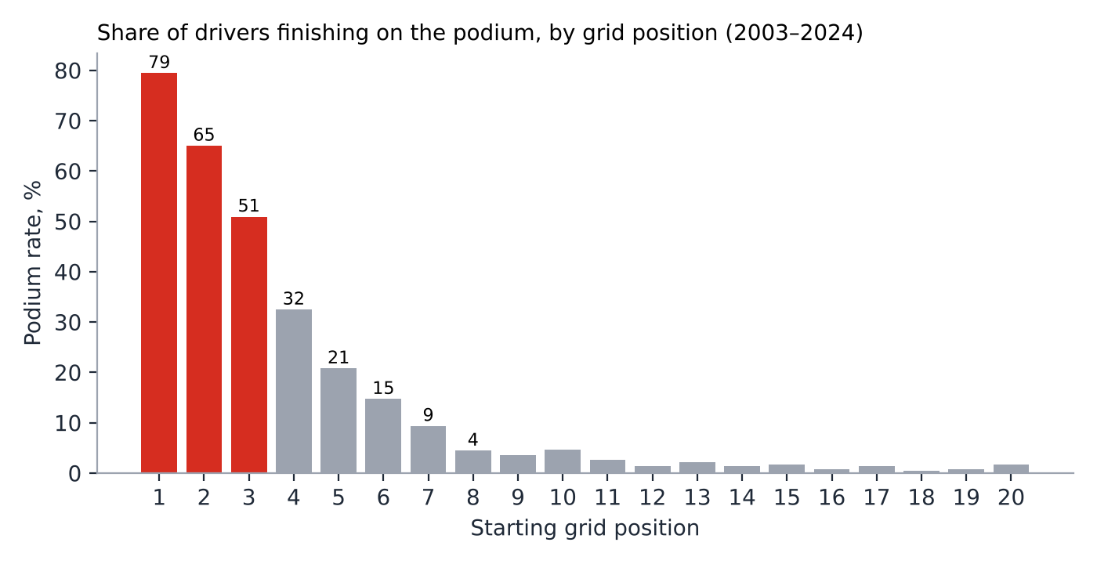
Figure 1. Podium rate by starting grid position, 2003–2024 (first three slots highlighted).
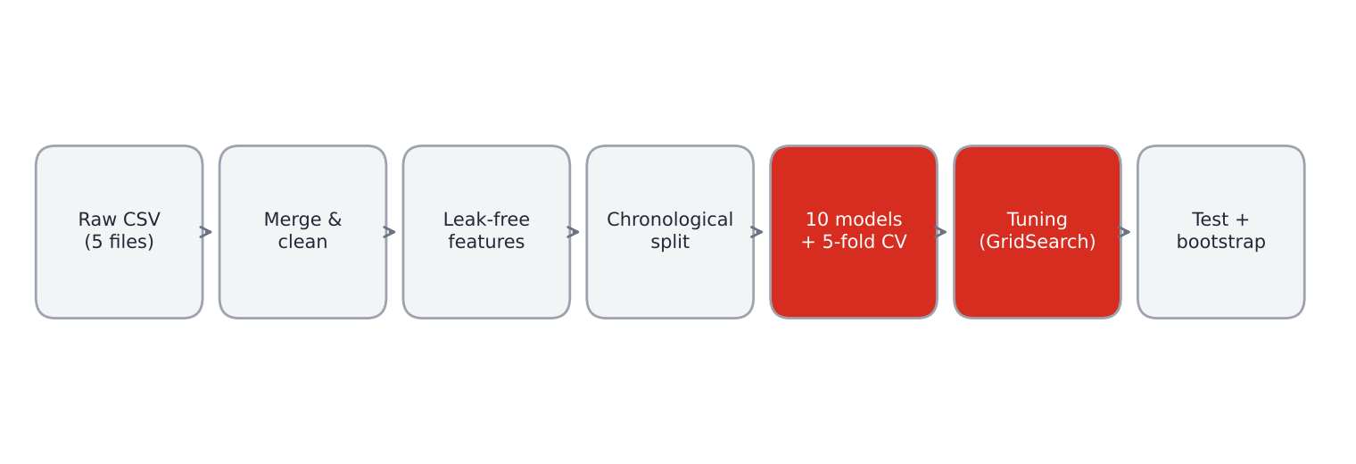
Figure 2. Overall experimental pipeline.

4.2 Comparison of preprocessing and feature sets
The first comparison concerns the information given to the models (Table 5). Using grid position alone gives a test PR-AUC of about 0.637 for all three models, identical to the baseline. Adding the grid-structure features (B) raises Logistic Regression and Gradient Boosting to about 0.665. The full 24-feature set (C), which adds driver, circuit and constructor form, gives the largest gain, to 0.705–0.714 (+0.07 over A). Further adding Elo ratings and the qualifying time gap (D) does not help: PR-AUC is unchanged or lower for Logistic Regression (0.707) and Gradient Boosting (0.697) and only marginally higher for Random Forest (0.708). Set C was therefore kept as the final representation.
Table 5. Effect of the feature set (test PR-AUC; cross-validated PR-AUC in brackets)
Feature set | Features | Logistic Regression | Random Forest | Gradient Boosting
A. Grid position only | 1 | 0.6368 (0.6431) | 0.6365 (0.6343) | 0.6364 (0.6339)
B. Grid structure | 9 | 0.6646 (0.6569) | 0.6399 (0.6427) | 0.6641 (0.6527)
C. Final set (24 features) | 24 | 0.7139 (0.6948) | 0.7051 (0.6733) | 0.7052 (0.6898)
D. Final + Elo + quali gap | 33 | 0.7071 (0.6944) | 0.7078 (0.6832) | 0.6971 (0.6906)

4.3 Cross-validation results
Table 6 reports the grouped 5-fold cross-validation results on the training seasons. The models are ranked by PR-AUC. Logistic Regression is first with 0.6995 ± 0.033, followed by Gradient Boosting (0.6971) and the Stacking Ensemble (0.6936). The weakest models are KNN (0.6541) and the RBF-kernel SVM (0.6424). Seven of nine models are within one fold standard deviation (about 0.033) of the leader, so their order is not reliable.
Table 6. Five-fold grouped cross-validation (training seasons)
Rank | Model | Family | PR-AUC | ROC-AUC | F1 | Top-3 | Fit time
1 | Logistic Regression Tuned | Linear | 0.6998 ± 0.033 | 0.9316 ± 0.012 | 0.6739 ± 0.041 | — | —
2 | Logistic Regression | Linear | 0.6995 ± 0.033 | 0.9319 ± 0.012 | 0.6739 ± 0.038 | 65.7% | 0.7 s
3 | Gradient Boosting | Boosting ensemble | 0.6971 ± 0.038 | 0.9328 ± 0.012 | 0.6790 ± 0.044 | 66.5% | 1.7 s
4 | Stacking Ensemble | Stacking ensemble | 0.6936 ± 0.035 | 0.9338 ± 0.011 | 0.6795 ± 0.043 | 66.2% | 26.8 s
5 | Neural Network (MLP) | Neural network | 0.6872 ± 0.032 | 0.9280 ± 0.012 | 0.6632 ± 0.041 | 64.2% | 2.4 s
6 | Extra Trees | Bagging ensemble | 0.6871 ± 0.034 | 0.9322 ± 0.010 | 0.6760 ± 0.042 | 66.0% | 7.8 s
7 | AdaBoost | Boosting ensemble | 0.6828 ± 0.053 | 0.9318 ± 0.014 | 0.6710 ± 0.040 | 66.4% | 8.6 s
8 | Random Forest | Bagging ensemble | 0.6792 ± 0.035 | 0.9306 ± 0.011 | 0.6719 ± 0.046 | 66.2% | 11.2 s
9 | KNN | Instance-based | 0.6541 ± 0.041 | 0.9171 ± 0.015 | 0.6458 ± 0.037 | 62.7% | 0.7 s
10 | SVM (RBF) | Kernel | 0.6424 ± 0.036 | 0.8719 ± 0.024 | 0.6599 ± 0.033 | 64.5% | 13.7 s
Top-3 for cross-validation is computed on out-of-fold predictions of the training races. Fit time includes the five cross-validation fits and the final fit.

4.4 Hyperparameter tuning
Logistic Regression was the best model with a parameter grid and was tuned with GridSearchCV. The best parameters were C = 10 and no class weighting (best cross-validated PR-AUC 0.6998). Tuning changed the test results only slightly (Table 7): F1 increased from 0.6723 to 0.6840 because the decision threshold changed from 0.3 to 0.32, precision increased from 0.5958 to 0.6195, and PR-AUC and ROC-AUC were unchanged (0.7140 and 0.9361). The fact that a 14-point grid changes ranking metrics by less than 0.001 shows that the model is already close to the best that these features can deliver.
Table 7. Logistic Regression before and after tuning (test set)
Metric | Before tuning | After tuning | Change
Accuracy | 0.8871 | 0.8941 | +0.0070
Precision | 0.5958 | 0.6195 | +0.0237
Recall | 0.7713 | 0.7636 | -0.0077
F1 | 0.6723 | 0.6840 | +0.0117
ROC-AUC | 0.9363 | 0.9361 | -0.0002
PR-AUC | 0.7139 | 0.7140 | +0.0001
Top-3 hit rate | 0.6628 | 0.6667 | +0.0039

4.5 Test-set results
Table 8 and Figure 3 show the results on the unseen seasons (2021-2024, 86 races). All models clearly exceed the baseline in ranking quality: ROC-AUC rises from 0.9082 to about 0.93 and PR-AUC from 0.6368 to 0.68–0.71. The tuned Logistic Regression has the best PR-AUC (0.7140) and F1 (0.6840). Extra Trees and the Stacking Ensemble have the highest ROC-AUC by a negligible margin (0.9364 and 0.9362 against 0.9363 for Logistic Regression). In Top-3 hit rate the best value is 66.7% against 65.1% for the baseline.
Table 8. Test-set metrics at the cross-validated threshold
Model | Accuracy | Precision | Recall | F1 | ROC-AUC | PR-AUC | Top-3
Logistic Regression Tuned | 0.8941 | 0.6195 | 0.7636 | 0.6840 | 0.9361 | 0.7140 | 66.7%
Logistic Regression | 0.8871 | 0.5958 | 0.7713 | 0.6723 | 0.9363 | 0.7139 | 66.3%
Gradient Boosting | 0.8930 | 0.6233 | 0.7248 | 0.6703 | 0.9346 | 0.7052 | 66.3%
Stacking Ensemble | 0.8941 | 0.6301 | 0.7132 | 0.6691 | 0.9362 | 0.7086 | 63.9%
Neural Network (MLP) | 0.8842 | 0.5961 | 0.7093 | 0.6478 | 0.9310 | 0.6939 | 63.2%
Extra Trees | 0.8924 | 0.6281 | 0.6938 | 0.6593 | 0.9364 | 0.7124 | 65.5%
AdaBoost | 0.8778 | 0.5656 | 0.8023 | 0.6635 | 0.9340 | 0.6951 | 64.7%
Random Forest | 0.8959 | 0.6447 | 0.6822 | 0.6629 | 0.9346 | 0.7051 | 64.7%
KNN | 0.8895 | 0.6172 | 0.6938 | 0.6533 | 0.9163 | 0.6755 | 63.2%
SVM (RBF) | 0.8924 | 0.6151 | 0.7558 | 0.6783 | 0.8790 | 0.6772 | 63.9%
Baseline (grid <= 3) | 0.8947 | 0.6498 | 0.6473 | 0.6485 | 0.9082 | 0.6368 | 65.1%
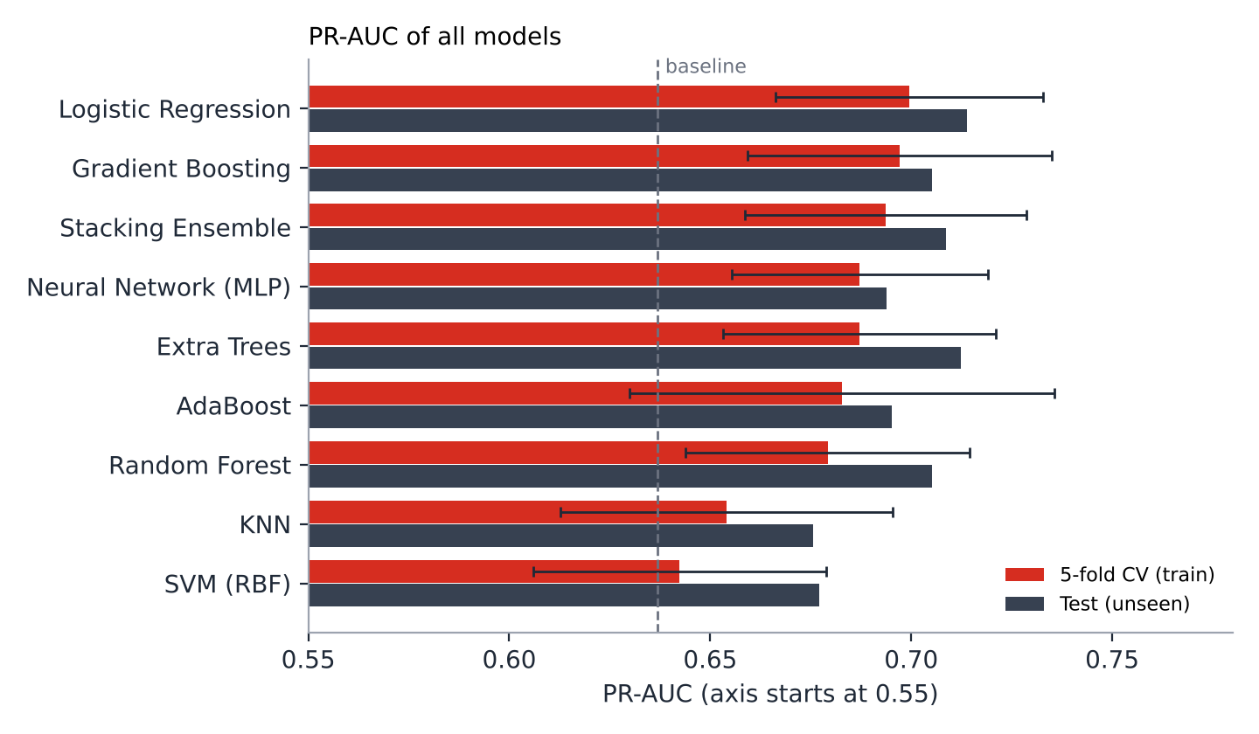
Figure 3. PR-AUC of all models: cross-validation (red, with standard deviation) and test (dark).

4.6 Are the differences real? Bootstrap confidence intervals
The test set contains only 86 races, so a difference of one or two points can be due to chance. Table 9 and Figure 4 report 95% bootstrap intervals (300 resamples of races). The result is clear. In PR-AUC, 9 of 10 entries are significantly better than the baseline (the interval of the difference lies above zero; the exception is KNN). In Top-3 hit rate, no model is significantly different from the baseline: every interval of the difference contains zero (for the tuned Logistic Regression [-2.1, 5.8] percentage points). The intervals of the models also overlap one another almost completely, so the ranking among the leading models is not statistically reliable.
Table 9. Test Top-3 hit rate and PR-AUC with 95% bootstrap confidence intervals
Model | Top-3 (95% CI) | Δ Top-3 vs baseline (95% CI, pp) | PR-AUC (95% CI) | Δ PR-AUC vs baseline (95% CI)
Logistic Regression Tuned | 66.7% [62.4, 71.9] | +1.5 pp [-2.1, 5.8] | 0.7140 [0.662, 0.773] | +0.077 [0.043, 0.110] *
Logistic Regression | 66.3% [62.0, 71.5] | +1.2 pp [-2.7, 5.4] | 0.7139 [0.661, 0.774] | +0.077 [0.043, 0.110] *
Gradient Boosting | 66.3% [62.0, 70.9] | +1.2 pp [-1.4, 3.7] | 0.7052 [0.654, 0.760] | +0.068 [0.042, 0.092] *
Stacking Ensemble | 63.9% [59.5, 68.2] | -1.2 pp [-3.5, 1.9] | 0.7086 [0.658, 0.768] | +0.072 [0.042, 0.103] *
Neural Network (MLP) | 63.2% [58.1, 68.6] | -1.9 pp [-6.2, 2.7] | 0.6939 [0.641, 0.753] | +0.057 [0.025, 0.096] *
Extra Trees | 65.5% [61.2, 69.8] | +0.4 pp [-2.3, 3.1] | 0.7124 [0.664, 0.769] | +0.076 [0.046, 0.104] *
AdaBoost | 64.7% [60.9, 69.4] | -0.4 pp [-3.5, 3.1] | 0.6951 [0.645, 0.754] | +0.058 [0.032, 0.085] *
Random Forest | 64.7% [59.5, 69.0] | -0.4 pp [-2.7, 2.3] | 0.7051 [0.654, 0.764] | +0.068 [0.036, 0.103] *
KNN | 63.2% [57.9, 69.4] | -1.9 pp [-6.2, 3.1] | 0.6755 [0.620, 0.731] | +0.039 [-0.000, 0.084]
SVM (RBF) | 63.9% [59.1, 68.6] | -1.2 pp [-4.3, 2.3] | 0.6772 [0.626, 0.740] | +0.040 [0.008, 0.073] *
Baseline: Top-3 65.1% [60.5, 69.8], PR-AUC 0.6368 [0.581, 0.685]. * the 95% interval of the difference lies above zero.
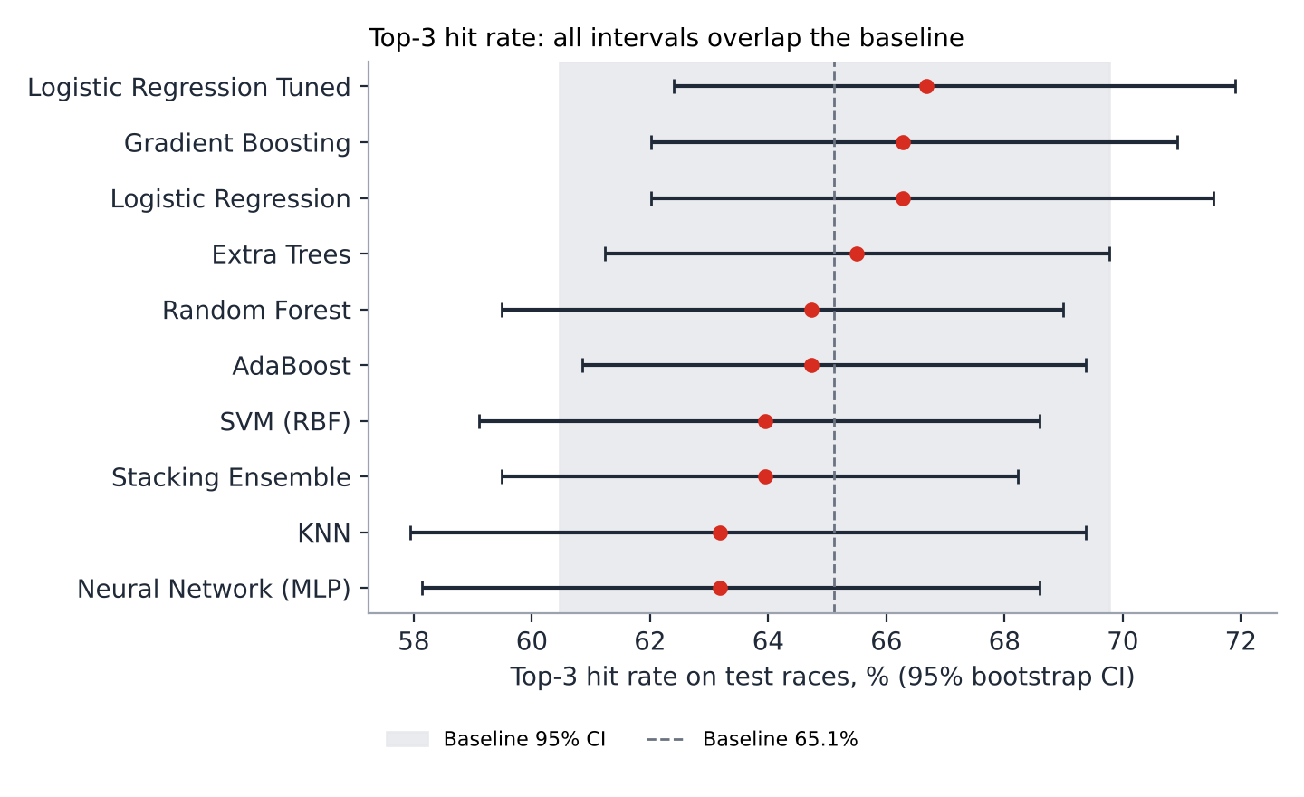
Figure 4. Top-3 hit rate on test races with 95% bootstrap intervals; the grey band is the baseline interval.

4.7 Error analysis and feature importance
The confusion matrix of the tuned Logistic Regression (Figure 5) shows 197 true positives, 121 false positives, 61 false negatives and 1,340 true negatives. The model finds 76.4% of podium finishers, and 62.0% of its podium predictions are correct. False positives are mostly front-row starters who lost positions at the start or retired, and false negatives are drivers who started in the midfield and benefited from incidents or strategy; neither group is predictable from pre-race data.
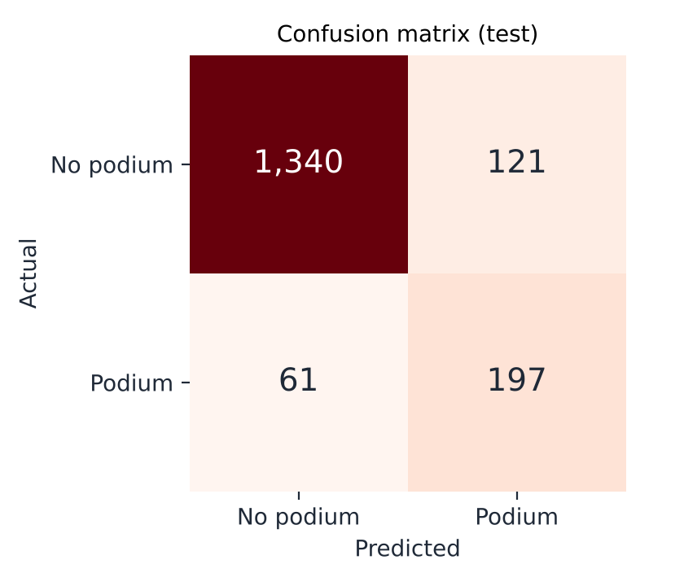
Figure 5. Confusion matrix of the tuned Logistic Regression on the test set.
Permutation importance (Figure 6) confirms the literature: grid_clean dominates with 0.461 (drop in PR-AUC when the feature is shuffled), roughly ten times more than the second feature, grid_zone (0.047). Driver experience (0.028), constructor form rank (0.027) and the top-10-start flag (0.024) follow. This explains why the full feature set adds about 0.07 PR-AUC to a grid-only model but not more.
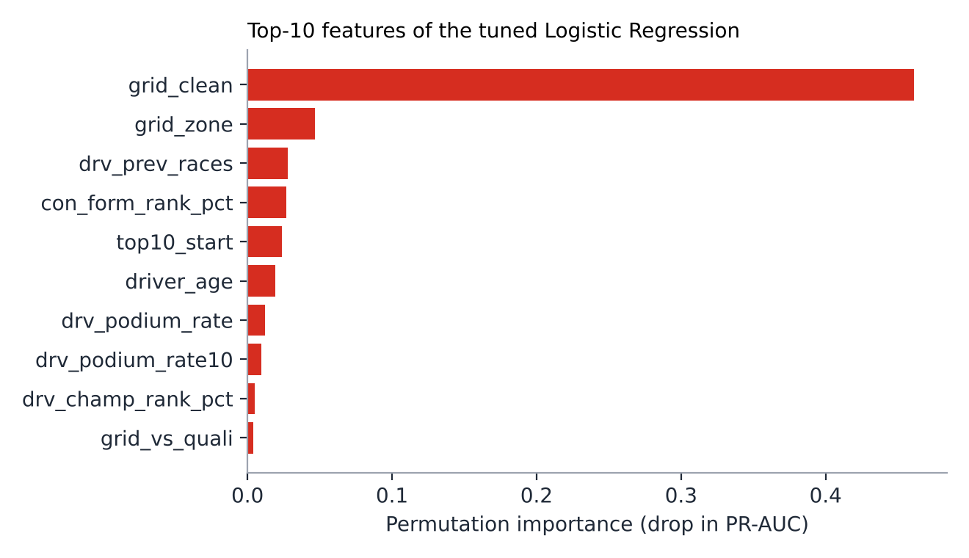
Figure 6. Ten most important features (permutation importance on the test set).

4.8 Race-level examples
Table 10 shows the five drivers with the highest predicted podium probability in the last three races of the test set. In the 2024 Abu Dhabi and Qatar Grands Prix the model nominated one of three actual podium finishers, in Las Vegas two of three. The examples show both the value and the limits of the approach: the pole-sitter and the grid leaders receive high probabilities, but a driver who started 19th (Leclerc in Abu Dhabi, probability 14.5%) finished third, which no pre-race model could anticipate with confidence.
Table 10. Highest predicted podium probabilities in the last three test races
Race | Driver | Team | Grid | P(podium) | Actual
2024 Abu Dhabi Grand Prix | Norris | Mclaren | 1 | 80.8% | P1
 | Piastri | Mclaren | 2 | 63.5% | P10
 | Max Verstappen | Red Bull | 4 | 49.1% | P6
 | Sainz | Ferrari | 3 | 42.2% | P2
 | Leclerc | Ferrari | 19 | 14.5% | P3
2024 Qatar Grand Prix | Max Verstappen | Red Bull | 2 | 66.0% | P1
 | Russell | Mercedes | 1 | 63.9% | P4
 | Norris | Mclaren | 3 | 56.1% | P10
 | Leclerc | Ferrari | 5 | 43.7% | P2
 | Piastri | Mclaren | 4 | 38.3% | P3
2024 Las Vegas Grand Prix | Russell | Mercedes | 1 | 61.2% | P1
 | Sainz | Ferrari | 2 | 49.7% | P3
 | Leclerc | Ferrari | 4 | 49.6% | P4
 | Norris | Mclaren | 6 | 45.9% | P6
 | Max Verstappen | Red Bull | 5 | 36.2% | P5
Rows highlighted in red are drivers who actually finished on the podium.

4.9 Discussion
Relation to the objectives. The pipeline meets the objectives: a leakage-free dataset was built (O1); a baseline and suitable metrics were defined (O2); nine models were compared (O3) under grouped cross-validation and a chronological test (O4); differences were tested statistically (O5); and a working application was delivered (O6).
Answers to the research questions.
- RQ1. Starting position is by far the strongest factor (permutation importance 0.461), followed by grid zone and driver/constructor form; the strongest single correlations with the target are driver and constructor podium rates (0.57 and 0.56).
- RQ2. Yes. Using only pre-race information, the tuned Logistic Regression reaches ROC-AUC 0.936 and PR-AUC 0.714 against 0.637 for the baseline; the Top-3 improvement of +1.5 pp is not statistically significant.
- RQ3. Grid-related features dominate; errors come from front-row starters who lose positions and midfield starters who gain them through incidents or strategy.
- RQ4. The models generalise to unseen seasons: test PR-AUC (0.714) is at least as high as cross-validated PR-AUC (0.700), so there is no sign of overfitting to the training seasons.
Why does a simple model win? With about 7,000 training rows, one dominant feature and a large random component, the signal is almost linear in the engineered features. Logistic Regression has low variance and well-calibrated probabilities, whereas flexible models (Random Forest, boosting, neural network) have more capacity than the data can use. This agrees with the literature, where deep networks win only on large telemetry data (Sasikumar et al., 2025), SVM wins on a small tabular set (García Tejada, 2023) and gradient boosting is preferred mainly for probability quality (Sargur Yathishkumar, 2025). The ensemble and stacking models did not help because their base models make similar errors.
Consistency with the literature. The dominance of grid position agrees with Sargur Yathishkumar (2025), whose SHAP analysis ranks grid position and recent form first, and with the constructor effect reported by van Kesteren and Bergkamp (2023), which is reflected in our constructor form features. The modest ceiling agrees with the low explained variance of Fatima and Johrendt (2023; R² = 0.39) and with the pre-race macro-F1 of 0.43–0.45 of Sargur Yathishkumar (2025). Their scores are not directly comparable with ours (four-class target, different split and metrics), so the comparison with the grid baseline under one protocol is the more reliable statement.
Honest interpretation. The models rank drivers much better than the baseline (PR-AUC +0.077), but when only three drivers are nominated per race the improvement (+1.5 pp) is within statistical noise. The practical value of the model is therefore mainly in calibrated probabilities for the whole field rather than in a better top-3 list.

4.10 Practical applications
- Broadcasting and fan engagement: pre-race podium probability graphics for every driver, updated after qualifying.
- Fantasy sports and decision support: ranking drivers by podium probability to shortlist candidates; the model is an analytical aid and not betting advice.
- Performance benchmarking: the difference between actual and predicted outcome quantifies over- and under-performance of drivers and teams relative to what their grid position and form imply.
- Risk assessment: probabilities for drivers starting far back help quantify how rare a podium from the back of the grid is (about 14.5% for the 19th starter in Abu Dhabi 2024 according to the model).
- Education and research: a reproducible pipeline and dashboard for teaching leakage-free validation, imbalanced classification and statistical comparison of models.

4.11 Limitations and further research
- Small test set. Only 86 test races; confidence intervals are wide and model rankings are unreliable.
- Missing race-day information. Weather, tyre choice, pit strategy, safety cars, penalties and car-development news are not in the dataset, although Sargur Yathishkumar (2025) includes race-level weather and shows that podium rates differ between dry and wet races.
- Non-stationarity. Regulations and car concepts change between eras; the 2022 ground-effect rules and the 2026 power-unit changes may shift relationships.
- Independent probabilities. The classifier gives each driver a separate probability; the sum over a race is not constrained to three. Race-level ranking or Plackett–Luce models could enforce this.
- Tuning scope. Only the best model was tuned; the others use sensible defaults. XGBoost and LightGBM were not evaluated in the reported run.
- Data source. The dataset is community-maintained; small errors in historical records are possible.
Further research. (1) Add weather forecasts, tyre and strategy data (for example from the FastF1 API). (2) Use learning-to-rank or Plackett–Luce models to predict the full finishing order. (3) Calibrate probabilities (for example isotonic calibration, which lowered the test ECE from 0.0975 to 0.0243 in Sargur Yathishkumar, 2025) and evaluate them with Brier score and log-loss, and add SHAP explanations. (4) Evaluate rolling-origin validation across more seasons. (5) Add sequence models for in-race prediction when lap-by-lap data are available.

5. Conclusion
The study developed and evaluated a machine learning pipeline for predicting Formula 1 podium finishers. The main findings and conclusions, numbered according to the objectives, are:
- Dataset (O1). A leakage-free dataset of 8,970 driver–race records from 428 Grands Prix (2003–2024) with 24 pre-race features was built; podium finishers are 14.3% of the records.
- Baseline and metrics (O2). The rule “top-3 on the grid” reaches PR-AUC 0.6368, ROC-AUC 0.9082 and a Top-3 hit rate of 65.1%. PR-AUC and the race-level Top-3 hit rate were chosen as the main metrics.
- Models (O3). Nine models from seven families were compared. Logistic Regression, Gradient Boosting and the Stacking Ensemble were the best by cross-validated PR-AUC (0.6995, 0.6971, 0.6936); KNN and the RBF-SVM were the worst (0.6541 and 0.6424).
- Validation and tuning (O4). The tuned Logistic Regression achieved on unseen seasons ROC-AUC 0.9361, PR-AUC 0.7140, F1 0.6840, recall 76.4%, precision 62.0% and a Top-3 hit rate of 66.7% (baseline 65.1%). Feature-set comparison showed that grid position alone gives PR-AUC 0.637 and the full set about 0.71; Elo ratings and qualifying time gaps added nothing.
- Statistical reliability (O5). 9 of 10 models are significantly better than the baseline in PR-AUC, but none is significantly better in Top-3 hit rate (95% bootstrap intervals include zero), and the leading models cannot be separated statistically.
- Application and limits (O6). A working Flask application reproduces all experiments and displays results in eight pages. The approach is useful for calibrated probabilities and benchmarking, but its accuracy is limited by the absence of weather, tyre and incident data and by a small test set.
Recommendations. For practical use, a regularised Logistic Regression on pre-race features is recommended as the default model because it is accurate, fast, interpretable and as good as complex alternatives. Future work should add race-day data, rank-based models and probability calibration, and should be validated on more seasons as they become available.

6. References
Aguad, F., & Thraves, C. (2024). Optimizing pit stop strategies in Formula 1 with dynamic programming and game theory. European Journal of Operational Research, 319(3), 908–919. https://doi.org/10.1016/j.ejor.2024.07.011
Breiman, L. (2001). Random forests. Machine Learning, 45(1), 5–32. https://doi.org/10.1023/A:1010933404324
Efron, B., & Tibshirani, R. J. (1993). An introduction to the bootstrap. Chapman & Hall.
Fatima, S. S. W., & Johrendt, J. (2023). Deep-Racing: An embedded deep neural network (EDNN) model to predict the winning strategy in Formula 1 racing. International Journal of Machine Learning and Computing, 13(3), 97–103. https://doi.org/10.18178/ijml.2023.13.3.1135
Friedman, J. H. (2001). Greedy function approximation: A gradient boosting machine. The Annals of Statistics, 29(5), 1189–1232. https://doi.org/10.1214/aos/1013203451
García Tejada, L. (2023). Applying machine learning to forecast Formula 1 race outcomes [Master’s thesis, Aalto University]. https://ml-theses.org/theses/81-forecasting-formula-1-race-outcomes.html
Hettmann, V. F. (2024). Optimizing race strategy: A machine learning model for predicting Formula 1 pit stop timing [Master’s thesis, NOVA University Lisbon]. http://hdl.handle.net/10362/175111
Leischner, M. R. (2024). From data to podium: A machine learning model for predicting Formula 1 compound decisions [Master’s thesis, NOVA University Lisbon]. http://hdl.handle.net/10362/179736
Mistry, V., & Smith, W. A. P. (2025). AutoF1: An RNN-based approach to simulating strategic decision-making in Formula 1. IEEE International Conference on Intelligent Transportation Systems (ITSC). https://doi.org/10.1109/ITSC60802.2025.11423678
O’Hanlon, E. (2022). Using supervised machine learning to predict the final rankings of the 2021 Formula One Championship [Master’s thesis, National College of Ireland]. NORMA. https://norma.ncirl.ie/6628/
Patil, A., Jain, N., Agrahari, R., Hossari, M., Orlandi, F., & Dev, S. (2023). A data-driven analysis of Formula 1 car races outcome. In Artificial intelligence and cognitive science (Communications in Computer and Information Science, Vol. 1662, pp. 134–146). Springer. https://doi.org/10.1007/978-3-031-26438-2_11
Pedregosa, F., Varoquaux, G., Gramfort, A., Michel, V., Thirion, B., Grisel, O., Blondel, M., Prettenhofer, P., Weiss, R., Dubourg, V., Vanderplas, J., Passos, A., Cournapeau, D., Brucher, M., Perrot, M., & Duchesnay, É. (2011). Scikit-learn: Machine learning in Python. Journal of Machine Learning Research, 12, 2825–2830.
Rao, R. (n.d.). Formula 1 World Championship (1950–2024) [Data set]. Kaggle. https://www.kaggle.com/datasets/rohanrao/formula-1-world-championship-1950-2020
Saito, T., & Rehmsmeier, M. (2015). The precision-recall plot is more informative than the ROC plot when evaluating binary classifiers on imbalanced datasets. PLOS ONE, 10(3), Article e0118432. https://doi.org/10.1371/journal.pone.0118432
Sargur Yathishkumar, L. (2025). Predicting Formula 1 podium finish probabilities using machine learning: A comparative study of pre-race and within-race feature scenarios [Master’s thesis, National College of Ireland]. NORMA. https://norma.ncirl.ie/9904/
Sasikumar, A., Leema, A. A., & Balakrishnan, P. (2025). Data-driven pit stop decision support for Formula 1 using deep learning models. Frontiers in Artificial Intelligence, 8, Article 1673148. https://doi.org/10.3389/frai.2025.1673148
Surendran, A. (2023). Analysing the most influential factor in Formula One: A deep learning approach for predicting driver and team ranks [Master’s thesis, National College of Ireland]. NORMA. https://norma.ncirl.ie/7624/
van Kesteren, E.-J., & Bergkamp, T. (2023). Bayesian analysis of Formula One race results: Disentangling driver skill and constructor advantage. Journal of Quantitative Analysis in Sports, 19(4). https://doi.org/10.1515/jqas-2022-0021

Appendix A. Web application and source code

A.1 How to run the program
- Install the requirements: pip install -r requirements.txt.
- Place the five CSV files in the data/ folder.
- Start the server: python app.py, then open http://127.0.0.1:5000.
- Press “RUN ML PIPELINE”. The pipeline runs in about 1.5 minutes and all pages are filled with the results (results are cached; /run?refresh=1 recomputes them).

A.2 Pages of the application
Page | Content
Overview | Dataset size, train/test years, best model, class balance, comparison with the baseline
03 Data Preparation | Chronological train/test split
04 Feature Engineering | Feature table with types and meaning, removed features, target correlation, feature importance
05 Model Training | Metric cards for every model, baseline and tuned model
06 Cross-validation | Mean ± standard deviation and fold values
07 Hyperparameter Tuning | Best parameters, before/after table, confusion matrix
08 Model Comparison | Leaderboard, bar charts, bootstrap significance, model profiles and key findings
Predictions | Top-3 hit rate versus baseline and predictions for the last three test races

A.3 Code structure: which code corresponds to which model
File / function | Purpose
app.py | Flask server, endpoints / and /run, result cache
ml/pipeline.py → load_data, merge_data, add_history_features | Data loading, merging and leak-free feature engineering
ml/pipeline.py → select_features, create_preprocessor | Collinearity selection; imputation, winsorisation, scaling, encoding
ml/pipeline.py → build_models() | Logistic Regression, KNN, SVM (RBF), Neural Network (MLP), Random Forest, Extra Trees, AdaBoost, Gradient Boosting, Stacking Ensemble (and XGBoost, LightGBM if installed)
ml/pipeline.py → PARAM_GRIDS | Hyperparameter grids of every tunable model
ml/pipeline.py → cross_validate_model, best_threshold | Grouped 5-fold CV and threshold selection
ml/pipeline.py → bootstrap_ci | Race-level bootstrap confidence intervals
ml/pipeline.py → run_ml() | Full experiment: training, CV, tuning, test, importance, examples
experiments/feature_set_ablation.py | Comparison of four feature sets (Table 5)
templates/index.html, static/css, static/js/app.js | Dashboard (pages, styles, rendering of results)

